Thailand Seafood Industry Denies Human Trafficking Allegations
Steve Herman
June 24,2014
BANGKOK — Thailand reels in more than $7 billion annually as the world’s third largest exporter of seafood, but the industry has been tainted by links to human trafficking.
Leaders of Thailand’s shrimp and tuna suppliers say they are being unfairly maligned, causing damage to their businesses which employ hundreds of thousands of people.
Thailand’s fishing industry relies on migrant labor. Rights groups and Western media have uncovered evidence of a brutal system of slavery utilizing trafficked workers.
Min Min Chan, from Myanmar, claims that eight years ago, at the age of 17, he was tricked by a recruiter and sold to a Thai fishing boat for little more than $600.
He says for several years he toiled on the ship with little sleep, water or food. And when he became seriously ill, the captain told him not to stop working.
“I thought it was better to die by jumping into the water than to die by being tortured by these people," the former seafood worker said. "When I was about to jump, my friend grabbed me from behind and saved my life.”
He later escaped and hid out on Indonesia’s Ambon island until this year when he was repatriated by the International Organization For Migration.
Such testimony has led to Thailand being listed among the worst violators of trafficking in persons.
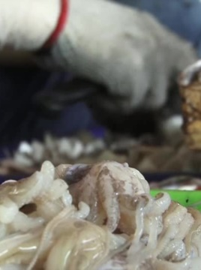
In an annual report released Friday, the U.S. State Department cites surveys that show between 17 and 57 percent of those in Thailand’s seafood industry work against their will.
Those statistics are rejected by industry officials here, who question the sources and reliability of the data.
The Thai Tuna Industry Association, formed last year, says it allows external verification to ensure workers are treated ethically.
At a news conference Tuesday, a coalition of Thailand’s frozen shrimp industry said, “There is no slavery involved in the shrimp supply chain.”
Industry leader Panisuan Jamnarnwej says Thailand’s prawns have been clean of exploitive labor for years.
The former president of the Thai Frozen Foods Association says the industry cannot risk concealing damaging information.
“Consumer perception, we have to work on. We have to provide the truth," said Panisuan Jamnarnwej. "If we keep lying, sooner or later, they’ll discover it and it’ll be even worse than what’s happening at the moment.”
The publicity is having an impact.
Some major international retailers are dropping suppliers linked to the allegations of slavery and overseas buyers plan to work with non-governmental organizations to try to ensure that there is no forced labor in the supply chain.

