US Congress Grants Top Honor to Civil Rights Leaders
WASHINGTON — The U.S. Congress has posthumously granted its top honor - the Congressional Gold Medal - to the late civil rights leader Martin Luther King, Jr. and his wife, Coretta Scott King.
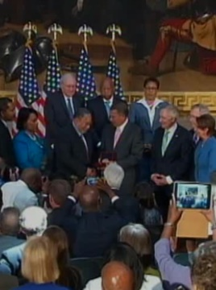
The two - who spent their lives working to end racial discrimination and segregation - were honored at a ceremony marking the 50th anniversary of the signing of the landmark Civil Rights Act.
Congressional leaders from both sides of the aisle joined hands as they sang one of the best known tunes from the civil rights movement of the 1960s.
King's daughter, Bernice, who heads The King Center, based in Atlanta, and her two brothers, Martin Luther King, III, and Dexter Scott King, watched as the medal was handed to Lonnie Bunch, the director of the Smithsonian National Museum of African American History and Culture.
"With the acquisition of this medal, the Smithsonian will ensure that as long as there is America, the courage the impact and the legacy of Martin Luther King will be honored preserved and remembered. Thank you very much," said Bunch.
Senate Minority Leader Mitch McConnell called racial intolerance in the United States the cancer of injustice that was allowed to metastasize for nearly a century after the end of the Civil War.
"A pastor with a booming voice and a potent message helped change all of that. Through the power of his words and the force of his example, Dr. Martin Luther King, Jr. made those who may have wanted to look away focus on what he once called the long night of racial injustice," said McConnell.
The law that outlawed racial segregation and discrimination was signed on July 2, 1964, by then-U.S. president Lyndon B. Johnson. Congresswoman Marcia Fudge acknowledged his role in pushing the legislation through Congress.
"These servant leaders committed their lives to moving America closer to what it can be. Due to the work of Dr. King and President Johnson, I am able to stand here today as the third African American and second woman to represent the 11th District of Ohio and I greet you on behalf of the 43 members of the Congressional Black Caucus, which I am honored to chair," said Fudge.
Senate Majority Leader Harry Reid emphasized that the battle against racism in America was not fought only in the nation's capital.
"The battle for civil rights was fought on bus rides through South Carolina, Mississippi, and even on the Edmund Pettus Bridge in Selma, Alabama," said Reid.
Events honoring the 50th anniversary of the Civil Rights Act, including exhibits, lectures, concerts and commemorations of historic dates leading up to the signing of the legislation, are taking place nationwide this year

