**Task 1: Ashik, Roseline Tuli**

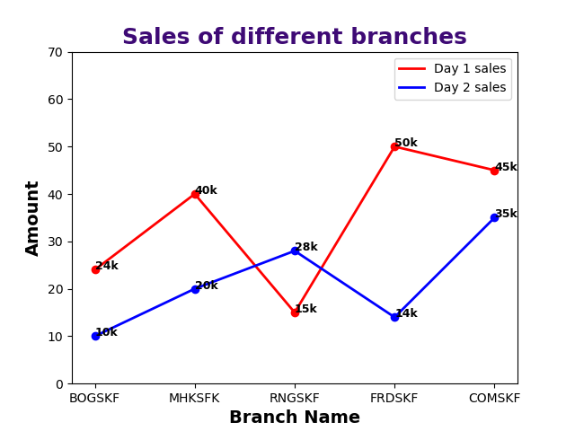

Develop this exact graph using Matplotlib, save the graph as task1.png file, submit the code with the saved picture.

**Task 2: Kanon, Tuli Tamanna Rini**

Make a query for top 10 branches sales between two months. Plot the line chart just like task 1 using this value, save the graph as task.png file, submit the code with the saved picture. Please limit y axis values and rotate branch name 90 degrees.

**Task 3: Hanif, Md. Shahadat, Sanchita Saha**

**x = ['Rahat', 'Shibli', 'Karim', 'Raju']  
y = [30000,100000,40000,20000]  
z = [5000, 10000, 6000, 10000]**

Using this values plot the below graph, save the graph as a .png file, submit the code with the saved picture.

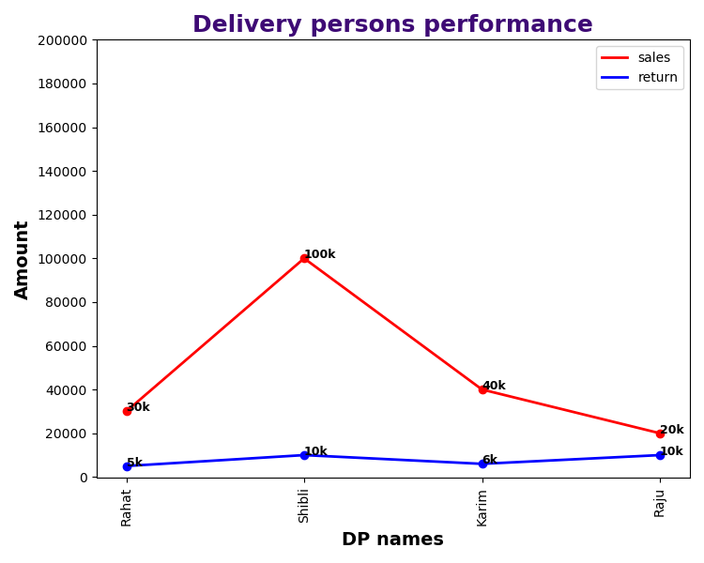

**Task 4: Sagir Ahmed, BM. Ashik**

|  |  |  |
| --- | --- | --- |
| Sales person | Day-01 | Day-02 |
| Habib | 30000 | 50000 |
| Raihan | 100000 | 10000 |
| Rocky | 40000 | 60000 |
| Kabir | 20000 | 100000 |

Using this value plot the below graph, save the graph as a .png file, submit the code with the saved picture. Show legend in the top left.

