INSTRUCTIONS

**Summary**

Over 6 rounds, you will be able to trade securities in an online marketplace. Each share of a traded security pays off $1, if there exists a solution of the “knapsack problem” that satisfies the threshold condition of that security. The knapsack problem is a problem where one is asked to find the right items from a collection of possible items that fit a given knapsack while reaching a certain value.

During the experiment, you will have access to two websites. One will be an online trading platform, and the other will be a website where you can try out solutions to the knapsack problem at hand, to determine the values of a particular knapsack, and thus whether you should buy or sell securities. You earn money by buying shares of securities whose threshold value *can* be achieved given the knapsack at hand and by selling shares of securities whose threshold value *cannot* be achieved with the given knapsack. Additionally, you will earn a fixed $2 reward for each suggested solution to the knapsack problem you submit (independently of whether this solution is correct or not).

At the end of the experiment, your earnings from trading will be determined by two randomly selected trading rounds. Your performance in each round will be equal to the sum of remaining cash and the payoffs from your final share holdings in that round, plus the reward for submitting a suggested solution to the knapsack problem.

**Setting: Knapsack Problems**

In our knapsack problems, one is given a list of 10 items and is asked to optimally load them in a knapsack. Each item has a *weight* and a *value*. The knapsack has a *weight limitation* that may prevent one from loading all items in the knapsack. Given this limitation, one is asked to determine whether the set of items *can* achieve a pre-specified threshold value. The total value of a proposed knapsack equals the sum of the values of its individual items.

You can think of the problem as asking the following question: *Given the weight constraint of the knapsack, does there exist a combination of items that* ***at least*** *achieves a total knapsack value of X?*

In each of the 6 rounds (plus a practice round) you can see the corresponding knapsack problem online*,* at <http://bmmlab.org/games>. Log into the website with the ID and password you are given, and navigate to “Play Knapsack Game,” where you pick the problem corresponding to the market from the drop-down list (see Table 1 below for the list of problem identifiers). An example of the interface is shown in Figure 1 below. You will be asked to refresh this webpage and login again between each round, in order to navigate to the next problem.

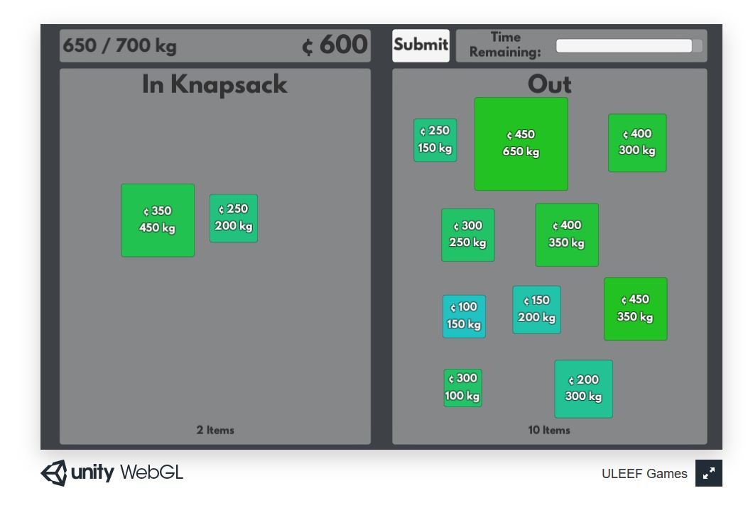

Figure 1: Knapsack problem interface

|  |  |  |
| --- | --- | --- |
| Round | Knapsack Problem Name | Market Name |
| Practice | KP-Trial | KPM-Trial |
| 1 | KP-Ant | KPM-Ant |
| 2 | KP-Beaver | KPM-Beaver |
| 3 | KP-Camel | KPM-Camel |
| 4 | KP-Dolphin | KPM-Dolphin |
| 5 | KP-Elephant | KPM-Elephant |
| 6 | KP-Frog | KPM-Frog |

Table 1: Knapsack problem and market names

You can try for yourself which items you think should be in the knapsack, by moving the items you want in the knapsack in the “IN” panel, while keeping the others in the “OUT” panel (which is to the right in the above picture, but at other times will be to the left). Items are identified by their WEIGHT (their size increases with weight) and VALUE (their colour changes from blue to green as value increases). Before the round ends, you should SUBMIT your suggested solution by clicking on the “Submit” button. You have to submit your solution at the latest by the end of trading. (There is a white bar next to the submit button which indicates “time remaining”; please ignore it.) You earn $2 when you submit your suggested solution, independent of whether it is correct or not.

**Important:** You are not allowed to access any webpages other than the two you are instructed to use (the knapsack problem and the market pages)! Failure to do so will lead to exclusion from the experiment.

**Earnings from Trading in the Online Market**

You can earn money by *trading in a market* where shares can be bought or sold. There will be 4 types of traded securities in each market, each with a different threshold value attached to it (see Table 2 below for an example). You will be provided with a separate document called **Securities**, whichincludes all the tradeable securities and their corresponding threshold values for each trading round.

|  |  |
| --- | --- |
| Security | Threshold Value |
| Security 30 | 30 |
| Security 50 | 50 |
| Security 70 | 70 |
| Security 90 | 90 |

Table 2: Example of tradeable securities and their corresponding threshold values

After markets close, **each share** of a security will pay off **$1** *if* there exists a knapsack whose total value is equal or higher than the threshold value of that security. For example, let us assume that a knapsack has a maximum total value of 52. In this case, each share of ‘Security 30’ and of ‘Security 50’ (see Table 2 above) would pay $1, whereas ‘Security 70’ and ‘Security 90’ would expire worthless. In other words, only the shares of securities whose attached threshold value can be satisfied by the given knapsack will pay off at the end of trading.

If your solution to the knapsack problem at hand matches or exceeds the corresponding threshold value of a security, you can earn money by *buying* shares of that security. On the other hand, if your solution to the knapsack problem has a lower value than the threshold value of another security, you could earn money by *selling* shares of that security. For instance, if your optimal knapsack reaches a maximum value of 89, you would prefer to buy shares of ‘Security 30’, ‘Security 50’, and ‘Security 70’. If the maximum total value of that knapsack is indeed 89, you should be selling shares of ‘Security 90’.

Your total earnings from each trading round will consist of (i) the amount of final cash holdings, plus (ii) the sum of payoffs from each share that you hold at the end of trading. At the end of the experiment, **two** rounds will be randomly selected as “payment rounds”.

**Trading in the Online Market**

Trading takes place through an electronic trading platform called *Adhoc-Markets*. In *Adhoc-Markets* you submit *limit orders*, which are orders to buy or sell at a price you determine, or, if possible, at any better price. Transactions take place from the moment a buy order with a higher price crosses a sell order with a lower price or vice versa. Orders remain valid until you cancel them or the marketplace closes. You will be given ample opportunity to train yourself in submitting and canceling orders.

You can access *Adhoc-Markets* as follows: use your logon information sheet and log onto <https://adhocmarkets.com/> using the ID labelled “Trading Market” and the same password you have used to access the knapsack problem. You should then navigate to the market name for the corresponding round (see Table 1 above for a list of market names). Each market will be open for a pre-determined time period (approximately 10 minutes). Instructors will notify you at halftime as well as one minute before markets close.

|  |  |  |
| --- | --- | --- |
|  | Website | Suggested Web Browser |
| Knapsack Problem | <http://bmmlab.org/games> | Firefox |
| Online Market | <https://adhocmarkets.com/> | Chrome |

Table 3: Websites to use and suggested Web Browsers