Things to try:

Cross validation – via random subsampling:

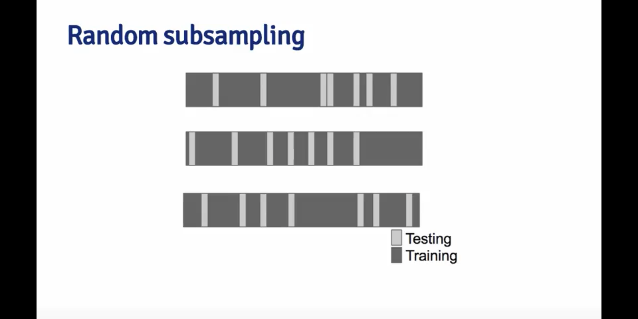

K-fold cross validation:

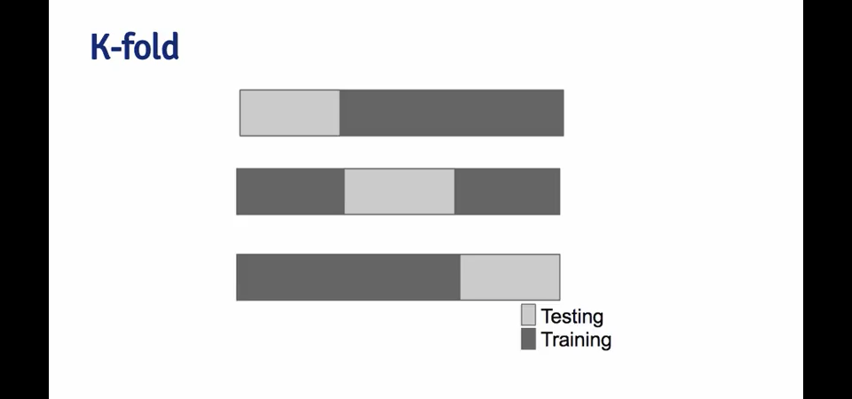

Training – test – validation sets: Split at 60-20-20, do all training on the training data set. Evaluate on the test data set, and use the minimum errors to tune the model (e.g. the algorithm and selection of predictors). Once an optimum solution has been found, test it once on the validation set to get a truer measure of the out of sample error.

Additional things we need:

* Remove patients who die on the table from the out of room model (keep in in room)
* Remove patients who have an ASA status of moribund