Using FitNesse to Test Services

Version 2.0, 16th April 2019

What is FitNesse
FitNesse is a wiki-based test framework that has been around for about 15 years. It was developed by ‘Uncle Bob’ Martin with his son Micah. It is an evolution of an earlier non-wiki-based test framework called ‘Fit’. More details here.
Essentially you develop a (lightweight) Java application (C++ and python can also be used) that interfaces between the wiki and the application you want to test.

Getting Started
Download the standalone jar file and run ‘java –jar jarfile’. It accepts a number of parameters (including –p for port number), most of which have default values (more details). It has a built in web server which runs by default on port 80. Once it’s up and running you can access the wiki locally with ‘http://localhost’. You can ignore the occasional ‘concurrency’ exceptions in the console – known issues that don’t impact functionality as far as I know.
If tests are likely to return a lot of data it would be advisable to allocate more memory than the default by using the -Xmx jvm parameter. A value of 4096 would be a sensible value to run a full production-level test suite:
java –Xmx4096M –jar fitnesse-standalone.jar
The first time you run FitNesse it creates a folder called FitNesseRoot, into which it will put some default wiki pages (Front page, user Guide, the acceptance test suite for FitNesse itself, etc.).
Any wiki pages you create are stored as text files and subfolders below the root folder ‘FitNesseRoot’. That means you can migrate your test pages to another instance of FitNesse by simply copying the relevant files and folders from ‘FitNesseRoot/FitNesse’ to the target machine and the tests should run straight away.

Java Framework
The Java framework will be lightweight and is only used to interface with the application under test. All tests will be written in the wiki itself. Although the initial version of the framework should be sufficient to build most test cases it will likely evolve over time. The goal is to reach a stage where the Java framework has matured to the point where it rarely, if ever, needs to be updated at all.
The wiki test suite will include a scenario library which should contain all the scenarios, or building blocks, necessary to create useful test cases. It will also contain references to what FitNesse refers to as ‘fixtures’. These are used to build decision tables, perhaps the most common way to implement a test case. The other very useful table type is a ‘script’ table. This can be used to assemble a number of scenarios into a sequence that simulates a full use case. The scenarios and fixtures, details of which are given later, are implemented in the Java framework.
The Java framework and wiki test suites will likely be under version control in RTC/GitHub. The current structure of the project is shown below. Fixtures and scenarios are (currently) either Rest or Databases services. In line with best practice, base functionality in the framework should have good junit test coverage (helpful for debugging issues if nothing else):
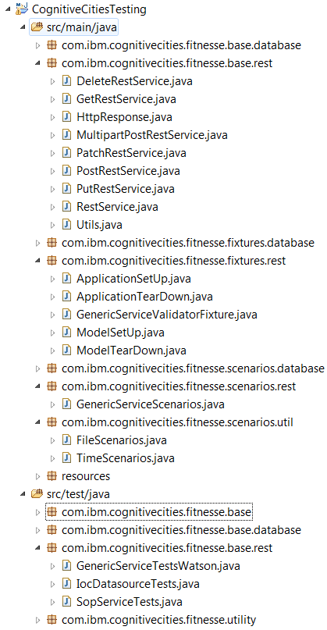
To facilitate the junit tests some key properties are read statically from a property file /fitnesse/testfiles/Test.properties in a base test class (TestBase):
webHost=dubperfwow2-web.mul.ie.ibm.com
webUser=sysadmin
webPassword=us3rpa88
dbHost=dubperfwow2-db.mul.ie.ibm.com
dbUser=db2i1own
dbPassword=us3rpa88
appHost=dubperfwow2-app.mul.ie.ibm.com
appHostUser=root
appHostKeyFile=/fitnesse/testfiles/windows_laptop_brendan.ppk
appHostKeyPassword=

Offline Tests
FitNesse can be invoked from the command line to run tests or test suites. Fitnesse will start up, run the test or suite of tests and then shut down. In other words, the test suites could be run, for example, from Jenkins. The output format of the offline tests can be junit, text, html or xml. Junit is likely to be the most suitable for our purposes. An example of such a command would be:
java -jar fitnesse-standalone.jar -d "/fitnesse" -p 8080 -o -b TestSuite_Results.xml -c "Fitnesse.CognitiveCitiesSuiteofSuites.TestSuites.IocSuite.IocServicesSuite?suite&format=junit"

Page Types
There are four main page types:

Static Page
Used, for example, to display a contents list

Test Page
Used for an individual test or a set of tests. A ‘Test’ button is displayed at the top of the page to run the test.

Suite Page
Used for a suite of tests, or a suite of suites. A ‘Suite’ button is displayed at the top of the page to run the suite.

Special Pages
These are documented in more detail here. The main ones of interest are shown below. These are set up as regular test pages with special names.
- ScenarioLibrary: library of reusable scenarios, the building blocks of test cases
- SuiteSetUp: Set up page for suites (e.g., create database connections, set global variables like ‘host name’). The contents of this page are accessible to all child suites and tests. The suite set up page will be invoked once at the start of all suites at and below its level. If more than one SuiteSetUp page is configured in hierarchy of suites and tests only the innermost page is executed. We can use the !include page functionality if we need to include code from a parent SuiteSetUp page (see example below)
- SuiteTearDown: Clean up page for suites (e.g., close database connections). The suite tear down page will be invoked once at the end of all suites at and below its level. If more than one SuiteTearDown page is configured in hierarchy of suites and tests only the innermost page is executed. We can use the !include page functionality if we need to include code from a parent SuiteTearDown page
- SetUp: Set up page for tests (e.g., set up model-specific parameters). This will be executed before all tests at the same level and below. E.g., if you have 3 test cases at and below the level of the SetUp page the scripts in the SetUp page will be executed three times. If multiple SetUp pages are defined the innermost SetUp page takes precedence and the outer ones are not executed.
- TearDown: clean up page for resources allocated in SetUp. This will be executed after all tests at the same level and below. E.g., if you have 3 test cases at and below the level of the TearDown page the scripts in the TearDown page will be executed three times. If multiple TearDown pages are defined the innermost TearDown page takes precedence and the outer ones are not executed.
The hierarchy used during development of the framework is shown below:
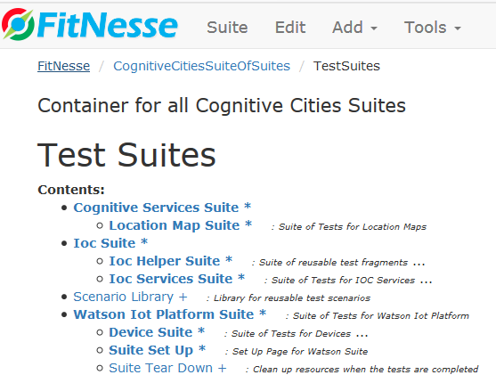

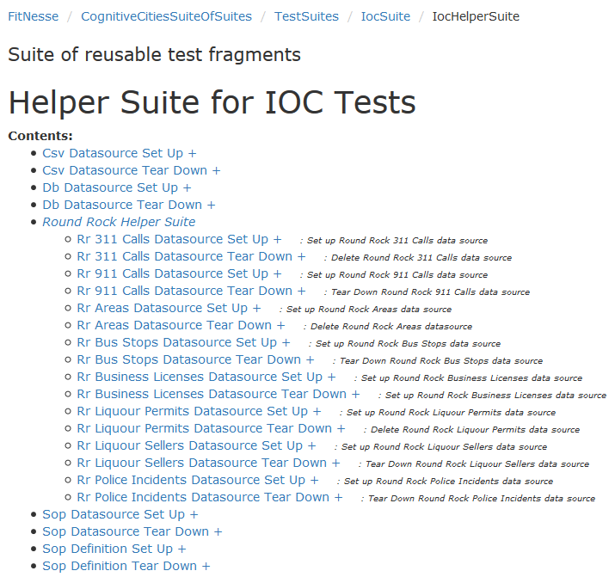
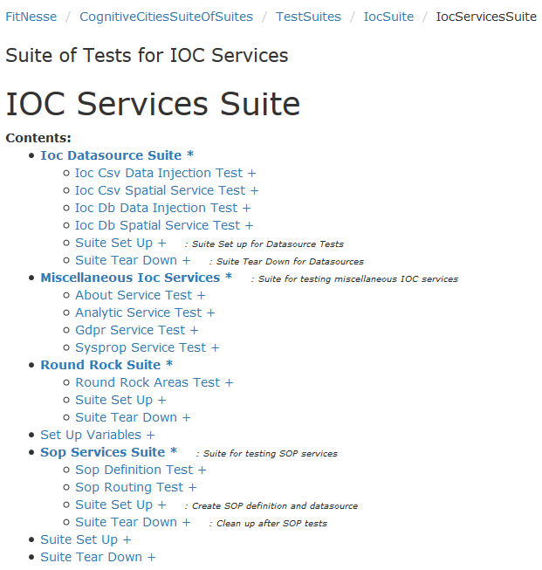

SuiteSetUp/SuiteTearDown Pages
As mentioned, these are executed once at the start of every suite of tests at and below the level they are defined. A top-level SuiteSetUp page is a convenient way to initialise parameters that the Java Framework needs to execute all, or most, tests. For example, we use simple Application and Database classes to initialise parameters needed to run all Rest services and database actions:
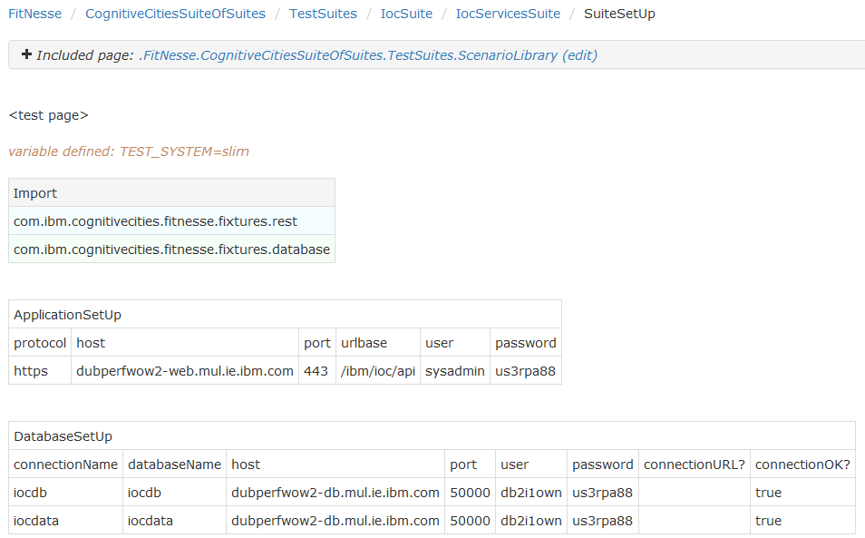
The idea is that you will only need to update these variables once per environment. By using placeholders it should be possible to have Jenkins dynamically update these values when running the test suites after a new build is installed.
A SuiteTearDown page can then be used to clean up resources allocated in the corresponding SuiteSetUp page. In the example below we call ApplicationTearDown and DatabaseTearDown classes, the latter of which is used to close the connections opened previously:
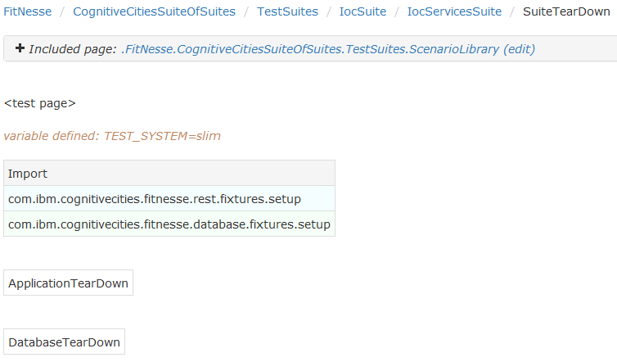

Hierarchical Suite Set Up/Tear Down Pages
If there is more than one Suite Set Up page in a hierarchy FitNesse will only apply the innermost one. There may be situations where we want to use Suite SetUp/TearDown pages to do special initialisations for a group of tests. For example, for IOC data source testing we might want to create one or more data sources, run a series of test cases, and then delete the data sources. We can do this in SuiteSetUp/SuiteTearDown pages. However, we will also want to inherit the initialisations from the top-level SuiteSetUp page and avoid having to duplicate code. To achieve this we can use FitNesse’s include functionality to include the top-level set up/tear down pages (documentation). We can take this a stage further and define a helper suite with useful test fragments that we can include where necessary:

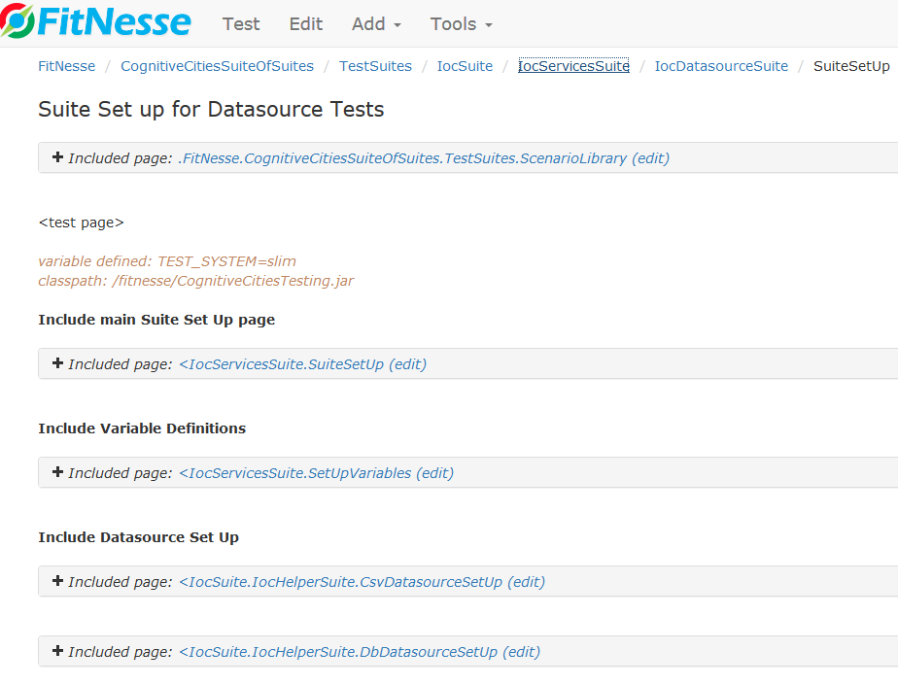

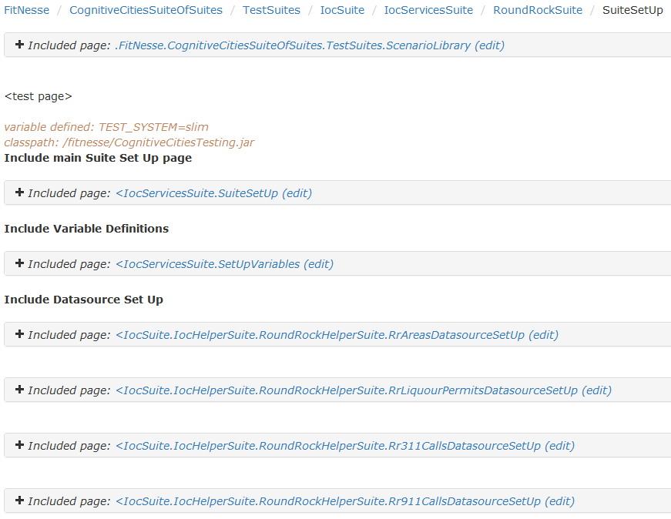

Variable Declaration
In the above example we are also including a ‘SetUpVariables’ page. This is a useful technique for initialising some global variables using FitNesse’s !define keyword (documentation). These kind of variables are for use within FitNesse itself, so no need to propagate them back to the Java Framework using fixtures. By using the include functionality we only need define them in one place:
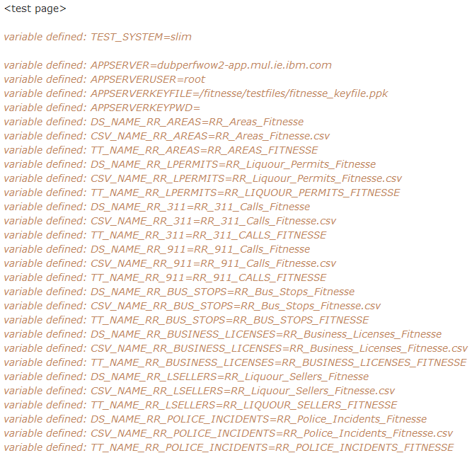
FitNesse variables are replaced inline by FitNesse at render time, for example in the file copy function shown above. Note that the documentation states that variables defined in a parent or included page are visible in the child page. That doesn’t seem to be the case, so you may need to include them explicitly in child pages also.

Building a Test Case
There are two test systems available in FitNesse. The more modern one is a lightweight system called Slim, and the one will be referenced and used from now on.
The two most useful table types to build test cases are decision tables (many variations available) and script tables (details of all Slim tables are here).

Decision Table
The first row of a decision table is the name of the fixture to be called (essentially a java class we implement). The columns of a decision table are a series of setters and getters (getters are indicated by a trailing ?). The setters set values in the fixture class and the getters retrieve values that are used for validation. A special method ‘execute()’, if defined in the fixture class, is invoked by fitnesse after the setters and before the getters, and which runs the logic of the fixture. Each row of the table represents a separate execution of the fixture. A method called reset(), if defined, is called at the start of each row to initialise variables.
Below is a typical example:
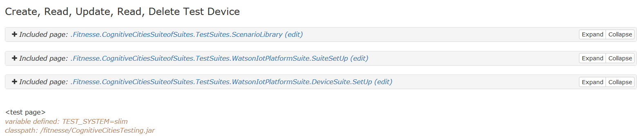
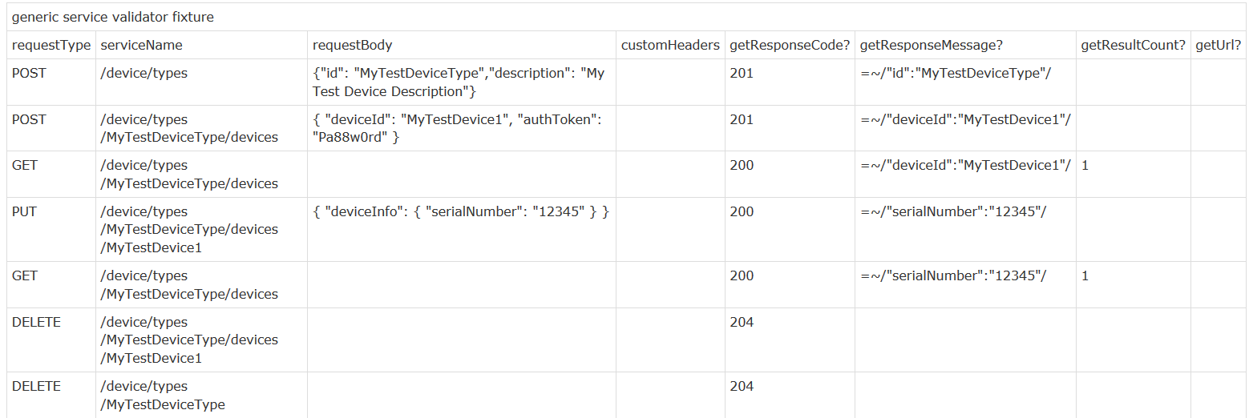
Here we see that the special pages ScenarioLibrary, SuiteSetUp and SetUp will be included and instantiated before the test is run and SuiteTearDown will be called after the test is run.
A fixture called ‘generic service validator fixture’ is invoked. Fitnesse will remove the spaces, change to sentence case and then instantiate a class called GenericServiceValidatorFixture that we will have defined. The class should be in one of the packages imported in the setup pages (the ‘classpath’ definition on the page references the jar or jars in which the packages can be found):
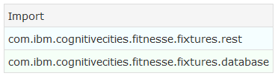
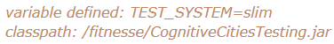
The decision table sets the requestType, serviceName, requestBody and customHeaders (fitnesse will invoke setRequestType, setServiceName, setRequestBody and setCustomHeaders). customHeaders is a semi-colon separated list of key:value headers, for example: ‘Content-Type: application/json’.
public class GenericServiceValidatorFixture {
public String serviceName;
public String url;
public String requestType;
public String requestBody;
public String customHeaders;
HttpResponse response;
public static String responseId = null;

public GenericServiceValidatorFixture() {
reset();
}

public void setRequestType(String type) {
this.requestType = type;
}

public void setServiceName(String name) {
this.serviceName = name;
}

public void setRequestBody(String body) {
this.requestBody = body;
}

public void setCustomHeaders(String headers) {
this.customHeaders = headers;
}

private String buildUrl() {
return String.format(Constants.GENERIC_SERVICE_URL,
ApplicationSetUp.protocol,
ApplicationSetUp.host,
ApplicationSetUp.port,
ApplicationSetUp.urlbase,
serviceName);
}

public int getResponseCode() {
return response.getHttpResponseCode();
}

public String getUrl() {
return url;
}

public String getResponseId() {
return responseId;
}

public JSONObject getResponseMap() {
return Utils.jsonAsObject(response.getHttpResponseMessage());
}

public String getResponseMessage() {
return response.getHttpResponseMessage();
}

public int getResultCount() {
return response.getHttpResponseObjectCount();
}

public HttpResponse defaultServiceResponse() {
return new HttpResponse(500,"ERROR");
}

public void execute() {
RestService restService = null;
response = defaultServiceResponse();
try {
url = buildUrl();
if (requestType.equalsIgnoreCase("GET"))
restService = new GetRestService(customHeaders);
else if (requestType.equalsIgnoreCase("PUT"))
restService = new PutRestService(customHeaders);
else if (requestType.equalsIgnoreCase("POST"))
restService = new PostRestService(customHeaders);
else if (requestType.equalsIgnoreCase("DELETE"))
restService = new DeleteRestService(customHeaders);
else if (requestType.equalsIgnoreCase("PATCH"))
restService = new PatchRestService(customHeaders);
else
response.setHttpResponseMessage
(Messages.REST_ERROR_BAD_REQUEST_TYPE);
if (restService != null) {
response = restService.callService(
requestBody, url, ApplicationSetUp.user,
ApplicationSetUp.password, true);

if (requestType.equalsIgnoreCase("POST") ||
requestType.equalsIgnoreCase("GET"))
saveResponseId(customHeaders);
}

} catch (Exception e) {
e.printStackTrace();
}
}

public void reset() {
requestType = "";
requestBody = "";
serviceName = "";
customHeaders = "";
response = defaultServiceResponse();
}

private void saveResponseId(String customHeaders) {
String id = Utils.extractIdFromResponse(getResponseMessage(), customHeaders);
if (id != null)
responseId = id;
}
}
The fixture (via execute()) will then call the requested Rest service. Fitnesse then calls getResponseCode(), getResponseMessage(), getResultCount() and getUrl(), and compares their return values against the contents of the cells in each row. If they match the cell is highlighted in green, otherwise they are highlighted in red. For POST services we can also capture generated IDs using getResponseId()
If the corresponding cell in the row is blank Fitnesse will just display the return value (highlighted in blue) and skip validation. In the above example we call getUrl() and fitnesse displays its value - useful for debugging if there is a failure.
When validating a fixture invocation Fitnesse will expect an exact match between the return value and the contents of the cell. However, you can also use regular expressions if you want to match part of the return value. This is implemented with =~/{searchString}/. For numerical values you can use value comparisons (link).
An example of a fixture after successful validation:
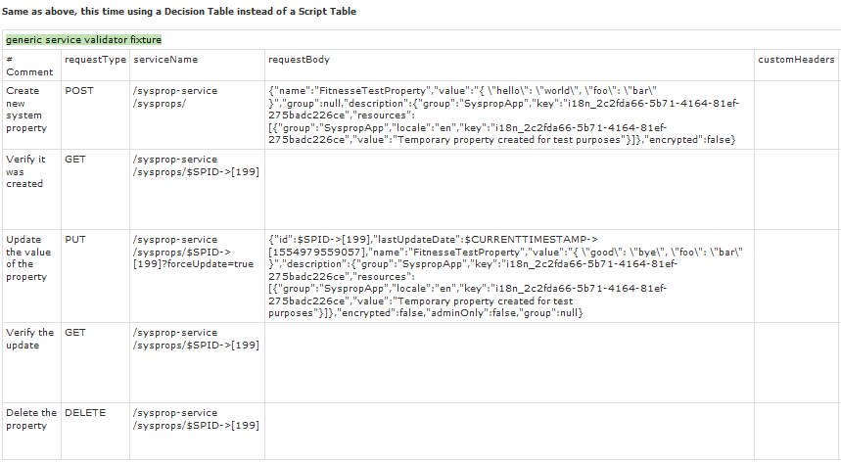
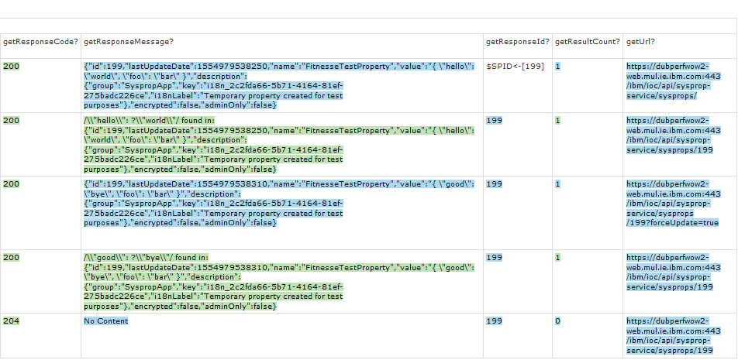
A special use case for decision tables will invoke an individual scenario (from the Scenario Library) multiple times. Here we call a scenario called ‘read service’. It will invoke a generic read service with the specified service name and custom headers. It will validate that the response code matches the value under ‘expectedCode’, the response contains the text specified under ‘searchFor’ and the number of returned items matches the value under the ‘expectedCount’ header.
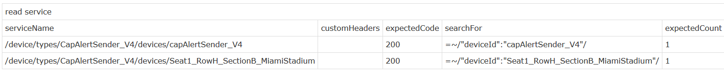
A comment column can be created anywhere in a decision table by placing # before the header. For example:
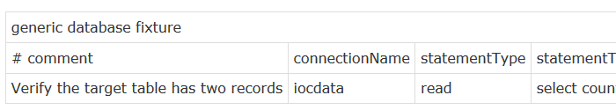
Values returned by getters can be stored in variables and reused at any point in a test case. This is particularly useful in the case where we want to reuse IDs generated by particular POST services. See the section ‘Capturing Generated IDs’ below for more details.

Capturing Generated IDs

Decision Tables
As mentioned above, a method called getResponseId() can be used to return IDs generated by the POST services. If a POST service returns an ‘id’ field the value is captured and stored in a static variable. The value of the variable is only overwritten when a subsequent POST service is invoked and returns a new ID value. If a POST service doesn’t return an ‘id’ field the existing value is retained and not overwritten. A READ service will also return the value of an ‘id’ field if present. For decision tables the value of the response id can be stored in a Fitnesse variable of your choosing:
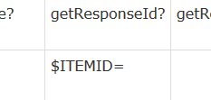
Let’s say a POST service returns the following JSON response:
{
"version":"draft",
"created":"2019-04-05T21:12:00Z",
"createdBy":"a-9kpzic-cfbqvnuh2h",
"updated":"2019-04-05T21:12:00Z",
"updatedBy":"a-9kpzic-cfbqvnuh2h",
"name":"testSchema_LI",
"id":"5ca7c4a0ecbfc5002863b8e4",
"schemaType":"json-schema",
"schemaFileName":"testSchema_LI.json",
"contentType":"application/octet-stream",
"refs":{
"content":"/api/v0002/draft/schemas/5ca7c4a0ecbfc5002863b8e4/content"
}
}

The value of ‘id’ here was generated by Watson. Thus ‘getResponseId()’ will return ‘5ca7c4a0ecbfc5002863b8e4’. $ITEMID can then be used in subsequent services if necessary.

Below is an example involving IOC data sources. After creating the data source we save the returned ID as $DSID. We then call the data injection POST service to add a new item to the data source. The ID generated by that service is saved as $ITEMID. We can then use both saved IDs to update the new data source item:

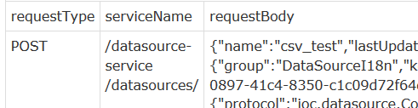 … 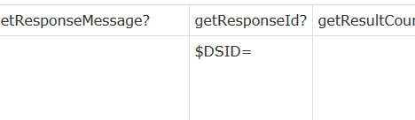
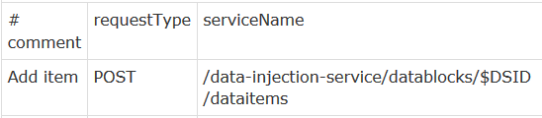 …
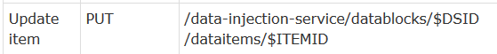

There is no practical limit to the number of variables that can be used in this way.

Script Tables
For script tables that use the scenario library the returned ID from POST and READ services is saved in a fixed variable called $RID. See below:

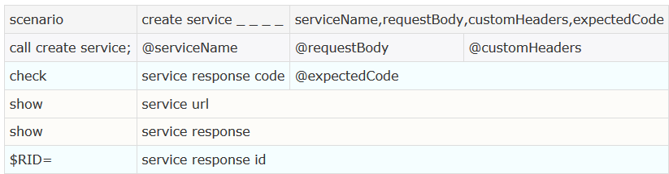

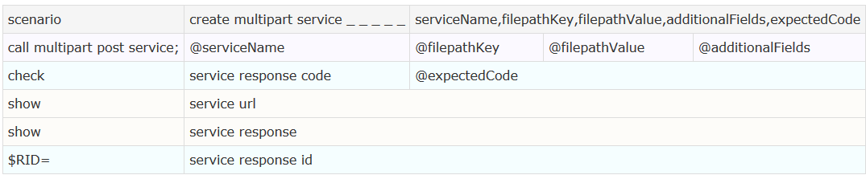

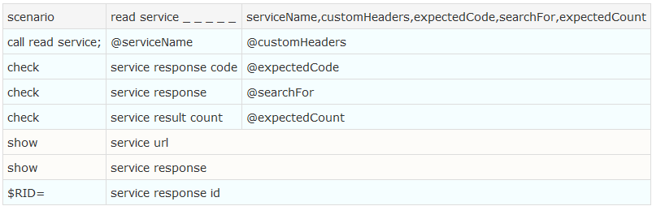

A Watson example of how $RID might be used is shown below:

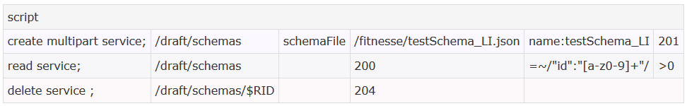

An IOC data source example is shown below. We first create the data source; the returned ID will be saved in the variable $RID by the library ‘create service’ scenario:

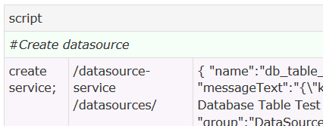

Now we can use $RID to read/delete the data source:

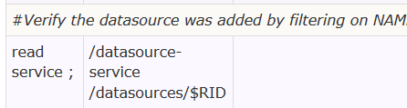

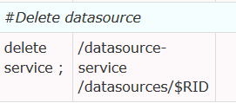

The limitation with script tables is that we can’t use more than one $RID at the same time. For example, a use case that creates an IOC data source and then injects a new item will generate two IDs (one for the data source and one for the item). Once the injection service has been called $RID is overwritten with its ID, so we no longer have access to the data source ID. For use cases that require more than one ID to be used at the same time you have to use decision tables, as in the earlier data source example.

ID field with different name
By default a field name of ‘id’ is assumed for services that return generated IDs. However, some services might use a different field name. For example, IOC’s SOP definition service uses the field name ‘uid’. To handle this the fixture ModelSetUp can be used to override the default value. Calling ModelTearDown will restore the default field name ‘id’. ModelSetUp/ModelTearDown can be called as part of a SetUp/TearDown or placed directly within a test case (more than once if necessary), as in this example:

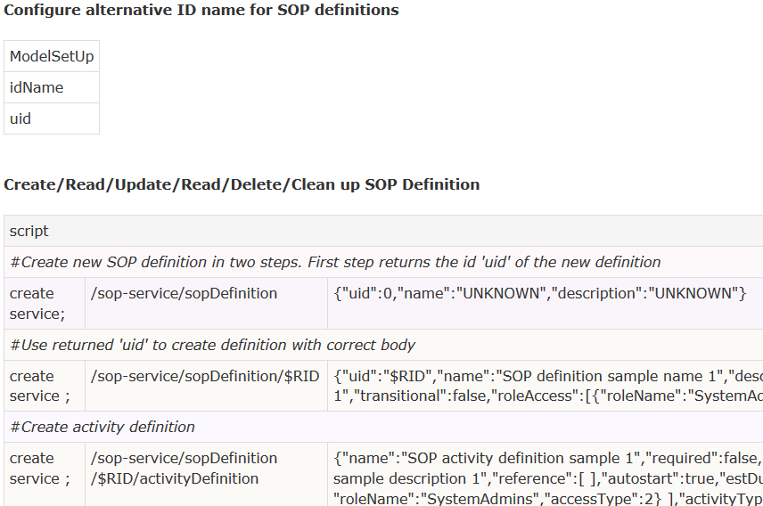

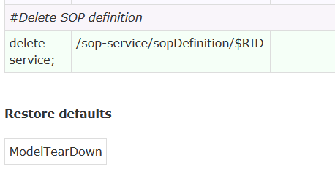

Disabling the ID Save Feature
For script tables it may be useful to disable the capturing of a returned ID. This can be done by passing in a custom header ‘saveid:false’. For example, the activityDefinition sop service returns a dummy ‘uid’ of zero that we may not want to save:

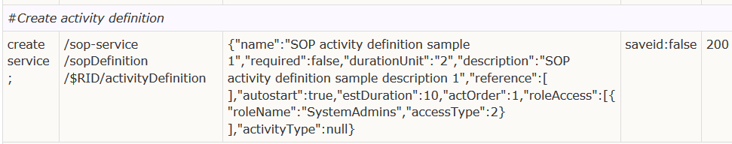

Full Http Response as Hash Map
For most scenarios capturing the id in a response will be sufficient. However, occasionally you may want to capture the value of an arbitrary field in a http response.
We can access field values in a Json response using Hash Maps (documentation). The custom method ‘getResponseMap()’ has been defined to return http and database responses as a map, which can then be saved as usual using a FitNesse variable:
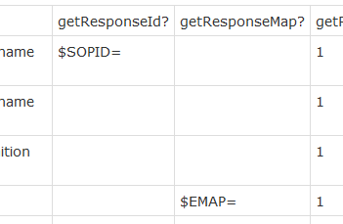

At run time FitNesse will display as a nested table:

Http Response:
{
"uid":65100,
"objectId":1890726,
"dataSourceId":240
}

Map displayed as nested table:
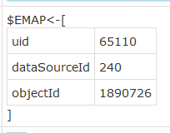

We can then use the back-tick operator to extract the value of any key in the map and use it in subsequent services:

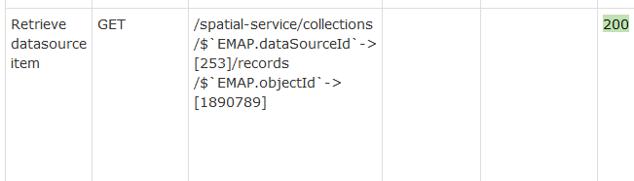

The evaluated url:
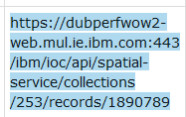

Note that this feature can be resource intensive, so should be used only where necessary (i.e., don’t always include the ‘getResponseMap()’ column in decision tables.

Script Table
Script tables can be used to build test cases from individual scenarios. The scenarios can be a mixture of, for example, Rest and database service calls. Script tables are simpler than decision tables. However, they do have some restrictions, including the restriction mentioned in the ‘Capturing Generated IDs’ section above.
The first cell in each row in a script table names the scenario, followed by zero or more input parameters that are passed to the scenario routine. For example, the following (truncated) script table implements the lifecycle of a device: create, read, update, read, delete:
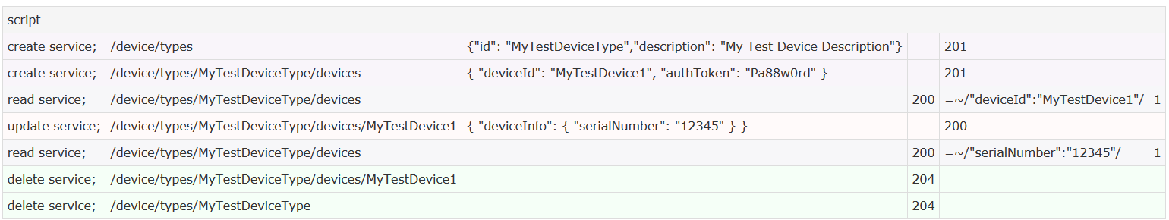
Let’s look at the read/get service in more detail:
Here, we are calling the scenario ‘read service’, passing in five parameters: service name, custom headers (blank in this case), expected resonse code, search string and expected result count. The scenario looks like this:
The first step in the scenario calls the method ‘callReadService’, passing in the first two parameters of the scenario (serviceName and customHeaders). The next step uses the reserved word ‘check’ to verify that the function serviceResponseCode() returns a value matching expectedCode. The next steps also uses ‘check’ to verify that the return value of the function serviceResponse() contains ‘searchFor’ (in this case we are using regular expression syntax). The next ‘check’ verifies that the function serviceResultCount() equals the value ‘expectedCount’. The two ‘show’ steps are used for debug purposes, showing respectively the url and the full response content. The final step saves the value of the response ‘id’ field, if present, in the variable $RID.
A successful execution of a scenario is displayed as below using an expandable section:
Expanding reveals the individual steps called:
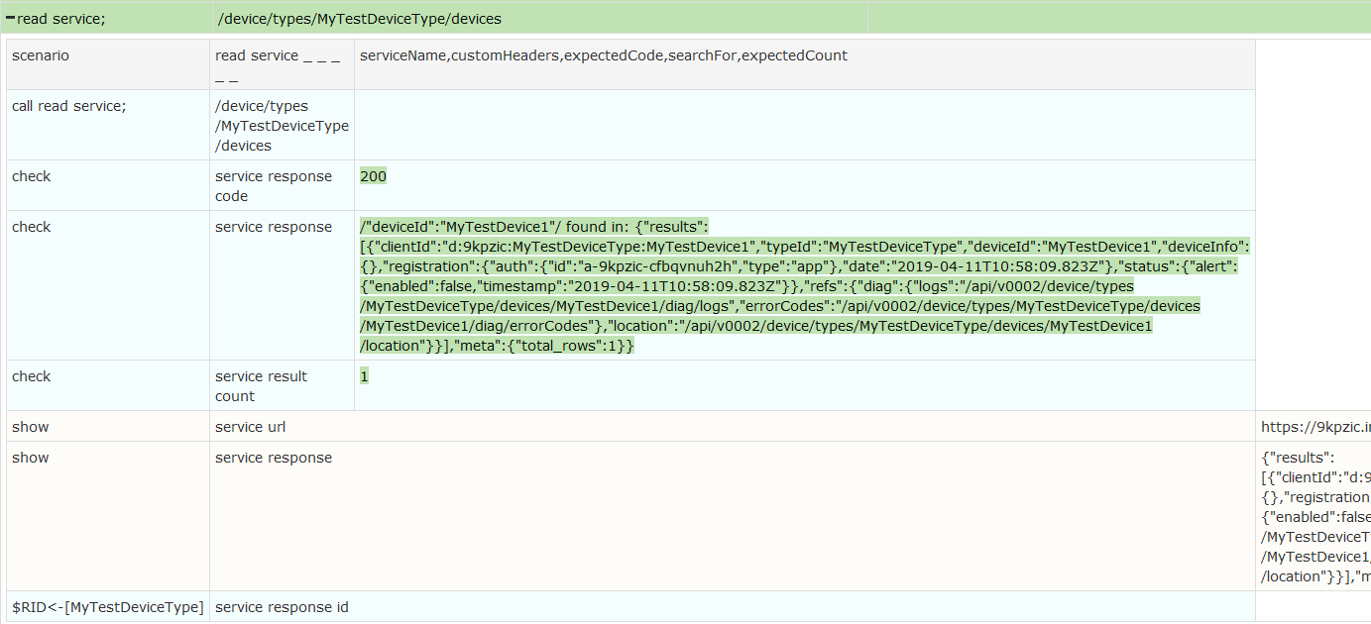
In this example there was no ‘id’ field in the response to the read service, so the value of $RID (MyTestDeviceType) is that of an earlier create step:
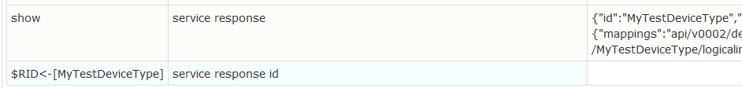
Care should be taken with the read scenario to not return too much data (via the serviceResponse () function) and potentially cause time outs or memory exhaustion. To compensate, the amount of memory allocated to the jvm can be increased when starting FitNesse (see the ‘Getting Started’ section).
The scenario below will invoke a POST service, passing in the additional parameter ‘requestBody’:
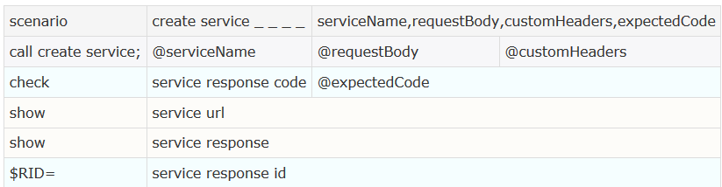
As mentioned earlier, in a case where you are not sure how many items will be returned, you can leave the cell blank and FitNesse will skip the validation step. You can also use value comparisons for integer return values:
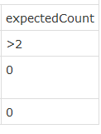

Fixtures

Generic Rest Service Fixtures
The generic service validator fixture is designed to handle any Rest Service.
Inputs to the generic fixture are: request type (GET, PUT, POST, DELETE, PATCH), service name, request body (can be left blank when not applicable) and custom headers (semi-colon separated list of key:value header pairs).
Methods that can be called for verification/display purposes: getResponseCode(), getResponseMessage(), getResultCount() and getUrl(). getResponseId() can also be invoked after POST and READ services to capture generated IDs (see the ‘Capturing Generated IDs’ section). getResponseMap() is available to return the fields in a read/post response as a map (see earlier section ‘Full Http Response as Hash Map’).
Below are a variety of ‘device instance’ and ‘device type’ services using the generic fixture:
After execution, FitNesse displays the result as follows ({search for} found in: {response}):
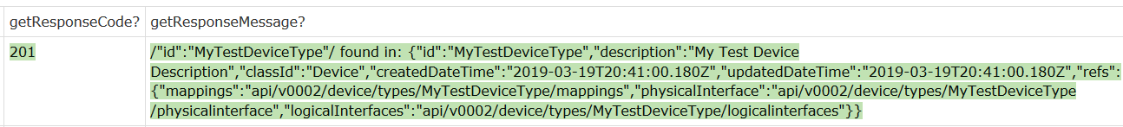

Generic Database Fixture
This fixture can be used to interact with any of the application databases. SuiteSetUp below creates a connection to BLUDB:
If the connection is created successfully the test output will look as follows:
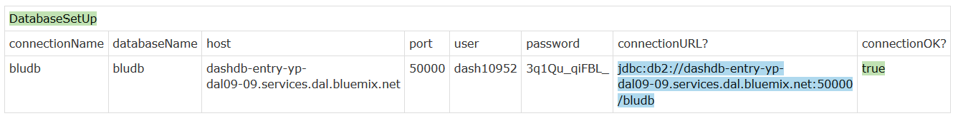
The connection name can then be passed to the fixture.
Inputs to the generic database fixture are: connection name (bludb), statement type (create, read, update, delete), statement text and response format for queries (currently only JSON is supported).
Methods that can be called for verification/display purposes: getResponse(), getResultCount(), getResponseMessage(). The latter returns “OK” for all successful executions. In the case of an SQL error the full error message is returned (useful for negative testing).
The method getFirstResultField() can be used to capture the value of the first field in the response. The example below captures the value of objectid for the ‘Central’ area in the Round Rock areas datasource and saves it in the Fitnesse variable $ACENTRAL:
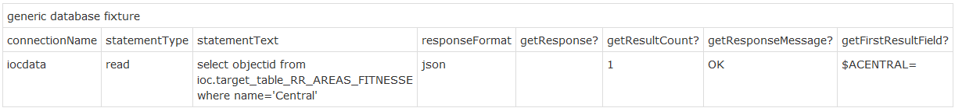
Like other methods it can also be used to verify that the value returned is the expected one (by placing the expected value in the cell):
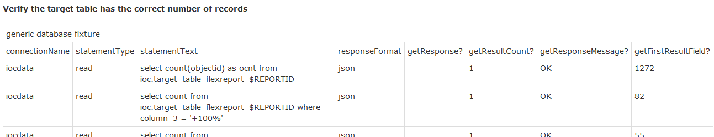
The method getResponseMap() is available to return the fields in a database read operation as a map (see earlier section ‘Full Http Response as Hash Map’).
The sample decision table below is used to create a source table for a database type IOC data source. The last step verifies that two records are present in the target table:
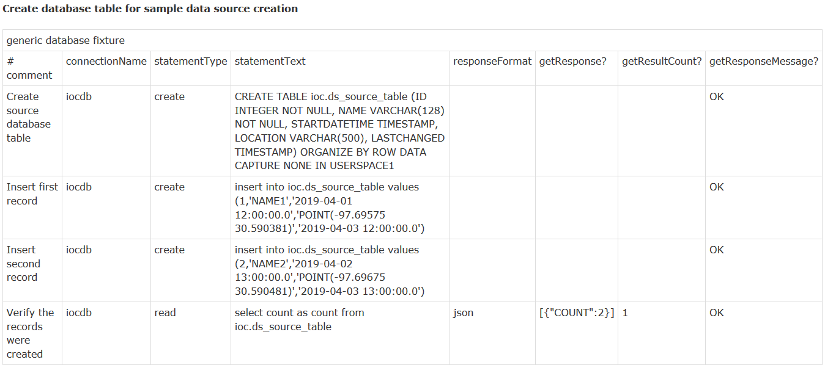
Below is a trivial decision table that uses the fixture to perform some hypothetical negative tests:
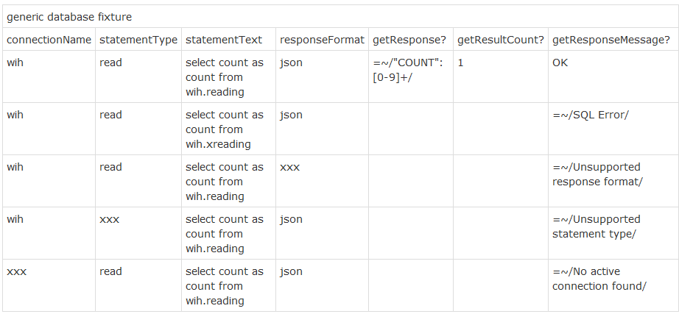
After execution FitNesse produces the following:
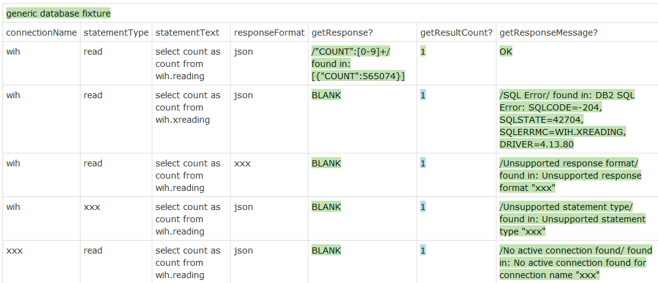

Scenarios
Scenarios are stored in the special ScenarioLibrary page. There appears to be a restriction in FitNesse whereby you cannot use the same method name in different fixtures; otherwise FitNesse may get confused and potentially call a requested method on the wrong object. To avoid this possibility we make sure that every method name is unique. We also avoid using hierarchical Java classes to implement scenarios as this has caused problems that are difficult to debug; try to keep all related scenarios in a single Java class.

Generic Rest Service Scenarios
These can be used to build test cases for arbitrary rest services. Currently, we have nine scenarios defined:
- read service (inputs: serviceName, customHeaders, expectedCode, searchFor, expectedCount). If there is an ‘id’ field in the response it is saved in the variable $RID
- create service (inputs: serviceName, requestBody, customHeaders, expectedCode). If a POST service generates an ID value (returned as an ‘id’ field in the response) it is saved in the variable $RID.
- update service (inputs: serviceName, requestBody, customHeaders, expectedCode)
- delete service (inputs: serviceName, customheaders, expectedCode, searchFor)
- create multipart form service (inputs: serviceName, filepathKey, filepathValue, additionalFields (semi-colon separated list of key:value pairs), expectedCode. This service will call POST with a file parameter (the path defined by ‘filepathValue’ must exist on the file system where FitNesse resides). If the service generates an ID value (returned as an ‘id’ field in the response) it is saved in the variable $RID.
Below is a lifecycle scenario for SOP definitions that demonstrates most of the features of script tables and scenario libraries:
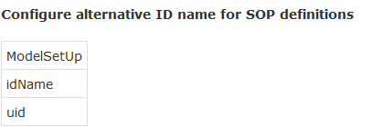
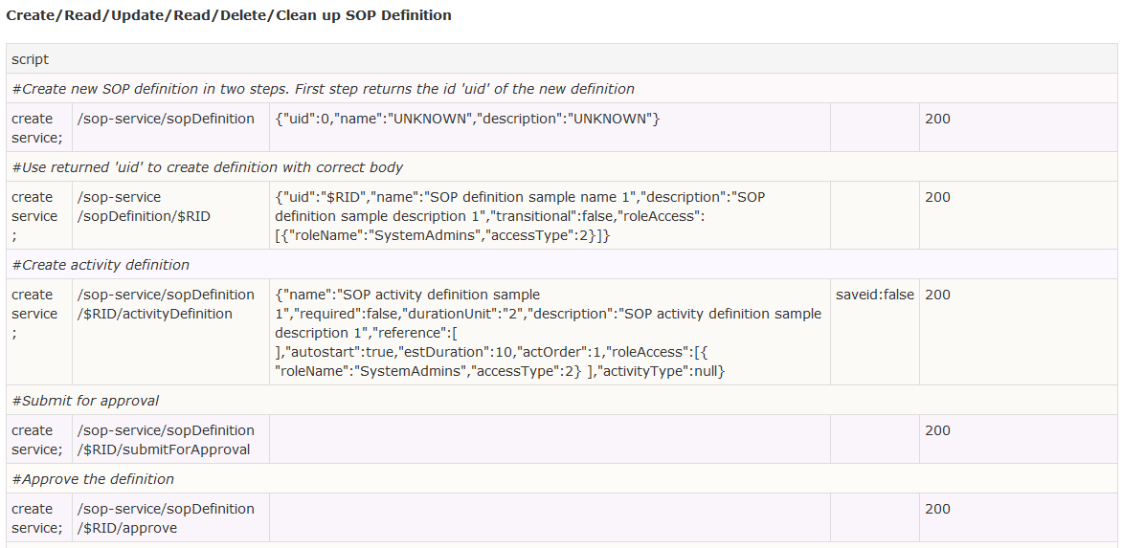
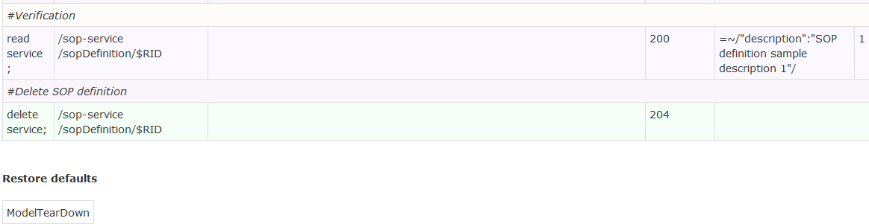

Database Scenarios
This is a set of scenarios that can be used to interact with the three main databases using the three connection names created in the Suite set up section. The defined scenarios are as follows:
- database read (inputs: connectionName, responseFormat, sqlStmt, searchFor, expectedCount,firstFieldValue)
- database create (inputs: connectionName, sqlStmt)
- database update (inputs: connectionName, sqlStmt)
- database delete (inputs: connectionName, sqlStmt)
The database read scenario, for example, is defined as follows:
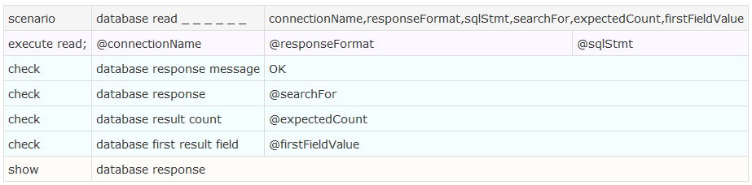
This verifies that the response contains @searchFor, the number of records returned equals @expectedCount and the value of the first field equals @firstFieldValue.
Database scenarios can be mixed with rest service scenarios in script tables to, for example, validate side effects. For example, in an IOC data source scenario we can verify that records have reached the target table:
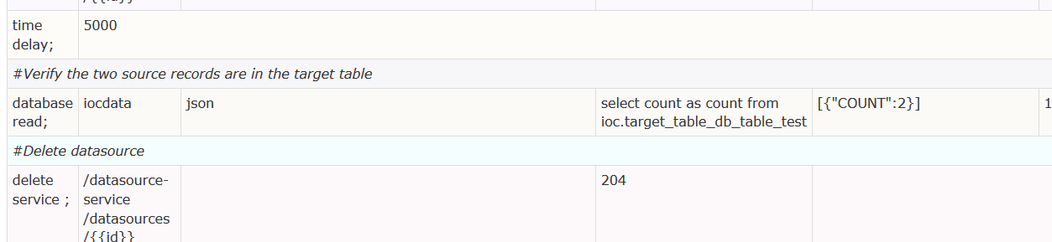

Time Functions
Currently the following scenarios/functions are defined:
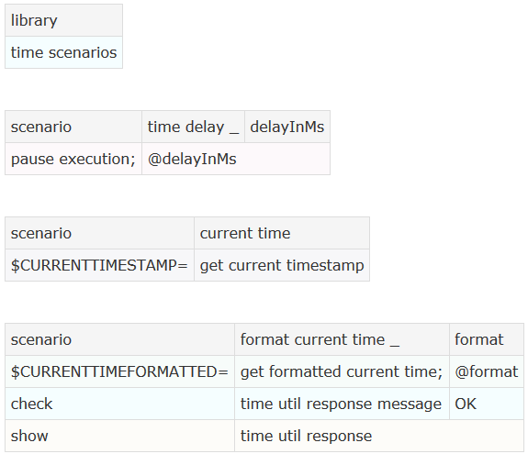
The first function can be used to pause execution of a test script. For example, pausing while waiting for an IOC data receiver to poll for an update:
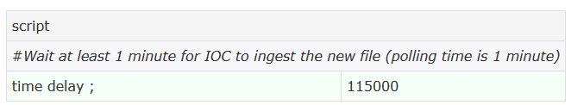
The second scenario will return the current timestamp in milliseconds. The scenario saves the value in a variable called $CURRENTTIMESTAMP, which can then be used in other scenarios. For example, in this example we pass the current timestamp to an IOC service that updates a system property:
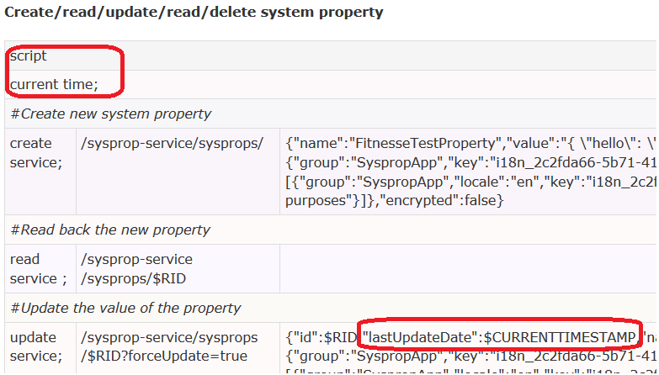
The final scenario will return the current time as a formatted string. It takes the format string as parameter (if left blank it defaults to ‘yyyy-MM-dd HH:mm:ss’). The formatted time string is saved in the variable $CURRENTTIMEFORMATTED. This can then be used in subsequent scenarios. In the first example we use the default format, in the second we use a custom format:
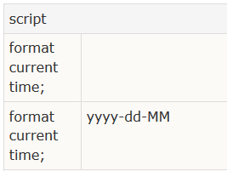
The output in each case is shown below:
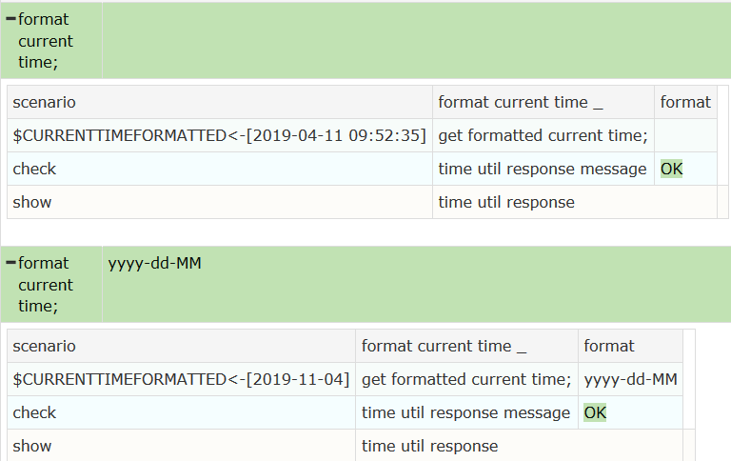

File Functions
The following scenarios/functions are currently defined: local and remote copying of files, deleting local files and search/replace in files.
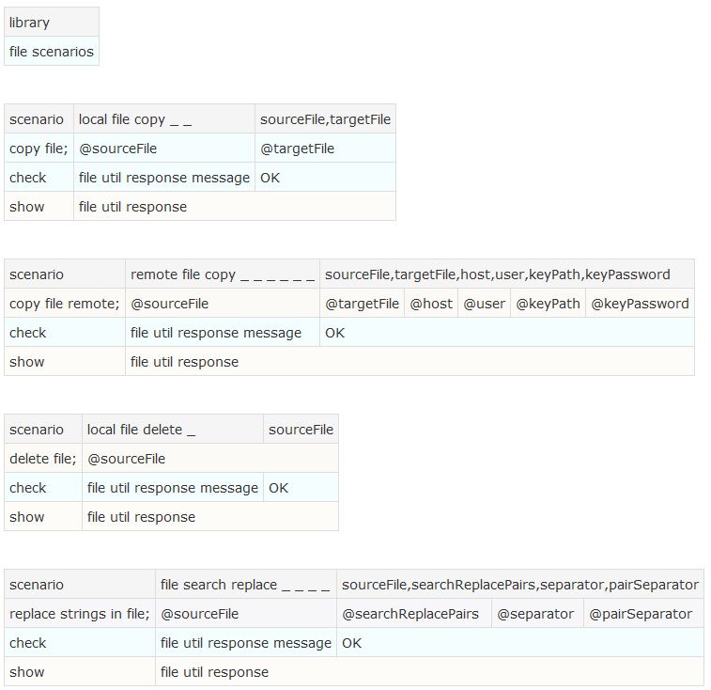
The local copy function takes two parmeters:
- Source file path
- Target file path
The remote copy function takes 6 parameters:
- Source file path
- Target File path
- Target host/IP address
- User name for remote host
- Key file for source host with public and private keys
- Password for key file (blank if none)
Remote copying can be used, for example, to set up a CSV type data source by copying source CSVs file to the default csv input folder on the app server:
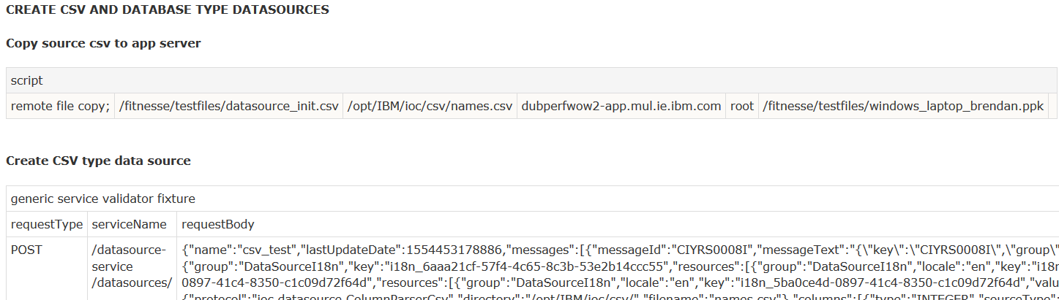
The local delete function takes one parameter:
- Source file path
The search/replace scenario takes four parameters:
- Input file
- List of search/replace pairs
- Separator between search and replace strings – if left blank this defaults to ‘:’
- Separator between search/replace pairs – if left blank this defaults to ‘;’
This function could be used to prepare a template file for a variety of tests. E.g., you might copy the template file first, then replace a number of search strings:
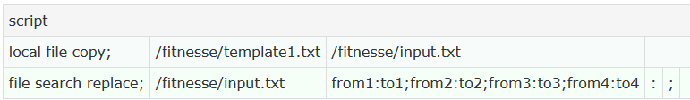

Before:
foo
from1...from2...
from3...from4...
bar

After:
foo
to1...to2...
to3...to4...
bar

