IOC data source type for Watson IoT Logical Interfaces

Introduction
Logical Interfaces are the key concept in Watson’s message infrastructure. A client application can receive event data associated with a logical interface by subscribing to the relevant topic.
Events transmitted by devices can have arbitrary schemas. For example a temperature sensor might emit a single field:
{
"t": 23.5,
}
An operator might submit an alert (via a virtual device) with richer content, for example:
{
"id":"2",
"parentid":"1",
"event":"Smoke in waste bin",
"certainty":"Observed",
"msgType":"Alert",
"severity":"Severe",
"sender":"Martin",
"urgency":"Immediate",
"category":"Fire",
"description":"",
"sent":"2019-01-18T15:22:23.026Z",
"area":"Area A",
"status":"InProgress",
"headline":"Smoke",
"lastupdate":"2019-01-18T15:22:23.026Z",
"identifier":"",
"startdate":"2018-11-03T20:05:00Z",
}
Watson IoT has a complex model defining the relationships between devices, events and interfaces (example). A device can emit events conforming to one or more schemas. A physical interface is attached to a device type and one or more event types are then bound to that interface (in most cases there will be one event type). A physical interface can then be connected to a logical interface. The logical interface is associated with its own schema (which might be the same as that of the input event). A mapping is defined that transforms an event conforming to the input schema into an event conforming to the logical interface’s schema. The schema of interest here is that of the logical interface. A logical interface can be associated with more than one physical interface, and thus more than one device type, as depicted in this schematic:
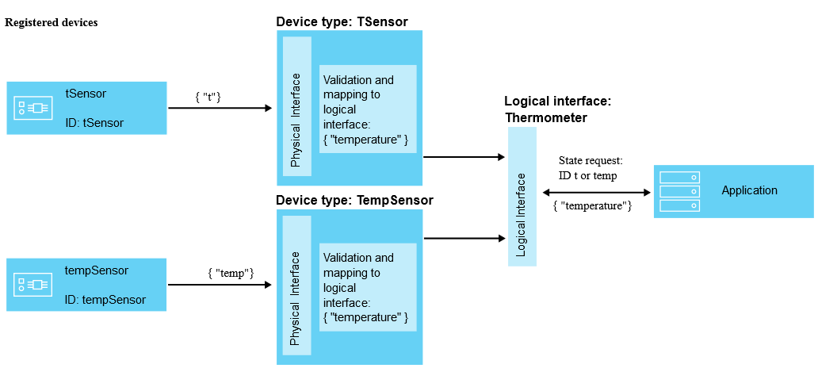
In the above example the tSensor device emits temperature events (t) in deg Celsius, while the tempSensor device emits temperature events (temp) in deg Farenheit. The logical interface defines a temperature event normalised in deg Celsius. The mapping between the tempSensor physical interface and the logical interface performs the necessary Farenheit->Celsius conversion. Our model should support the mapping of multiple physical interfaces to a single logical interface.

Subscribing to Watson IoT Events
Events emitted by devices registered in Watson IoT are published to pre-defined topics in the internal messaging sub-system. The topic naming convention varies according to the nature of the event information. With the correct information an application can subscribe to any of the pre-defined topics.

Connection Information
The message url format is as follows:
{orgId}.messaging.internetofthings.ibmcloud.com:{port}
For example:
9kpzic.messaging.internetofthings.ibmcloud.com:8883
The broker Client ID must conform to the pattern:
a:{orgId}:{applicationId}
For example:
a:9kpzic:Box1_MiamiStadium_UID
Note that {applicationId} must be unique to each client. If more than one client connects using the same ID the server will disconnect all but one of the clients.

Device Related Topics
Pre-defined device related topics are as follows:
- device event: iot-2/type/{typeId}/id/{deviceId}/evt/{eventId}/fmt/json
- device command: iot-2/type/{typeId}/id/{deviceId}/cmd/{eventId}/fmt/json
- device state: iot-2/type/{typeId}/id/{deviceId}/intf/{logicalInterfaceId}/evt/state
- device state error: iot-2/type/{typeId}/id/{deviceId}/err/data
- rule trigger: iot-2/intf/{logicalInterfaceId}/rule/{ruleId}/evt/trigger
- rule error: iot-2/intf/{logicalInterfaceId}/rule/err/data
- device monitoring: iot-2/type/{typeId}/id/{deviceId}/mon

For all topic names the ‘+’ symbol can be used as a wild card.

Logical Interface Topic
The topic of interest to IOC would be the logical interface state topic. A logical interface in IoT can be configured to publish no messages, all messages, or just messages that result in a state change. (This is the topic used by Watson’s DB2 connector.)
When a logical interface is defined raw event data is transformed according to the physical->logical interface mapping definitions and the output event is published to the device state topic. An example topic would be:
iot-2/type/CapAlertSender/id/Box1_MiamiStadium/intf/5c34b812ff58100027dfd74a/evt/state
To subscribe to events from all devices of the specified type the following topic can be used:
iot-2/type/CapAlertSender/id/+/intf/5c34b812ff58100027dfd74a/evt/state
An example message published to this topic would be:
{
"topic":"iot-2/type/CapAlertSender_V4/id/Seat5_RowG_SectionA_MiamiStadium/intf/5c34b812ff58100027dfd74a/evt/state",
"payload":"{\"state\":{\"id\":\"2\",\"parentId\":\"1\",\"event\":\"Smoking violation\",\"certainty\":\"Observed\",\"msgType\":\"Alert\",\"severity\":\"Moderate\",\"sender\":\"John\",
\"urgency\":\"Future\",\"category\":\"Health\",\"sent\":\"2019-01-18T16:50:48.643Z\",\"expires\":\"2019-01-18T16:50:48.643Z\",\"area\":\"Gate C\",\"enddate\":\"2018-11-02T19:06:00Z\",\"status\":\"Complete\",\"headline\":\"Violation\",\"lastupdate\":\"2019-01-18T16:50:48.643Z\",\"effective\":\"2019-01-18T16:50:48.643Z\",\"onset\":\"2019-01-18T16:50:48.643Z\",\"startdate\":\"2018-11-02T19:05:00Z\"},\"timestamp\":\"2019-01-18T16:50:48Z\",\"updated\":\"2019-01-18T16:50:48Z\"}",
"qos":0,
"retain":false,
"_msgid":"9684401a.7f24e"
}

Implementing a LOGICALINTERFACE datasource in IOC

UI Configuration Wizard inputs:

- Organization id
- mqtt port
- user (or API-KEY)
- password (or API-TOKEN)
- logical interface id
- logical interface schema file
- device id
- device type
- device location
- device category

Sample configuration:
datasource-service/datasources/CapAlertSender1
{
"description": "",
"type": "LOGICALINTERFACE",
"source": {
"org": "9kzpic",
"port": 8883,
"user": "a-9kpzic-cfbqvnuh2h",
"password": "*****",
"options": {
},
"interface": {
"id": "5c34b812ff58100027dfd74a",
"schema": "path_to_schema/capalert.xsd",
"device": {
"id": "Box1_MiamiStadium",
"location": "POINT(-93.1965780 44.9842060)",
"type": "CapAlertSender",
"category": "Physical"
}
}
},
"receiver": {
"type": "com.ibm.ioc.datareceiver.types.LogicalInterface",
"started": false
},
"columns": [
]
}

Datasource details
- The GPS location of the device would be used to enrich events and fulfil IOC’s minimum field requirements. We might also consider allowing the user to map a field in the input event schema to the location column
- A new column parser type would use the logical interface schema file to initialise column mappings (DATASOURCE_COLUMNS)
- A new data receiver type would be required to process messages received from the mqtt server
- On start-up of the receiver we connect to the server and stay connected until the receiver is stopped.
- An mqtt callback can be used to ensure we reconnect and re-subscribe when connection to the server is lost (see non-IoT example ‘IoTConsumerApplication.zip’ attached here)
- On receiver start-up we subscribe to the relevant topic: iot-2/type/{deviceType}/id/{deviceId}/intf/{logicalInterfaceId}/evt/state
- No need for a timer task to poll for updates as the server will push messages to our subscription callback
- IOT’s java client libraries don’t (currently) support subscriptions to logical interfaces, so we would have to implement our own mqtt client. An example is described and attached here.
- We have the option to implement real-time message handling (i.e., process individual messages immediately on receipt) or implement a short-term fixed-interval timer to batch closely-spaced messages. The former would be inefficient in high-throughput scenarios. Perhaps we could give the user the option to choose one or the other. I’ve used a short 3 second timer in my sample (even a 1-second timer should also fine)
- Something additional to consider (as a stretch goal) is that a customer might want to load historical data for the interface (e.g., via CSV).

