**H2 In_memory Database Configuration**

1. **Changed default configuration for H2 database in application.properties file like below**

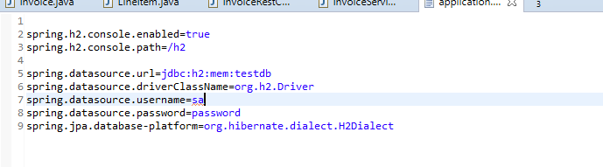

**We can access H2 console with below link**

<http://localhost:8080/h2>

We can connect to the H2 DB by providing the login details

Username : sa

Password : password

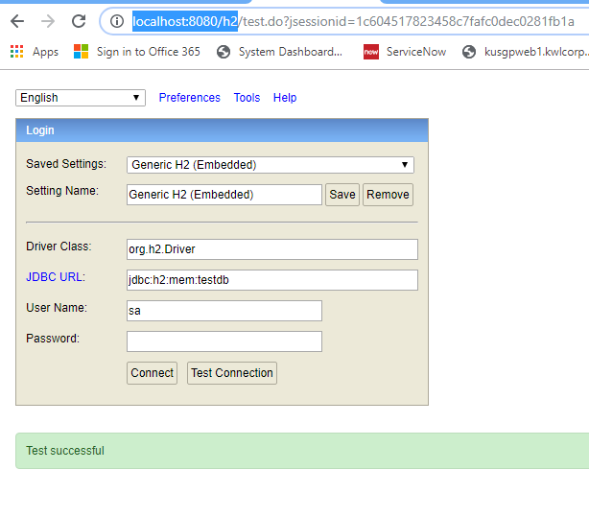

Intially we don’t have any records

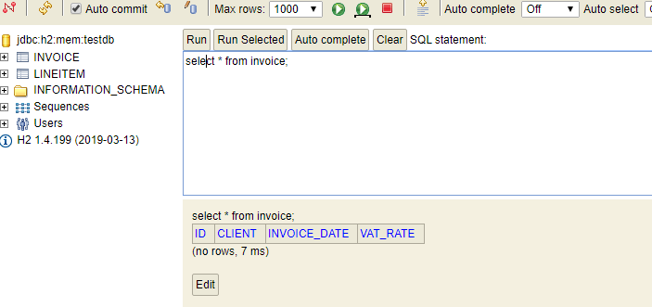

I am using Swagger-UI to Test Restful WebServices. We can access swagger-ui with below link

<http://localhost:8080/swagger-ui.html>

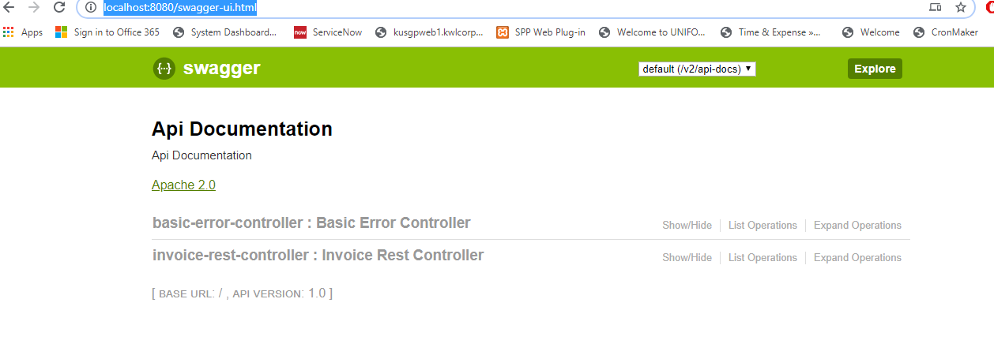

We can see and test all available services from swagger

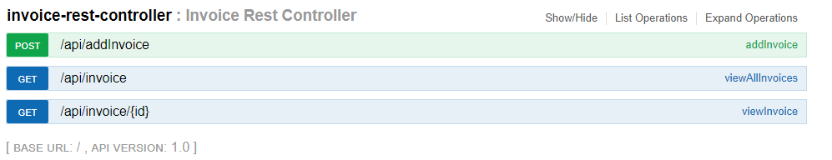

Tested AddInvoice Service

1. Input

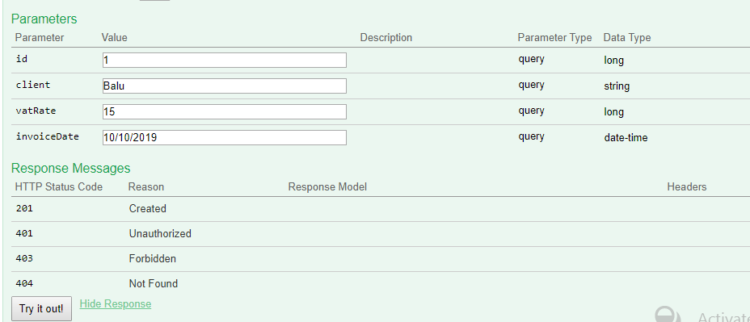

1. Output

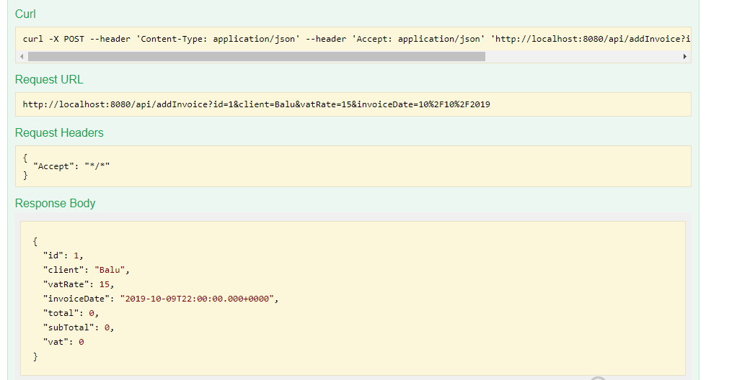

Invoice inserted successfully in H2 DataBase

