I am using Swagger-UI to Test Restful WebServices. We can access swagger-ui with below link

<http://localhost:8080/swagger-ui.html>

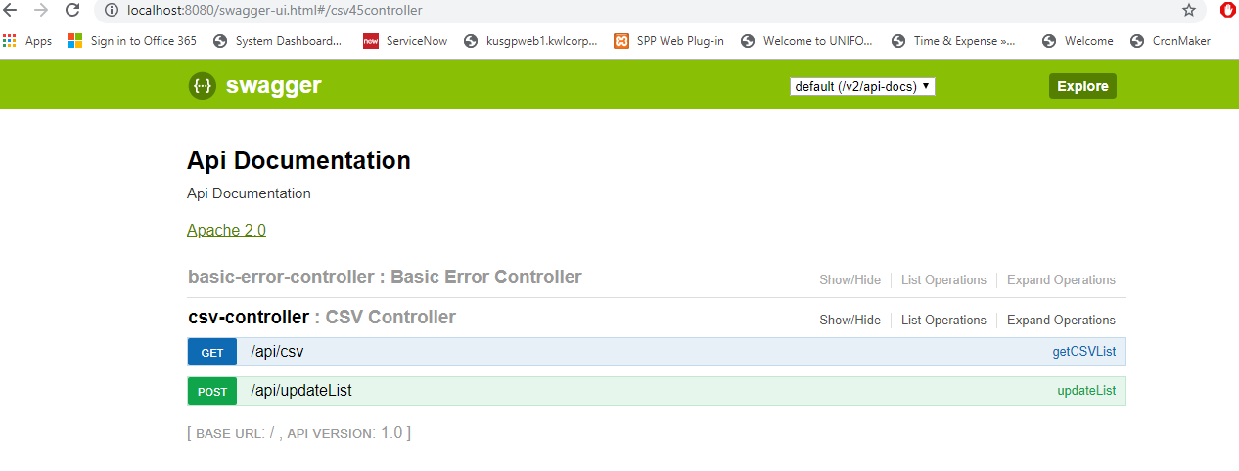

getList () : Json Response

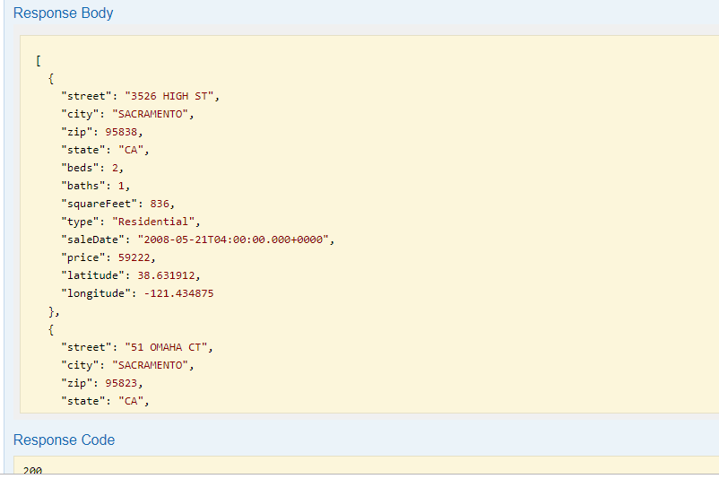

UpdateList() :

Request Body:

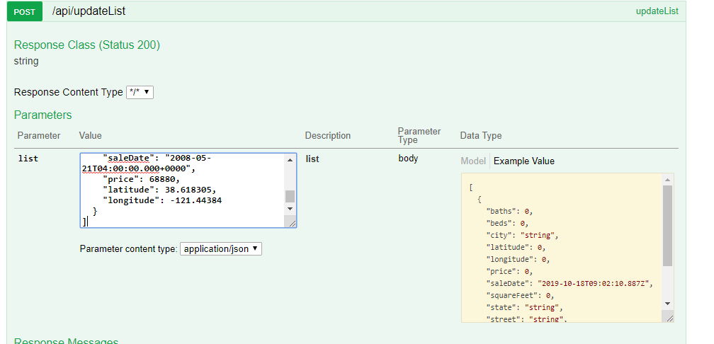

Response ::

