Corey Osher

3/2/2021

Foundations of Database MGMT

Assignment Seven

github.com/coreyosher/DBFoundations-Module07

SQL Functions

# Introduction

This paper discusses user defined functions and their functionality. I talk about basic uses for user defined functions and show some examples. Lastly, I talk about scalar, inline, and multi-statement functions and their benefits.

# SQL UDF Uses

User-Defined-Functions serve a handful of purposes. They can act as a check constraint by referencing a column in another table that you can’t otherwise do. See Figure 1.

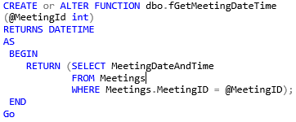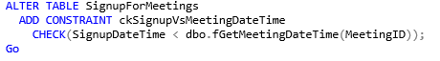Fig.1

The Alter Table statement adds a constraint by checking the function against another table’s column. This is very helpful. Scaler UDF’s can be used to return a single value as an expression. Using a parameter in this way is super useful. See Figure 2 for a Scaler Function.

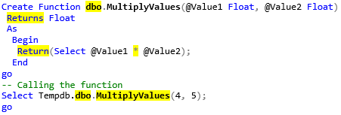Fig. 2

User defined functions can use parameters which Views cannot. Views can reach the same result using the “where” clause, but I could imagine if you became proficient with functions, you would probably want to stick to the same flow.

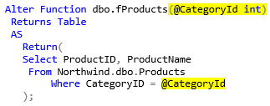Figure. 3

# Scalar, Inline, & Multi-Statement Functions

Scalar functions can be helpful by creating a new column that is a result of applying a relationship between two previous columns. Multiplying two columns to create an extended price is a common example. See Figure 2 and Figure 4 together.

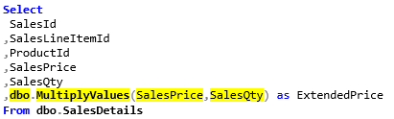Fig.4

An in-line table-valued function just returns a single set of rows. Figure 5 shows the function to sort the table and return only films with the duration requested.

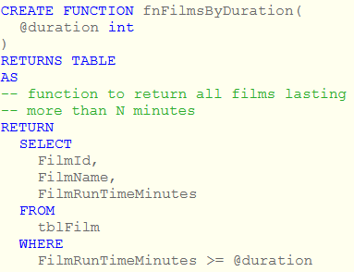Fig.5

In Figure 6, you can see all the films have a duration of 190+ minutes.

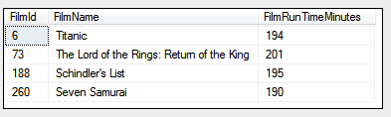Fig.6

While a in-line table valued function can only have 1 select statement, a Multi-Statement table valued function can have many or also just 1. With a MSTVF, you can modify and aggregate the output table in the function body. See Figure 7.

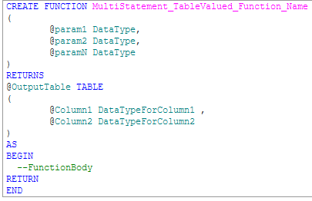Fig. 7

“A  multi-statement table-valued function (which I wall call from now on the equally unmemorable MSTVF) is a function which returns a table of data, but only after some additional processing.” (https://www.wiseowl.co.uk/blog/s347/multi-statement.htm)

# Summary

User defined functions can vary quite but are very useful. Instead of being bound to the basic built-in functions, molding your own function to perfection for a specific use sounds ideal! Scalar, In-line and MSTVF functions are awesome tools to have in your toolbox.