
CSA15 – CLOUD COMPUTING AND BIG DATA ANALYTICS

ASSIGNMENT 1 – CO1
Design, Analyse and Validate a Cloud-Based Solution for Migrating a
Legacy University Management System
CO1: Apply cloud computing technologies including hardware–software evolution, virtualization, web services, and service models to develop cloud-based solutions.

Field | Details | Field | Details
Student Name | Monal Raj.B | Register Number | 192511176
Department / Section | B.E-CSE | Academic Year / Semester | 2025
Faculty Name | Dr.R.Latha | Nature of Assignment | Individual
Duration | 1 Week | Total Marks | 50
Submission Date | 02.11.2026 | Evaluation Date

MARK SHEET (Rubric-based evaluation)
Task | Title | Max | Awarded | Evidence / evaluation focus
1 | Introduce Cloud Computing | 3 |  | Definition; characteristics; deployment models; scenario mapping
2 | Trace Evolution and Hardware Evolution | 3 |  | Timeline; hardware evolution; relevance to university
3 | Analyse Internet Software Evolution | 3 |  | Web/software evolution; SOA; APIs; scenario relevance
4 | Apply Server Virtualization | 5 |  | Hypervisor types; VM/container comparison; consolidation; limitations
5 | Apply Web Services | 4 |  | SOA and SOAP/REST; three university APIs; request/response examples
6 | Analyse IaaS, PaaS and SaaS | 5 |  | Responsibility layers; five-application mapping; comparison; providers
7 | Examine XaaS | 3 |  | Four or more variants; two justified choices; provider risks
8 | Design Cloud Solution Architecture | 5 |  | Labelled diagram; deployment/service models; scaling; security; DR
9 | Hands-on Implementation and Documentation | 4 |  | Running VM/container; PaaS/SaaS; tests; actual screenshots
10 | Evaluate and Recommend  Final Solution | 7 |  | Three-way comparison; 3-year costs; risks; phased roadmap
11 | Day-4 Design Challenge | 8 |  | Impact; evaluation; adaptation; evidence-based defence
 | TOTAL | 50 |  | Percentage :

EVIDENCE VERIFICATION CHECKLIST

Tasks | Evidence expected | Status (✓  / P / ✗) | Evaluator note
1–3 | Conceptual explanations,  comparisons and relevant  illustrations | ✓ | Explanations and relevant scenario mapping documented
4 | Virtualization calculations with stated assumptions and peak-load caution | ✓ | Calculations present; practical capacity validation recommended
5–7 | API examples, service responsibility table and justified XaaS choices | ✓ | Required conceptual evidence documented
8 | Labelled architecture diagram,  caption below figure and component justification | ✓ | Architecture documented; sizing assumptions need testing
9 | Actual code, environment details, execution logs, API outputs and screenshots | P | Procedures provided; actual execution evidence not established
10 | Cost assumptions, 3-year totals, risk controls and migration roadmap | ✓ | Estimates and rationale documented
11 | Day-4 changes, 10× load strategy,  99.9% target and 40-college isolation | ✓ | Design analysis documented; practical validation pending

IMPLEMENTATION EVIDENCE CHAIN

Evidence item | Status | Observation
Source code | ✓ | Flask REST API and Dockerfile provided in the proposed implementation
Virtualization | P | Docker container configuration documented; running-container evidence required
PaaS or SaaS | P | Managed web-service deployment procedure described; live deployment not verified
Functional test | P | Expected HTTP 200 response and JSON output documented; actual output required
Failure case | P | HTTP 404 test case documented; actual execution record required
Screenshots | P | Screenshot requirements identified; authentic screenshots need verification
Reproducibility | ✓ | Build commands, run commands, endpoints and expected results specified

OVERALL REMARKS

_______________  Student Signature | _______________  Faculty Signature | _______________  Program Director

MANDATORY SUBMISSION EVIDENCE CHECK

✓ = Present in documented answer; P = Partly present; ✗ = Missing / not satisfied
Task | Evidence expected | Status | Evaluator note
1 | Cloud definition, characteristics, deployment models and scenario mapping | ✓ | All conceptual requirements covered
2 | Evolution timeline, hardware development and university relevance | ✓ | Well explained with relevant examples
3 | Internet software evolution, SOA and APIs | ✓ | Clear explanation and scenario relevance
4 | Hypervisors, VM/container comparison and consolidation calculations | ✓ | Calculations included; peak-load limitations discussed
5 | SOAP/REST comparison and three university APIs | ✓ | API methods and request/response examples documented
6 | IaaS/PaaS/SaaS responsibility layers and application mapping | ✓ | All five applications categorized with justification
7 | XaaS variants and two justified selections | ✓ | Six variants explained; DBaaS and DRaaS recommended
8 | Labelled architecture, scaling, security and disaster recovery | ✓ | Design and component justifications documented
9 | Working container, PaaS/SaaS deployment, actual tests and screenshots | P | Code and procedures provided; actual execution evidence requires verification
10 | Three-year cost comparison, risks and migration roadmap | ✓ | Cost assumptions, calculations and recommendations included
11 | Impact analysis, 10× load, 99.9% availability and tenant isolation | ✓ | Changed requirements evaluated; load-test evidence recommended

IMPLEMENTATION EVIDENCE CHAIN
Evidence item | Status | Observation
Source code | ✓ | Python Flask REST API and Dockerfile documented
Virtualization | P | Docker build and run procedures provided; execution screenshot required
PaaS or SaaS | P | Cloud deployment steps described; actual deployment confirmation required
Functional test | P | HTTP 200 and expected JSON response documented; actual test output required
Failure case | P | HTTP 404 test case included; execution evidence required
Screenshots | P | Required screenshots identified but authenticity and completeness not verified
Reproducibility | ✓ | Installation, configuration, commands and testing steps documented
Interpretation | ✓ | Technical outcomes and implementation limitations explained
Code and report consistency | ✓ | Proposed API, Docker configuration and testing procedure are aligned

SUBMISSION CHECKLIST (Not Separately Marked)
Requirement | Status
All 11 tasks answered | ☒ Yes ☐ Partly ☐ No
Cloud concepts and comparisons explained | ☒ Yes ☐ Partly ☐ No
Virtualization calculations included | ☒ Yes ☐ Partly ☐ No
API examples and service models explained | ☒ Yes ☐ Partly ☐ No
Cloud architecture diagram included | ☒ Yes ☐ Partly ☐ No
Implementation and testing evidence provided | ☐ Yes ☒ Partly ☐ No
Three-year cost analysis and roadmap included | ☒ Yes ☐ Partly ☐ No
Day-4 design challenge completed | ☒ Yes ☐ Partly ☐ No
Figures and screenshots included | ☐ Yes ☒ Partly ☐ No
Table and figure numbering correct | ☐ Yes ☒ Partly ☐ No
Viva recommended | ☒ Yes ☐ No

CSA15 – Cloud Computing and Big Data Analytics

ASSIGNMENT 1
CO1: Apply cloud computing technologies including hardware–software evolution, virtualization, web services, and service models to develop cloud-based solutions.

Assignment Title: Design, Analyse and Validate a Cloud-Based Solution for Migrating a Legacy University Management System (Total Marks – 50)
Duration: 1 week

Scenario – Smart Campus Cloud Migration
A multi-campus university currently runs its Student Information System, Learning Management System, Library System, Exam Portal and Email on ageing physical servers in a single on-premise data centre. Each application has its own dedicated server, which stays idle for most of the year but fails to cope during admissions, result publication and online-exam weeks.
The university's current environment is:
- 12 physical servers, average CPU utilisation of about 15%, with peaks above 95% during admissions and exams
- Approximately 25,000 students and 2,000 staff across 4 campuses
- Applications built as large monolithic programs, with no public interfaces for mobile apps or partner colleges
- High capital expenditure, slow procurement (6–8 weeks per server) and no disaster recovery site
As a cloud consultant, you must study how computing evolved to the cloud model, and then design a cloud-based solution that uses virtualization, web services and an appropriate mix of service models (IaaS, PaaS, SaaS and XaaS) for the university. All recommendations must be justified in terms of cost, scalability, availability and manageability.
Design Challenge:
On Day 4, the university announces that it will launch a mobile app and open student-record and fee-payment services to 40 affiliated colleges. Expected load is 10 times the current peak, with a requirement of 99.9% availability and a limited operating budget. Re-evaluate your original design and decide whether it should be retained, modified or redesigned.

TASK 1 – Introduce Cloud Computing and Map It to the Scenario (3 Marks)
Design and Propose cloud computing model for the context of the university's problems.
- Definition of cloud computing and the five essential characteristics (on-demand self-service, broad network access, resource pooling, rapid elasticity, measured service)
- Deployment models (public, private, hybrid, community) and which one suits the university
- Three problems of the current on-premise setup and how each cloud characteristic addresses them
- Benefits and limitations of cloud adoption for the university

Evidence Expected
A clear explanation of cloud characteristics and deployment models, mapped to the university's actual problems.

TASK 2 – Trace the Evolution and Hardware Evolution (3 Marks)
Trace how computing infrastructure evolved to make cloud computing possible.
- A timeline from mainframes, minicomputers and PCs, to client–server, clusters, grid computing, utility computing and cloud
- Hardware evolution: multi-core processors, commodity servers, high-capacity storage, high-speed networking and data centres
- How each stage solved a limitation of the previous one
- Which stage the university's current system corresponds to, with reasons

Evidence Expected
A labelled timeline or diagram, with a justified explanation of how hardware advances enabled the cloud.

TASK 3 – Analyse Internet Software Evolution (3 Marks)
Explain how internet software evolved and why it supports cloud services.
- Evolution from static web pages to dynamic web, Web 2.0, SOA, mashups and cloud-hosted applications
- Role of browsers, HTTP, AJAX and APIs in delivering software over the internet
- Comparison between desktop software, client–server software and web-delivered software
- How this evolution affects the design of the university's applications

Evidence Expected
A comparative explanation of software evolution stages, linked to the university's application design.

TASK 4 – Apply Server Virtualization (5 Marks)
Apply server virtualization to consolidate the university's 12 physical servers.
- Explain how a hypervisor works, and distinguish Type-1 and Type-2 hypervisors, with examples
- Compare full virtualization, para-virtualization, OS-level virtualization (containers) and hardware-assisted virtualization
- Propose which applications should run as virtual machines and which as containers, with reasons
- Calculate the consolidation: with an average utilisation of 15% per server and a target host utilisation of 70%, estimate how many physical hosts are needed (show your assumptions and working)
- Discuss live migration, snapshots and resource over-commitment as benefits, and the risks of virtualization (noisy neighbour, hypervisor failure, security isolation)
Show your calculation. A final number without working will not receive full credit.

Evidence Expected
A justified virtualization plan with a worked consolidation calculation and discussion of benefits and risks.

TASK 5 – Apply Web Services (4 Marks)
Analyse web services to expose the university's functions to other systems.
- Overview of web services and their role in cloud and SOA
- Compare SOAP, WSDL, UDDI and RESTful services (HTTP methods, JSON/XML)
- Identify at least three university functions to expose as web services (for example, result lookup, fee payment, library search) and define the endpoint, method and sample request/response for each
- Justify whether SOAP or REST is more suitable for each function

Evidence Expected
A defined set of web services with sample request/response formats and a justified choice of SOAP or REST

TASK 6 – Analyse the Service Models: IaaS, PaaS and SaaS (5 Marks) Analyse which service model fits each university application.
- Define IaaS, PaaS and SaaS, and show who manages which layer (hardware to application) in each model
- Categorise the five university applications (SIS, LMS, Library, Exam Portal, Email) into IaaS, PaaS or SaaS, with reasons
- Compare the models on control, cost, scalability, maintenance effort and vendor lock-in
- Give one real provider example for each model
Present your categorisation in a table, but explain the reasoning behind each decision. A table alone is not sufficient.

Evidence Expected
A reasoned mapping of applications to service models, supported by a layer-wise responsibility comparison.

TASK 7 – Examine XaaS (3 Marks)
Examine the broader XaaS (Anything-as-a-Service) concept for the university.
- Explain XaaS and describe at least four variants (for example DaaS,
BaaS/MBaaS, FaaS, DBaaS, Security-as-a-Service, Disaster-Recovery-as-a-Service)
- Select two XaaS offerings that would benefit the university, and justify them
- Discuss the risks of over-reliance on multiple 'as-a-Service' providers

Evidence Expected
An analysis of XaaS variants, with justified selection of two offerings for the university.

TASK 8 – Design the Cloud Solution Architecture (5 Marks)
Bloom's Level: Level 6 – Create | Action verbs: Design, Construct, Propose
Create a complete cloud architecture for the university by combining virtualization, web services and service models.
- An architecture diagram showing users, load balancer, web/application tier, database tier, storage, API layer and DR region
- The deployment model and the service model chosen for each component
- How elasticity (auto-scaling) will handle admissions and exam peaks
- Basic security and availability measures (access control, encryption, backup, multi-zone deployment)

Evidence Expected
A labelled architecture diagram with written justification for each component and design decision.

TASK 9 – Hands-on Implementation and Documentation (4 Marks)
Implement a small proof-of-concept of your design using a free-tier cloud account or a local virtualization tool.
- Create a virtual machine or container (using AWS/Azure/GCP free tier, VirtualBox, or Docker) and host a simple web page or REST API for one university function
- Deploy a SaaS or PaaS component (for example a cloud-hosted database, a serverless function or a static site)
- Test the web service with a client (browser, Postman or curl) and record the output
- Provide screenshots, configuration steps and any issues faced

Evidence Expected
Annotated screenshots and clear, reproducible steps showing that the proof-of-concept works.

TASK 10 – Evaluate and Recommend the Final Solution (7 Marks)
Evaluate your design and recommend the final cloud solution for the university.
- Compare on-premise, IaaS-based and PaaS/SaaS-based options on cost
(CapEx vs OpEx), scalability, availability, security and effort
- Estimate a simple 3-year cost comparison using stated assumptions
- Identify the main risks (vendor lock-in, data privacy, downtime, skills gap) and give mitigation steps
- Provide your final recommendation and a short migration roadmap (which application moves first, and why)
Your recommendation must be supported by the analysis in the previous tasks. Choosing a popular cloud provider without justification is not sufficient.

Evidence Expected
A technically justified recommendation, supported by a cost comparison, risk analysis and migration roadmap.

DAY-4 DESIGN CHALLENGE

TASK 11 – Re-evaluate and Adapt the Design (8 Marks)

Changed Requirement
The university will now launch a mobile app and open student-record and fee-payment services to 40 affiliated colleges. Expected load is 10 times the current peak, availability must be 99.9%, and the operating budget is limited.
Re-evaluate your original design in response to these changed conditions. You may:
RETAIN → MODIFY → or REDESIGN
your original solution.
Impact Analysis – 2 Marks Discuss:
- What has changed from the original problem
- Which original assumptions (load, users, availability, cost) are affected
- Why the web services and APIs now become critical
- How multi-tenant access by 40 colleges affects security and isolation
Evidence Expected: A clear analysis of how the changed requirements affect the original cloud design.
Evaluation of the Original Design – 2 Marks Discuss:
- Whether the chosen service models and virtualization plan can handle a 10x load
- Whether auto-scaling and the single-region deployment are sufficient for
99.9% availability (about 8.76 hours of downtime allowed per year)
- Whether cost remains acceptable under the new load
- Whether another service model or XaaS offering would give better overall results
Evidence Expected: A technically supported evaluation of the original design under the new conditions.
Adaptation or Redesign – 2 Marks Discuss:
- Decide whether to retain, modify or redesign the solution
- Describe the revised architecture (for example API gateway, container orchestration, serverless components, multi-zone deployment or a hybrid model)
- Explain what changed in the service model mix and in the virtualization approach
- If you retain the original design, give sufficient technical justification for why no change is required
Evidence Expected: An appropriate design response to the changed requirement, with clear technical reasoning.
Evidence-Based Defence – 2 Marks Discuss:
- Capacity and availability calculations
- Cost comparison between the original and the revised design
- Security and multi-tenancy considerations
- Trade-offs such as vendor lock-in, complexity and migration effort
Evidence Expected: A well-supported final decision that follows logically from the analysis.

MARK DISTRIBUTION
Task | Title | Bloom's Level | Marks
Task 1 | Cloud Computing – Introduction & Characteristics | L2 – Understand | 3
Task 2 | Evolution & Hardware Evolution | L2 – Understand | 3
Task 3 | Internet Software Evolution | L2 – Understand | 3
Task 4 | Server Virtualization | L3 – Apply | 5
Task 5 | Web Services | L3 – Apply | 4
Task 6 | Service Models: IaaS, PaaS, SaaS | L4 – Analyze | 5
Task 7 | XaaS | L4 – Analyze | 3
Task 8 | Design the Cloud Solution Architecture | L6 – Create | 5
Task | Title | Bloom's Level | Marks
Task 9 | Hands-on Implementation & Documentation | L3 – Apply | 4
Task 10 | Evaluate & Recommend the Final Solution | L5 – Evaluate | 7
 | Subtotal

Task 11 | Day-4 Design Challenge | L4 / L5 / L6 | 8
 | TOTAL |  | 50

1. Introduction
Cloud computing is a modern computing model that provides computing resources such as servers, storage, databases, networking and software through the internet. It allows organizations to access resources whenever required without purchasing and maintaining expensive physical infrastructure.
In this scenario, the university operates 12 physical servers across its existing data centre. These servers have an average CPU utilisation of only 15%, but during admissions, examination periods and result publication, utilisation exceeds 95%.
To overcome these limitations, the university should migrate its applications to a cloud-based infrastructure using virtualization, web services and suitable cloud service models.
2. Evolution of Computing to Cloud Computing
Computing has evolved through several stages to provide better resource utilization, scalability and accessibility.
Computing Model | Description | Limitation
Mainframe Computing | Multiple users access a centralized powerful computer. | Expensive infrastructure.
Personal Computing | Each user operates an individual computer. | Limited resource sharing.
Client-Server Computing | Clients request services from centralized servers. | Server dependency and maintenance.
Distributed Computing | Multiple computers work together to perform tasks. | Complex management.
Grid Computing | Distributed resources are combined to solve large problems. | Resource coordination complexity.
Virtualization | Multiple virtual machines operate on one physical server. | Requires proper resource management.
Cloud Computing | Computing resources are delivered over the internet on demand. | Depends on network connectivity and provider services.
Conclusion: Cloud computing evolved to provide flexible, scalable and cost-effective computing resources without requiring organizations to maintain large physical data centres.
3. Problems in the Existing System
The university's current infrastructure has several limitations.
- Low resource utilization: The 12 physical servers operate at only 15% average CPU utilization.
- Performance issues: CPU utilization exceeds 95% during admissions and online examinations.
- High capital expenditure: Purchasing and maintaining dedicated physical servers increases costs.
- Slow procurement: Obtaining additional servers requires approximately 6–8 weeks.
- No disaster recovery: Hardware failure or disasters may result in permanent data loss or service interruption.
- Limited accessibility: Monolithic applications do not provide public interfaces for mobile applications or affiliated colleges.
- Poor scalability: The existing infrastructure cannot efficiently handle sudden increases in users.
4. Proposed Cloud Architecture
The university should adopt a hybrid cloud architecture initially, with a gradual migration of suitable applications to public cloud infrastructure.
The proposed architecture uses virtualization, load balancing, auto-scaling, web services and centralized monitoring.

Architecture Components
Component | Purpose
User Layer | Students, faculty, administrators and affiliated colleges access services.
Web Application Layer | Provides access to SIS, LMS, Library, Exam Portal and Email.
API Gateway | Handles requests from mobile applications and partner colleges.
Load Balancer | Distributes incoming traffic across multiple application servers.
Virtualization Layer | Creates multiple virtual machines on shared physical infrastructure.
Database Layer | Stores student records, examination results and payment information.
Cloud Storage | Stores documents, assignments, backups and examination materials.
Security Layer | Provides authentication, encryption and access control.
Monitoring Layer | Monitors performance, resource utilization and availability.

5. Application of Virtualization
Virtualization allows multiple virtual machines (VMs) to run on a single physical server using a hypervisor.
Instead of maintaining 12 dedicated physical servers, the university can consolidate its applications into fewer high-capacity cloud hosts.
Implementation
- Create separate virtual machines for SIS, LMS, Library and Exam Portal.
- Allocate CPU, RAM and storage according to application requirements.
- Use a hypervisor such as VMware ESXi, Microsoft Hyper-V or KVM.
- Dynamically allocate resources during admissions and examinations.
- Use VM snapshots and backups for recovery.
Benefits
- Reduces physical hardware requirements.
- Improves CPU and memory utilization.
- Reduces electricity and maintenance expenses.
- Supports rapid deployment of new servers.
- Improves application isolation and manageability.
6. Selection of Cloud Service Models
The university should use an appropriate combination of IaaS, PaaS, SaaS and XaaS.
Service Model | Application in University | Justification
IaaS | Virtual machines, storage and networking. | Provides flexible infrastructure without purchasing physical servers.
PaaS | Application development, databases and API deployment. | Simplifies application development and reduces server management.
SaaS | Email, collaboration and productivity tools. | Eliminates the need to maintain email servers.
XaaS | Backup-as-a-Service, Security-as-a-Service and Monitoring-as-a-Service. | Provides specialized services on demand.
A. Infrastructure as a Service (IaaS)
IaaS provides virtual machines, networking and storage through the cloud.
The university can migrate its existing monolithic applications to cloud-based virtual machines without completely rewriting them.
Examples: AWS EC2, Microsoft Azure Virtual Machines and Google Compute Engine.
B. Platform as a Service (PaaS)
PaaS provides an environment for developing, testing and deploying applications.
The university can modernize its applications and develop APIs for mobile applications and affiliated colleges.
Examples: Azure App Service, Google App Engine and AWS Elastic Beanstalk.
C. Software as a Service (SaaS)
SaaS provides ready-to-use software through the internet.
The university can migrate its email and collaboration services to SaaS platforms.
Examples: Microsoft 365 and Google Workspace.
D. Anything as a Service (XaaS)
XaaS provides different computing services through subscription-based models.
The university can use:
- Backup as a Service (BaaS).
- Security as a Service (SECaaS).
- Monitoring as a Service (MaaS).
- Disaster Recovery as a Service (DRaaS).
7. Application of Web Services
Web services allow different applications to communicate with each other through standard interfaces.
The university should introduce RESTful APIs using HTTP/HTTPS and JSON.
Proposed Web Services
Web Service | Function
Student API | Retrieves student profiles and academic information.
Examination API | Provides examination schedules and results.
Fee Payment API | Enables secure online fee transactions.
Library API | Provides book availability and borrowing information.
Authentication API | Handles login and identity verification.
College Integration API | Allows affiliated colleges to access authorized services.
Advantages:
- Enables mobile application integration.
- Supports communication between different applications.
- Provides standardized data exchange.
- Reduces dependency on monolithic application interfaces.
- Simplifies integration with 40 affiliated colleges.

8. Cost, Scalability, Availability and Manageability
Factor | Proposed Solution | Expected Benefit
Cost | Pay-as-you-go cloud resources. | Reduces initial capital expenditure.
Scalability | Auto-scaling and load balancing. | Handles sudden increases in users.
Availability | Multi-zone deployment and backups. | Reduces service interruption.
Manageability | Centralized cloud monitoring. | Simplifies administration.
Security | Encryption, IAM and MFA. | Protects university information.
Disaster Recovery | Automated backups and recovery services. | Improves business continuity.
9. Design Challenge – Day 4 Re-evaluation
On Day 4, the university announces three major requirements:
- Launch a mobile application.
- Open student-record and fee-payment services to 40 affiliated colleges.
- Support 10 times the current peak workload with 99.9% availability and a limited operating budget.
These requirements significantly increase the demand on the original cloud architecture.
9.1 Impact Analysis
Requirement | Impact on Existing Design
Mobile application | Requires mobile-friendly APIs and backend services.
40 affiliated colleges | Requires secure multi-tenant access.
10× peak load | Requires significantly greater computing capacity.
99.9% availability | Requires redundancy and fault tolerance.
Limited budget | Requires optimized resource allocation.
9.2 Decision: Modify the Original Design
Recommended decision: Modify
The original cloud architecture should not be completely discarded. Instead, it should be modified into a more scalable, API-driven and highly available architecture.
A complete redesign would increase migration costs and implementation time. Retaining the original design without changes would not satisfy the new requirements.
Therefore, a phased modification is the most suitable approach.
9.3 Modified Architecture
The modified architecture includes:
1. API Gateway
- Provides a common entry point for mobile applications and affiliated colleges.
- Controls API requests and authentication.
- Applies rate limiting to prevent excessive requests.
2. Auto-Scaling
- Automatically increases application instances when traffic increases.
- Reduces instances when demand decreases.
- Avoids paying for unnecessary computing resources.
3. Load Balancing
- Distributes requests across multiple application instances.
- Prevents individual servers from becoming overloaded.
- Improves application responsiveness.
4. Multi-Zone Deployment
- Deploys application instances across multiple availability zones.
- Ensures that applications continue operating if one zone fails.
- Improves overall service availability.
5. Managed Database
- Uses a managed relational database with replication.
- Supports frequent student-record and fee-payment transactions.
- Provides automated backups and recovery.
6. Security and Access Control
- Uses multi-factor authentication.
- Implements role-based access control (RBAC).
- Provides separate access permissions for each affiliated college.
- Encrypts sensitive information during transmission and storage.
7. Monitoring and Disaster Recovery
- Monitors CPU, memory, network traffic and application response time.
- Generates alerts when performance decreases.
- Maintains automated backups and recovery procedures.
10. Handling 10 Times the Current Peak Load
The university should design its system to support ten times the existing peak workload.
For example, if the current peak is represented by 1,000 simultaneous users, the modified architecture should be designed and tested for at least 10,000 simultaneous users.
Illustrative assumption, not an actual user count supplied in the scenario.
Load Management Strategy
Strategy | Implementation
Auto-Scaling | Adds application instances when demand increases.
Load Balancing | Distributes incoming user requests.
Caching | Stores frequently accessed information temporarily.
CDN | Delivers static content from geographically distributed locations.
Database Replication | Distributes read requests across replicas.
Queue Management | Processes background tasks asynchronously.
These techniques improve response time and reduce pressure on the main application servers and databases.
11. Achieving 99.9% Availability
Availability represents the percentage of time a system remains operational.
The required availability is 99.9%.
\[ \text{Availability}= \frac{\text{Uptime}}{\text{Total Time}}\times100 \]
For a 30-day month:
\[ \text{Allowed Downtime} =30\times24\times60\times0.001 \]
\[ \boxed{43.2\text{ minutes per month}} \]
The calculation assumes a 30-day month and a 99.9% availability target.
Measures to Achieve Availability
- Deploy application instances across multiple availability zones.
- Configure automatic health checks.
- Use load balancers to redirect traffic from failed instances.
- Maintain replicated databases.
- Implement automated backup and recovery.
- Monitor infrastructure continuously.
- Test disaster recovery procedures regularly.
The university must also verify that the entire application stack, including databases, networking and external payment services, meets the availability target. A cloud provider's individual service SLA does not automatically guarantee 99.9% availability for the complete university application.
12. Security Considerations
Since the university handles sensitive student records and payment information, security is essential.
Security Measure | Purpose
IAM | Controls user permissions.
MFA | Provides additional login security.
HTTPS/TLS | Protects data during transmission.
Data Encryption | Protects stored information.
Firewall and WAF | Blocks unauthorized and malicious traffic.
RBAC | Provides role-based access to university services.
Audit Logs | Records user activities and transactions.
Regular Backups | Protects against accidental data loss.
For payment services, the university should integrate a compliant payment gateway rather than storing sensitive card information directly.

13. Implementation Plan
The migration should be performed in phases to reduce risk and control expenditure.
Phase | Activities
Phase 1: Assessment | Analyze existing applications, servers and databases.
Phase 2: Cloud Setup | Configure cloud accounts, networking and security.
Phase 3: Virtualization | Migrate suitable applications into virtual machines.
Phase 4: Application Modernization | Develop APIs and integrate the mobile application.
Phase 5: Scalability | Configure auto-scaling, caching and load balancing.
Phase 6: Security | Implement encryption, MFA and access control.
Phase 7: Testing | Conduct performance, security and failover testing.
Phase 8: Deployment | Gradually migrate users to the cloud environment.
14. Expected Outcomes
After implementing the modified cloud architecture, the university can expect the following outcomes:
- Reduced capital expenditure through pay-as-you-go infrastructure.
- Improved resource utilization through virtualization.
- Better performance during admissions and examination periods.
- Support for mobile applications and 40 affiliated colleges.
- Ability to handle ten times the current peak workload, subject to capacity testing.
- Improved availability through multi-zone deployment.
- Faster application deployment using PaaS and web services.
- Improved data protection through automated backups and encryption.
- Centralized monitoring and easier infrastructure management.
- Better disaster recovery and business continuity.

15. Conclusion
The university's existing physical infrastructure is expensive, difficult to scale and unable to handle sudden increases in workload. Cloud computing provides an effective solution through virtualization, IaaS, PaaS, SaaS, XaaS and web services.
Initially, a hybrid cloud architecture is suitable for migrating existing applications while minimizing disruption. However, the Day 4 requirements introduce significantly higher workloads, mobile application integration and external college access.
Therefore, the original design should be modified rather than retained or completely redesigned. By introducing API gateways, auto-scaling, load balancing, multi-zone deployment, managed databases and strong security controls, the university can build a scalable, cost-effective and highly available cloud environment capable of supporting its future requirements.
Important final decision for the assignment:
Option | Decision | Reason
Retain | No | Original architecture cannot handle all new requirements.
Modify | Yes | Existing architecture can be extended economically.
Redesign | No | Complete replacement increases cost and migration complexity.
Final Answer: Modify the original hybrid cloud architecture into a highly available, API-driven and auto-scaling cloud solution.

TASK 1 – Introduce Cloud Computing and Map It to the Scenario (3 Marks)
1. Definition of Cloud Computing
Cloud computing is a technology that provides computing resources such as servers, storage, databases, networking and software over the internet whenever required. It allows organizations to access IT resources without purchasing and maintaining expensive physical infrastructure.
In the given university scenario, cloud computing can replace the existing 12 physical servers with flexible cloud-based resources to support approximately 25,000 students and 2,000 staff across four campuses.

2. Five Essential Characteristics of Cloud Computing

Characteristic | Explanation | Application to University Scenario
1. On-Demand Self-Service | Users can access computing resources whenever required without manual interaction with the service provider. | The university can create additional virtual servers during admissions and examination periods.
2. Broad Network Access | Cloud services are accessible through the internet using computers, laptops, tablets and smartphones. | Students and staff can access SIS, LMS, Library and Exam Portal from all four campuses.
3. Resource Pooling | Computing resources are shared among multiple users using a common infrastructure. | The university can share cloud resources among different applications instead of maintaining 12 dedicated physical servers.
4. Rapid Elasticity | Resources can be increased or decreased automatically according to workload. | Additional computing resources can be allocated during admissions, result publication and online examinations.
5. Measured Service | Cloud resource usage is monitored and measured, allowing users to pay according to consumption. | The university pays for the computing resources it uses instead of investing heavily in idle physical servers.
3. Cloud Deployment Models
Cloud computing has four major deployment models.
A. Public Cloud
Public cloud infrastructure is owned and managed by third-party cloud providers and delivered over the internet.
- Resources are shared among multiple customers.
- Provides flexible and scalable computing.
- Uses a pay-as-you-go pricing model.
- Examples: AWS, Microsoft Azure and Google Cloud.
Application: The university can host its LMS, web applications and student portals on public cloud infrastructure.
B. Private Cloud
Private cloud infrastructure is dedicated to a single organization.
- Provides greater control over infrastructure.
- Supports customized security policies.
- Requires additional management and maintenance.
- Suitable for sensitive organizational information.
Application: The university can use a private cloud for highly sensitive student records and administrative information if dedicated infrastructure is required.
C. Hybrid Cloud
Hybrid cloud combines public cloud and private cloud environments, allowing data and applications to operate across both.
- Combines flexibility and control.
- Supports workload distribution.
- Provides flexibility for sensitive applications.
- Reduces the need to move every application immediately.
Application: The university can host general applications and scalable workloads in the public cloud while retaining selected sensitive systems in a private environment.
D. Community Cloud
Community cloud infrastructure is shared by multiple organizations with common requirements.
- Supports organizations with similar security and operational needs.
- Shares infrastructure costs.
- Provides collaboration between participating organizations.
Application: The university and its 40 affiliated colleges could share a community cloud platform for academic records, examination services and educational resources.
4. Recommended Deployment Model
Recommended: Hybrid Cloud
The most suitable deployment model for the university is Hybrid Cloud Computing.
The university should initially adopt a hybrid cloud model because it provides scalability, security, flexibility and cost optimization.
Proposed implementation:
Environment | Applications
Public Cloud | LMS, student portal, web applications and scalable application servers.
Private Cloud | Sensitive student records and selected administrative systems, where required.
SaaS Cloud | Email and collaboration services.
Cloud Backup | Database backups and disaster recovery.
Justification:
- Cost: Reduces investment in physical servers.
- Scalability: Supports sudden increases in student traffic.
- Security: Provides control over sensitive university information.
- Availability: Supports backup and recovery across different environments.
- Manageability: Allows centralized monitoring and administration.

5. Three Problems of the Existing On-Premise Setup and Cloud Solutions
Existing Problem | Relevant Cloud Characteristic | Cloud-Based Solution
1. Low resource utilization: 12 physical servers operate at only 15% average CPU utilization. | Resource Pooling and Measured Service | Shares computing resources and charges according to actual consumption, reducing idle infrastructure costs.
2. Performance issues: CPU utilization exceeds 95% during admissions and examinations. | Rapid Elasticity and On-Demand Self-Service | Automatically increases computing resources during peak periods and reduces them when demand decreases.
3. Slow procurement and limited accessibility: New servers require 6–8 weeks, and applications have no public interfaces. | Broad Network Access and On-Demand Self-Service | Provides internet-accessible applications and allows computing resources to be provisioned quickly without purchasing hardware.
6. Benefits of Cloud Adoption for the University
- Cost Reduction: Reduces capital expenditure on physical servers and maintenance.
- Scalability: Supports changing workloads during admissions and examinations.
- High Availability: Improves service continuity through redundant infrastructure.
- Accessibility: Enables students and staff to access applications from all four campuses.
- Resource Optimization: Improves utilization through virtualization and resource pooling.
- Faster Deployment: New servers and applications can be deployed quickly.
- Disaster Recovery: Provides automated backup and recovery options.
- Easy Management: Enables centralized monitoring of university applications.
7. Limitations of Cloud Adoption
- Internet Dependency: Cloud applications require reliable internet connectivity.
- Security Risks: Sensitive student information must be protected against unauthorized access.
- Recurring Costs: Subscription and resource consumption charges can increase if usage is not monitored.
- Vendor Lock-in: Moving applications between cloud providers may be difficult.
- Migration Complexity: Existing monolithic applications may require modifications before cloud migration.
- Compliance Requirements: Student records and payment information must be handled according to applicable data protection and regulatory requirements.
8. Final Recommendation
The university should adopt a Hybrid Cloud Deployment Model using virtualization and suitable cloud services.
The five essential characteristics of cloud computing directly address the university's existing problems:
- On-demand self-service reduces server procurement delays.
- Broad network access improves accessibility.
- Resource pooling reduces idle server resources.
- Rapid elasticity handles examination and admission traffic.
- Measured service reduces unnecessary infrastructure expenditure.
Therefore, hybrid cloud computing is an appropriate solution for improving the university's cost efficiency, scalability, availability and manageability while supporting future digital services.

TASK 2 – Trace the Evolution and Hardware Evolution (3 Marks)
1. Introduction
Cloud computing did not develop suddenly. It evolved through several stages of computing technology, starting from centralized mainframe computers and progressing towards distributed computing, virtualization and modern cloud infrastructure.
The development of powerful processors, large-capacity storage devices, high-speed networks and advanced data centres made cloud computing possible.
In the university scenario, understanding this evolution helps explain why migrating from dedicated physical servers to cloud infrastructure is an effective solution.
2. Timeline of Computing Infrastructure Evolution
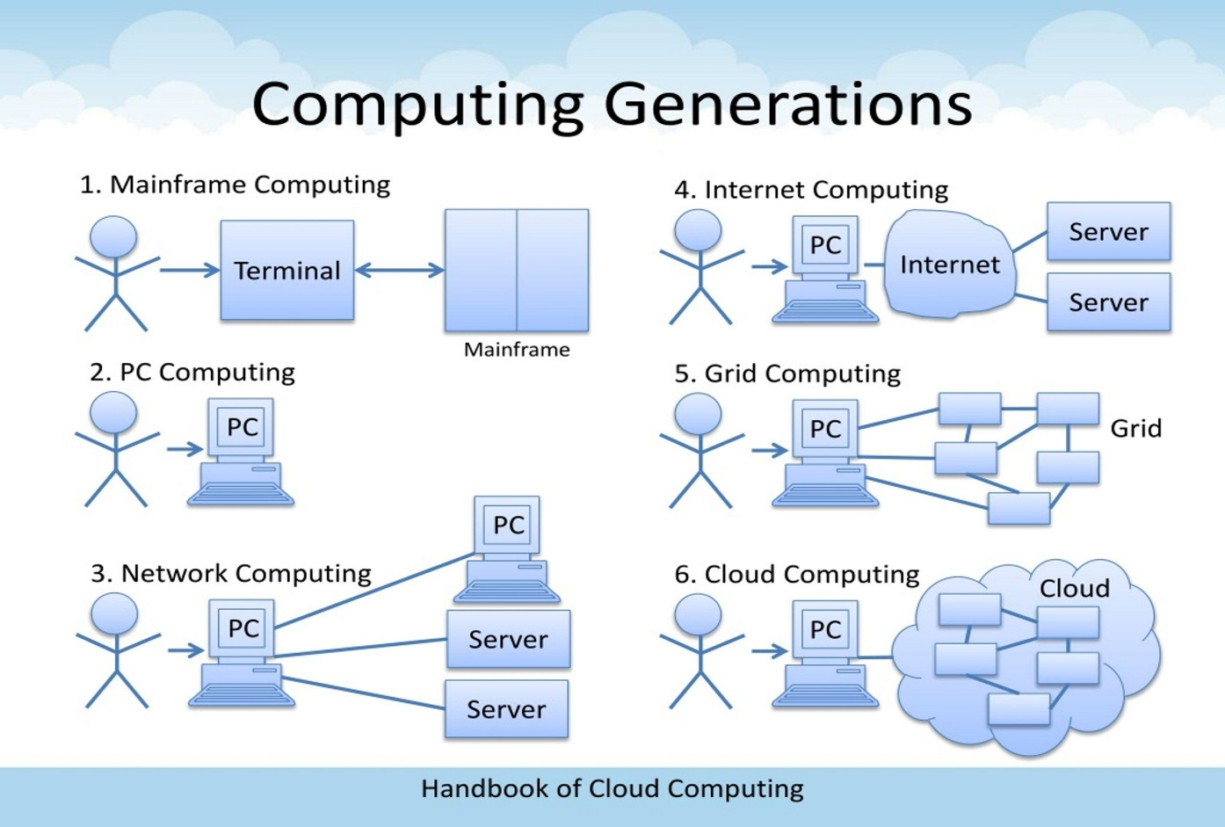

Stage | Period (Approx.) | Description | Limitation Solved
1. Mainframe Computing | 1950s–1960s | Large centralized computers served multiple users through terminals. | Centralized processing reduced the need for separate computers for every user.
2. Minicomputers | 1960s–1970s | Smaller and less expensive computers provided computing facilities to departments and organizations. | Reduced the high cost and size of mainframe systems.
3. Personal Computers (PCs) | 1970s–1980s | Individual users received access to their own computers. | Reduced dependency on centralized computer systems.
4. Client–Server Computing | 1980s–1990s | Clients requested services and data from centralized servers through networks. | Enabled resource sharing and centralized application management.
5. Cluster Computing | 1990s | Multiple interconnected computers worked together as a single system. | Improved processing power and availability beyond a single server.
6. Grid Computing | 1990s–2000s | Distributed computers from different locations shared resources to perform large tasks. | Enabled sharing of computing resources across multiple organizations and locations.
7. Utility Computing | 2000s | Computing resources were provided based on usage, similar to electricity and water services. | Introduced consumption-based pricing and reduced the need to purchase all computing resources.
8. Cloud Computing | 2000s–Present | Computing resources are delivered over the internet on demand using virtualization and distributed data centres. | Provides scalability, flexibility, resource sharing and pay-as-you-go services.
3. Explanation of Each Evolution Stage
3.1 Mainframe Computing
- Mainframes were large and powerful centralized computers.
- Multiple users accessed the same computer through connected terminals.
- Processing and data storage were handled centrally.
- They were expensive and required specialized maintenance.
Limitation: Mainframes were costly and provided limited flexibility for smaller organizations.

3.2 Minicomputers
- Minicomputers were smaller and less expensive than mainframes.
- Departments could operate their own computing systems.
- They supported multiple users.
- They reduced dependency on large centralized systems.
Limitation: Computing resources were still limited compared with modern systems.
3.3 Personal Computers (PCs)
- PCs provided individual computing facilities.
- Users could run applications locally.
- They improved accessibility and personal productivity.
- However, sharing data and resources across computers was difficult.
Limitation: Individual systems created problems with centralized management and resource sharing.
3.4 Client–Server Computing
- Clients requested services from centralized servers.
- Servers stored data and processed requests.
- Networks enabled communication between computers.
- Applications and databases could be centrally managed.
Limitation: A single server could become overloaded and create a single point of failure.
3.5 Cluster Computing
- Multiple computers were connected to work as a single computing system.
- Processing tasks were distributed among different machines.
- Improved processing capacity and reliability.
- Used in scientific computing and high-performance applications.
Limitation: Clusters generally required coordinated infrastructure and management within a controlled environment.
3.6 Grid Computing
- Connected geographically distributed computing resources.
- Combined processing power from multiple computers.
- Allowed organizations to share computing resources.
- Useful for scientific research and large computational tasks.
Limitation: Resource coordination and management across different systems were complex.
3.7 Utility Computing
- Provided computing resources according to actual usage.
- Introduced a consumption-based payment model.
- Users paid for the resources they consumed.
- Reduced the need for organizations to purchase all infrastructure in advance.
Limitation: Utility computing introduced the pay-per-use concept, but did not by itself provide all the automation, elasticity and service capabilities of modern cloud platforms.
3.8 Cloud Computing
- Provides servers, storage, databases and software through the internet.
- Uses virtualization to share physical resources.
- Supports automatic scaling according to workload.
- Provides on-demand access and measured billing.
- Offers public, private, hybrid and community deployment models.
Advantage: Cloud computing combines distributed infrastructure, virtualization, networking and utility-based service delivery.
4. Hardware Evolution That Enabled Cloud Computing
Hardware improvements played an important role in the development of cloud computing.
Hardware Development | Description | Contribution to Cloud Computing
Multi-Core Processors | Processors contain multiple processing cores. | Allow multiple tasks and virtual machines to execute efficiently.
Commodity Servers | Standardized, relatively low-cost server hardware. | Enable providers to build large data centres economically.
High-Capacity Storage | Advanced HDDs, SSDs and storage arrays. | Support large databases, backups and cloud storage services.
High-Speed Networking | High-bandwidth Ethernet and fibre-optic connections. | Enable fast communication between servers and users.
Data Centres | Large facilities containing interconnected servers, storage and networking equipment. | Provide centralized infrastructure for delivering cloud services.
4.1 Multi-Core Processors
- Earlier processors mainly executed tasks using a single processing core.
- Modern processors contain multiple cores.
- Multiple tasks can execute simultaneously.
- They improve the performance of virtual machines and cloud applications.
University Application: Multiple virtual machines can share the processing resources of a powerful cloud server.
4.2 Commodity Servers
- Commodity servers are standardized servers manufactured using commonly available hardware.
- They are relatively affordable compared with specialized high-end systems.
- Cloud providers can deploy thousands of servers.
- Failed servers can be replaced without rebuilding the entire infrastructure.
University Application: The university can avoid purchasing dedicated physical servers for every application.
4.3 High-Capacity Storage
- Modern storage devices provide large storage capacities.
- SSDs provide faster data access than traditional HDDs.
- Storage systems support replication and backup.
- Distributed storage improves data availability.
University Application: Student records, examination results, assignments and library information can be stored securely in cloud databases and storage systems.
4.4 High-Speed Networking
- Modern networks support high-speed data transmission.
- Fibre-optic communication enables long-distance connectivity.
- Advanced networking improves communication between data centres.
- Load balancing distributes incoming requests across servers.
University Application: Students from all four campuses can access university applications with improved performance, provided reliable internet connectivity is available.
4.5 Data Centres
- Data centres contain large numbers of interconnected servers.
- They provide power backup, cooling and physical security.
- They support redundant networking and storage.
- They enable continuous operation of cloud services.
University Application: The university can use cloud provider data centres instead of building and maintaining its own disaster recovery facility.

5. How Hardware Evolution Enabled Cloud Computing
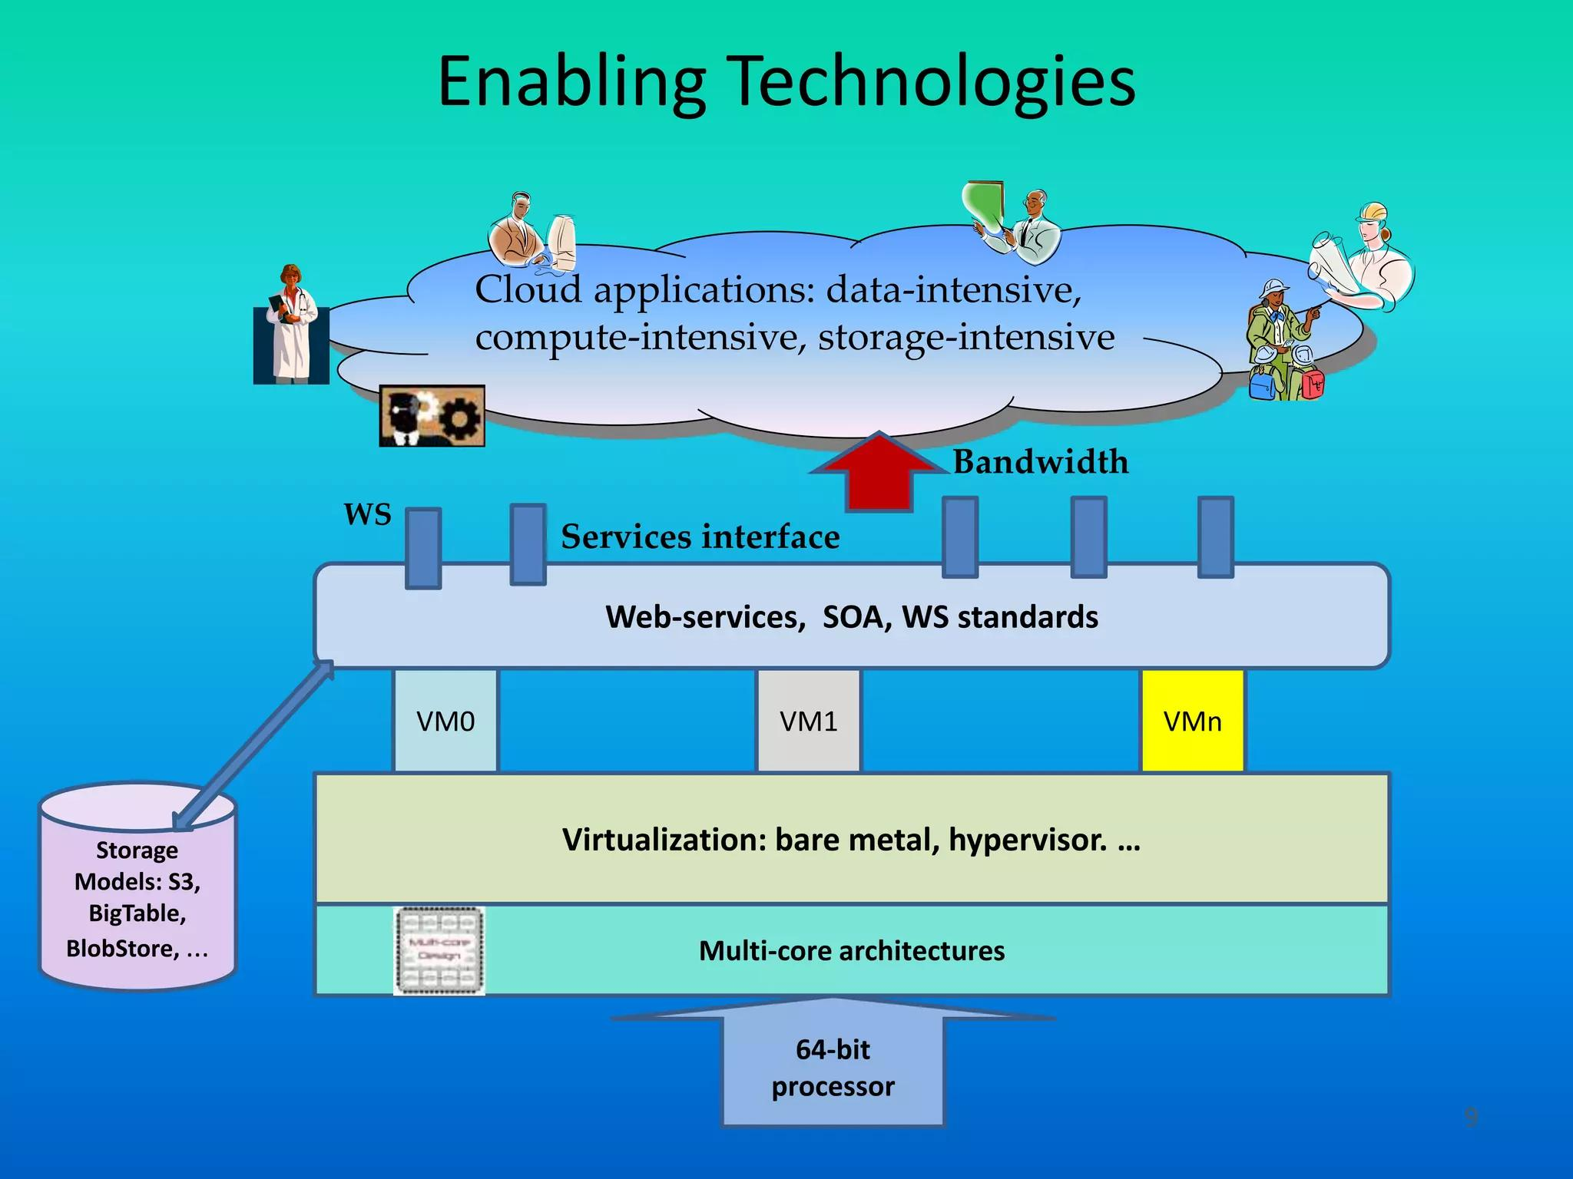
The following sequence explains the relationship between hardware development and cloud computing.
Hardware Advancement | Cloud Computing Capability Enabled
Multi-core processors | Parallel processing and efficient virtualization.
Commodity servers | Affordable large-scale computing infrastructure.
High-capacity storage | Large-scale cloud databases and backups.
High-speed networking | Fast communication and remote resource access.
Advanced data centres | Reliable and scalable cloud infrastructure.
Explanation: These hardware advancements allowed cloud providers to combine thousands of physical computing resources into large infrastructure pools. Virtualization and automated management then made these resources available to customers whenever required.

6. Which Stage Does the University's Current System Correspond To?
Current Stage: Client–Server Computing
The university's existing infrastructure primarily corresponds to the traditional client–server computing model.
Reasons
- The university operates 12 dedicated physical servers.
- Each application has its own dedicated server.
- Students and staff access applications through client devices.
- Applications depend on centralized on-premise servers.
- Server resources are not dynamically shared across applications.
- There is no cloud-based auto-scaling or disaster recovery infrastructure.
Comparison: Existing System vs Cloud Computing
Factor | Existing Client–Server System | Proposed Cloud System
Infrastructure | 12 dedicated physical servers | Shared virtualized cloud infrastructure
CPU Utilization | Approximately 15% average | Resources allocated according to demand
Scalability | Requires physical server procurement | Rapid provisioning and auto-scaling
Procurement | 6–8 weeks | Resources can be provisioned quickly
Availability | No disaster recovery site | Multi-zone deployment and backup
Cost | High capital expenditure | Pay-as-you-go operating expenditure
Accessibility | Limited by existing application interfaces | Internet-based access and APIs
7. Conclusion
Computing infrastructure evolved from mainframe computers to minicomputers, personal computers, client–server systems, clusters, grid computing, utility computing and finally cloud computing.
Hardware advancements such as multi-core processors, commodity servers, high-capacity storage, high-speed networking and modern data centres made large-scale cloud infrastructure possible.
The university's current system belongs primarily to the traditional client–server computing stage because it depends on 12 dedicated physical servers and lacks dynamic resource allocation.
Therefore, migrating towards cloud computing will improve resource utilization, scalability, availability and cost efficiency while supporting the university's future digital requirements.

TASK 3 – Analyse Internet Software Evolution (3 Marks)
1. Introduction
Internet software has evolved from simple static web pages into dynamic, interactive and cloud-hosted applications. This evolution allows users to access software, data and services through web browsers without installing applications on every computer.
Technologies such as HTTP, web browsers, AJAX, Web Services and APIs have made it possible to develop scalable cloud-based applications.
In the university scenario, internet software evolution helps modernize the Student Information System (SIS), Learning Management System (LMS), Library System, Exam Portal and Email services.
2. Evolution of Internet Software
Stage | Description | Limitation Solved
1. Static Web Pages (Web 1.0) | Websites displayed fixed HTML content. Users mainly viewed information without interacting with the website. | Provided information through the internet instead of distributing printed documents.
2. Dynamic Web | Websites started generating content based on user requests and database information. | Overcame the limitations of fixed content by supporting interactive services.
3. Web 2.0 | Introduced interactive websites, social networking, user-generated content and collaboration. | Improved user participation and real-time interaction.
4. Service-Oriented Architecture (SOA) | Applications were divided into reusable services that communicate through standard interfaces. | Reduced dependency on large, tightly connected applications.
5. Mashups | Combined data and services from multiple sources into one application. | Enabled integration of different web services.
6. Cloud-Hosted Applications | Applications are hosted on cloud infrastructure and accessed through the internet. | Improved scalability, availability and accessibility without requiring local installation.
2.1 Static Web Pages (Web 1.0)
- Early websites mainly contained static HTML pages.
- Content remained the same until manually updated.
- Users could read information but had limited interaction.
- Websites were mainly used to publish announcements and documents.
University Application: The university could publish admission notifications, academic calendars and general announcements through static websites.
Limitation: Static pages cannot efficiently support student login, examination registration or dynamic result checking.
2.2 Dynamic Web
- Dynamic websites generate content based on user requests.
- They communicate with databases.
- Users can log in and submit information.
- Server-side technologies process requests and return customized responses.
University Application: Students can log in to the Student Information System and view personal details, attendance and examination results.
Improvement: It supports database-driven applications instead of displaying only fixed information.
2.3 Web 2.0
- Web 2.0 introduced interactive and collaborative websites.
- Users can create, share and update information.
- Supports comments, discussions and real-time collaboration.
- Provides a better user experience.
University Application:
- Students can participate in online discussions.
- Faculty members can share learning materials.
- Students can submit assignments online.
- Users can receive notifications and announcements.
Improvement: It transformed websites from information-display platforms into interactive applications.
2.4 Service-Oriented Architecture (SOA)
- SOA organizes applications into independent, reusable services.
- Services communicate through standard interfaces.
- Different applications can share common services.
- Reduces tight coupling between software components.
University Application:
The university can separate its monolithic application into services such as:
- Student Management Service.
- Examination Service.
- Library Management Service.
- Fee Payment Service.
- Authentication Service.
Improvement: Different university applications can communicate without depending on one large monolithic program.
2.5 Mashups
- A mashup combines information or functionality from multiple web services.
- It uses APIs to obtain data from different sources.
- The combined information is presented through a single interface.
University Application:
The university mobile application can combine:
- Student academic information from the SIS.
- Examination schedules from the Exam Portal.
- Fee payment services from a payment gateway.
- Campus location information from a mapping service.
Improvement: Students can access multiple services through one application.
2.6 Cloud-Hosted Applications
- Applications are hosted on cloud infrastructure.
- Users access services through browsers or mobile applications.
- Cloud providers manage the underlying computing infrastructure.
- Applications can scale according to user demand.
University Application:
The university can host SIS, LMS, Library and Exam Portal applications on cloud infrastructure.
Improvement: Students and staff can access university services from any campus without depending on a particular physical server.
3. Role of Internet Technologies in Cloud Services
The following technologies play an important role in delivering cloud-based applications.
3.1 Web Browsers
A web browser is software used to access websites and web applications over the internet.
Examples:
- Google Chrome.
- Mozilla Firefox.
- Microsoft Edge.
- Safari.
Role in University:
Students can access the LMS, SIS and Exam Portal through a browser without installing separate desktop software.
3.2 HTTP (Hypertext Transfer Protocol)
HTTP is an application-layer protocol used for communication between web clients and web servers.
- The browser sends HTTP requests to the server.
- The server processes the request.
- The server returns an HTTP response.
- HTTPS provides encrypted communication using TLS.
Example:
When a student opens the examination portal, the browser sends an HTTPS request to retrieve examination information.
Role in University: Enables secure communication between students, university applications and cloud servers.
3.3 AJAX (Asynchronous JavaScript and XML)
AJAX allows web pages to communicate with servers asynchronously without reloading the entire page.
- Uses JavaScript to send background requests.
- Updates only the required portion of a webpage.
- Improves responsiveness.
- Can exchange JSON or XML data.
University Example:
When a student checks examination results, AJAX can retrieve the result and update the webpage without refreshing the entire page.
3.4 APIs (Application Programming Interfaces)
An API allows different software applications to communicate and exchange information through defined interfaces.
- Supports application integration.
- Enables mobile application development.
- Allows external organizations to access authorized services.
- Supports communication between independent applications.
University Example:
The university can provide APIs to 40 affiliated colleges to access authorized student records, examination details and fee-payment services.

4. Comparison of Desktop, Client–Server and Web-Delivered Software
Factor | Desktop Software | Client–Server Software | Web-Delivered Software
Installation | Installed on individual computers. | Client software may need installation. | Usually accessed through a browser.
Processing | Mainly performed locally. | Shared between client and server. | Mainly performed on web/cloud servers, with some browser-side processing.
Data Storage | Usually local or shared storage. | Centralized server database. | Cloud or remotely hosted database.
Accessibility | Limited to installed devices. | Depends on network and client setup. | Accessible through the internet.
Updates | Must be installed on individual systems. | Client and server updates may be required. | Centralized application updates.
Scalability | Limited by local hardware. | Depends on server capacity. | Supports cloud scaling.
Maintenance | Managed on individual computers. | Managed on clients and servers. | Centralized application management.
Example | Desktop accounting software. | Traditional university management system. | Cloud-based LMS and student portal.
Main Difference
- Desktop Software: Runs mainly on an individual computer.
- Client–Server Software: Clients communicate with centralized servers.
- Web-Delivered Software: Applications are accessed through browsers over the internet and can be hosted on cloud infrastructure.
5. Impact of Internet Software Evolution on University Application Design
The university currently uses large monolithic applications without public interfaces. This limits mobile access and integration with affiliated colleges.
Internet software evolution provides a way to modernize these applications.
Proposed Application Design
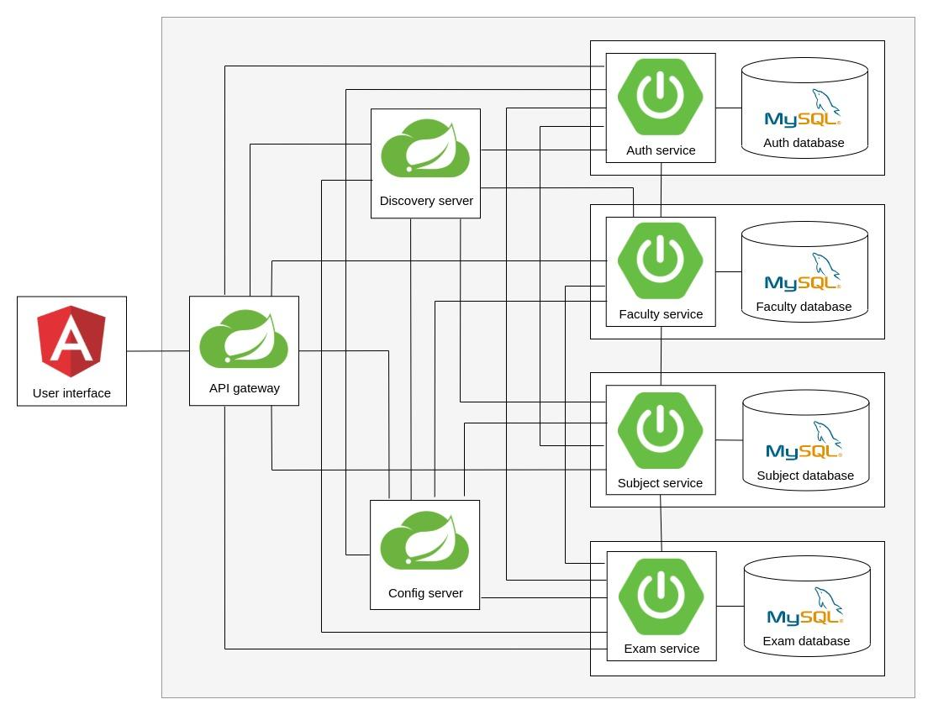
The university should adopt a web-based, API-driven application architecture.

Application | Proposed Design | Benefit
Student Information System | Web-based application with REST APIs. | Students can access academic records from anywhere.
Learning Management System | Cloud-hosted interactive application. | Supports online classes, assignments and learning materials.
Library System | Web application connected to a centralized database. | Enables online book searching and availability checking.
Exam Portal | Scalable web application with secure authentication. | Handles high traffic during online examinations.
Email System | SaaS-based email platform. | Reduces email server maintenance.
Mobile Application | Uses APIs to communicate with university services. | Provides convenient mobile access.
College Integration | Secure APIs with role-based access. | Allows 40 affiliated colleges to access authorized services.
Recommended Design Improvements
1. Replace Monolithic Architecture
Divide large applications into smaller independent services such as student management, examination, library and fee payment.
2. Introduce REST APIs
Use RESTful APIs with HTTP/HTTPS and JSON to allow communication between university applications, mobile applications and affiliated colleges.
3. Use Cloud Hosting
Host applications on cloud infrastructure to support flexible computing resources and rapid scaling.
4. Implement Responsive Web Design
Develop interfaces that work on desktops, laptops, tablets and smartphones.
5. Introduce Centralized Authentication
Use a common authentication service with role-based access for students, faculty, administrators and affiliated colleges.
6. Improve Application Integration
Use APIs and web services to connect SIS, LMS, Library and Exam Portal without requiring users to access multiple disconnected systems.
6. Benefits to the University
- Accessibility: Students can access services from any location.
- Integration: Different applications can communicate through APIs.
- Scalability: Cloud-hosted applications can support increasing user traffic.
- Maintainability: Centralized updates simplify application maintenance.
- User Experience: AJAX and dynamic web technologies improve responsiveness.
- Mobile Support: APIs enable the development of mobile applications.
- Collaboration: Web 2.0 technologies support communication between students and faculty.
- External Connectivity: Secure APIs allow affiliated colleges to access authorized university services.
7. Conclusion
Internet software evolved from static web pages to dynamic websites, Web 2.0, Service-Oriented Architecture, mashups and cloud-hosted applications. Technologies such as browsers, HTTP, AJAX and APIs made software accessible, interactive and capable of communicating across different platforms.
For the university, this evolution provides an opportunity to replace monolithic applications with modern web-based and API-driven services.
Therefore, the university should adopt cloud-hosted applications supported by REST APIs, centralized authentication and responsive web interfaces. This will improve accessibility, integration, scalability and manageability while supporting the proposed mobile application and services for 40 affiliated colleges.

TASK 4 – Apply Server Virtualization (5 Marks)
1. Introduction
Server virtualization is a technology that allows multiple virtual machines (VMs) to run on a single physical server using a software layer called a hypervisor.
Each virtual machine operates like an independent computer with its own operating system, CPU allocation, memory, storage and applications.
In the university scenario, 12 physical servers are currently dedicated to different applications, with an average CPU utilization of only 15%. This results in significant wastage of computing resources.
By applying server virtualization, the university can consolidate its applications into fewer physical servers, improve resource utilization, reduce hardware costs and simplify infrastructure management.
2. Working of a Hypervisor
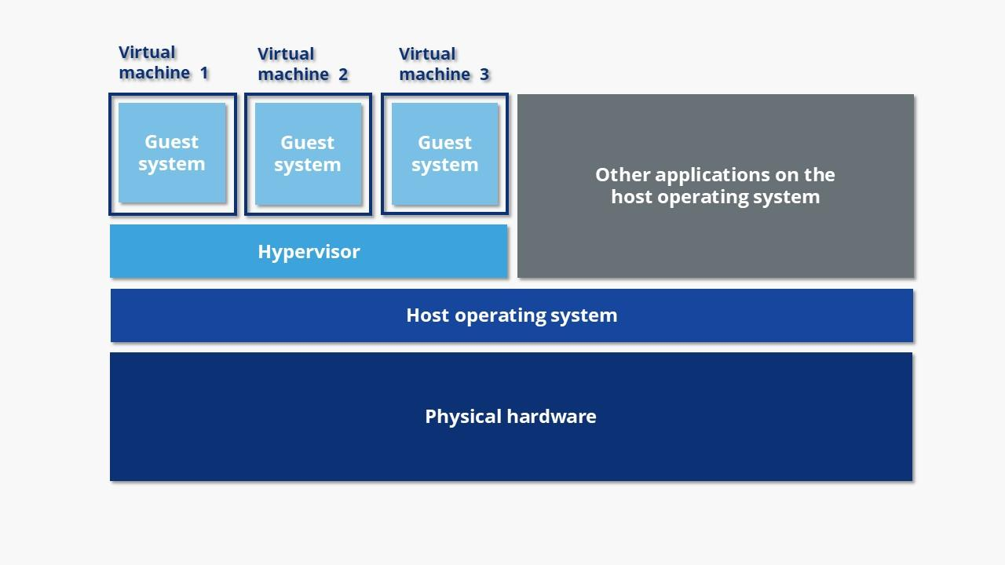
A hypervisor is software or firmware that creates, runs and manages multiple virtual machines on a physical server.
It acts as an intermediate layer between the physical hardware and virtual machines.
Working Process
- The physical server provides CPU, RAM, storage and network resources.
- The hypervisor is installed on the physical server or on top of a host operating system.
- The hypervisor creates multiple virtual machines.
- Each virtual machine receives allocated virtual CPU, memory and storage.
- Each VM runs its own guest operating system and applications.
- The hypervisor manages resource allocation and isolation between virtual machines.
University Application: Instead of running each university application on a separate physical server, multiple applications can run in independent virtual machines on shared physical hosts.
3. Types of Hypervisors
There are two major types of hypervisors.
3.1 Type-1 Hypervisor (Bare-Metal Hypervisor)
A Type-1 hypervisor runs directly on the physical hardware without requiring a conventional host operating system.
Characteristics:
- Direct access to physical hardware.
- Better performance and resource management.
- Suitable for enterprise data centres.
- Provides strong VM isolation.
Examples:
- VMware ESXi.
- Microsoft Hyper-V.
- Xen.
- KVM (Kernel-based Virtual Machine).
University Application: Type-1 hypervisors are recommended for the university's production servers because they provide efficient resource management and support multiple virtual machines.
3.2 Type-2 Hypervisor (Hosted Hypervisor)
A Type-2 hypervisor runs as an application on top of an existing host operating system.
Characteristics:
- Requires an existing operating system.
- Easy to install and configure.
- Suitable for development and testing.
- May have additional performance overhead.
Examples:
- Oracle VirtualBox.
- VMware Workstation.
- VMware Fusion.
University Application: Type-2 hypervisors can be used by university developers to test application updates and new operating systems before production deployment.
Difference Between Type-1 and Type-2 Hypervisors
Factor | Type-1 Hypervisor | Type-2 Hypervisor
Installation | Directly on hardware | On a host operating system
Performance | Generally higher | Generally lower due to additional software layer
Resource Management | Direct hardware management | Managed through host OS
Security | Smaller attack surface when properly configured | Depends on host OS security as well
Usage | Production data centres | Development and testing
Examples | ESXi, Hyper-V, Xen, KVM | VirtualBox, VMware Workstation
Recommendation: The university should use a Type-1 hypervisor for production infrastructure because it is designed for enterprise server virtualization.
4. Comparison of Virtualization Techniques
There are four important virtualization techniques used in modern computing infrastructure.
4.1 Full Virtualization
Full virtualization creates a complete virtual hardware environment for each virtual machine.
- Each VM runs an independent guest operating system.
- Guest operating systems do not need modification.
- The hypervisor provides virtual hardware to each VM.
- Provides isolation between virtual machines.
Example: VMware ESXi and VirtualBox.
University Application: The existing SIS, LMS and Library applications can run in separate VMs with their own operating systems.
4.2 Para-Virtualization
Para-virtualization allows the guest operating system to communicate directly with the hypervisor using special interfaces or hypercalls.
- Guest operating system must be modified or virtualization-aware.
- Reduces some virtualization overhead.
- Improves communication between the guest OS and hypervisor.
- Requires compatible guest operating systems.
Example: Xen para-virtualization.
University Application: It can be considered for specialized workloads where performance optimization is important and guest OS modification is possible.
4.3 OS-Level Virtualization (Containers)
OS-level virtualization creates isolated environments called containers that share the same host operating system kernel.
- Containers are lightweight compared with VMs.
- They start quickly.
- They use fewer hardware resources.
- Multiple applications can run independently in containers.
- They share the host kernel.
Examples: Docker and Kubernetes.
University Application: The university can run REST APIs, authentication services and mobile application backends using containers.
4.4 Hardware-Assisted Virtualization
Hardware-assisted virtualization uses processor features to support virtualization efficiently.
- Uses CPU technologies such as Intel VT-x and AMD-V.
- Improves execution of virtual machines.
- Reduces virtualization overhead.
- Supports efficient isolation and execution of guest operating systems.
University Application: The university should select cloud or physical server hosts with hardware virtualization support to improve VM performance.
Comparison Table
Factor | Full Virtualization | Para-Virtualization | OS-Level Virtualization | Hardware-Assisted Virtualization
Basic Concept | Simulates complete hardware | Guest communicates with hypervisor | Shares host OS kernel | Uses CPU virtualization extensions
Guest OS | Unmodified | Modified or virtualization-aware | No separate guest kernel | Usually unmodified
Resource Usage | Higher than containers | Depends on implementation | Low | Depends on VM configuration
Performance | Good | Can reduce overhead | Generally lightweight | Improves VM execution efficiency
Isolation | VM-level isolation | VM-level isolation | Process/container isolation | Hardware-supported VM isolation
Example | VMware ESXi | Xen PV | Docker | Intel VT-x, AMD-V
Important distinction: Hardware-assisted virtualization is a hardware support technique that can be used with full virtualization. It is not necessarily a separate alternative to full and para-virtualization.
5. Proposed Virtualization Plan for University Applications
The university should adopt a combination of virtual machines and containers.
- VMs should be used for existing applications that require independent operating systems.
- Containers should be used for lightweight, independently deployable services.
- SaaS should replace applications such as email wherever practical.
Application Allocation
University Application | Recommended Technology | Reason
Student Information System (SIS) | Virtual Machine | Existing monolithic application requires an independent OS environment.
Learning Management System (LMS) | Virtual Machine initially | Supports existing application without major code modification.
Library System | Virtual Machine | Provides application isolation and compatibility.
Exam Portal | Virtual Machine initially | Supports existing software and independent resource allocation.
Email System | SaaS | Reduces server maintenance and operational costs.
Student Authentication Service | Container | Lightweight and independently deployable.
Mobile Application Backend | Containers | Supports rapid deployment and scaling.
REST API Services | Containers | Allows independent updates and efficient resource utilization.
Database Services | Managed Cloud Database or dedicated VM | Provides reliable storage, backups and controlled resource allocation.
Why Use Both VMs and Containers?
Virtual Machines:
- Suitable for legacy applications.
- Support different operating systems.
- Provide independent OS environments.
- Reduce the need to rewrite existing applications.
Containers:
- Require fewer resources.
- Start quickly.
- Support microservices architecture.
- Allow independent application deployment and scaling.
Recommendation: Initially migrate the four existing monolithic applications into VMs. Gradually modernize selected components into containers as the university develops its mobile application and college integration APIs.
6. Server Consolidation Calculation
Minimum estimated hosts: 3
The university currently operates 12 physical servers with an average CPU utilization of 15%.
The target utilization of each consolidated physical host is 70%.
We need to calculate how many physical hosts are required to consolidate the existing servers without exceeding the target average CPU utilization.
Given Data
Parameter | Value
Existing physical servers | 12
Average CPU utilization per server | 15%
Target host utilization | 70%
Capacity of each original server | 100%
Step 1: Calculate Total CPU Workload
Each of the 12 servers uses 15% of its CPU capacity.
Total CPU Workload = Number of Servers × Average CPU Utilization
Total CPU Workload = 12 × 15%
Total CPU Workload = 180%
Therefore, the combined workload is equivalent to 180% of one original server's CPU capacity.
Step 2: Calculate Required Physical Hosts
Each new physical host should operate at a maximum target utilization of 70%.
Required Hosts = Total CPU Workload ÷ Target Host Utilization
Substituting the values:
Required Hosts = (12 × 15) ÷ 70
Required Hosts = 180 ÷ 70
Required Hosts = 2.57
Step 3: Round Up to the Next Whole Number
Since physical servers cannot be purchased in fractions, round up to the next whole number.
Required Physical Hosts = 3
Step 4: Verify the Result
Average Utilization = Total CPU Workload ÷ Number of Hosts
Average Utilization = 180% ÷ 3
Average Utilization = 60%
Therefore, three physical hosts are sufficient because their average utilization is 60%, which is below the target utilization of 70%.
Assumptions and Practical Recommendation
The calculation assumes:
- All 12 original servers have approximately equal CPU capacity.
- The 15% utilization represents an average workload.
- The new hosts have sufficient CPU capacity to handle the combined workload.
- CPU is the limiting resource; RAM, storage and network requirements must be checked separately.
- The calculation does not include peak workload or a failed-host scenario.
- Practical Recommendation:
- Although three hosts are sufficient mathematically, the university should consider four physical hosts to provide N+1 redundancy and additional capacity during peak periods.
- With four equal-capacity hosts:
- Average Utilization = Total CPU Workload ÷ Number of Hosts
- Average Utilization = 180% ÷ 4
- Average Utilization = 45%
- Therefore, with four physical hosts, the average CPU utilization will be 45%, providing additional capacity and improved fault tolerance.
- Note: N+1 redundancy means that if one physical host fails, the remaining three hosts can handle the workload, assuming sufficient capacity and proper VM distribution.
This provides more operating headroom and allows one host to fail while the remaining three continue handling the average workload, assuming suitable failover capacity.
7. Benefits of Server Virtualization
7.1 Live Migration
Live migration transfers a running virtual machine from one physical host to another without significant service interruption.
Benefits:
- Allows hardware maintenance without shutting down applications.
- Reduces service downtime.
- Supports workload balancing.
- Improves infrastructure availability.
University Example: The university can move the LMS virtual machine to another host while performing maintenance on the original host.
7.2 Snapshots
A snapshot captures the state of a virtual machine at a particular point in time.
Benefits:
- Allows recovery after unsuccessful software updates.
- Helps developers test application changes.
- Makes rollback easier.
- Reduces recovery time for certain failures.
University Example: Before updating the Exam Portal, administrators can create a snapshot and revert to the previous state if the update fails.
Note: Snapshots are not a replacement for independent backups.
7.3 Resource Over-Commitment
Resource over-commitment allows the hypervisor to allocate more virtual resources than the physical resources available, based on the assumption that all VMs will not use their maximum allocation simultaneously.
Benefits:
- Improves hardware utilization.
- Reduces the number of physical servers required.
- Supports flexible resource allocation.
- Reduces infrastructure costs.
University Example: Multiple VMs can be allocated virtual CPUs based on expected demand, while the hypervisor schedules actual CPU execution according to workload.
8. Risks and Challenges of Virtualization
Risk | Explanation | Solution
Noisy Neighbour | One VM consumes excessive CPU, memory or network resources, affecting other VMs. | Apply resource limits, reservations and monitoring.
Hypervisor Failure | Failure of the hypervisor can affect all VMs running on that host. | Use multiple hosts, high availability and failover mechanisms.
Security Isolation | Vulnerabilities may allow unauthorized access between virtual machines. | Apply security patches, isolation controls and access restrictions.
Resource Over-Commitment | Excessive allocation can cause CPU contention or memory exhaustion. | Monitor resource utilization and maintain sufficient capacity.
Single Point of Failure | Multiple applications may depend on one physical host. | Distribute critical VMs across different hosts.
Data Loss | VM storage failure may affect multiple applications. | Maintain independent backups and replicated storage.
Explanation of Major Risks
1. Noisy Neighbour Problem
When multiple VMs share the same physical server, one VM may consume excessive resources. This can reduce the performance of other VMs.
Solution: Use resource allocation policies and continuous monitoring.
2. Hypervisor Failure
If a hypervisor crashes, all virtual machines running on that physical host may become unavailable.
Solution: Implement high availability and distribute VMs across multiple physical hosts.
3. Security Isolation
Although VMs are isolated, vulnerabilities in the hypervisor or incorrect configurations may create security risks.
Solution: Regularly update the hypervisor, implement strong access control and monitor virtual network traffic.
9. Final Proposed Virtualization Architecture
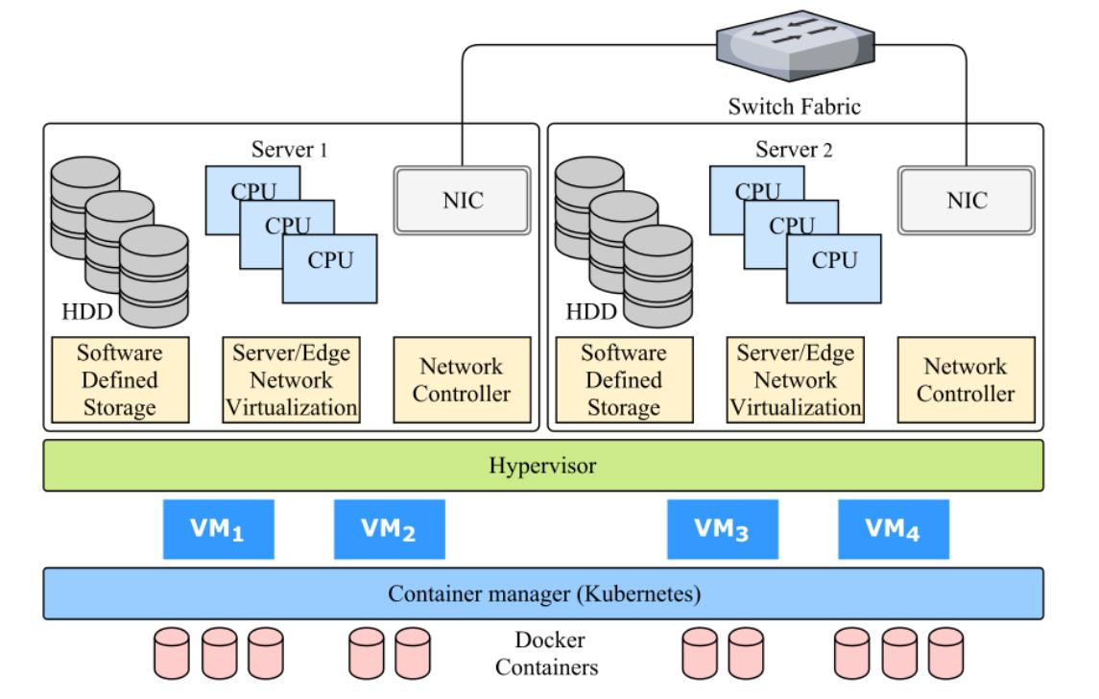
The university should implement the following architecture:
- Deploy four physical hosts with Type-1 hypervisors.
- Consolidate the existing 12 physical servers into virtual machines.
- Run SIS, LMS, Library and Exam Portal in separate VMs initially.
- Deploy new REST APIs and mobile application services using containers.
- Use managed cloud databases for student records and transactions where appropriate.
- Configure live migration and high availability.
- Implement snapshots and automated independent backups.
- Monitor CPU, RAM, storage and network utilization.

10. Conclusion
Server virtualization is an effective solution for consolidating the university's 12 physical servers. By using Type-1 hypervisors, the university can operate multiple virtual machines on fewer physical hosts.
The consolidation calculation shows that a minimum of three physical hosts is required, based on the given average CPU utilization of 15% and target utilization of 70%. However, four hosts are recommended for better fault tolerance and peak-load management.
Existing monolithic applications should initially run in virtual machines, while new APIs and mobile application services should use containers.
Therefore, server virtualization will reduce hardware requirements, improve resource utilization, simplify management and provide a scalable foundation for the university's cloud migration.

TASK 5 – Apply Web Services (4 Marks)
1. Introduction to Web Services
A web service is a software component that allows two or more applications to communicate and exchange data over a network using standard protocols such as HTTP and HTTPS.
Web services enable different applications, platforms and programming languages to communicate without requiring the same technology.
In the university scenario, the existing applications (Student Information System, Learning Management System, Library System, Exam Portal and Email) operate as separate monolithic applications without public interfaces.
By implementing web services, the university can expose its functions to mobile applications, students, staff and 40 affiliated colleges.
Role of Web Services in Cloud Computing and SOA
- Application Integration: Connects SIS, LMS, Library and Exam Portal.
- Cloud Accessibility: Allows applications hosted on cloud infrastructure to communicate over the internet.
- Reusability: The same service can be used by websites, mobile applications and partner colleges.
- Interoperability: Supports communication between applications developed using different programming languages.
- Scalability: Services can be independently deployed and scaled.
- Automation: Enables automatic communication between systems without manual data exchange.
Relationship Between SOA and Web Services
Service-Oriented Architecture (SOA) is an architectural approach in which applications are divided into independent, reusable services.
Web services provide the communication mechanism through which these services interact.
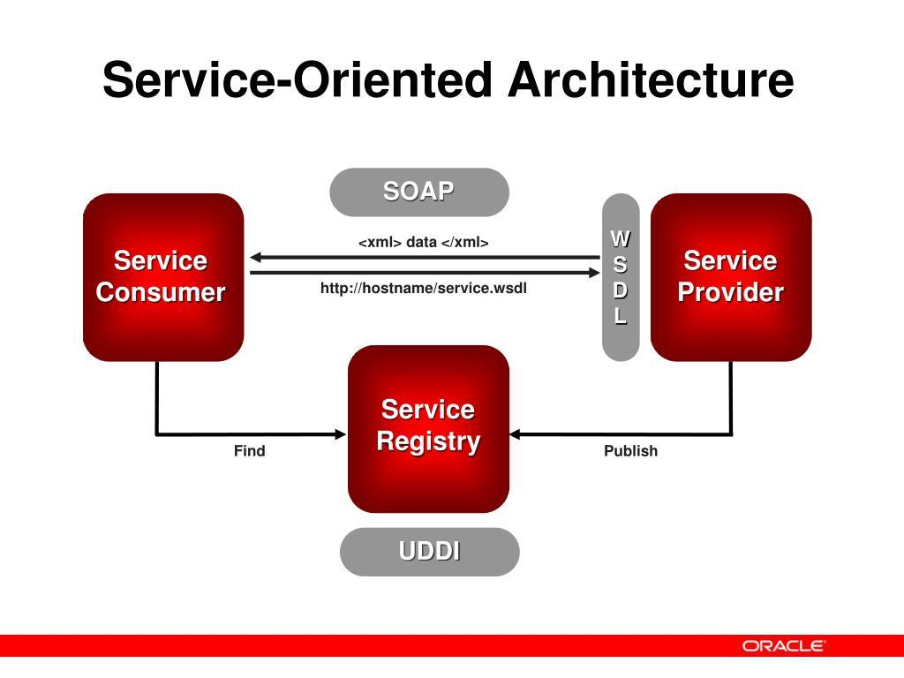
Example: The university's Fee Payment Service can be accessed by the student portal and mobile application through the same web service.
2. Types of Web Service Technologies
The important web service technologies include SOAP, WSDL, UDDI and REST.
2.1 SOAP (Simple Object Access Protocol)
SOAP is a protocol used for exchanging structured information between applications.
Characteristics:
- Uses XML-based messages.
- Supports HTTP and other transport protocols.
- Follows a predefined message structure.
- Supports standards for security and reliable messaging.
- Suitable for complex enterprise applications.
University Application: SOAP can be used for secure fee-payment transactions and integration with external financial systems that require strict message contracts.
Example: A fee-payment service can send a structured XML request to a payment processing system.
2.2 WSDL (Web Services Description Language)
WSDL is an XML-based language used to describe a web service and how clients can access it.
Characteristics:
- Defines available operations.
- Specifies input and output message formats.
- Identifies communication protocols.
- Describes service endpoints.
- Helps client applications understand how to communicate with a SOAP service.
University Application: WSDL can describe the university's examination result service, including its operations and request/response formats.
2.3 UDDI (Universal Description, Discovery and Integration)
UDDI is a standard for publishing and discovering web service information through a service registry.
Characteristics:
- Acts as a service directory.
- Helps applications discover available services.
- Stores service descriptions and access information.
- Supports service-provider discovery.
University Application: The university can maintain a service registry containing available services such as student records, fee payment and library search for affiliated colleges.
2.4 RESTful Web Services
REST (Representational State Transfer) is an architectural style used to develop web services using standard HTTP methods.
Characteristics:
- Uses HTTP/HTTPS.
- Commonly exchanges data in JSON format.
- Supports lightweight communication.
- Uses resources identified by URLs.
- Is stateless, meaning each request contains the information required to process it.
University Application: REST APIs can allow mobile applications and affiliated colleges to access student details, examination results and library information.
3. Comparison of SOAP, WSDL, UDDI and REST
Factor | SOAP | WSDL | UDDI | REST
Type | Communication protocol | Service description language | Service registry | Architectural style
Purpose | Exchanges structured messages | Describes web services | Discovers web services | Provides web-based API communication
Data Format | XML | XML | XML-based registry information | JSON or XML
Transport | HTTP, SMTP and others | Usually accessed through service metadata over HTTP | Registry access through defined interfaces | HTTP/HTTPS
Communication | Structured messages | Defines service operations and messages | Service discovery | Resource-based communication
Complexity | Relatively high | Used with service contracts | Requires registry infrastructure | Relatively simple
Best Use | Enterprise transactions | Describing SOAP services | Discovering services | Mobile and web applications
3.1 HTTP Methods Used in REST
RESTful services use different HTTP methods to perform operations on resources.
HTTP Method | Purpose | University Example
GET | Retrieve information | View examination results.
POST | Create or submit information | Initiate a fee-payment request.
PUT | Completely update a resource | Update student profile information.
PATCH | Partially update a resource | Update student contact details.
DELETE | Remove a resource | Delete an authorized temporary record.
3.2 JSON and XML
JSON (JavaScript Object Notation)
- Lightweight data exchange format.
- Easy to read and understand.
- Commonly used in REST APIs.
- Requires less data than equivalent XML in many cases.
Example:
{
"student_id": "STU101",
"name": "Arun",
"department": "CSE"
}
XML (Extensible Markup Language)
- Uses tags to represent structured information.
- Supports complex message structures.
- Commonly used in SOAP web services.
- Supports strict message validation through XML Schema.
Example:
<Student>
<StudentID>STU101</StudentID>
<Name>Arun</Name>
<Department>CSE</Department>
</Student>
Difference Between JSON and XML
Factor | JSON | XML
Structure | Key-value pairs | Tags and elements
Readability | Simple and compact | More verbose
Data Size | Usually smaller | Usually larger
Parsing | Relatively simple | More complex
Usage | REST APIs | SOAP services
Best Suitable For | Mobile and web applications | Structured enterprise messaging
4. Proposed Web Services for the University
The university should expose its important functions through RESTful APIs so that students, staff, mobile applications and affiliated colleges can access authorized services.
The following five web services are proposed.

4.1 Student Result Lookup Service
Purpose: Allows students and authorized affiliated colleges to retrieve examination results.
Parameter | Details
Service Name | Student Result Service
Endpoint | /api/v1/results/{student_id}
HTTP Method | GET
Data Format | JSON
Authentication | OAuth 2.0 / secure token
Sample Request:
GET /api/v1/results/STU101
Authorization: Bearer <access_token>
Sample Response:
{
"student_id": "STU101",
"student_name": "Arun",
"semester": 5,
"subject": "Computer Networks",
"grade": "A",
"result": "PASS"
}
Justification – REST:
REST is suitable because result lookup mainly involves retrieving information. GET requests are lightweight and easy to integrate with mobile applications and college portals.
4.2 Fee Payment Service
Purpose: Allows students to pay university fees through an online payment gateway.

Parameter | Details
Service Name | Fee Payment Service
Endpoint | /api/v1/payments
HTTP Method | POST
Data Format | JSON
Authentication | OAuth 2.0 / secure token
Sample Request:
POST /api/v1/payments
Content-Type: application/json
Authorization: Bearer <access_token>
Request Body:
{
"student_id": "STU101",
"amount": 15000,
"payment_type": "Semester Fee",
"currency": "INR"
}
Sample Response:
{
"transaction_id": "TXN1001",
"student_id": "STU101",
"amount": 15000,
"payment_status": "SUCCESS",
"message": "Payment completed successfully"
}
Justification – REST:
REST is suitable for mobile and web-based payment integration because it supports lightweight JSON requests and responses. The actual payment must be processed through a secure payment gateway with transaction verification, idempotency and appropriate security controls.
SOAP may be preferred if an external financial institution specifically requires SOAP-based integration or WS-Security standards.

4.3 Library Search Service
Purpose: Allows students and staff to search for books and check their availability.
Parameter | Details
Service Name | Library Search Service
Endpoint | /api/v1/library/books?title=cloud
HTTP Method | GET
Data Format | JSON
Authentication | Access token
Sample Request:
GET /api/v1/library/books?title=cloud
Authorization: Bearer <access_token>
Sample Response:
{
"books": [
{
"book_id": "B101",
"title": "Cloud Computing",
"author": "Thomas Erl",
"availability": "Available"
},
{
"book_id": "B102",
"title": "Cloud Architecture",
"author": "Michael J. Kavis",
"availability": "Issued"
}
]
}
Justification – REST:
REST is suitable because library search mainly retrieves information. GET requests make searching simple and efficient for students using browsers and mobile applications.

4.4 Student Information Service
Purpose: Allows authorized applications and affiliated colleges to retrieve student information.
Parameter | Details
Service Name | Student Information Service
Endpoint | /api/v1/students/{student_id}
HTTP Method | GET
Data Format | JSON
Authentication | OAuth 2.0 with role-based access
Sample Request:
GET /api/v1/students/STU101
Authorization: Bearer <access_token>
Sample Response:
{
"student_id": "STU101",
"name": "Arun",
"department": "Computer Science",
"semester": 5,
"college_id": "COL101"
}
Justification – REST:
REST provides a simple way for mobile applications and affiliated colleges to retrieve student information. Role-based authorization ensures that each college can access only permitted student records.
4.5 Examination Schedule Service
Purpose: Allows students to view examination schedules and important dates.
Parameter | Details
Service Name | Examination Schedule Service
Endpoint | /api/v1/exams/schedule/{student_id}
HTTP Method | GET
Data Format | JSON
Authentication | Secure access token
Sample Request:
GET /api/v1/exams/schedule/STU101
Authorization: Bearer <access_token>
Sample Response:
{
"student_id": "STU101",
"semester": 5,
"examinations": [
{
"subject": "Computer Networks",
"date": "2026-11-15",
"time": "10:00 AM"
},
{
"subject": "Cloud Computing",
"date": "2026-11-18",
"time": "10:00 AM"
}
]
}
Justification – REST:
REST is suitable because examination schedules are frequently retrieved by large numbers of students. Its lightweight requests and JSON responses make it suitable for mobile and web applications.
Note: The student names, IDs, amounts and examination dates above are illustrative sample data.
5. Comparison of SOAP and REST for University Functions
University Function | Recommended Technology | Reason
Student Result Lookup | REST | Simple data retrieval using GET.
Fee Payment | REST | Easy mobile integration and lightweight JSON communication.
Library Search | REST | Fast retrieval of book information.
Student Information | REST | Easy integration with affiliated college portals.
Examination Schedule | REST | Supports frequent requests from students.
External Banking Integration | SOAP or REST | SOAP may be required by financial institutions needing strict message contracts and WS-Security.
Why REST Is More Suitable for the University
REST is recommended as the primary web service architecture because:
- Simplicity: REST APIs are easier to develop and maintain.
- Performance: JSON messages are generally lightweight.
- Mobile Integration: Mobile applications can easily communicate with REST APIs.
- Scalability: REST services can be independently deployed and scaled.
- Compatibility: REST supports different programming languages and platforms.
- Cost Efficiency: Development and integration are generally simpler.
However, SOAP should be used when an external system requires SOAP-specific standards, strict XML contracts or WS-Security.
6. Proposed Web Service Architecture
The university should implement an API Gateway to manage communication between students, mobile applications, affiliated colleges and internal university services.
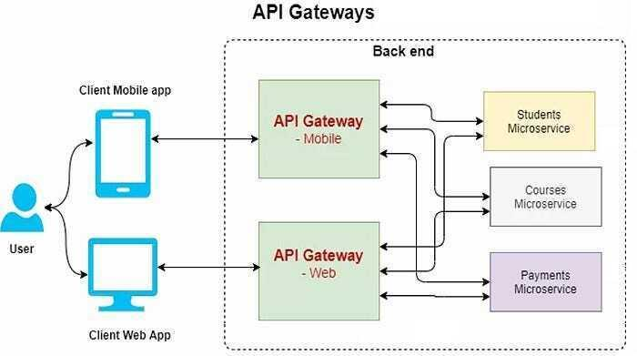
Working Process
- Students or affiliated colleges send requests through a web browser or mobile application.
- The API Gateway receives incoming requests.
- Authentication verifies the identity of the requester.
- Authorization checks the permissions assigned to the user or college.
- The gateway forwards requests to the appropriate university service.
- The service retrieves or updates the required information in the database.
- The server returns a JSON response to the requesting application.
Security Measures
- Use HTTPS to encrypt communication.
- Implement OAuth 2.0 authentication.
- Apply role-based access control.
- Use API rate limiting to prevent excessive requests.
- Maintain audit logs for student-record access.
- Use secure payment gateway integration.
- Validate all incoming requests.
7. Conclusion
Web services play an important role in connecting independent applications and enabling cloud-based communication. SOAP, WSDL, UDDI and REST provide different approaches to web service communication, description and discovery.
For the university, RESTful web services are the most suitable choice for student result lookup, fee payment, library search, student information and examination schedules because they provide lightweight communication, easy mobile integration and scalability.
By implementing an API Gateway and secure REST APIs, the university can expose its services to mobile applications and 40 affiliated colleges without requiring every application to be completely redesigned.
Final Recommendation: Adopt REST as the primary web service architecture and use SOAP selectively for external enterprise integrations that require SOAP-specific standards. This approach improves interoperability, accessibility, scalability and manageability while supporting the university's cloud migration.

TASK 6 – Analyse the Service Models: IaaS, PaaS and SaaS (5 Marks)
1. Introduction
Cloud computing provides different service models that allow organizations to use computing resources without purchasing and maintaining all the underlying infrastructure.
The three major cloud service models are:
- IaaS – Infrastructure as a Service
- PaaS – Platform as a Service
- SaaS – Software as a Service
Each model provides a different level of control, flexibility and responsibility.
In the university scenario, five major applications are currently running on 12 dedicated physical servers:
- Student Information System (SIS).
- Learning Management System (LMS).
- Library Management System.
- Examination Portal.
- Email System.
The university should select an appropriate cloud service model for each application based on its existing architecture, security requirements, scalability and maintenance needs.
2. Definition of Cloud Service Models
2.1 Infrastructure as a Service (IaaS)
IaaS provides virtualized computing infrastructure such as virtual machines, storage, networks and processing power over the internet.
The cloud provider manages the physical infrastructure, while the university manages the operating system, middleware, applications and data.
Characteristics:
- Provides virtual machines and storage.
- Allows users to install their own operating systems.
- Provides greater control over infrastructure.
- Supports flexible resource allocation.
- Uses a pay-as-you-go pricing model.
University Example: The university can migrate its existing Student Information System to cloud-based virtual machines without completely rewriting the application.
Real Provider Examples:
- Amazon Web Services EC2.
- Microsoft Azure Virtual Machines.
- Google Compute Engine.
2.2 Platform as a Service (PaaS)
PaaS provides a complete development and deployment environment for building, testing and running applications without managing the underlying infrastructure.
The cloud provider manages the hardware, virtualization, operating system and runtime environment, while the university manages its applications and data.
Characteristics:
- Provides application development platforms.
- Reduces infrastructure management.
- Supports faster application deployment.
- Provides automatic scaling in supported services.
- Simplifies application maintenance.
University Example: The university can use PaaS to develop and deploy REST APIs connecting the LMS, Library System, mobile application and affiliated colleges.
Real Provider Examples:
- Microsoft Azure App Service.
- Google App Engine.
- AWS Elastic Beanstalk.
2.3 Software as a Service (SaaS)
SaaS provides ready-to-use software applications through the internet, usually using a web browser or mobile application.
The cloud provider manages the complete infrastructure, platform and application. The university mainly manages user accounts, access permissions and its data/configuration within the service.
Characteristics:
- No need to install software on individual computers.
- Accessible through web browsers.
- Updates and maintenance are handled by the provider.
- Usually follows subscription-based pricing.
- Reduces infrastructure management responsibilities.
University Example: The university can replace its existing email server with a cloud-based email service.
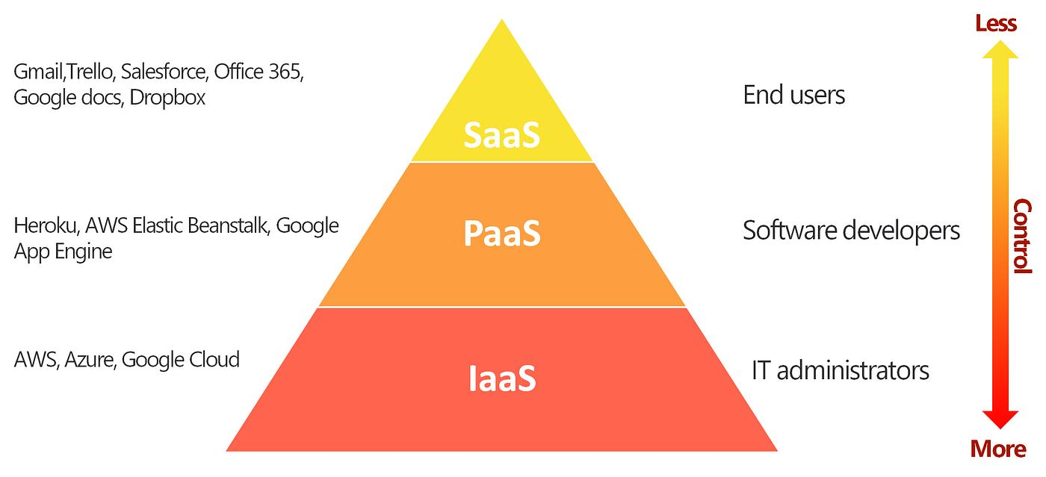
Real Provider Examples:
- Microsoft 365.
- Google Workspace.
- Salesforce.
3. Layer-Wise Responsibility Comparison
Cloud service models differ according to which responsibilities are handled by the cloud provider and which are handled by the customer.
The main layers are:
- Physical Hardware.
- Virtualization.
- Operating System.
- Middleware and Runtime.
- Application.
- Data.

Responsibility Table
Computing Layer | IaaS | PaaS | SaaS
Physical Hardware | Provider | Provider | Provider
Virtualization | Provider | Provider | Provider
Operating System | University | Provider | Provider
Middleware | University | Provider | Provider
Runtime Environment | University | Provider | Provider
Application | University | University | Provider
Data and Configuration | University | University | Shared responsibility
Explanation:
- IaaS: The provider manages physical servers and virtualization. The university manages the operating system, software and applications.
- PaaS: The provider manages infrastructure and the application platform. The university develops and manages its application and data.
- SaaS: The provider manages the complete software stack. The university manages users, access permissions and its data usage according to the service agreement.
Note: Data protection, identity management and security responsibilities remain shared even when using SaaS.
4. Categorisation of the Five University Applications
The university should use a combination of IaaS, PaaS and SaaS instead of selecting only one service model for all applications.
Proposed Categorisation
University Application | Recommended Service Model | Reason
Student Information System (SIS) | IaaS | Existing monolithic application can be migrated to virtual machines without major code changes.
Learning Management System (LMS) | PaaS | Supports application modernization, online learning features and scalable deployment.
Library Management System | PaaS | Supports web-based development, database integration and API connectivity.
Examination Portal | IaaS | Provides greater control over the existing examination application and its server resources.
Email System | SaaS | Eliminates the need to maintain dedicated email servers.
4.1 Student Information System (SIS) – IaaS
Reason for Selection:
The Student Information System stores important student information, including personal details, attendance, academic records and examination information.
Since the university's existing applications are monolithic, migrating SIS to IaaS is a suitable initial approach.
Implementation:
- Create virtual machines using cloud infrastructure.
- Install the required operating system.
- Migrate the existing SIS application.
- Configure database connectivity and security.
- Allocate CPU, memory and storage according to workload.
Justification:
IaaS allows the university to retain control over its operating system, application configuration and security settings. It also avoids the need to completely rewrite the existing application during initial migration.
4.2 Learning Management System (LMS) – PaaS
Reason for Selection:
The Learning Management System provides online classes, assignments, learning materials, assessments and communication between students and faculty.
It requires flexibility to support increasing numbers of users during online classes and examination periods.
Implementation:
- Deploy the LMS using a managed application platform.
- Connect it to a managed cloud database.
- Integrate REST APIs for mobile access.
- Enable automatic scaling where supported.
- Provide centralized application monitoring.
Justification:
PaaS reduces operating system and server maintenance. It allows developers to focus on LMS features rather than managing physical or virtual infrastructure.
4.3 Library Management System – PaaS
Reason for Selection:
The Library Management System handles book searching, availability, borrowing records and student access.
It can be modernized as a web-based application and integrated with the university mobile application.
Implementation:
- Deploy the library application on a PaaS platform.
- Connect it to a managed database.
- Develop REST APIs for book searching.
- Provide web and mobile access.
- Enable automatic application deployment.
Justification:
PaaS simplifies development and maintenance while supporting integration with other university services. It also makes it easier to update library features without managing the underlying operating system.
4.4 Examination Portal – IaaS
Reason for Selection:
The Examination Portal experiences heavy traffic during examination registration, online examinations and result publication.
It also requires control over application configurations, security and computing resources.
Implementation:
- Deploy the existing examination application on cloud virtual machines.
- Configure load balancing across application instances.
- Allocate additional CPU and memory during peak periods.
- Maintain database backups.
- Implement monitoring and disaster recovery.
Justification:
IaaS provides greater control over the existing examination application and its server environment. It is suitable for an initial migration without requiring major application modifications.
The university can later modernize selected examination components using PaaS and containers.
4.5 Email System – SaaS
Reason for Selection:
The existing university email system requires dedicated servers, storage, maintenance and security updates.
Managing email infrastructure internally increases operational costs.
Implementation:
- Migrate university email accounts to Microsoft 365 or Google Workspace.
- Configure university email domains.
- Create student and staff accounts.
- Configure access permissions and security policies.
- Enable spam filtering and email backup options.
Justification:
SaaS eliminates the need to maintain dedicated email servers. The provider manages the application, infrastructure and software updates, reducing the university's maintenance workload.

5. Comparison of IaaS, PaaS and SaaS
Factor | IaaS | PaaS | SaaS
Control | High | Medium | Low
Initial Cost | Relatively low compared with purchasing hardware | Relatively low | Low initial cost
Operating Cost | Depends on VM, storage and network usage | Depends on platform usage | Usually subscription-based
Scalability | Flexible, often requires configuration | Often provides managed scaling | Provider manages scaling
Maintenance | High | Medium | Low
Infrastructure Management | University manages OS and above | Provider manages infrastructure and platform | Provider manages complete application stack
Customization | High | Moderate to high | Limited to available features
Vendor Lock-in | Moderate | Potentially high | Potentially high
Suitable For | Existing applications and legacy systems | Application development and deployment | Ready-to-use software
Explanation of the Comparison
1. Control
- IaaS provides the highest control because the university manages operating systems and applications.
- PaaS provides control over application development but not the underlying platform.
- SaaS provides limited control because the provider manages the complete application.

2. Cost
- IaaS avoids purchasing physical servers but requires operating system and application administration.
- PaaS reduces infrastructure maintenance and development costs.
- SaaS reduces server maintenance costs through subscription-based software.
3. Scalability
- IaaS allows the university to increase VM capacity and deploy additional instances.
- PaaS provides managed scaling capabilities depending on the platform.
- SaaS providers manage the underlying application infrastructure and scaling.
4. Maintenance Effort
- IaaS requires the university to manage operating systems, middleware and application updates.
- PaaS reduces maintenance because the provider manages the infrastructure and platform.
- SaaS requires the least infrastructure maintenance because the provider manages the software.
5. Vendor Lock-in
Vendor lock-in occurs when moving applications or data from one cloud provider to another becomes difficult or expensive.
- IaaS generally offers more portability when standard operating systems and VM formats are used.
- PaaS may create dependency on provider-specific development tools and managed services.
- SaaS may create dependency on proprietary software, data formats and subscription arrangements.
The university should use standard APIs, maintain data export options and avoid unnecessary dependence on proprietary technologies.

6. Overall Recommendation for the University
The university should adopt a multi-service cloud strategy by combining IaaS, PaaS and SaaS.
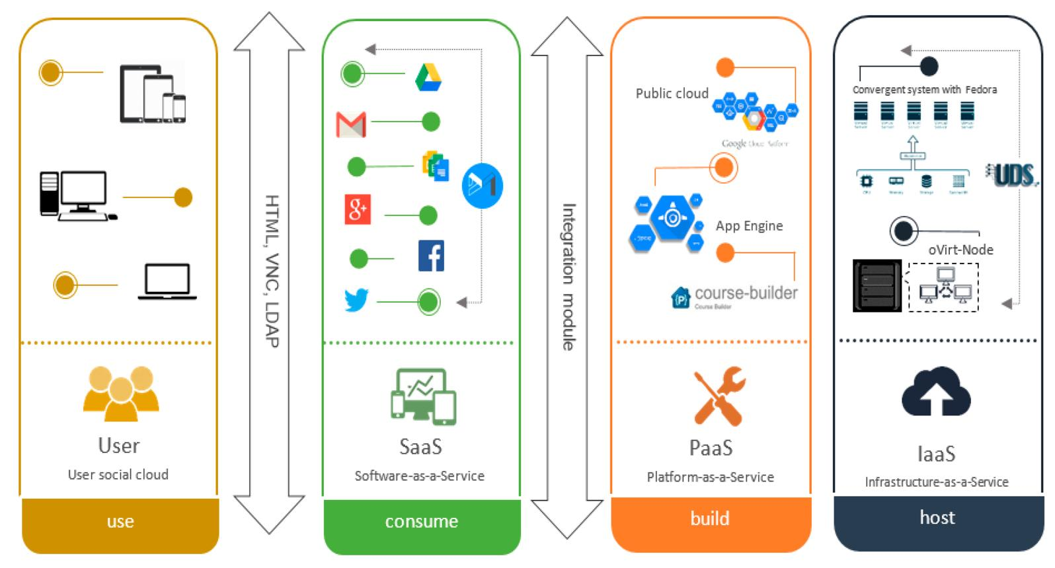
Recommended Implementation
Service Model | University Applications | Main Benefit
IaaS | SIS and Examination Portal | Supports existing applications with greater infrastructure control.
PaaS | LMS and Library System | Simplifies application development, integration and scaling.
SaaS | Email System | Reduces infrastructure maintenance and operational costs.
The migration should be performed gradually:
- Migrate SIS and Exam Portal to IaaS without major code modifications.
- Modernize LMS and Library applications using PaaS.
- Migrate the Email System to SaaS.
- Introduce REST APIs to connect all five applications.
- Implement centralized authentication and security.
- Monitor cloud usage to control operational costs.

7. Conclusion
IaaS, PaaS and SaaS provide different levels of control, flexibility and management in cloud computing.
For the university, IaaS is suitable for existing monolithic applications such as SIS and the Examination Portal because it provides greater control and supports migration without major code changes.
PaaS is suitable for the LMS and Library System because it simplifies application development, integration and deployment. SaaS is suitable for the Email System because it eliminates the need to maintain dedicated email infrastructure.
Therefore, combining all three service models provides a cost-effective, scalable and manageable cloud solution for the university.
Final Recommendation:
- SIS → IaaS
- LMS → PaaS
- Library System → PaaS
- Examination Portal → IaaS
- Email System → SaaS
This combination balances application compatibility, infrastructure control, scalability and maintenance costs while supporting the university's future mobile application and 40 affiliated colleges.

TASK 7 – Examine XaaS (3 Marks)
1. Introduction to XaaS (Anything as a Service)
XaaS stands for Anything as a Service. It is a cloud computing concept in which different IT resources, platforms, software, storage, security and other services are delivered over the internet on a subscription or pay-as-you-use basis.
Instead of purchasing and maintaining all IT resources, organizations can obtain the services they require from cloud service providers.
XaaS extends the traditional cloud service models (IaaS, PaaS and SaaS) by providing specialized services for specific business requirements.
University Scenario:
The university has approximately 25,000 students and 2,000 staff across four campuses. It needs reliable storage, mobile application support, database management, security and disaster recovery.
By adopting suitable XaaS offerings, the university can reduce infrastructure costs, improve service availability and simplify IT management.
2. Different Variants of XaaS
There are several types of XaaS that provide specialized cloud services.
2.1 DaaS (Desktop as a Service)
DaaS provides virtual desktop environments through the internet. Users can access their desktops and applications from different devices without requiring powerful local computers.
Features:
- Provides centrally managed virtual desktops.
- Supports remote access.
- Reduces local hardware requirements.
- Simplifies desktop updates and maintenance.
University Application:
Students and faculty members can access virtual computer laboratories from laptops or other devices. They can use required academic software without installing it on their personal computers.
2.2 BaaS / MBaaS (Backend as a Service / Mobile Backend as a Service)
MBaaS provides ready-made backend services for mobile applications.
Features:
- Provides user authentication.
- Supports cloud database connectivity.
- Provides push notifications.
- Supports file storage and application APIs.
- Reduces backend development effort.
University Application:
The university can use MBaaS to develop its student mobile application. Students can log in, check results, receive examination notifications and view fee details.
2.3 FaaS (Function as a Service)
FaaS allows developers to execute individual functions in response to events without managing servers.
It is commonly associated with serverless computing.
Features:
- Executes code when triggered by events.
- Automatically manages execution infrastructure.
- Scales according to incoming requests.
- Charges are generally based on execution and resource consumption.
University Application:
When examination results are published, a cloud function can automatically generate notifications and send result alerts to registered students.
2.4 DBaaS (Database as a Service)
DBaaS provides managed database services through the cloud without requiring organizations to maintain database servers.
Features:
- Provides managed database infrastructure.
- Supports automated backups.
- Simplifies database maintenance.
- Offers monitoring and scaling features.
- Reduces database administration workload.
University Application:
The university can store student records, examination results, library information and fee transactions using managed cloud databases.
2.5 Security as a Service (SECaaS)
Security as a Service provides security solutions through cloud-based platforms.
Features:
- Provides threat detection.
- Supports identity and access management.
- Provides firewall and network security services.
- Supports malware protection and security monitoring.
- Helps protect sensitive information.
University Application:
The university can use cloud-based security services to protect student records, staff accounts, online examination systems and payment transactions.
2.6 DRaaS (Disaster Recovery as a Service)
DRaaS provides cloud-based disaster recovery solutions that help restore applications and data after unexpected failures.
Features:
- Provides cloud-based data replication.
- Supports backup and recovery.
- Helps restore applications after disasters.
- Reduces dependence on a secondary physical data centre.
- Improves business continuity.
University Application:
Since the university currently has no disaster recovery site, DRaaS can protect important student records, examination information and academic applications against server failures or data-centre disasters.
3. Two Recommended XaaS Offerings for the University
Among the different XaaS variants, the following two offerings would provide significant benefits to the university.
3.1 DBaaS (Database as a Service)
Recommended XaaS 1
Reason for Selection:
The university manages approximately 25,000 students and 2,000 staff across four campuses. Its applications generate and maintain large amounts of information, including student records, examination results, library details and fee transactions.
Managing separate physical database servers increases maintenance costs and creates difficulties during peak workloads.
Proposed Implementation:
- Migrate university databases to a managed cloud database.
- Configure automated backups.
- Enable database monitoring.
- Use replication for improved availability.
- Configure access permissions for different departments.
- Scale database resources according to workload.
Benefits:
- Reduces database server maintenance.
- Supports centralized data management.
- Provides automated backup facilities.
- Improves database availability.
- Supports increasing numbers of students and affiliated colleges.
- Reduces the need to purchase additional database hardware.
Real Provider Examples:
- Amazon RDS.
- Microsoft Azure SQL Database.
- Google Cloud SQL.
Justification: DBaaS is suitable because the university requires reliable, scalable database management for its SIS, LMS, Library and Examination Portal without maintaining dedicated database infrastructure.
3.2 DRaaS (Disaster Recovery as a Service)
Recommended XaaS 2
Reason for Selection:
The university currently operates a single on-premise data centre without a disaster recovery site.
If the data centre experiences hardware failure, power failure, cyberattacks or natural disasters, important university applications may become unavailable.
This can interrupt admissions, online examinations, result publication and student services.
Proposed Implementation:
- Replicate critical application data to cloud storage.
- Maintain backups of important university databases.
- Configure recovery procedures for critical applications.
- Test disaster recovery regularly.
- Establish recovery time and recovery point objectives.
Benefits:
- Protects important university data.
- Reduces downtime after unexpected failures.
- Improves business continuity.
- Avoids the need to construct a separate physical disaster recovery centre.
- Supports recovery of critical applications.
- Improves availability of university services.
Real Provider Examples:
- AWS Elastic Disaster Recovery.
- Azure Site Recovery.
- Google Cloud disaster recovery solutions.
Justification: DRaaS is suitable because the university has no existing disaster recovery site. It provides an alternative recovery environment and helps maintain critical services during unexpected failures.
4. Comparison of the Two Selected XaaS Offerings
Factor | DBaaS | DRaaS
Main Purpose | Managed database services | Disaster recovery
Primary Use | Store and manage university data | Restore applications and data after failures
Maintenance | Provider manages database infrastructure | Provider manages recovery infrastructure and services
Scalability | Supports increasing database workloads | Supports recovery capacity requirements
Cost Benefit | Reduces database administration and hardware costs | Avoids building a separate physical recovery site
University Application | SIS, LMS, Library and Exam Portal databases | Recovery of university applications and records
5. Risks of Over-Reliance on Multiple XaaS Providers
Although XaaS provides several advantages, depending heavily on multiple service providers can introduce certain risks.
Risk | Explanation | Possible Solution
Vendor Lock-in | Moving data and applications between providers may be difficult. | Use standard formats and APIs.
Security Risks | Student information may be stored across multiple external platforms. | Implement encryption and strict access control.
Service Dependency | Failure of a provider may interrupt university services. | Maintain backup and alternative recovery arrangements.
Integration Complexity | Different providers may use different technologies and interfaces. | Use standard APIs and centralized integration.
Cost Management | Multiple subscriptions and usage charges may increase expenditure. | Monitor usage and review provider costs regularly.
Data Privacy | Sensitive student information may be exposed through incorrect configurations or unauthorized access. | Apply data protection policies and regular security audits.
Network Dependency | Cloud services require reliable internet connectivity. | Maintain redundant network connections.
Explanation of Major Risks
1. Vendor Lock-in
If the university uses different proprietary platforms, transferring applications and databases to another provider may become expensive and complicated.
Solution: Use open standards, portable databases and standard REST APIs.
2. Security and Privacy Risks
Student records, examination results and payment information are sensitive. Using multiple providers increases the number of systems and access points that must be secured.
Solution: Implement encryption, multi-factor authentication, role-based access control and regular security audits.
3. Service Dependency
If a cloud provider experiences an outage, the university's dependent applications may become unavailable.
Solution: Maintain independent backups, recovery arrangements and alternative access procedures.
4. Cost Management
Using several XaaS providers may result in unexpected subscription, storage, network and data-transfer costs.
Solution: Monitor resource usage, establish budgets and regularly evaluate service subscriptions.
6. Conclusion
XaaS (Anything as a Service) extends cloud computing by providing specialized services such as DaaS, MBaaS, FaaS, DBaaS, Security as a Service and DRaaS.
For the university, DBaaS and DRaaS are the two most beneficial offerings. DBaaS simplifies database management and supports increasing data requirements, while DRaaS provides disaster recovery capabilities and protects critical university information.
However, excessive dependence on multiple service providers can introduce vendor lock-in, security risks, integration difficulties and unexpected costs.
Therefore, the university should adopt XaaS carefully by selecting reliable providers, implementing security controls and monitoring service usage.
Final Recommendation:
- DBaaS: For scalable and managed university databases.
- DRaaS: For disaster recovery and business continuity.
These two services will improve data management, reliability, availability and operational efficiency while supporting the university's future cloud expansion.

TASK 8 – Design the Cloud Solution Architecture (5 Marks)
1. Introduction
The university currently operates 12 physical servers in a single on-premise data centre. These servers support the Student Information System (SIS), Learning Management System (LMS), Library System, Examination Portal and Email System.
The existing infrastructure suffers from low average CPU utilization, high maintenance costs, slow server procurement, limited scalability and the absence of a disaster recovery site.
To overcome these problems, a hybrid cloud architecture is proposed by combining virtualization, web services, IaaS, PaaS, SaaS and XaaS.
The proposed architecture will support approximately 25,000 students, 2,000 staff members and 40 affiliated colleges while providing scalability, security, availability and cost efficiency.

2. Proposed Cloud Architecture Diagram
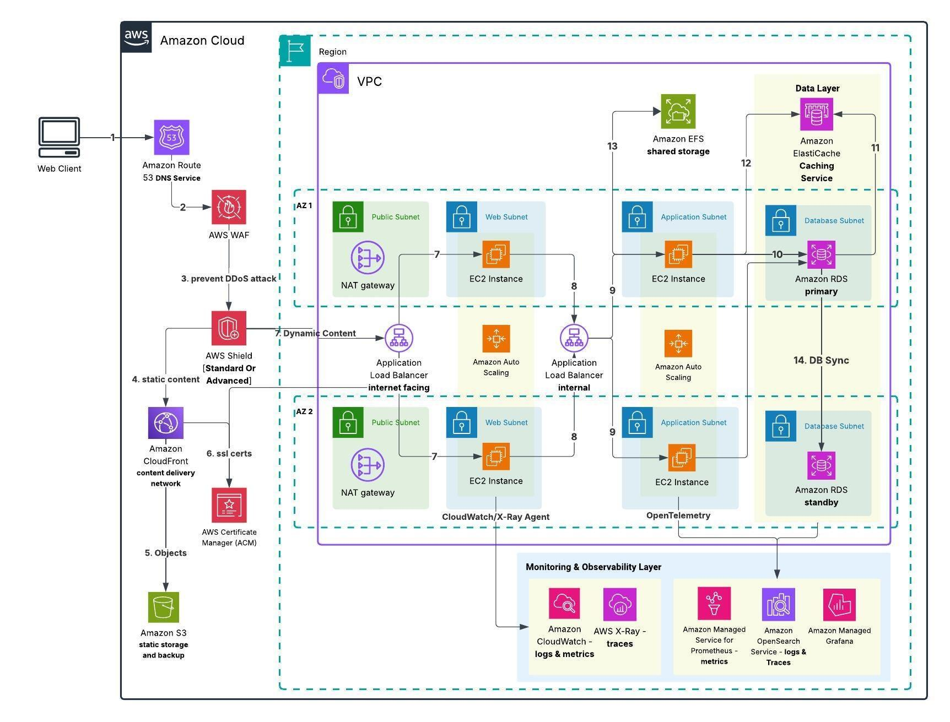
Architecture Components and Data Flow
The proposed architecture consists of the following layers:
- User Layer: Students, faculty, administrators and affiliated colleges access university services through browsers and mobile applications.
- Internet and Security Layer: HTTPS, firewall and Web Application Firewall (WAF) protect incoming traffic.
- Load Balancer: Distributes incoming requests across multiple application instances.
- API Gateway Layer: Manages REST API requests, authentication, authorization and communication with university services.
- Web and Application Layer: Runs SIS, LMS, Library and Exam Portal applications using virtual machines and containers.
- Database Layer: Stores student information, examination results, library records and fee transactions.
- Storage Layer: Stores documents, assignments, examination files, backups and other university data.
- Disaster Recovery Layer: Maintains replicated data and recovery resources in a separate cloud region.
Working of the Architecture
- Students and staff access university applications using browsers or mobile applications.
- Affiliated colleges access authorized university functions through REST APIs.
- Incoming requests pass through security controls and the load balancer.
- The API Gateway forwards requests to the appropriate application service.
- Application servers communicate with managed databases and cloud storage.
- Auto-scaling increases or decreases application resources according to demand.
- Critical data is backed up and replicated to a separate disaster recovery region.
3. Deployment Model Selection
The recommended deployment model is Hybrid Cloud.
A hybrid cloud combines private cloud infrastructure with public cloud services, allowing an organization to use both environments according to its requirements.
Why Hybrid Cloud Is Suitable
- The university can maintain sensitive student records using controlled cloud environments.
- Public cloud resources can support applications with changing workloads.
- SaaS can be used for email and other ready-made services.
- Cloud resources can be increased during admissions and examination periods.
- Disaster recovery can be maintained in a separate public cloud region.

Proposed Deployment
Environment | University Usage | Justification
Private Cloud | Sensitive university applications and restricted databases | Provides greater control over sensitive information.
Public Cloud | Web applications, APIs, auto-scaling and storage | Provides flexible resources and pay-as-you-use pricing.
Hybrid Cloud | Integration of private and public cloud resources | Balances security, flexibility and cost.
Recommendation: Use a hybrid cloud with public-cloud infrastructure and managed services, while keeping sensitive data and access policies under university control. A separate private cloud should be maintained only where regulatory, security or existing infrastructure requirements justify its cost.
4. Service Model Selection for Each Architecture Component
Different architecture components require different cloud service models.
Architecture Component | Selected Service Model | Technology / Example | Purpose
Physical Infrastructure | IaaS | AWS EC2 / Azure Virtual Machines | Provides virtual computing resources.
Hypervisor and Virtual Machines | IaaS | VMware ESXi / KVM | Runs multiple isolated virtual machines.
Web and Application Tier | IaaS / PaaS | Virtual machines and managed application hosting | Runs university applications.
API Gateway | PaaS | Amazon API Gateway / Azure API Management | Manages REST API communication.
Container Platform | PaaS | Amazon ECS / Azure Kubernetes Service | Runs scalable containerized services.
Database Tier | DBaaS | Amazon RDS / Azure SQL Database | Stores and manages university records.
Cloud Storage | IaaS / Storage-as-a-Service | Amazon S3 / Azure Blob Storage | Stores documents and backups.
Email System | SaaS | Microsoft 365 / Google Workspace | Provides university email services.
Disaster Recovery | DRaaS | AWS Elastic Disaster Recovery / Azure Site Recovery | Supports application and data recovery.
Security | Security-as-a-Service | Cloud WAF and security monitoring services | Protects university applications and information.
Explanation of Component Selection
1. User Layer – SaaS
Users access ready-to-use services such as email and online learning applications through browsers or mobile applications.
2. Web and Application Layer – IaaS and PaaS
Existing monolithic applications such as SIS and the Examination Portal can initially run on IaaS virtual machines. New mobile application backends and API services can run on PaaS or managed container platforms.
This approach avoids rewriting all existing applications immediately.
3. API Gateway – PaaS
A managed API Gateway provides a centralized entry point for mobile applications and affiliated colleges. It handles API routing, authentication, authorization and rate limiting.
4. Database Tier – DBaaS
Managed databases reduce the university's database administration workload. They support automated backups, monitoring, replication and scaling.
5. Storage Tier – Storage as a Service
Cloud object storage can store student documents, assignments, examination files, application logs and backups.
6. Disaster Recovery – DRaaS
DRaaS provides recovery infrastructure in another cloud region and helps restore important applications when the primary environment fails.
5. Virtualization and Application Deployment
The university should consolidate its existing 12 physical servers using server virtualization.
Proposed Virtualization Plan
- Deploy Type-1 hypervisors on suitable physical hosts or use cloud virtual machines.
- Migrate existing SIS, LMS, Library and Exam Portal applications into separate VMs initially.
- Use containers for newly developed REST APIs and mobile application services.
- Use managed cloud databases instead of maintaining unnecessary dedicated database servers.
- Implement centralized monitoring and resource allocation.
Application Deployment Strategy
Application | Deployment Technology | Reason
Student Information System | Virtual Machine (IaaS) | Supports existing monolithic application.
Learning Management System | VM initially, then PaaS | Supports gradual modernization and scaling.
Library System | PaaS / Containers | Supports API integration and independent deployment.
Examination Portal | Virtual Machine (IaaS) | Provides control over the existing application.
Email System | SaaS | Reduces email infrastructure maintenance.
Mobile Application Backend | Containers / PaaS | Supports flexible deployment and scaling.
Student and College APIs | Containers / PaaS | Supports independent services and API integration.
Justification: This combination allows the university to migrate existing applications without major modifications while developing modern, scalable services for mobile users and affiliated colleges.
6. Elasticity and Auto-Scaling Mechanism
Elasticity is the ability of cloud infrastructure to automatically increase or decrease computing resources according to workload requirements.
The university experiences heavy traffic during:
- Student admissions.
- Examination registration.
- Online examinations.
- Result publication.
- Fee-payment deadlines.
The proposed architecture uses auto-scaling and load balancing to handle these traffic variations.
Working of Auto-Scaling
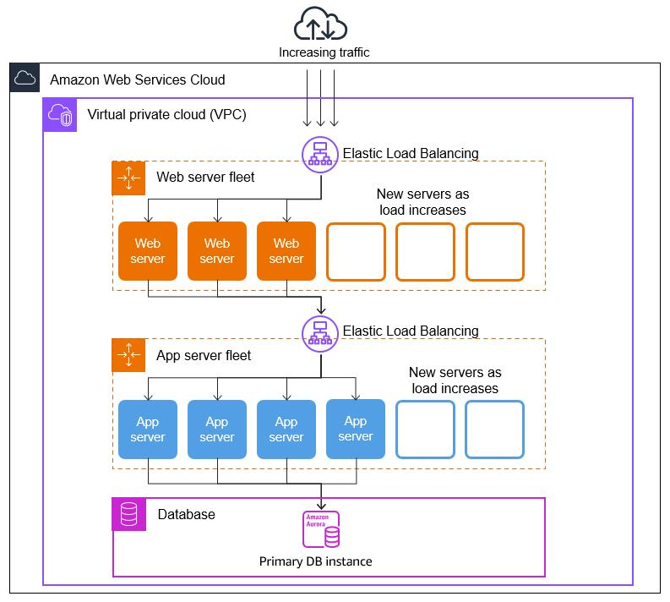
- Students and staff send requests to university applications.
- The load balancer distributes requests across available application instances.
- Monitoring services continuously measure CPU utilization, memory usage and request traffic.
- When resource utilization exceeds predefined thresholds, additional application instances are launched.
- When demand decreases, unnecessary instances are removed.
- The load balancer automatically distributes traffic across the available instances.
Example Auto-Scaling Configuration
The following values are illustrative configuration targets, not measured university performance.
Workload Condition | CPU Utilization | Auto-Scaling Action
Normal Period | Below 40% | Maintain minimum instances.
Moderate Traffic | 40–60% | Monitor resource demand.
High Traffic | Above 60% | Add application instances.
Critical Traffic | Above 80% | Scale out rapidly and trigger alerts.
Low Traffic | Below 30% | Remove unnecessary instances gradually.
Benefits During Peak Periods
Admissions Period:
When thousands of students submit admission applications simultaneously, auto-scaling launches additional web and application instances to handle the requests.
Examination Period:
During online examinations, additional application resources are allocated to maintain responsiveness and prevent server overload.
Result Publication:
When examination results are announced, load balancing distributes requests across multiple application instances to prevent a single server from becoming overloaded.

Advantages
- Handles sudden increases in user traffic.
- Reduces the need to purchase permanent hardware.
- Improves application responsiveness.
- Prevents unnecessary resource consumption during low-demand periods.
- Supports the university's future expansion.
Recommendation: Configure auto-scaling with suitable minimum and maximum instance limits, health checks and scheduled capacity increases before predictable admission and examination peaks.
7. Security and Availability Measures
The university stores sensitive information such as student records, examination results, staff details and fee transactions. Therefore, security and availability must be important parts of the proposed architecture.
7.1 Access Control and Authentication
- Implement Role-Based Access Control (RBAC).
- Provide separate access permissions for students, faculty and administrators.
- Use Multi-Factor Authentication (MFA) for privileged accounts.
- Use OAuth 2.0 for API authentication and authorization.
- Restrict affiliated colleges to their authorized student records.
Justification: Prevents unauthorized users from accessing confidential university information.
7.2 Data Encryption
- Use HTTPS with TLS to protect data during transmission.
- Encrypt databases and storage at rest.
- Securely manage encryption keys.
- Protect payment information using secure payment gateway integration.
Justification: Prevents unauthorized access to sensitive student and financial information.
7.3 Backup and Recovery
- Schedule automatic database backups.
- Maintain independent copies of important university data.
- Replicate critical information to a separate recovery region.
- Test backup restoration regularly.
- Define Recovery Time Objective (RTO) and Recovery Point Objective (RPO).
Justification: Protects university information against accidental deletion, hardware failure and cyberattacks.
7.4 Multi-Zone Deployment
The university should deploy critical application instances across multiple availability zones within the primary cloud region.
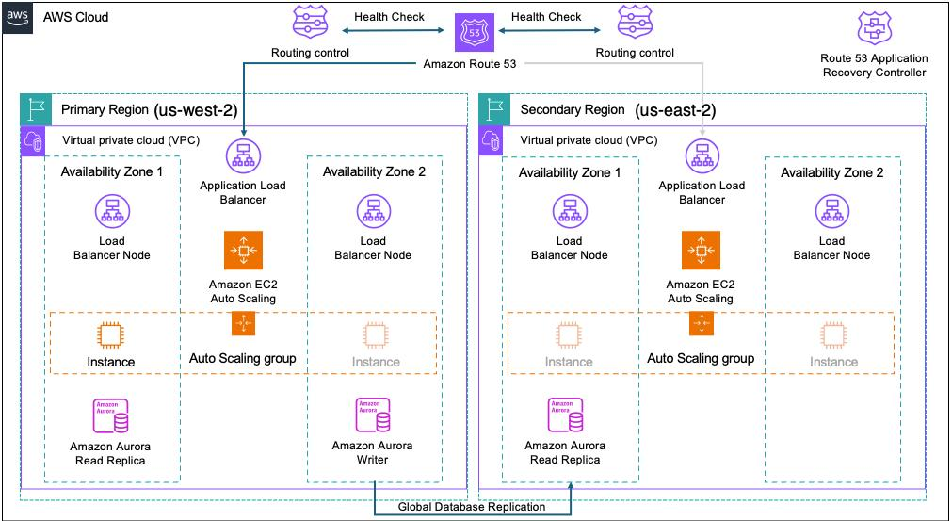
Working:
- Deploy application instances in at least two availability zones.
- Distribute requests using a load balancer.
- Maintain database replication between availability zones.
- Monitor the health of application instances.
- Automatically redirect traffic when an instance or zone becomes unavailable.
Justification: If one availability zone fails, the other zone can continue serving university users.
7.5 Disaster Recovery Region
The university should maintain a separate disaster recovery region containing replicated data and recovery resources.
If the primary cloud region becomes unavailable, critical applications can be restored in the recovery region.
Justification: Provides business continuity and reduces the risk of losing important university information.
Security and Availability Summary
Measure | Implementation | Expected Benefit
Authentication | MFA and OAuth 2.0 | Secure user access.
Authorization | Role-Based Access Control | Restricts unauthorized access.
Encryption | TLS and encryption at rest | Protects sensitive data.
Backup | Automated cloud backups | Supports data recovery.
Multi-Zone Deployment | Applications across two or more zones | Reduces service interruptions.
Load Balancing | Distributes incoming requests | Prevents server overload.
Auto-Scaling | Automatically adjusts resources | Handles peak workloads.
Disaster Recovery | Separate cloud recovery region | Supports business continuity.
Monitoring | Centralized logging and alerts | Detects failures and security threats.
8. Availability Requirement – 99.9%
The university requires 99.9% service availability.
This means the total allowable downtime is approximately:
Annual downtime = 365 × 24 × 60 × (100% − 99.9%)
Annual downtime = 525,600 × 0.001
Annual downtime = 525.6 minutes
Annual downtime = 8.76 hours
Therefore, the proposed architecture should be designed to achieve at least 99.9% availability through multi-zone deployment, load balancing, monitoring, backups and disaster recovery.
The actual availability depends on the cloud provider's service-level agreements, application design and recovery configuration.
9. Final Proposed Architecture – Component Justification
Component | Proposed Solution | Main Justification
User Access | Browser and Mobile Application | Supports access across four campuses and affiliated colleges.
Deployment Model | Hybrid Cloud | Balances control, flexibility and cost.
Virtualization | Type-1 Hypervisor and VMs | Consolidates existing server workloads.
Load Balancer | Managed Cloud Load Balancer | Distributes traffic across application instances.
Web/Application Tier | IaaS and PaaS | Supports existing and modernized applications.
API Layer | REST APIs and API Gateway | Enables mobile and college integration.
Database Tier | DBaaS | Provides managed and scalable database services.
Storage | Cloud Object Storage | Stores documents and backups.
Email | SaaS | Reduces email server maintenance.
Security | Security-as-a-Service | Protects university applications and records.
Auto-Scaling | Cloud Auto-Scaling | Handles admissions and examination traffic.
DR Region | DRaaS | Provides recovery during major failures.
10. Conclusion
The proposed hybrid cloud architecture combines server virtualization, RESTful web services, API Gateway, IaaS, PaaS, SaaS and XaaS to modernize the university's IT infrastructure.
Virtualization reduces physical server requirements, while web services enable communication between university applications, mobile devices and 40 affiliated colleges.
IaaS supports existing monolithic applications, PaaS supports modern application development, and SaaS reduces infrastructure maintenance. DBaaS and DRaaS improve database management and disaster recovery.
Auto-scaling, load balancing, multi-zone deployment, encryption and access control help the university handle peak workloads while targeting 99.9% availability.
Final Recommendation: Adopt a hybrid cloud architecture with scalable application services, managed databases, secure REST APIs and a separate disaster recovery region. This solution provides a flexible, secure and cost-effective foundation for the university's future growth.
TASK 9 – Hands-on Implementation and Documentation
1. Aim
To implement a small proof-of-concept of the proposed hybrid cloud architecture by creating a Docker-based REST API for a university function and deploying a static web page using GitHub Pages.
2. Selected Implementation
For this proof-of-concept, the Student Information Service is selected. Students can enter their student ID and retrieve basic student details through a REST API.
Component | Technology | Purpose
Virtualization | Docker | Runs the application inside a container
Backend | Python Flask | Provides REST API functionality
API format | JSON | Transfers student information
Client | Web browser / curl | Tests the API
PaaS-style hosting component | GitHub Pages | Hosts a static web page
Operating system | Windows 10/11 | Development environment
Why this approach? Docker is free to use for this local demonstration, and GitHub Pages provides free static website hosting. This demonstrates container-based deployment and a managed cloud hosting component without requiring a paid cloud account.
3. Architecture Diagram
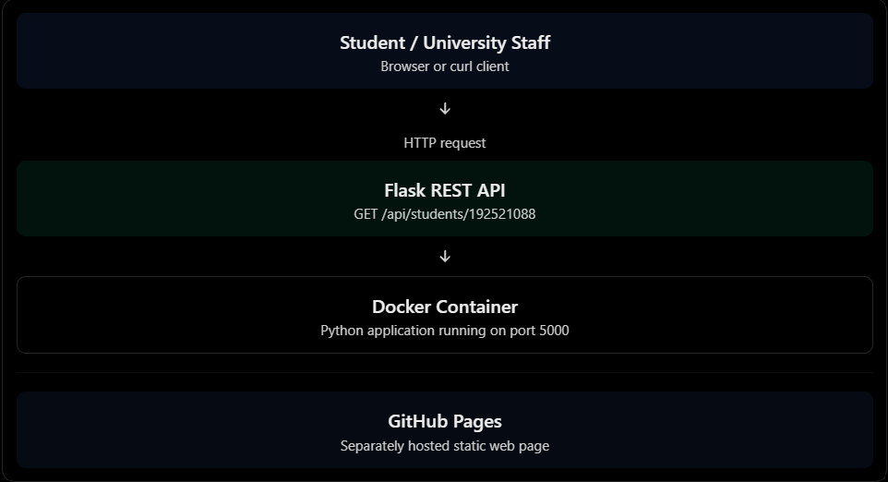
4. Software Requirements
- Python 3.10 or later
- Docker Desktop
- Visual Studio Code or any text editor
- Web browser
- GitHub account
- Internet connection for GitHub Pages deployment
5. Implementation and Configuration Steps
Step 1: Create the project folder
Create a folder named University-Student-API.
Inside it, create the following files:
University-Student-API/
│
├── app.py
├── requirements.txt
├── Dockerfile
└── index.html

Step 2: Develop the REST API
Create app.py and enter the following Python code.
from flask import Flask, jsonify

app = Flask(__name__)

students = {
"192521088": {
"name": "Student One",
"department": "Computer Science",
"year": "Third Year",
"status": "Active"
},
"192521089": {
"name": "Student Two",
"department": "Information Technology",
"year": "Third Year",
"status": "Active"
}
}

@app.route("/")
def home():
return jsonify({
"message": "University Student Information API",
"status": "Running"
})

@app.route("/api/students/<student_id>", methods=["GET"])
def get_student(student_id):
student = students.get(student_id)

if student:
return jsonify({
"student_id": student_id,
"student_details": student
}), 200

return jsonify({
"error": "Student not found"
}), 404

if __name__ == "__main__":
app.run(host="0.0.0.0", port=5000)
Explanation:
- Flask is used to develop the REST API.
- The application stores sample student details.
- The GET method retrieves student information.
- The API returns the response in JSON format.
- If the student ID does not exist, the API returns a 404 error.
Note: The student records are sample data created for demonstration. They are not connected to the university's actual student database.
Step 3: Create the requirements file
Create requirements.txt.
Flask==3.1.1
This file specifies the Python dependency required to execute the application.
Step 4: Create the Dockerfile
Create a file named Dockerfile.
FROM python:3.12-slim

WORKDIR /app

COPY requirements.txt .

RUN pip install --no-cache-dir -r requirements.txt

COPY app.py .

EXPOSE 5000

CMD ["python", "app.py"]
Explanation:
- FROM selects the Python base image.
- WORKDIR creates the working directory.
- COPY transfers application files into the container.
- RUN installs Flask.
- EXPOSE documents the application port.
- CMD starts the Flask application.
Step 5: Build the Docker image
Open the terminal inside the project folder and execute:
docker build -t university-student-api .
This command creates a Docker image named university-student-api.
To verify the image:
docker images
Step 6: Run the Docker container
Execute:
docker run -d -p 5000:5000 --name student-api university-student-api
The application will run inside the Docker container.
To check whether the container is running:
docker ps
Expected: A running container named student-api with port mapping 5000:5000.
Step 7: Test the REST API
Open a browser and enter:
http://localhost:5000/
Expected response:
{
"message": "University Student Information API",
"status": "Running"
}
Now test the student information endpoint:
http://localhost:5000/api/students/192521088
Expected response:
{
"student_id": "192521088",
"student_details": {
"name": "Student One",
"department": "Computer Science",
"year": "Third Year",
"status": "Active"
}
}
You can also test using curl:
curl http://localhost:5000/api/students/192521088
Test an invalid student ID:
curl http://localhost:5000/api/students/123456789
Expected response:
{
"error": "Student not found"
}
The invalid request should return HTTP status code 404.
6. Deploy the Static Website Using GitHub Pages
GitHub Pages is used as the managed static website hosting component in this proof-of-concept.
Create index.html with the following code:
<!DOCTYPE html>
<html>
<head>
<title>University Student Portal</title>
</head>
<body>
<h1>University Student Information Portal</h1>
<p>Proof-of-concept static website hosted using GitHub Pages.</p>
<p>Student information is provided through the REST API.</p>
</body>
</html>
Deployment steps:
- Log in to your GitHub account.
- Create a new repository named university-student-portal.
- Upload the index.html file.
- Open the repository's Settings.
- Select Pages from the sidebar.
- Under Build and deployment, select Deploy from a branch.
- Select the main branch and / (root) folder.
- Save the settings.
- Wait for GitHub Pages to publish the website.
- Open the published website link displayed in the Pages settings.
The GitHub Pages website and the local Docker API are separate deployments in this demonstration. The static website does not automatically connect to the local API.
7. Testing and Expected Results
Test case | Input / Action | Expected result | Status to record
API availability | Open / | API running message | Record after testing
Valid student | Enter ID 192521088 | Student details in JSON | Record after testing
Invalid student | Enter ID 123456789 | Student not found, HTTP 404 | Record after testing
Docker deployment | Execute docker ps | Container shown as running | Record after testing
Static website | Open GitHub Pages URL | University portal page displayed | Record after deployment
Sample test output
Expected successful response
HTTP Status: 200 OK

Student ID: 192521088
Name: Student One
Department: Computer Science
Year: Third Year
Status: Active
Expected error response
HTTP Status: 404 Not Found

{
"error": "Student not found"
}
These are expected outputs. Run the commands and replace the examples with your actual results before submitting.
8. Screenshots and Evidence
The following screenshots should be captured from your own system after completing the implementation.
Screenshot | What to capture | Suggested caption
1 | Project folder and source files in VS Code | Figure 1: Project structure
2 | Docker image build completed in terminal | Figure 2: Docker image creation
3 | docker ps showing the running container | Figure 3: Container deployment
4 | Browser showing the API home response | Figure 4: API availability test
5 | Browser showing valid student JSON response | Figure 5: Successful REST API request
6 | Browser or terminal showing 404 response | Figure 6: Invalid student ID test
7 | GitHub Pages website open in browser | Figure 7: Static website deployment
Important: Do not use sample outputs as screenshots. Capture the actual output from your computer and insert it under the corresponding figure caption. You can use Snipping Tool (Win + Shift + S) on Windows.

9. Issues Faced and Solutions
The following are possible issues and solutions. Include only the issues you actually encounter.
Issue | Possible reason | Solution
Docker command not recognized | Docker is not installed or running | Install and start Docker Desktop
Port 5000 already in use | Another application uses the port | Use -p 5001:5000 and access port 5001
Flask module not found | Dependency not installed | Rebuild the Docker image
Container exits immediately | Application startup error | Check logs using docker logs student-api
GitHub Pages not displaying | Deployment is still processing or configuration is incorrect | Check repository Pages settings and deployment status
To inspect application logs:
docker logs student-api
To stop the container:
docker stop student-api
10. Result
A proof-of-concept University Student Information System was designed and prepared using Python Flask and Docker. A REST API was created to retrieve student information using student IDs. The application was configured to run inside a Docker container, and GitHub Pages was selected to host a separate static university portal page.
The implementation demonstrates container-based virtualization, REST web services, JSON data exchange, API testing, and managed static website hosting. It provides a basic practical example of how the proposed university cloud architecture can be implemented.

TASK 10 – Evaluate and Recommend the Final Solution
1. Introduction
The university currently operates its Student Information System (SIS), Learning Management System (LMS), Library System, Examination Portal and Email System using ageing physical servers in a single on-premise data centre.
The existing infrastructure has several limitations:
- Twelve physical servers operate at an average CPU utilization of only 15%.
- CPU utilization exceeds 95% during admissions and examinations.
- Purchasing and installing new servers takes approximately 6–8 weeks.
- The university does not have a separate disaster recovery site.
- Monolithic applications make integration with mobile applications and affiliated colleges difficult.
- High initial infrastructure costs increase the university's capital expenditure.
To overcome these limitations, three deployment approaches are evaluated: traditional on-premise infrastructure, IaaS-based cloud infrastructure and PaaS/SaaS-based cloud infrastructure.
2. Comparison of Cloud Deployment Options
2.1 On-Premise Infrastructure
In the on-premise approach, the university purchases and maintains its own physical servers, storage devices, networking equipment and software.
Advantages:
- Complete physical control over infrastructure.
- Direct control over data storage and security policies.
- Existing applications can continue running without major modifications.
- No dependency on an external cloud provider for basic infrastructure operations.
Disadvantages:
- High initial capital expenditure for purchasing servers.
- Hardware maintenance and replacement require additional costs.
- Scaling resources during admissions and examinations is difficult.
- Establishing a separate disaster recovery site increases expenses.
- University IT staff must manage hardware, operating systems, backups and security.
2.2 IaaS-Based Cloud Infrastructure
Infrastructure as a Service provides virtual machines, storage, networking and computing resources through a cloud provider.
Examples include Amazon EC2, Microsoft Azure Virtual Machines and Google Compute Engine.
Advantages:
- No need to purchase physical servers.
- Virtual machines can be created whenever required.
- Computing resources can be increased or decreased based on demand.
- Infrastructure can be distributed across multiple availability zones.
- The university retains control over operating systems and applications.
Disadvantages:
- The university remains responsible for operating system updates and application maintenance.
- Poor resource management can increase monthly cloud bills.
- Migration of legacy applications may require configuration changes.
- Cloud security configuration requires technical expertise.
2.3 PaaS/SaaS-Based Cloud Infrastructure
Platform as a Service provides managed application development and deployment environments. Software as a Service provides ready-to-use software applications through the internet.
Examples include Azure App Service, AWS Elastic Beanstalk, Amazon RDS, Microsoft 365 and Google Workspace.
Advantages:
- Reduced infrastructure maintenance.
- Automatic platform updates and managed services.
- Faster application development and deployment.
- Easier scaling during peak periods.
- Reduced administrative workload for university IT staff.
Disadvantages:
- Less control over the underlying infrastructure.
- Potential vendor lock-in.
- Subscription and usage charges may increase over time.
- Data migration between providers may be complex.
- Dependence on provider availability and service-level agreements.
2.4 Overall Comparison
Evaluation factor | On-premise | IaaS | PaaS/SaaS
Cost model | High CapEx | Mainly OpEx | Mainly OpEx
Initial investment | Very high | Low | Low
Scalability | Limited | High | Very high for managed services
Availability | Depends on local infrastructure | Multi-zone deployment possible | Provider-managed availability options
Security control | High physical control | Shared responsibility | Shared responsibility with less infrastructure control
Maintenance | University manages everything | Shared between provider and university | Provider manages more of the platform
Deployment speed | Slow | Fast | Very fast
Disaster recovery | Requires separate infrastructure | Cloud-based DR possible | Managed backup and recovery options
Technical effort | High | Medium to high | Low to medium
Vendor dependency | Hardware and software vendors | Cloud provider | Greater platform/service dependency
Analysis: On-premise infrastructure provides greater physical control but does not solve the university's scalability and disaster recovery problems economically. IaaS provides flexibility while preserving control over legacy applications. PaaS and SaaS reduce maintenance effort and are suitable for applications that can use managed services.
Therefore, a hybrid cloud architecture combining IaaS, PaaS and SaaS is more suitable than adopting only one service model.
3. Three-Year Cost Comparison
A simplified three-year financial comparison is prepared to evaluate the three infrastructure approaches.
The estimates are illustrative planning assumptions, not actual quotations from AWS, Azure or Google Cloud. Actual costs depend on application size, database capacity, storage, network traffic, licensing, support plans and regional pricing.
3.1 Assumptions
The following assumptions are considered:
- The university has approximately 25,000 students and 2,000 staff.
- The existing infrastructure consists of 12 physical servers.
- The university requires computing resources for SIS, LMS, Library, Examination Portal and Email.
- The university must support increased traffic during admissions and examinations.
- A disaster recovery solution is required.
- The comparison covers a three-year period.
- All values are estimated in Indian Rupees (INR).
3.2 Estimated On-Premise Cost
Cost component | Estimated cost
Purchase of 12 physical servers | ₹36,00,000
Storage and networking equipment | ₹12,00,000
Initial installation and setup | ₹4,00,000
Backup and disaster recovery infrastructure | ₹10,00,000
Initial CapEx | ₹62,00,000
Annual maintenance and support | ₹6,00,000
Annual electricity and cooling | ₹3,00,000
Annual IT infrastructure administration | ₹6,00,000
Three-year recurring cost:
Annual recurring cost = ₹6,00,000 + ₹3,00,000 + ₹6,00,000
Annual recurring cost = ₹15,00,000
Three-year recurring cost = ₹15,00,000 × 3
Three-year recurring cost = ₹45,00,000
Total three-year on-premise cost:
₹62,00,000 + ₹45,00,000 = ₹1,07,00,000
3.3 Estimated IaaS-Based Cloud Cost
Cost component | Estimated cost
Initial migration and setup | ₹5,00,000
Virtual machines and computing | ₹12,00,000 per year
Storage and backup | ₹3,00,000 per year
Networking and data transfer | ₹2,00,000 per year
Security and monitoring | ₹2,00,000 per year
Cloud administration and support | ₹3,00,000 per year
Annual recurring cost:
₹12,00,000 + ₹3,00,000 + ₹2,00,000 + ₹2,00,000 + ₹3,00,000
Annual recurring cost = ₹22,00,000
Three-year recurring cost = ₹22,00,000 × 3
Three-year recurring cost = ₹66,00,000
Total three-year IaaS cost:
₹5,00,000 + ₹66,00,000 = ₹71,00,000
3.4 Estimated PaaS/SaaS-Based Cloud Cost
Cost component | Estimated cost
Initial application migration and setup | ₹7,00,000
Managed application platform | ₹8,00,000 per year
Managed database services | ₹4,00,000 per year
SaaS email and collaboration | ₹3,00,000 per year
Storage and backup | ₹2,00,000 per year
Security and monitoring | ₹2,00,000 per year
Managed service administration | ₹1,00,000 per year
Annual recurring cost:
₹8,00,000 + ₹4,00,000 + ₹3,00,000 + ₹2,00,000 + ₹2,00,000 + ₹1,00,000
Annual recurring cost = ₹20,00,000
Three-year recurring cost = ₹20,00,000 × 3
Three-year recurring cost = ₹60,00,000
Total three-year PaaS/SaaS cost:
₹7,00,000 + ₹60,00,000 = ₹67,00,000

3.5 Three-Year Cost Comparison
Cost category | On-premise | IaaS | PaaS/SaaS
Initial cost | ₹62 lakh | ₹5 lakh | ₹7 lakh
Annual recurring cost | ₹15 lakh | ₹22 lakh | ₹20 lakh
Three-year recurring cost | ₹45 lakh | ₹66 lakh | ₹60 lakh
Total 3-year cost | ₹107 lakh | ₹71 lakh | ₹67 lakh

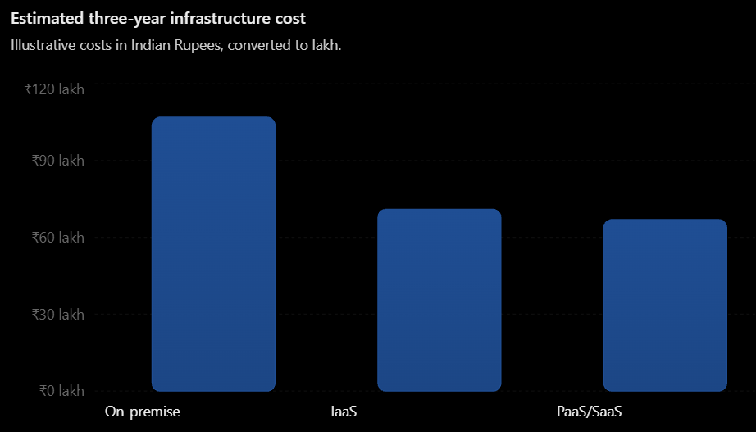
3.6 Cost Analysis
Based on the estimates:
- On-premise infrastructure has the highest three-year cost of ₹107 lakh.
- IaaS reduces the estimated cost to ₹71 lakh.
- PaaS/SaaS has the lowest estimated cost of ₹67 lakh.
Estimated savings using IaaS:
₹107 lakh − ₹71 lakh = ₹36 lakh
Percentage savings = (₹36 lakh ÷ ₹107 lakh) × 100
Percentage savings = 33.64%
Estimated savings using PaaS/SaaS:
₹107 lakh − ₹67 lakh = ₹40 lakh
Percentage savings = (₹40 lakh ÷ ₹107 lakh) × 100
Percentage savings = 37.38%
Therefore, the estimated PaaS/SaaS approach provides the lowest three-year cost among the three options.
Important financial limitation: These figures are simplified estimates. They do not represent a detailed total cost of ownership study. They assume comparable workloads and service levels, and exclude taxes, inflation, major application redevelopment, unexpected data-transfer charges and possible licensing changes. A final procurement decision should use workload-based provider quotations and include a contingency allowance.
4. Risk Analysis and Mitigation
Cloud migration introduces several technical, operational and security risks. The university must identify and manage these risks before moving critical applications.
Risk | Description | Mitigation strategy
Vendor lock-in | Dependence on one provider's proprietary services makes migration difficult. | Use open standards, containers, REST APIs and portable databases. Maintain data export and exit plans.
Data privacy | Student records, examination data and fee details may be exposed or accessed without authorization. | Apply encryption, MFA, RBAC, audit logging and data classification. Follow applicable Indian data protection requirements.
Cloud downtime | Provider outages or network failures may interrupt university services. | Deploy across multiple availability zones, configure backups, monitor health and maintain disaster recovery procedures.
Skills gap | University staff may lack experience in cloud administration, security and monitoring. | Provide cloud training, certification programmes and practical workshops. Use managed services where appropriate.
Unexpected costs | Uncontrolled resource usage and data transfer may increase bills. | Configure budgets, alerts, auto-scaling limits and regular cost reviews.
Data loss | Accidental deletion, corruption or ransomware may affect university records. | Maintain automated backups, versioning, database replication and periodic recovery tests.
API security threats | Public interfaces may be attacked or misused by unauthorized users. | Use API gateways, OAuth 2.0, HTTPS, rate limiting, validation and security monitoring.
4.1 Vendor Lock-In
Vendor lock-in occurs when applications depend heavily on a particular cloud provider's proprietary technologies.
For example, an application developed using a provider-specific database or serverless platform may require significant modification before migration to another provider.
Mitigation:
- Use Docker containers for application portability.
- Prefer REST APIs and standard data formats such as JSON.
- Maintain database backups in portable formats.
- Document the architecture and migration procedures.
- Avoid unnecessary dependence on proprietary services.
4.2 Data Privacy and Security
The university stores sensitive information such as student records, examination results, personal details and fee-payment information.
Unauthorized access or data leakage can damage the university's reputation and violate legal requirements.
Mitigation:
- Encrypt data during transmission using HTTPS/TLS.
- Encrypt stored data using appropriate encryption mechanisms.
- Apply role-based access control.
- Enable multi-factor authentication.
- Maintain audit logs.
- Apply data retention and access policies.
- Assess applicable Indian data protection requirements, including the Digital Personal Data Protection Act, 2023, and rules in force.
4.3 Downtime and Service Availability
Cloud outages, network failures and application errors may prevent students and staff from accessing university services.
The university requires 99.9% availability.
Annual permitted downtime for a 365-day year:
Total annual minutes = 365 × 24 × 60
Total annual minutes = 525,600
Permitted downtime = 525,600 × 0.1%
Permitted downtime = 525.6 minutes per year
This is approximately 8 hours and 46 minutes.
Mitigation:
- Deploy application instances across multiple availability zones.
- Use load balancers and health checks.
- Maintain database backups and replication.
- Establish a separate disaster recovery region.
- Define Recovery Time Objective (RTO) and Recovery Point Objective (RPO).
- Conduct regular disaster recovery tests.
The 99.9% target must be validated against the end-to-end application architecture and provider SLAs; using a cloud service alone does not guarantee this availability.
4.4 Skills Gap
Cloud infrastructure requires knowledge of virtualization, networking, database administration, cloud security, monitoring and automation.
Mitigation:
- Train university IT staff.
- Provide cloud certification programmes.
- Develop internal cloud administration guidelines.
- Use managed database and application services.
- Engage cloud consultants during the initial migration phase.
5. Final Cloud Solution Recommendation
Recommended approach: Hybrid Cloud
After evaluating the three infrastructure approaches, a hybrid cloud architecture combining IaaS, PaaS and SaaS is recommended for the university.
This solution provides a balance between cost, scalability, security, application compatibility and management effort.
5.1 Reasons for Selecting Hybrid Cloud
1. Cost Optimization
The existing physical servers have low average utilization. Virtualization allows multiple workloads to run on fewer physical resources. Cloud services also reduce the need for large upfront hardware purchases.
2. Scalability
During admissions and examinations, resource requirements increase significantly. Cloud auto-scaling allows computing resources to increase during peak periods and decrease during normal periods.
3. Availability
Cloud deployment across multiple availability zones, together with backup and disaster recovery services, improves application availability and business continuity.
4. Legacy Application Compatibility
The SIS and Examination Portal are existing monolithic applications. They can initially be migrated to IaaS virtual machines without requiring complete redevelopment.
5. Application Modernization
The LMS, Library System and mobile application backend can gradually move to PaaS and container-based platforms. This supports easier development and API integration.
6. Reduced Management Effort
The university can use SaaS for email and collaboration instead of maintaining its own email infrastructure.
5.2 Recommended Cloud Service Allocation
University application | Recommended service model | Reason
Student Information System | IaaS initially | Supports existing legacy application
Learning Management System | PaaS | Supports scalability and application modernization
Library Management System | PaaS | Supports web services and API integration
Examination Portal | IaaS initially | Maintains compatibility with existing application
Email System | SaaS | Reduces email server maintenance
Student database | DBaaS | Provides managed database, backups and replication
Mobile application backend | PaaS | Supports API integration and automatic scaling
Student document storage | Storage as a Service | Provides scalable object storage
Disaster recovery | DRaaS | Supports recovery during infrastructure failure
Application security | Security as a Service | Provides managed security and monitoring
5.3 Recommended Cloud Provider
A provider should be selected after a technical and commercial evaluation rather than simply choosing a popular platform.
For this university, Microsoft Azure is a suitable candidate for the primary cloud platform, subject to a competitive proof-of-concept and final pricing review.
Reasons for considering Azure include:
- Azure Virtual Machines can host existing Windows or Linux-based university applications.
- Azure App Service and Azure Kubernetes Service support application modernization.
- Azure SQL Database provides a managed relational database option.
- Azure API Management can expose secure APIs to mobile applications and affiliated colleges.
- Azure Blob Storage supports scalable document storage.
- Azure Site Recovery provides disaster recovery capabilities.
- Microsoft 365 can provide managed email and collaboration services.
AWS and Google Cloud should also be considered during procurement. The final selection should compare regional availability, service compatibility, support, compliance, network connectivity and three-year total cost.
6. Migration Roadmap
The university should follow a phased migration strategy rather than moving all applications to the cloud simultaneously.
Proposed migration phases
- Phase 1 – Assessment and Planning
Identify application dependencies, server capacity, databases, security requirements and migration priorities. Prepare backups and a migration plan.
- Phase 2 – Email System Migration
Move the university email system to SaaS because it is a well-defined service that can reduce infrastructure maintenance and provide early migration experience.
- Phase 3 – Library System Migration
Move the Library System to PaaS or a container platform. It is a suitable early application for testing web-based deployment and REST API integration.
- Phase 4 – LMS Migration
Move the LMS to PaaS after compatibility testing. Configure auto-scaling to handle increased student access during academic activities.
- Phase 5 – SIS and Examination Portal Migration
Migrate the legacy SIS and Examination Portal to IaaS virtual machines first. Modernize their components gradually after validating data integrity and application functionality.
- Phase 6 – API and Mobile Integration
Deploy an API gateway and expose secure student-record and fee-payment services to the mobile application and 40 affiliated colleges.
- Phase 7 – Disaster Recovery and Optimization
Configure multi-zone availability, a separate disaster recovery region, automated backups, monitoring and cost optimization. Conduct failover and recovery tests.
6.1 Which Application Should Move First?
The Email System should be migrated first because it is a suitable SaaS workload and does not require the university to maintain its own email servers.
This provides early experience in cloud identity management, user migration, access control and service administration.
The Library System can follow because it is a suitable candidate for web-based modernization and REST API integration.
The SIS and Examination Portal should be migrated later because they are critical legacy applications. They require detailed compatibility testing, database validation and carefully planned migration windows.
7. Expected Outcomes
After implementing the recommended hybrid cloud solution, the university can expect the following improvements:
Existing problem | Expected improvement
Low average physical server utilization | Better resource utilization through virtualization
High peak-period CPU utilization | Dynamic resource scaling
Long hardware procurement time | Faster provisioning of cloud resources
No disaster recovery site | Cloud-based disaster recovery
Monolithic applications | Gradual application modernization
No public interfaces | Secure REST API integration
High infrastructure maintenance | Reduced hardware and platform management
Limited access across campuses | Internet-accessible centralized services
The solution is designed to support approximately 25,000 students, 2,000 staff and 40 affiliated colleges, subject to capacity testing and appropriate cloud resource sizing.
The architecture should also be load-tested against the expected ten-times-current-peak demand before production deployment.
8. Conclusion
After evaluating on-premise, IaaS and PaaS/SaaS approaches, the hybrid cloud model is recommended as the most appropriate solution for the university.
The three-year illustrative cost comparison estimates ₹107 lakh for on-premise infrastructure, ₹71 lakh for IaaS and ₹67 lakh for PaaS/SaaS. These estimates indicate the potential financial benefit of cloud adoption, although actual savings must be confirmed through workload-based quotations.
The recommended architecture combines IaaS for legacy applications, PaaS for modernized university applications and SaaS for email and collaboration. It also includes DBaaS, API management, auto-scaling, multi-zone deployment, security controls and disaster recovery.
A phased migration beginning with email, followed by the Library System and LMS, will reduce migration risks. The SIS and Examination Portal can then be migrated carefully after compatibility and data-integrity testing.
Therefore, the proposed hybrid cloud solution provides a technically justified and financially practical direction for improving scalability, availability, security, manageability and future growth of the university's IT infrastructure.
TASK 11 – Re-evaluate and Adapt the Design
1. Introduction
The original cloud architecture was designed to support the university's Student Information System (SIS), Learning Management System (LMS), Library System, Examination Portal and Email System for approximately 25,000 students and 2,000 staff across four campuses.
The original recommendation was a hybrid cloud architecture combining IaaS, PaaS and SaaS.
However, the university has introduced new requirements:
- Launch a mobile application for students.
- Provide student-record and fee-payment services to 40 affiliated colleges.
- Support an expected load of 10 times the current peak.
- Maintain 99.9% service availability.
- Operate within a limited budget.
These changes increase the requirements for scalability, availability, security and API management.
After evaluating the original design, the recommended decision is to MODIFY the existing hybrid cloud architecture rather than completely redesign it.
2. Impact Analysis (2 Marks)
2.1 What Has Changed from the Original Problem?
In the original scenario, the university mainly provided services to its students and staff through internal campus applications.
The new requirement introduces external users from 40 affiliated colleges and mobile application users. Therefore, the system must support a much larger number of concurrent users and secure external access.
Original requirement | Changed requirement | Impact
25,000 students and 2,000 staff | Students, staff, mobile users and 40 affiliated colleges | Increased user base
Normal and peak academic traffic | 10 times the current peak load | Higher computing and network capacity
Mainly internal application access | Public mobile and college access | Secure internet-facing services
Limited application integration | Multiple external API integrations | API gateway becomes necessary
General availability requirement | 99.9% availability | Stronger redundancy and disaster recovery
Controlled infrastructure spending | Limited operating budget under higher demand | Cost optimization becomes important
2.2 Impact on Original Assumptions
A. Load Assumption
The original design assumed that the system would handle normal university workloads with occasional peaks during admissions and examinations.
The new requirement expects ten times the current peak load.
For example, if the current peak workload is 1,000 requests per second, the revised system must support:
Required peak capacity = 1,000 × 10
Required peak capacity = 10,000 requests per second
This is an illustrative example because the actual current peak request rate has not been provided.
Therefore, the original fixed-resource deployment may not be sufficient.
B. User Assumption
The original design mainly considered students, faculty and administrative staff.
Now, 40 affiliated colleges must also access student records and fee-payment services.
This introduces different categories of users, such as:
- Students accessing their own records.
- University administrators managing student information.
- College administrators accessing their institution's students.
- Finance staff verifying fee transactions.
- Mobile application users accessing services remotely.
The system must identify and authorize users according to their roles and institution.
C. Availability Assumption
The new requirement specifies 99.9% availability.
Annual permitted downtime:
Total annual minutes = 365 × 24 × 60
Total annual minutes = 525,600
Permitted downtime = 525,600 × 0.001
Permitted downtime = 525.6 minutes per year
This is approximately 8 hours and 46 minutes per year.
The original design must therefore include redundancy, automated recovery and continuous monitoring.
D. Cost Assumption
The university has a limited operating budget, but the expected load has increased significantly.
A traditional approach of permanently increasing the number of virtual machines may increase monthly expenses.
Therefore, the revised design should use:
- Automatic scaling.
- Serverless functions for event-based processing.
- Managed databases.
- Resource monitoring.
- Reserved or committed-use pricing for predictable workloads.
- Scale-to-zero where appropriate.
- Cost alerts and budget limits.
2.3 Why Web Services and APIs Become Critical
Previously, most applications were accessed through university-controlled interfaces.
Now, mobile applications and 40 affiliated colleges require secure access to university services.
Web services and APIs provide a standard method for communication between different applications.
For example:
API | HTTP method | Purpose
/api/v1/students/{id} | GET | Retrieve student records
/api/v1/students/{id}/fees | GET | View fee details
/api/v1/payments | POST | Submit fee-payment request
/api/v1/payments/{id} | GET | Check payment status
/api/v1/colleges/{id}/students | GET | Retrieve authorized college student records
REST APIs with JSON are recommended because they are lightweight, widely supported and suitable for mobile and web applications.
An API gateway becomes important because it provides:
- Authentication and authorization.
- Request routing to backend services.
- Rate limiting and throttling.
- Request validation.
- API monitoring and logging.
- Protection against excessive or unauthorized requests.
For fee payments, the system should use a secure payment gateway and verify payment confirmations using authenticated callbacks or webhooks. Sensitive card details should not be stored directly by the university application.
2.4 Impact of Multi-Tenant Access by 40 Colleges
Multi-tenancy means that one application or platform serves multiple independent organizations while keeping their data separated.
In this scenario, all 40 affiliated colleges use the university's common application platform.
However, one college must not access another college's student records.
For example:
- College A can access only College A student information.
- College B can access only College B student information.
- University administrators can access records according to their assigned privileges.
- Students can access only their own permitted information.
The revised system should implement:
- Unique college identification or tenant ID.
- Role-Based Access Control (RBAC).
- Tenant-aware authorization checks.
- Database row-level security or equivalent tenant isolation.
- OAuth 2.0 / OpenID Connect authentication.
- Multi-factor authentication for privileged accounts.
- Encryption during transmission and storage.
- Audit logging for all sensitive operations.
Impact: Multi-tenancy increases security and database isolation requirements. Tenant identification must be verified on the server side for every request rather than trusting a college ID supplied by the client.
3. Evaluation of the Original Design (2 Marks)
3.1 Can the Original Service Models Handle 10 Times the Load?
The original design used IaaS for legacy applications, PaaS for modernized applications and SaaS for email.
This service model combination is still appropriate, but the resource configuration and application deployment must be improved.
Original component | Evaluation under new requirement | Required change
SIS on IaaS virtual machines | Can support increased load with adequate capacity, but fixed VMs may become insufficient | Use load balancing and autoscaling
LMS on PaaS | Suitable for variable traffic | Configure horizontal scaling
Library System on PaaS | Suitable for moderate API workloads | Optimize application and database access
Examination Portal on IaaS | Can support peak demand with sufficient resources | Add redundant instances and performance testing
Email on SaaS | Provider-managed service | Retain SaaS
DBaaS | Suitable for managed database operations | Add read replicas, connection pooling and capacity planning
API gateway | Not sufficiently emphasized in the original architecture | Introduce centralized API management
The original service models do not need to be completely replaced. Instead, the architecture needs more scalable deployment and stronger access control.
3.2 Are Auto-Scaling and Single-Region Deployment Sufficient for 99.9% Availability?
Auto-scaling automatically increases or decreases resources based on workload.
However, auto-scaling alone does not guarantee availability.
For example:
- If one virtual machine fails, another instance must handle its requests.
- If one availability zone fails, workloads must continue in another zone.
- If a database becomes unavailable, a standby or recovery mechanism must exist.
- If an entire cloud region fails, a separate disaster recovery region may be required.
Therefore, the revised architecture should use:
- Multiple availability zones within the primary region.
- Load balancing between application instances.
- Health checks and automatic instance replacement.
- Database replication and automated backups.
- A secondary disaster recovery region.
- Monitoring and automated failover procedures.
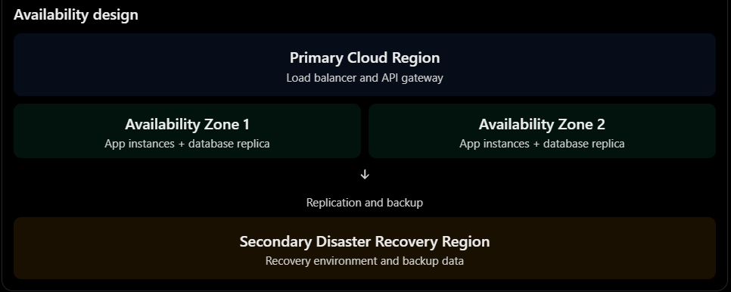
The primary region provides high availability through multi-zone deployment, while the secondary region provides disaster recovery during a major regional failure.
3.3 Does the Original Cost Remain Acceptable?
The original three-year estimated costs were:
Deployment model | Original three-year cost
On-premise | ₹107 lakh
IaaS | ₹71 lakh
PaaS/SaaS | ₹67 lakh
The new requirement increases the workload by a factor of ten at peak periods.
The previous cost estimates cannot be treated as final because additional capacity, API management, security, database scaling and disaster recovery are now required.
A permanently provisioned system designed for ten times peak capacity could be expensive.
Therefore, the university should use a combination of:
- PaaS for managed application hosting.
- Serverless computing for short event-driven operations.
- Container orchestration for applications requiring continuous processing.
- DBaaS for managed database operations.
- Auto-scaling to handle peak traffic.
- Cost monitoring to prevent unnecessary resource consumption.
3.4 Would Another XaaS Offering Give Better Results?
Yes. Additional XaaS services can improve the revised design.
XaaS offering | Application | Benefit
FaaS (Function as a Service) | Payment callbacks, notifications and event processing | Executes code only when triggered
DBaaS (Database as a Service) | Student records and fee information | Managed backups, replication and database administration
API Management as a Service | Mobile app and college APIs | Centralized security, routing and rate limiting
Security as a Service | WAF and threat monitoring | Managed application protection
DRaaS (Disaster Recovery as a Service) | Secondary recovery environment | Supports recovery after major failures
CaaS (Container as a Service) | Backend microservices | Simplifies container deployment and scaling

4. Adaptation or Redesign (2 Marks)
4.1 Final Decision: Modify the Original Design
Decision: MODIFY
The original hybrid cloud architecture will be retained because it already provides IaaS, PaaS and SaaS capabilities.
However, several components will be upgraded to support ten times the current peak load, external college access, mobile services and 99.9% availability.
A complete redesign is unnecessary because the original architecture can be extended using managed cloud services, container orchestration, API management and multi-zone deployment.
4.2 Revised Cloud Architecture
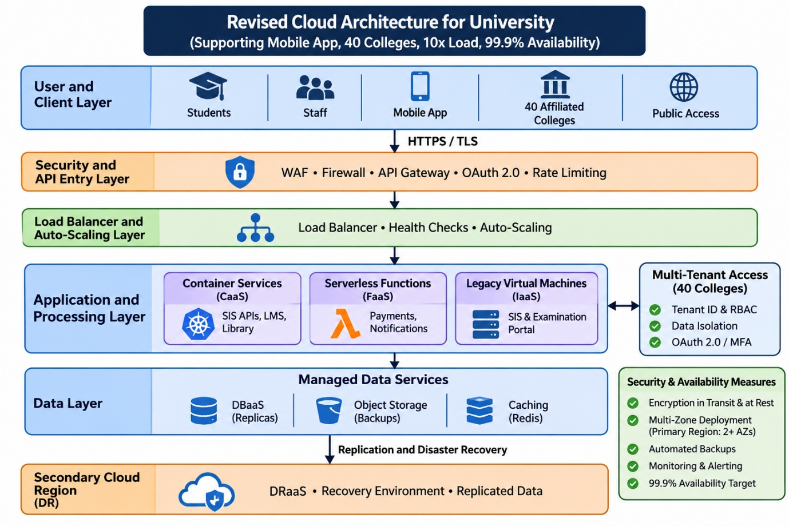

4.3 Changes in Service Models
Component | Original service model | Revised service model | Reason
SIS | IaaS | IaaS + containerized API services | Preserve legacy application while scaling new interfaces
LMS | PaaS | PaaS / CaaS | Support increased concurrent access
Library System | PaaS | PaaS / CaaS | Support external API access
Examination Portal | IaaS | IaaS with multi-zone redundancy | Maintain application compatibility and availability
Email | SaaS | SaaS | No major change required
Student database | DBaaS | Highly available DBaaS | Support increased record access and replication
Mobile backend | PaaS | PaaS / CaaS | Support mobile users and API traffic
Payment processing | Not separately defined | FaaS + payment gateway | Process payment events and callbacks
API integration | Basic REST APIs | API Management as a Service | Secure access for 40 colleges
Disaster recovery | DRaaS | Multi-zone HA + cross-region DRaaS | Improve availability and recovery
4.4 Changes in Virtualization Approach
The original design mainly used virtual machines to host legacy applications.
The revised architecture uses a combination of virtualization technologies.
1. Virtual Machines
Virtual machines will continue to host legacy SIS and Examination Portal applications. They provide compatibility with existing operating systems and software.
2. Containers
Docker containers will package the modernized applications and APIs with their dependencies.
A container orchestration platform such as Azure Kubernetes Service (AKS) can manage deployment, scaling, health checks and replacement of failed containers.
3. Serverless Computing
Serverless functions will handle short event-driven tasks such as payment notifications, payment-status updates and email alerts.
4. Managed Databases
DBaaS will reduce database administration effort and provide managed backup and replication capabilities.
Reason for the revised approach: VMs provide compatibility, containers provide portability and horizontal scaling, and serverless functions reduce the need to maintain continuously running resources for occasional tasks.
4.5 Multi-Tenant Security Design
The revised system must provide secure access to all 40 affiliated colleges.
A tenant-aware security model will be implemented.
Security component | Implementation
Tenant identification | Unique tenant ID for every college
Authentication | OAuth 2.0 / OpenID Connect
Authorization | Role-Based Access Control
Data isolation | Tenant ID validation and row-level security
Communication | HTTPS/TLS
Sensitive data | Encryption at rest
API protection | Rate limiting and request validation
Monitoring | Audit logs and security alerts
Privileged access | Multi-factor authentication
For example, when College A requests a student record, the backend verifies the authenticated user's college identity and checks whether the requested student belongs to College A.
Even if College A changes a student ID or tenant ID in its request, the backend must reject unauthorized access.
This prevents one college from accessing another college's confidential records.
5. Evidence-Based Defence (2 Marks)
5.1 Capacity Calculation
The changed requirement specifies ten times the current peak load.
Assume the existing application handles 1,000 requests per second during peak periods.
This is an illustrative baseline used to demonstrate capacity planning.
Required peak request rate:
Required load = Current peak load × 10
Required load = 1,000 × 10
Required load = 10,000 requests per second
For additional headroom, assume the architecture is designed to support 20% above the expected peak.
Required design capacity = 10,000 × 1.20
Required design capacity = 12,000 requests per second
Therefore, the revised architecture should be load-tested to sustain at least 12,000 requests per second under the defined test conditions.
Actual VM and container counts cannot be calculated accurately from request rate alone. They must be established through load testing because application complexity, CPU usage, database queries, caching and network bandwidth affect capacity.
Availability Calculation
Required availability = 99.9%
Allowed downtime percentage = 100% − 99.9%
Allowed downtime percentage = 0.1%
Annual downtime = 525,600 × 0.001
Annual downtime = 525.6 minutes
Therefore, the revised design must maintain availability within approximately 8 hours and 46 minutes of downtime per year.
The use of multiple availability zones, health checks, load balancing and automated recovery reduces the risk of a single component failure causing a complete outage.
5.2 Cost Comparison: Original and Revised Design
The previous Task 10 estimated a three-year IaaS cost of ₹71 lakh and a PaaS/SaaS cost of ₹67 lakh.
For the revised hybrid architecture, additional capacity and managed services are required.
The following estimates are illustrative planning figures, not cloud-provider quotations.
Original Three-Year Cost
Cost component | Original estimated cost
Initial migration and setup | ₹7 lakh
Annual recurring cloud expenditure | ₹20 lakh
Three-year recurring expenditure | ₹60 lakh
Total | ₹67 lakh
Revised Three-Year Cost
Cost component | Revised estimated cost
Initial migration and architecture upgrade | ₹9 lakh
Application hosting and container platform | ₹10 lakh/year
Managed database and replication | ₹5 lakh/year
API gateway and security services | ₹3 lakh/year
Storage, backup and disaster recovery | ₹3 lakh/year
Networking and data transfer | ₹2 lakh/year
Monitoring and administration | ₹2 lakh/year
Total annual recurring cost | ₹25 lakh/year
Three-year recurring cost:
₹25 lakh × 3 = ₹75 lakh
Total revised three-year cost:
₹9 lakh + ₹75 lakh = ₹84 lakh
Cost Comparison
Cost category | Original design | Revised design
Initial setup | ₹7 lakh | ₹9 lakh
Annual recurring cost | ₹20 lakh | ₹25 lakh
Three-year recurring cost | ₹60 lakh | ₹75 lakh
Total three-year cost | ₹67 lakh | ₹84 lakh

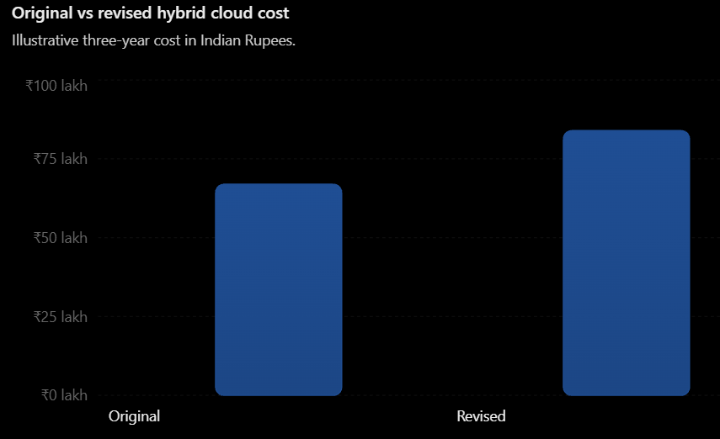Percentage increase:
(₹17 lakh ÷ ₹67 lakh) × 100 = 25.37%
The revised design increases the estimated three-year cost by approximately 25.37%.
However, the additional cost supports a ten-times-peak capacity target, external API access, improved security, multi-zone availability and disaster recovery.
Cost Optimization Measures
Since the operating budget is limited, the university should:
- Use serverless functions for event-driven workloads.
- Apply auto-scaling to avoid unnecessary idle resources.
- Use caching to reduce repeated database queries.
- Use read replicas for high-volume read operations where appropriate.
- Select reserved or committed-use pricing for predictable workloads.
- Apply storage lifecycle policies to archive older documents.
- Configure budget alerts and monthly usage reports.
- Conduct regular cloud resource reviews.
The revised architecture costs more than the original estimate, but the extra spending should be concentrated on critical services rather than permanently increasing every resource.

5.3 Security and Multi-Tenancy Considerations
The system will process student records and financial information for the university and 40 affiliated colleges.
Therefore, security must be implemented at the application, API, database and infrastructure levels.
Security threat | Mitigation
Unauthorized college access | Tenant-aware RBAC and server-side authorization
Student data leakage | Encryption and database isolation
API abuse | Rate limiting and throttling
Account compromise | MFA and secure authentication
Payment fraud | Trusted payment gateway and verified callbacks
Data modification | Audit logs and transaction controls
Network attacks | WAF, firewall and HTTPS
Database failure | Replication and tested backups
Fee-payment operations should also use unique transaction identifiers and idempotency keys to prevent duplicate processing when a client retries a payment request.
5.4 Trade-Off Analysis
Factor | Benefit of revised design | Trade-off
Scalability | Containers and auto-scaling support higher workloads | More infrastructure configuration
Availability | Multi-zone deployment and DR improve resilience | Additional service cost
Security | API gateway and tenant isolation protect external access | More complex identity and authorization management
Cost | Serverless and automatic scaling reduce idle capacity | Usage-based costs can be unpredictable
Portability | Containers improve application portability | Managed databases and APIs may still create vendor lock-in
Maintenance | Managed services reduce administrative work | Greater dependency on cloud provider
Migration | Existing VMs can remain during modernization | Temporary hybrid complexity
The university should accept some additional technical complexity because the new requirements cannot be met reliably through the original basic deployment.
However, the architecture should avoid unnecessary microservices and excessive managed components. Only services that provide measurable scalability, availability or security benefits should be introduced.
6. Final Recommendation
The original hybrid cloud architecture should be modified rather than completely redesigned.
The revised architecture will retain IaaS for legacy applications, PaaS for modern application hosting and SaaS for email services. It will introduce container orchestration, serverless processing, API management, DBaaS, multi-zone deployment and cross-region disaster recovery.
The most important changes are:
- Introduce a centralized API gateway for mobile applications and 40 affiliated colleges.
- Use containers and auto-scaling to support ten times the current peak workload.
- Deploy critical application components across multiple availability zones.
- Use a secondary region for disaster recovery.
- Implement tenant-aware access control and database isolation.
- Use serverless functions for payment events and notifications.
- Monitor cloud consumption to keep operating costs within budget.
The revised architecture should be validated through load testing, security testing, payment workflow testing and disaster recovery exercises before production launch.

