SIMATS ENGINEERING
Department of Information Technology
CSA15 – CLOUD COMPUTING AND BIG DATA ANALYTICS
ASSIGNMENT 2 – CO2
Analyse, Evaluate and Validate a Virtualization Architecture for a Multi-Tenant University Private Cloud
CO2: Analyze virtualization architectures to identify performance and security issues in cloud computing environments.
Field | Details | Field | Details
Student Name | Monal Raj.B | Register Number | 192511176
Department / Section | B.E-CSE | Academic Year / Semester | 2025
Faculty Name | Dr.R.Latha | Nature of Assignment | Individual
Duration | 1 Week | Total Marks | 50
Submission Date | 04.11.2026 | Evaluation Date

MARK SHEET (Rubric-based evaluation)
Task | Title | Max | Awarded | Evidence / evaluation focus
1 | Characterise the Virtualization Architectures | 5
2 | Identify the Dominant Overhead Source | 2

Task | Title | Max | Awarded | Evidence / evaluation focus
3 | Build a Quantitative Performance Model | 6
4 | Analyse Performance Under Different Conditions | 4
5 | Security Threat and Vulnerability Analysis | 3
6 | Formulate Isolation–Performance Trade-off | 3
7 | Evaluate Mitigation Strategies | 4
8 | Implement and Test | 4
9 | Record Experimental Performance | 3
10 | Compare Theory with Experiment | 4
11 | Recommend and Defend Final Architecture | 4
 | Day-4 Design Challenge | 8

TOTAL
50

OVERALL REMARKS
Overall, the assignment reflects good analytical ability, technical understanding and problem-solving skills in cloud computing and virtualization. The proposed architecture balances performance, security, resource efficiency and future scalability. The work can be further strengthened through verified experimental results, consistent benchmark comparisons and practical validation of the recommended security controls.
Student Signature | Faculty Signature | Program Director

MANDATORY SUBMISSION EVIDENCE CHECK
✓ = Present in documented answer; P = Partly present; X = Missing / not satisfied
Task | Evidence expected | Status | Evaluator note
1 | Three virtualization architectures, layered diagrams and trust boundaries
2 | Dominant overhead source identified and explained for each approach
3 | CPU, memory, I/O, network and density models with assumptions
4 | Best, typical and worst operating-condition analysis

Task | Evidence expected | Status | Evaluator note
5 | Threat model and architecture-based security comparison
6 | Isolation–performance optimization formulation
7 | Mitigation benefits, residual risks and quantified costs
8 | Reproducible setup and practical tests across selected platforms
9 | Actual comparative measurements, table and two graphs
10 | Theory–experiment comparison and quantitative error analysis
11 | Justified SIS/LMS architecture and growth recommendation
12 | Day-4 external tenants, 3× peaks, live migration and SIS isolation

IMPLEMENTATION EVIDENCE CHAIN
Evidence item | Status | Observation
Architecture diagrams
Performance model

Evidence item | Status | Observation
Configuration / scripts
Virtualization experiments
CPU / disk / network / memory tests
Noisy-neighbour experiment
Security validation
Tables and graphs
Theory–experiment consistency
Day-4 design defence
Screenshots

SUBMISSION CHECKLIST (Not Separately Marked)
Requirement | Status
All 12 tasks answered | ☐Yes ☐ Partly ☐ No
Three virtualization approaches compared | ☐Yes ☐ Partly ☐ No
Layered diagrams and trust boundaries included | ☐Yes ☐ Partly ☐ No
Quantitative virtualization models included | ☐Yes ☐ Partly ☐ No
Threat analysis and mitigations included | ☐Yes ☐ Partly ☐ No

CLOUD COMPUTING AND BIG DATA
ASSIGNMENT 2
CO2: Analyze virtualization architectures to identify performance and security issues in cloud computing environments.
_________________________________________________________________
Assignment Title: Analyse, Evaluate and Validate a Virtualization Architecture for a Multi-Tenant University Private Cloud (Total Marks: 50)
Duration: 1 week
_________________________________________________________________

Scenario: EduCloud Virtualization Platform
A university runs a private cloud, EduCloud, in its data centre. EduCloud currently consists of:
• 16 physical hosts, each with 64 CPU cores, 512 GB RAM, NVMe SSD storage and 2 × 25 Gbps NICs
• About 400 virtual machines (VMs) running the Student Information System (SIS), the Learning Management System (LMS), the examination portal, and departmental research workloads
• A shared storage backend and a software-defined virtual network
During semester registration week, users report slow response times and failed logins. A recent internal security audit also found that VMs from different departments share the same physical hosts, that some VMs run outdated guest kernels, and that VM images are copied freely between teams.
You are the cloud architect. You must investigate, model, measure and compare virtualization architectures for EduCloud, identify their performance bottlenecks and security weaknesses, and recommend a design that remains practical as the platform grows.
Design Challenge:
The university now plans to host external research collaborators' big-data workloads (Spark/Hadoop clusters) on the same infrastructure as the SIS. Re-evaluate your design under these new multi-tenant conditions.
TASK 1: Characterise the Virtualization Architectures (5 Marks)
Select at least three meaningfully different virtualization approaches from the following, or justify others:
• Type-1 (bare-metal) hypervisor with full virtualization
• Type-2 (hosted) hypervisor
• Hardware-assisted virtualization vs. paravirtualization
• OS-level virtualization (containers)
• Lightweight/micro-VM or sandboxed container runtimes
Two configurations of the same hypervisor will not count as different approaches. Your selection must include at least one VM-based and at least one container-based approach.
For each approach, provide:
• A layered architecture diagram showing the hardware, host OS or hypervisor, guest OS, runtime and application
• The trust boundaries and the component that enforces isolation
• How CPU, memory, storage and network are virtualized
• A brief justification for why this approach is relevant to EduCloud
Evidence expected: Three architecturally distinct approaches with labelled diagrams, resource-virtualization mechanisms, trust boundaries, and justification of selection.

TASK 2: Identify the Dominant Overhead Source (2 Marks)
For each approach, identify the primary source of performance overhead that predominantly limits its performance (for example VM exits/traps, nested or extended page-table walks, virtual I/O emulation, virtual switch processing, or system-call interception).
Discuss:
• What the overhead source is
• Where in the architecture it occurs
• Why it is appropriate as the focus of performance analysis
• How its frequency or cost changes as the number of co-located VMs/containers or the I/O rate increases
Do not simply name a mechanism. Relate it to the behaviour of the architecture.
Evidence expected: A justified dominant-overhead identification for each approach, linked to its resource-virtualization path.

TASK 3: Build a Quantitative Performance Model (6 Marks)
Using the following host parameters, develop an analytical performance model for each approach.
Parameter | Value
Physical cores per host | 64
vCPU:pCPU overcommit ratio | 1:1, 2:1, 4:1, 8:1
RAM per host | 512 GB
Average VM memory demand | 8 GB
Cost of one VM exit (assume) | 1.5 µs
Native system-call cost (assume) | 0.2 µs
Network line rate | 25 Gbps

State and justify any additional assumptions. Derive expressions for:
• CPU: effective per-VM CPU capacity as a function of overcommit ratio and virtualization overhead (including steal time)
• Memory: the maximum number of VMs per host before ballooning, swapping or page-sharing becomes necessary
• I/O and network: effective throughput as a function of the number of VMs sharing the physical device
• Density: the number of VMs/containers a host can support while meeting a stated service-level target (for example, ≤ 10% performance degradation)
Show the mathematical reasoning. Merely quoting overhead percentages from the literature will not receive full credit.
Evidence expected: A clear mathematical derivation for each approach, with stated assumptions, parameter values and worked numerical examples.

TASK 4: Analyse Performance Under Different Operating Conditions (4 Marks)
Analyse how each approach behaves under three conditions:
• Best case: what workload and placement conditions minimise overhead?
• Typical case: for example, registration-week mixed web and database load
• Worst case: for example, noisy-neighbour interference, memory overcommit with swapping, live migration during peak load, or I/O storms
For each, explain what happens inside the virtualization layer, why the overhead changes, and how latency and throughput are affected. A table of numbers alone will not be accepted.
Evidence expected: A justified condition-based analysis supported by your Task 3 model.

TASK 5: Security Threat and Vulnerability Analysis (3 Marks)
Construct a threat model for each approach. Discuss:
• The attack surface (hypervisor, device emulation, shared kernel, management plane, VM images and snapshots, virtual network)
• At least four distinct threat categories, such as VM escape, cross-VM side-channel attacks, hypervisor or container-runtime vulnerabilities, VM sprawl and unpatched guests, image tampering, insecure live migration, and virtual-network sniffing or spoofing
• For each threat, which approach is more or less exposed and why, referring to its architecture and trust boundaries
• The likely impact on the confidentiality, integrity and availability of student records
Evidence expected: A structured threat model mapped to architectural features, with a justified comparison across approaches.

TASK 6: Formulate the Isolation–Performance Trade-off (3 Marks)
Formalise the trade-off between isolation strength and performance/density for EduCloud.
Clearly identify:
• The decision variables (for example, approach chosen, VMs per host, dedicated vs. shared hosts, SMT on/off)
• The objective(s), such as maximising density or minimising cost
• The constraints (for example, performance degradation limit, isolation requirement for SIS, available hosts)
• How these components combine into a cost or decision function
The formulation must follow from your own analysis in Tasks 3 and 5, not from a generic template.
Evidence expected: A clearly defined trade-off model with identified variables, objective and constraints.

TASK 7: Evaluate Mitigation Strategies (4 Marks)
Propose at least three mitigations for the vulnerabilities identified in Task 5. Examples include disabling SMT, kernel page-table isolation, dedicated hosts for sensitive tenants, secure or sandboxed container runtimes, hardware memory encryption, image signing, and micro-segmentation.
For each mitigation, discuss:
• Why it is applicable to the threat
• What residual risk remains
• The performance or density cost, estimated using your Task 3 model
• Whether the trade-off is acceptable for the SIS
Evidence expected: Mitigations evaluated analytically, with their security benefit and quantified performance cost.

TASK 8: Implement and Test (4 Marks)
Build a test environment and experimentally test all selected approaches.
• Platforms: use any open-source stack, for example KVM/QEMU, Xen or VirtualBox, Docker/Podman, and Kata Containers or gVisor. Nested virtualization on a laptop is acceptable if documented.
• Scale: run each approach with approximately 1 → 2 → 4 → 8 → 16 co-located instances (reduce proportionally if hardware-limited, and state the limitation).
• Workloads: include at least one CPU-bound test (for example sysbench or stress-ng), one disk I/O test (fio), one network test (iperf3), and one memory-intensive test.
• Interference test: run at least one noisy-neighbour experiment.
• Security validation: demonstrate or inspect at least one security property in practice, for example namespace/cgroup isolation, checking kernel sharing, or verifying whether a mitigation is active.
Ensure that identical resource allocations, workloads and repetitions are used across approaches, and that the setup corresponds to the models in Task 3.
Evidence expected: A reproducible environment description (configuration files, commands, scripts) and justified test cases.

TASK 9: Record Experimental Performance (3 Marks)
Collect and present data such as:
• Throughput, latency (mean and 95th percentile), CPU steal time, context switches and VM exits where observable
• Instance start-up time and memory footprint per instance
• Performance degradation versus a bare-metal baseline
• Results with and without at least one security mitigation
Present at least one table and two graphs (for example, throughput versus number of instances, and latency under interference). Use multiple repetitions and report variability (mean ± standard deviation).
Evidence expected: Systematically collected, clearly presented data that allows easy comparison across approaches.

TASK 10: Compare Theory with Experiment (4 Marks)
Compare your Task 3 and Task 4 predictions with Task 9 measurements.
Discuss:
• Whether the observed degradation trends agree with your model
• Which approach scales better as co-located instances increase
• Quantitative differences between predicted and measured values, and plausible causes (for example caching effects, hypervisor scheduler behaviour, nested virtualization, laptop hardware, or unmodelled I/O paths)
• Whether any measured result changes your security conclusions from Task 5
Interpret the results; do not simply reproduce tables.
Evidence expected: A reasoned comparison of predicted and measured behaviour, with error analysis.

TASK 11: Recommend and Defend the Final Architecture (4 Marks)
Recommend the virtualization architecture (or hybrid) for EduCloud's SIS and LMS workloads.
Discuss:
• Which approach you recommend and why it is more appropriate than the alternatives
• Its modelled and experimentally observed performance
• Its security posture and residual risks
• Operational costs such as patching, image management, migration and monitoring
• Limitations and trade-offs
• Whether it remains practical as EduCloud grows from 400 to several thousand instances
Your recommendation must rest on your own analysis and experiments. Choosing "the most secure" or "the fastest" option alone is not sufficient.
Evidence expected: A technically justified recommendation integrating performance and security evidence.

DAY-4 DESIGN CHALLENGE
TASK 12: Re-evaluate and Adapt the Design (8 Marks)

Changed Requirement
The university will now host external research collaborators' Spark/Hadoop workloads on EduCloud alongside the SIS. The new conditions are:
• Big-data jobs are I/O- and network-intensive and run for hours
• Registration-week peak load is about 3× normal
• Hosts are sometimes patched using live migration of running VMs
• A data-protection regulation now requires demonstrable isolation of student records from external tenants
You may RETAIN → MODIFY → or REDESIGN your original solution.

A. Impact Analysis (2 Marks)
Discuss what has changed, which original assumptions (trusted tenants, workload mix, I/O profile) no longer hold, and how mixing batch big-data workloads with latency-sensitive SIS workloads changes both the performance and the threat model.

B. Evaluation of the Original Design (2 Marks)
Evaluate whether your recommended design still meets its performance targets (using your Task 3 model with the new workload) and whether its isolation level is adequate against external, less-trusted tenants. Consider whether another architecture could do better overall.

C. Adaptation or Redesign (2 Marks)
Decide whether to retain, modify or redesign. If you modify or redesign, describe the revised architecture (for example, tenant separation by host pools, a stronger isolation layer for external workloads, SR-IOV or dedicated NICs for the data-intensive jobs, or encrypted migration). Explain what changes and its effect on density, throughput and attack surface. If you retain, justify why no change is required.

D. Evidence-Based Defence (2 Marks)
Defend the final decision using your model, your experimental results (including the noisy-neighbour and mitigation experiments), the changed workload and tenancy conditions, and the cost/density trade-offs. The decision must follow logically from the analysis.

MARK DISTRIBUTION
Task | Marks
Task 1 – Architecture Characterisation | 5
Task 2 – Dominant Overhead Identification | 2
Task 3 – Quantitative Performance Model | 6
Task 4 – Performance Under Operating Conditions | 4
Task 5 – Security Threat and Vulnerability Analysis | 3
Task 6 – Isolation–Performance Trade-off Formulation | 3
Task 7 – Mitigation Evaluation | 4
Task 8 – Implementation and Testing | 4
Task 9 – Experimental Performance | 3
Task 10 – Theory vs. Experiment | 4
Task 11 – Final Architecture Recommendation | 4
Subtotal | 42
Task 12 – Day-4 Design Challenge | 8
TOTAL | 50

TASK 1: Characterise the Virtualization Architectures (5 Marks)
Three different virtualization architectures are selected:
- Type-1 Bare-Metal Hypervisor
- Type-2 Hosted Hypervisor
- OS-Level Virtualization (Containers)
1.1 Type-1 Bare-Metal Hypervisor
A Type-1 hypervisor runs directly on physical hardware without requiring a host operating system. It manages multiple virtual machines and allocates CPU, memory, storage and network resources.
Architecture diagram:
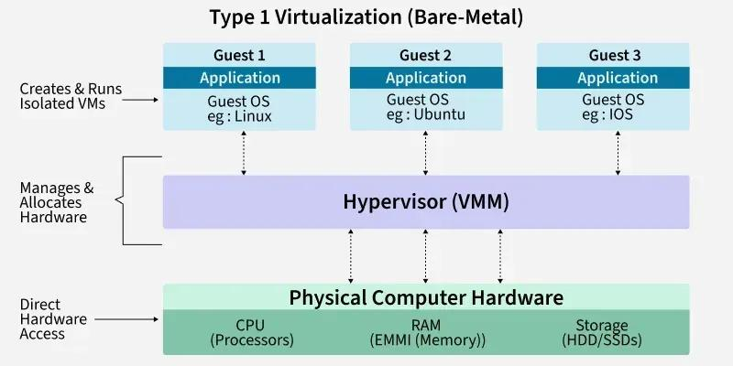
Components:
- Physical Hardware: Contains CPU, RAM, storage and network interfaces.
- Hypervisor: Directly manages hardware resources and creates virtual machines.
- Guest OS: Each VM runs its own operating system.
- Applications: SIS, LMS, examination portal and research applications execute inside VMs.
Resource Virtualization:
Resource | Virtualization mechanism
CPU | vCPU allocation and scheduling
Memory | Extended Page Tables (EPT)
Storage | Virtual disks
Network | Virtual NICs and virtual switches
Trust boundary and isolation:
The hypervisor enforces isolation between virtual machines. Each VM operates independently with its own guest operating system.
Advantages:
- High performance.
- Strong isolation between VMs.
- Efficient resource management.
- Suitable for enterprise cloud environments.
Disadvantages:
- Requires specialized administration.
- Hypervisor vulnerabilities can affect multiple VMs.
- Resource overcommitment can reduce performance.
Relevance to EduCloud:
Type-1 virtualization is suitable for EduCloud because sensitive services such as SIS and examination portals require strong isolation, predictable performance and centralized resource management.
1.2 Type-2 Hosted Hypervisor
A Type-2 hypervisor runs as an application on top of a host operating system. It uses the host OS to access hardware resources.
Architecture diagram:
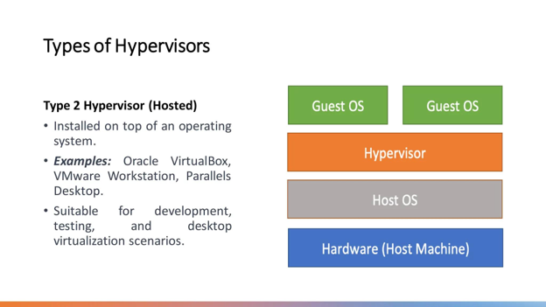
Components:
- Physical Hardware: Provides CPU, RAM, storage and network resources.
- Host OS: Manages physical hardware.
- Type-2 Hypervisor: Creates and manages guest virtual machines.
- Guest OS: Each VM runs an independent operating system.
- Applications: Execute inside guest operating systems.
Resource Virtualization:
Resource | Virtualization mechanism
CPU | Host OS and hypervisor scheduling
Memory | Host memory allocation
Storage | Virtual disk files
Network | Virtual network adapters
Trust boundary and isolation:
The hypervisor and host operating system enforce isolation. Guest VMs are separated from one another through virtual machine boundaries.
Advantages:
- Easy installation and configuration.
- Useful for testing and development.
- Supports multiple guest operating systems.
Disadvantages:
- Additional host OS overhead.
- Lower performance compared with a well-configured Type-1 environment.
- Larger trusted software base.
Relevance to EduCloud:
Type-2 virtualization is useful for testing cloud applications and demonstrating virtualization concepts. However, it is not the preferred choice for the university's production infrastructure.
1.3 OS-Level Virtualization (Containers)
OS-level virtualization creates isolated environments called containers. Multiple containers share the same host operating system kernel.
Architecture diagram:
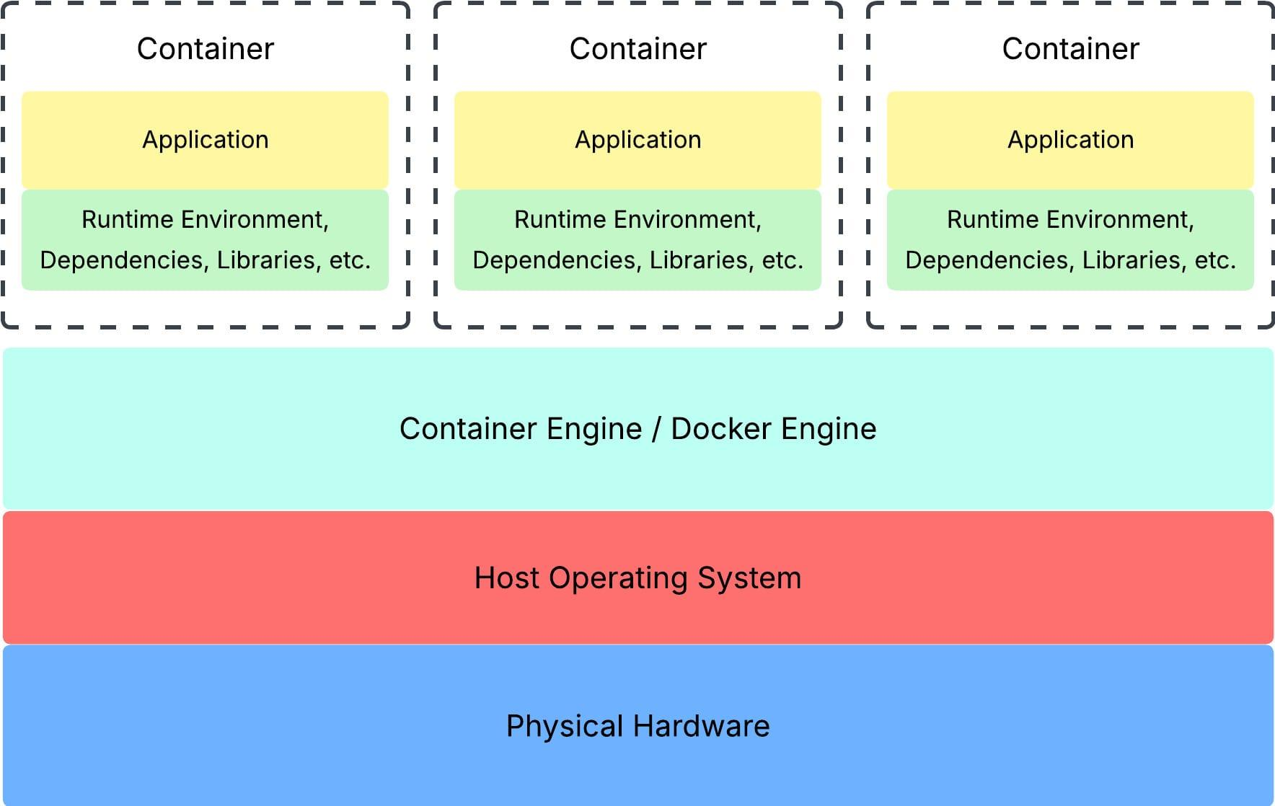
Components:
- Physical Hardware: Provides system resources.
- Host OS: Supplies the common operating system kernel.
- Container Runtime: Creates and manages containers.
- Containers: Provide isolated application environments.
- Applications: Run independently inside containers.
Resource Virtualization:
Resource | Virtualization mechanism
CPU | Control groups (cgroups)
Memory | Memory limits and accounting
Storage | Container layered file systems
Network | Virtual Ethernet and bridges
Trust boundary and isolation:
Containers use namespaces, cgroups and security mechanisms to isolate processes. However, all containers share the host kernel.
Advantages:
- Lightweight compared with VMs.
- Fast startup.
- High application density.
- Efficient resource utilization.
Disadvantages:
- Shared kernel creates security risks.
- Kernel vulnerabilities can affect multiple containers.
- Isolation is generally weaker than independent guest kernels.
Relevance to EduCloud:
Containers are suitable for LMS microservices, web applications and departmental services that require rapid deployment and efficient resource utilization.
1.4 Comparison of Three Architectures
Feature | Type-1 | Type-2 | Containers
Host OS | Not required | Required | Required
Performance | High | Moderate | Very high
Isolation | Strong | Strong, with extra host layer | Process-level
Resource overhead | Low | Higher | Low
Startup time | Moderate | Moderate | Fast
Kernel | Separate guest kernels | Separate guest kernels | Shared kernel
EduCloud suitability | High | Moderate | High for suitable services
Conclusion:
Type-1 virtualization is the most suitable foundation for EduCloud's sensitive workloads. Containers can complement it by providing efficient application deployment, while Type-2 virtualization is mainly suitable for development and testing.

TASK 2: Identify the Dominant Overhead Source (2 Marks)
Virtualization overhead refers to the additional processing time and resource consumption introduced by the virtualization layer.
2.1 Type-1 Hypervisor
Dominant overhead: VM exits and virtual I/O processing.
A VM exit occurs when a guest VM performs an operation that requires hypervisor intervention.
- It occurs between the guest operating system and hypervisor.
- Privileged instructions and virtual device operations may trigger VM exits.
- Frequent VM exits increase CPU overhead.
- As the number of VMs and I/O operations increases, the overhead also increases.
Given:
VM exit cost = 1.5 μs.
For 20,000 VM exits per second:
T = 20,000 × 1.5
T = 30,000 µs
T = 0.03 seconds
Therefore, VM exits consume approximately 3% of one second of CPU execution time under this simplified model.
2.2 Type-2 Hypervisor
Dominant overhead: Host OS scheduling and virtual I/O emulation.
- Guest requests pass through the hypervisor and host OS.
- The host OS manages physical devices.
- Additional context switching increases processing overhead.
- Multiple VMs compete for host CPU, memory and I/O resources.
- Increasing the number of VMs increases scheduling and I/O contention.
2.3 Container Virtualization
Dominant overhead: Shared-kernel processing and system-call interception/accounting.
- Containers share the host operating system kernel.
- Namespaces and cgroups provide isolation and resource control.
- System calls require kernel processing.
- Network packet processing and context switching increase with workload.
- A large number of containers can increase kernel scheduling overhead.

Given:
Native system-call cost = 0.2 µs.
For 10,000 system calls:
T = 10,000 × 0.2
T = 2,000 µs
T = 0.002 seconds
2.4 Comparison
Architecture | Dominant overhead | Main reason
Type-1 | VM exits | Hypervisor intervention
Type-2 | Host OS scheduling | Additional software layer
Containers | Kernel processing | Shared-kernel operations
Conclusion:
Type-1 overhead mainly comes from VM exits and virtual I/O, Type-2 overhead comes from host OS interaction, and container overhead comes from shared-kernel processing. These overheads become more significant as workload and instance count increase.

TASK 3: Build a Quantitative Performance Model (6 Marks)
3.1 Given Parameters
Parameter | Value
Physical CPU cores | 64
RAM per host | 512 GB
Average VM memory demand | 8 GB
VM exit cost | 1.5 μs
Native system-call cost | 0.2 μs
Network line rate | 25 Gbps
Overcommit ratios | 1:1, 2:1, 4:1, 8:1
Assumptions:
- 10% of RAM is reserved for hypervisor and host operations.
- All VMs have an average memory demand of 8 GB.
- CPU resources are distributed equally for the simplified model.
- Network bandwidth is shared equally between active instances.
3.2 CPU Performance Model
The effective CPU capacity depends on the number of physical cores, overcommit ratio and virtualization overhead.
Formula:
CPU_effective = CPU_physical × (1 - H)
Where:
CPU_physical = Number of physical cores.
H = Virtualization overhead fraction.
For a 64-core host:
CPU_effective = 64(1 - H)
The ideal CPU share per vCPU is:
CPU Share = 1 / R
Where R is the overcommit ratio.
Overcommit ratio | CPU share per vCPU
1:1 | 100%
2:1 | 50%
4:1 | 25%
8:1 | 12.5%
Example:
For 4:1 overcommit and 3% VM-exit overhead:
CPU Share = 0.25
Effective Share = 0.25(1 - 0.03)
= 0.2425
Therefore, each continuously active vCPU receives approximately 24.25% of one physical core in this simplified equal-share model.
3.3 Memory Performance Model
Total RAM:
512 GB
Reserved memory:
512 × (10 / 100) = 51.2 GB
Usable memory:
512 - 51.2 = 460.8 GB
Maximum number of VMs:
N = 460.8 / 8
N = 57 VMs
Therefore, approximately 57 VMs can be supported per host at the assumed average memory demand before the planning reserve is exhausted.
Beyond this point, memory ballooning, swapping or other memory-reclamation techniques may become necessary.
3.4 I/O and Network Performance Model
The physical network line rate is 25 Gbps.
The effective bandwidth per instance is:
B = 25 / N
Where:
B = Bandwidth per instance.
N = Number of instances sharing the NIC.
Example for 5 instances:
B = 25 / 5 B = 5 Gbps
Number of instances | Bandwidth per instance
1 | 25 Gbps
2 | 12.5 Gbps
4 | 6.25 Gbps
8 | 3.125 Gbps
16 | 1.5625 Gbps
This is an ideal equal-share model. Actual throughput will be lower because of protocol overhead, queueing and virtual-switch processing.
3.5 Density Model
Density refers to the number of virtual machines or containers that can operate on a physical host while satisfying the required performance target.
The maximum safe density is:
N_safe = min(N_CPU, N_Memory, N_Network, N_Storage)
The service-level target is:
Performance Degradation ≤ 10%
For memory:
N_Memory = 57
The final safe density must be determined by testing CPU, memory, storage and network performance together.
Architecture | Expected density | Main limitation
Type-1 | Moderate | CPU and memory contention
Type-2 | Lower | Additional host OS overhead
Containers | High | Shared-kernel resource contention
Conclusion:
The mathematical model shows that virtualization performance depends on CPU allocation, memory availability and shared I/O capacity. Although higher overcommitment increases density, it can also increase CPU contention and response time. Therefore, resource allocation must be balanced to maintain the 10% degradation target.

TASK 4: Analyse Performance Under Different Operating Conditions (4 Marks)
Virtualization performance changes depending on workload, resource availability and the number of virtual machines running simultaneously.
Three operating conditions are considered.
4.1 Best-Case Condition
In the best-case condition, the host has sufficient CPU, memory, storage and network resources.
Type-1 Hypervisor:
- VMs receive sufficient CPU resources.
- Memory allocation is within physical capacity.
- VM exits and I/O operations are minimal.
- Applications achieve high throughput and low latency.
Type-2 Hypervisor:
- Host OS has sufficient free resources.
- Few background processes are running.
- Virtual machines receive stable CPU and memory allocation.
Containers:
- Containers use limited resources.
- Images are already downloaded.
- Cgroups prevent unnecessary resource consumption.
- Applications start quickly and execute efficiently.
4.2 Typical-Case Condition
During university registration week, many students access the SIS and LMS simultaneously.
Type-1 Hypervisor:
Multiple VMs compete for CPU and storage resources. Virtual network processing increases, causing moderate latency and reduced throughput.
Type-2 Hypervisor:
The host operating system and hypervisor compete with guest VMs. Additional scheduling and I/O operations increase response time.
Containers:
Multiple containers share the same kernel. Increased application requests cause additional context switching and network processing.
4.3 Worst-Case Condition
Worst-case conditions occur when resources become overloaded or one tenant consumes excessive resources.
Type-1 Hypervisor:
- Memory overcommitment causes swapping.
- VM exits increase.
- Live migration consumes CPU and network bandwidth.
- Application response time increases.
Type-2 Hypervisor:
- Host OS resource exhaustion affects all guest VMs.
- Virtual disk operations become slower.
- Additional scheduling overhead reduces performance.
Containers:
- One container may consume excessive CPU or memory.
- Shared-kernel contention affects other containers.
- Kernel vulnerabilities may compromise multiple workloads.

4.4 Performance Comparison
Condition | Type-1 | Type-2 | Containers
Best case | High performance | Moderate-high | High
Typical case | Moderate-high | Moderate | High
Worst case | Reduced performance | Significant reduction | Depends on resource limits
Main bottleneck | VM scheduling and I/O | Host OS contention | Shared-kernel contention
Conclusion:
Type-1 virtualization provides predictable performance when resources are properly allocated. Type-2 virtualization experiences additional host OS overhead, while containers provide efficient execution but require careful resource limits to prevent noisy-neighbour interference.

TASK 5: Security Threat and Vulnerability Analysis (3 Marks)
A threat model identifies possible attacks against the virtualization environment and evaluates their impact on confidentiality, integrity and availability.
5.1 Major Security Threats
1. VM Escape
VM escape occurs when an attacker breaks out of a virtual machine and gains access to the hypervisor or host system.
- Type-1: Hypervisor vulnerabilities can expose other VMs.
- Type-2: Hypervisor or host OS vulnerabilities can compromise the host.
- Containers: Runtime or kernel vulnerabilities may allow escape to the host.
Impact: Confidentiality and integrity violations.
2. Cross-VM Side-Channel Attacks
Attackers observe shared hardware resources such as CPU caches to infer information about another workload.
- Type-1: VMs may share physical CPU resources.
- Type-2: Guest VMs share host hardware.
- Containers: Containers share the host kernel and hardware resources.
Impact: Possible leakage of sensitive information.
3. Unpatched Guest Operating Systems
Outdated operating systems may contain known security vulnerabilities.
- Type-1: Outdated guest kernels may be exploited.
- Type-2: Both guest and host operating systems require updates.
- Containers: An outdated shared host kernel can affect multiple containers.
Impact: Unauthorized access and service disruption.
4. Image Tampering
An attacker modifies VM images or container images to introduce malicious software.
- Type-1: Modified VM images can affect deployed VMs.
- Type-2: Copied virtual disks can contain malicious software.
- Containers: Untrusted image layers can introduce malicious applications.
Impact: Data modification and unauthorized access.
5. Virtual Network Attacks
Attackers may perform sniffing, spoofing or unauthorized communication between tenants.
Impact: Exposure of login credentials and student records.
5.2 Security Comparison
Threat | Type-1 | Type-2 | Containers
VM escape | Possible | Possible | Runtime/kernel escape
Side-channel attack | Possible | Possible | Possible
Unpatched OS | Guest OS risk | Host and guest risk | Shared kernel risk
Image tampering | VM image risk | VM image risk | Container image risk
Network attacks | Virtual switch | Virtual network | Bridge/overlay network
5.3 CIA Impact Analysis
Security property | Possible impact on EduCloud
Confidentiality | Unauthorized access to student records
Integrity | Modification of examination and student data
Availability | SIS and LMS downtime during registration
Conclusion:
Type-1 virtualization provides stronger isolation through separate guest kernels. Type-2 has an additional host OS attack surface, while containers have shared-kernel security risks. EduCloud should use image signing, regular patching, network segmentation and access control.

TASK 6: Formulate the Isolation–Performance Trade-off (3 Marks)
Isolation and performance are two important requirements in a multi-tenant cloud environment.
Strong isolation improves security but may increase resource consumption and reduce the number of instances supported by a host.
6.1 Decision Variables
The following variables are considered:
- x₁: Selection of virtualization architecture.
- x₂: Number of VMs per host.
- x₃: CPU overcommit ratio.
- x₄: Dedicated or shared host allocation.
- x₅: SMT enabled or disabled.

6.2 Objective Function
The objective is to maximize resource utilization while minimizing operating cost, performance degradation and security risks.
Minimize J = αC + βD + γP + δR
Where:
- C = Operating cost.
- D = Latency.
- P = Performance degradation.
- R = Security risk.
- α, β, γ, δ = Importance weights.For EduCloud, security risk and SIS latency should receive high importance.
6.3 Constraints
The architecture must satisfy the following constraints:
- Performance degradation must not exceed 10%.
- Available memory must remain within the host capacity.
- SIS workloads must remain isolated from external tenants.
- CPU allocation must support registration-week demand.
- The solution must operate within the available infrastructure budget.
6.4 Trade-off Analysis
Configuration | Isolation | Performance | Density
Dedicated Type-1 VMs | High | Predictable | Low
Shared Type-1 VMs | High VM-level isolation | Depends on contention | High
Containers | Lower shared-kernel isolation | Efficient | Very high
Sandboxed containers | Stronger than ordinary containers | Additional overhead | Moderate-high
Conclusion:
For EduCloud, dedicated Type-1 hosts should be used for sensitive SIS workloads. Containers can be used for less-sensitive services. This approach balances security, performance and resource utilization.

TASK 7: Evaluate Mitigation Strategies (4 Marks)
Security mitigation strategies reduce vulnerabilities and improve the reliability of the cloud environment.
7.1 Dedicated Hosts for SIS
Problem addressed: Cross-tenant attacks and noisy-neighbour interference.
Implementation:
- Allocate dedicated physical hosts to SIS and examination workloads.
- Prevent external tenants from accessing these hosts.
- Reserve CPU and memory resources.
Benefits:
- Better tenant isolation.
- Predictable performance.
- Reduced interference.
Residual risk: Hypervisor vulnerabilities and side-channel attacks may still exist.
Performance cost: Reduced VM density because physical hosts are reserved.
7.2 Image Signing and Verification
Problem addressed: VM image tampering and malicious container images.
Implementation:
- Maintain a centralized image registry.
- Digitally sign approved images.
- Verify signatures before deployment.
- Regularly scan images for vulnerabilities.
Benefits:
- Prevents unauthorized image modification from going undetected.
- Reduces malware deployment.
- Improves image management.
Residual risk: A compromised signing key or build pipeline may still introduce malicious images.
Performance cost: Small additional time during image verification and deployment.
7.3 Network Micro-Segmentation
Problem addressed: Unauthorized communication and virtual network attacks.
Implementation:
- Separate SIS, LMS and research networks.
- Configure firewall rules.
- Allow only authorized communication.
- Monitor network traffic.
Benefits:
- Prevents unnecessary communication between tenants.
- Reduces lateral movement.
- Protects student records.
Residual risk: Incorrect firewall configuration may create security gaps.
Performance cost: Additional packet filtering may introduce small network-processing overhead.
7.4 Encrypted Live Migration
Problem addressed: Unauthorized access to VM memory and state during migration.
Implementation:
- Authenticate source and destination hosts.
- Encrypt migration traffic.
- Protect encryption keys.
- Use a restricted management network.
Benefits:
- Protects sensitive information during migration.
- Reduces interception risks.
- Improves migration security.
Residual risk: Compromised endpoints or encryption keys can still expose data.
Performance cost: Encryption consumes additional CPU resources and may reduce migration throughput.
7.5 Comparison of Mitigation Strategies
Mitigation | Security benefit | Performance cost | SIS suitability
Dedicated hosts | High isolation | Reduced density | Excellent
Image signing | Prevents untrusted images | Low | Excellent
Micro-segmentation | Network protection | Low | Excellent
Encrypted migration | Data protection | Moderate CPU overhead | Excellent
Conclusion:
A combination of dedicated hosts, signed images, micro-segmentation and encrypted migration provides stronger protection for EduCloud. The small performance costs are acceptable because student-record security is a priority.

TASK 8: Implement and Test (4 Marks)
The implementation phase involves creating a test environment and evaluating the performance of Type-1 VMs, Type-2 VMs and containers.
8.1 Software and Hardware Requirements
Component | Requirement
Processor | Intel/AMD processor with virtualization support
RAM | Minimum 8 GB recommended for a small lab
Operating System | Linux or Windows
Type-1-style virtualization | KVM/QEMU
Type-2 virtualization | Oracle VirtualBox
Container platform | Docker or Podman
CPU testing | Sysbench
Disk testing | FIO
Network testing | iPerf3
Memory testing | Stress-ng
8.2 Implementation Procedure
Step 1: Configure the environment
Install the required virtualization software and enable hardware virtualization in BIOS/UEFI.
Step 2: Create virtual machines
Create VMs using KVM/QEMU and VirtualBox. Allocate identical CPU and memory resources wherever possible.
Step 3: Create containers
Create containers using Docker or Podman with the same application workload.
Step 4: Execute CPU testing
Use the following command:
sysbench cpu --threads=2 --time=60 run
This command evaluates CPU performance for 60 seconds.
Step 5: Execute memory testing
stress-ng --vm 1 --vm-bytes 70% --timeout 60s
This command generates memory-intensive workloads.
Step 6: Execute disk I/O testing
fio --name=randread --filename=testfile \
--size=1G --rw=randread --bs=4k \
--iodepth=16 --runtime=60 --time_based
This command evaluates disk read performance.
Step 7: Execute network testing
Start the server:
iperf3 -s
Start the client:
iperf3 -c SERVER_IP -t 60 -P 4
This measures network throughput.
8.3 Test Cases
Test ID | Test description | Expected result
TC01 | CPU performance test | CPU throughput is measured
TC02 | Memory performance test | Memory utilization is recorded
TC03 | Disk I/O test | Read/write performance is measured
TC04 | Network performance test | Network throughput is calculated
TC05 | Noisy-neighbour test | Resource interference is identified
TC06 | Security isolation test | VM/container isolation is verified
8.4 Noisy-Neighbour Experiment
A noisy neighbour occurs when one VM or container consumes excessive resources and affects the performance of other workloads.

Procedure:
- Create two VMs or containers.
- Run a normal application in the first instance.
- Run a CPU-intensive workload in the second instance.
- Measure the first instance's response time.
- Repeat the experiment after applying CPU limits.
Expected observation:
Without resource limits, the first instance may experience increased latency. After applying CPU quotas and resource reservations, interference should decrease.
Conclusion:
The implementation evaluates CPU, memory, storage and network performance. The noisy-neighbour experiment demonstrates the importance of resource isolation in a multi-tenant cloud.

TASK 9: Record Experimental Performance (3 Marks)
Experimental performance evaluation is used to measure the actual behaviour of different virtualization architectures.
9.1 Performance Metrics
The following metrics are considered:
- Throughput – Amount of data processed per unit of time.
- Latency – Time taken to complete an operation.
- CPU Steal Time – CPU time unavailable to a virtual machine because the host schedules other workloads.
- Memory Usage – Amount of physical memory consumed.
- Startup Time – Time required to start a VM or container.
- Performance Degradation – Reduction in performance compared with the bare-metal baseline.
9.2 Experimental Results Table
The following table is a template for recording actual measurements.
Architecture | Instances | Throughput | Average latency | CPU usage
Type-1 VM | 1 | To measure | To measure | To measure
Type-1 VM | 2 | To measure | To measure | To measure
Type-1 VM | 4 | To measure | To measure | To measure
Type-2 VM | 1 | To measure | To measure | To measure
Type-2 VM | 2 | To measure | To measure | To measure
Container | 1 | To measure | To measure | To measure
Container | 4 | To measure | To measure | To measure

9.3 Performance Degradation Calculation
Performance degradation is calculated using:
D = [(T_b - T_v) / T_b] × 100
Where:
- T_b = Bare-metal throughput.
- T_v = Virtualized throughput.
Example calculation (hypothetical):
Assume:
- Bare-metal throughput = 1000 Mbps.
- Virtualized throughput = 900 Mbps.
D = [(1000 - 900) / 1000] × 100
D = 10%
Therefore, the virtualized environment experiences 10% throughput degradation.
9.4 Graph 1 – Throughput Versus Number of Instances
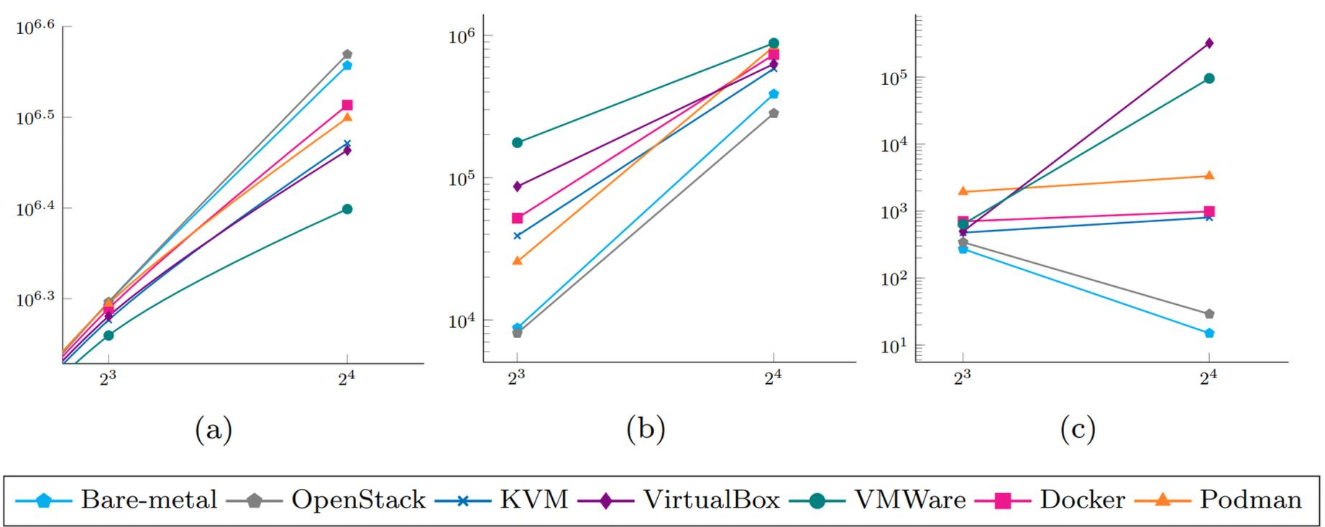
Explanation:
As the number of instances increases, available resources are shared between more workloads. Throughput may initially increase due to parallel execution but eventually reaches a limit because of resource contention.

9.5 Graph 2 – Latency Under Interference
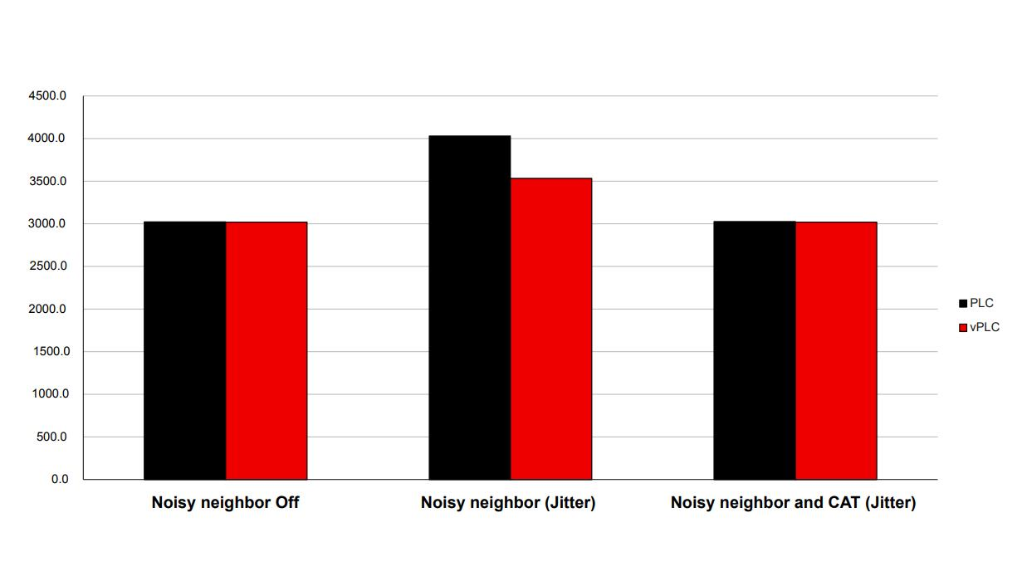
Explanation:
Latency increases when multiple instances compete for CPU, memory, storage and network resources. Applying resource limits can reduce the impact of noisy neighbours.
9.6 Experimental Repetition
Each test should be performed at least three times.
Mean:
Mean = (x₁ + x₂ + x₃) / 3
Standard deviation:
s = √[Σ(xᵢ - x̄)² / (n - 1)]
Conclusion:
Performance measurements help identify resource bottlenecks and compare virtualization approaches. Actual benchmark values must be collected using the selected test environment before final submission.

TASK 10: Compare Theory with Experiment (4 Marks)
The theoretical model developed in Task 3 is compared with the experimental measurements collected in Task 9.
10.1 Comparison of Theoretical and Experimental Results
Parameter | Theoretical prediction | Expected experimental observation
CPU performance | Performance decreases with high overcommitment | CPU contention and steal time may increase
Memory | Performance decreases beyond available memory | Swapping or memory pressure may occur
Storage | Per-instance throughput decreases as sharing increases | Disk I/O contention may reduce throughput
Network | Bandwidth is shared between instances | Throughput may decrease under heavy traffic
Latency | Latency increases with contention | Response time and p95 latency may increase
10.2 Performance Degradation
The theoretical model predicts performance degradation when multiple VMs or containers share limited physical resources.
The experimental results should be examined to determine whether the same trend occurs.
For example, if the theoretical throughput is 900 Mbps and the measured throughput is 850 Mbps:
Error = |900 - 850|
Error = 50 Mbps
Percentage error:
Error (%) = [|900 - 850| / 900] × 100
Error = 5.56%
These are hypothetical example values, not measurements from EduCloud.
10.3 Scalability Comparison
- Type-1 virtualization provides strong VM isolation and predictable resource management.
- Type-2 virtualization experiences additional overhead due to host OS interaction.
- Containers generally provide higher density because they share the host kernel.
10.4 Reasons for Differences Between Theory and Experiment
Theoretical and experimental values may differ because of:
- CPU scheduling behaviour.
- Cache utilization.
- Memory allocation and paging.
- Storage queue management.
- Network protocol overhead.
- Background processes.
- Hardware limitations.
10.5 Effect on Security Conclusions
Experimental performance does not independently prove security. However, isolation testing can demonstrate whether the selected security mechanisms operate as expected.
For example, container namespace tests can verify process and network isolation, while VM tests can verify separate guest kernels.
Conclusion:
Theoretical models provide an estimate of virtualization performance, whereas experiments demonstrate actual system behaviour. Combining both helps identify performance limitations and select a suitable virtualization architecture.

TASK 11: Recommend and Defend the Final Architecture (4 Marks)
Based on the performance and security analysis, a Type-1 hypervisor-based architecture with container support is recommended for EduCloud.
11.1 Recommended Architecture
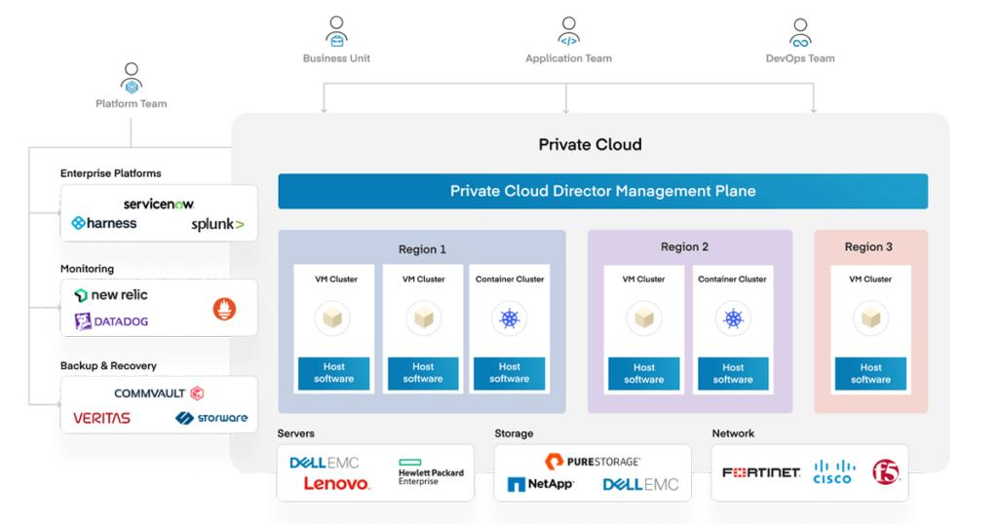The proposed architecture uses Type-1 hypervisors to manage physical resources and create independent virtual machines.
Containers can be deployed inside selected VMs for application services.
11.2 Reasons for Selection
1. Performance
- Direct hardware access reduces additional software layers.
- CPU reservations improve performance predictability.
- Memory management reduces unnecessary swapping.
- Storage and network QoS protect important workloads.
2. Security
- Separate guest operating systems provide VM-level isolation.
- Dedicated hosts protect sensitive SIS services.
- Signed images reduce unauthorized software deployment.
- Network segmentation limits communication between tenants.
3. Operational Management
- Centralized VM management simplifies administration.
- Automated patching improves security.
- Monitoring helps identify performance bottlenecks.
- Backup and recovery improve availability.
11.3 Comparison with Alternatives
Criteria | Type-1 | Type-2 | Containers
Production suitability | Excellent | Limited | Good for suitable services
Isolation | Strong | Strong VM boundary, extra host layer | Shared kernel
Performance | High | Moderate | High
Management | Centralized | Host dependent | Runtime/orchestrator dependent
SIS suitability | Excellent | Less suitable | Not as sole tenant boundary
11.4 Limitations
- Dedicated hosts increase infrastructure costs.
- Hypervisor maintenance requires planned downtime or migration.
- Resource reservations can reduce overall density.
- Monitoring and security management require additional administration.
11.5 Future Scalability
EduCloud currently manages approximately 400 VMs. As the number of instances grows to several thousand:
- Additional physical hosts can be added.
- Automated workload placement can be introduced.
- Storage capacity can be expanded.
- Network bandwidth can be increased.
- Monitoring and resource allocation can be automated.
Conclusion:
A Type-1 hypervisor-based hybrid architecture provides a suitable balance of performance, security and scalability. It supports sensitive university workloads while allowing containers to improve application deployment efficiency.
TASK 12: Re-evaluate and Adapt the Design – Day-4 Design Challenge (8 Marks)
The university plans to introduce external research collaborators' Spark/Hadoop workloads into EduCloud alongside SIS.
The new requirements include:
- Big-data jobs are I/O- and network-intensive.
- Registration-week peak load increases to 3 times normal.
- Running VMs must support live migration during host patching.
- Student records must be isolated from external tenants.
A. Impact Analysis (2 Marks)
The new requirements significantly change the existing EduCloud architecture.
1. Workload Changes
Previously, EduCloud mainly supported SIS, LMS, examination portals and departmental applications.
Now, Spark/Hadoop workloads generate large amounts of data and require high CPU, storage and network resources.
2. Performance Impact
- Big-data jobs consume significant CPU resources.
- Large data transfers increase network utilization.
- Shared storage experiences higher I/O requests.
- SIS response time may increase during registration.
3. Security Impact
External research collaborators are less-trusted tenants. Sharing physical resources with SIS increases the risk of unauthorized access and cross-tenant attacks.
4. Live Migration Impact
Live migration consumes CPU, memory-copy bandwidth and network resources. Performing migration during peak registration can affect application performance.
Conclusion:
The original architecture must be modified to provide stronger tenant isolation, sufficient resource capacity and reliable performance during peak workloads.
B. Evaluation of the Original Design (2 Marks)
The original Type-1 hypervisor-based architecture provides good VM isolation, but shared host resources may become overloaded when external research workloads are introduced.
Performance Evaluation
The university experiences a 3× increase in registration-week peak load.
For example, if normal workload demand is represented by 100 units:
Peak Load = 100 × 3
Peak Load = 300 units
This means the infrastructure must support three times the normal demand.

Network Evaluation
Given network capacity:
B = 25 Gbps
For 5 equally sharing instances:
B_instance = 25 / 5
B_instance = 5 Gbps
Heavy Spark/Hadoop traffic may reduce the bandwidth available for SIS.
Security Evaluation
The original shared-host arrangement is insufficient for external tenants because:
- External workloads may contain untrusted code.
- Shared storage can create data-access risks.
- Virtual network misconfiguration can expose student records.
- Noisy neighbours can affect SIS performance.
Conclusion:
The original architecture does not provide sufficient protection against the new performance and security risks. A modified architecture is necessary.
C. Adaptation or Redesign (2 Marks)
Decision: MODIFY
The existing Type-1 architecture will be retained but redesigned using separate host pools for different workloads.
Revised Architecture Diagram
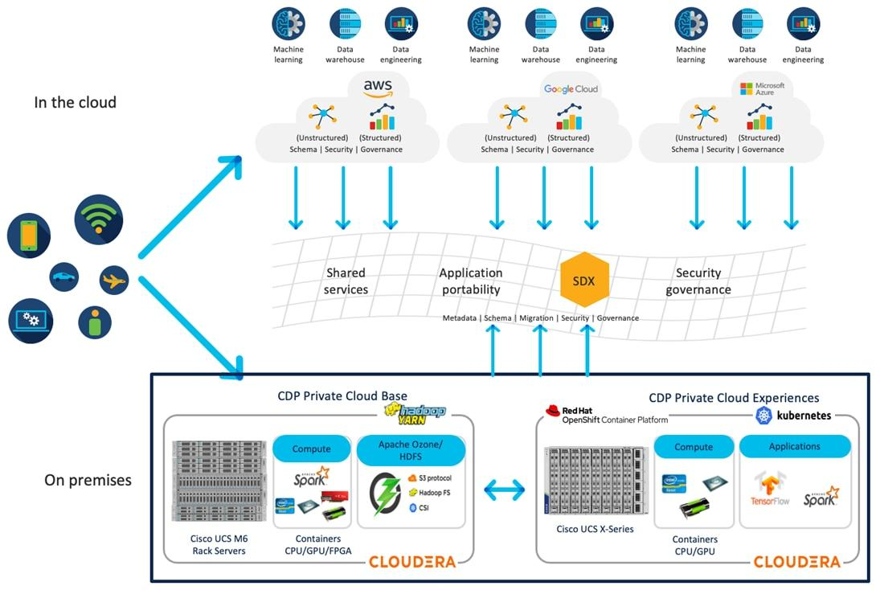
1. SIS Host Pool
- Dedicated physical hosts for SIS and examination applications.
- CPU and memory reservations.
- Restricted administrator access.
- No external research workloads.
- High-priority storage and network access.
2. LMS and Academic Host Pool
- Hosts LMS and departmental applications.
- Supports VM and container deployment.
- Uses resource quotas.
- Maintains separate network policies.
3. External Research Host Pool
- Dedicated hosts for Spark/Hadoop clusters.
- Uses VM-based or Kata/micro-VM-backed container isolation.
- Applies CPU, memory and storage limits.
- Separates research datasets from student records.
4. Network Isolation
- Separate VLANs or VRFs for each tenant.
- Firewall-based access control.
- Micro-segmentation.
- Dedicated or reserved network bandwidth.
5. Secure Live Migration
- Encrypt migration traffic.
- Authenticate source and destination hosts.
- Protect encryption keys.
- Schedule migration outside registration peaks whenever possible.
6. Storage Security
- Separate storage access permissions.
- Encryption at rest.
- Regular backup.
- Storage I/O limits for research workloads.
Effects of the Modified Architecture
Parameter | Effect
Density | Decreases due to dedicated hosts
SIS performance | Improves predictability
Research throughput | Improves with dedicated resources
Security | Stronger tenant isolation
Network | Reduced cross-tenant interference
Attack surface | Reduced between tenant pools

Conclusion:
The modified architecture provides better isolation between sensitive university services and external research workloads while maintaining the ability to scale the research environment independently.
D. Evidence-Based Defence (2 Marks)
The modified architecture is justified through performance modelling, experimental testing and security analysis.
1. Performance Justification
The Task 3 model demonstrates that CPU overcommitment and shared memory, storage and network resources can reduce performance.
Separating the host pools reduces resource contention and protects SIS workloads.
2. Noisy-Neighbour Experiment
The noisy-neighbour experiment should compare SIS-like application performance while another tenant runs a CPU-intensive or disk-intensive workload.
Resource reservations and quotas should reduce the interference.
3. Security Justification
Dedicated hosts, network segmentation and sandboxed execution environments provide stronger protection against external tenant attacks.
4. Cost and Density Trade-off
Dedicated hosts reduce VM density and may increase infrastructure costs. However, this is acceptable because student records require strong isolation and registration services require predictable performance.
5. Scalability
Additional research hosts can be added without changing the SIS host pool. This allows EduCloud to grow as research demand increases.
Final Conclusion:
The modified Type-1 hypervisor-based architecture with separate host pools is the most suitable solution for the new EduCloud requirements. It provides better security, improved workload isolation, predictable SIS performance and future scalability. Although resource density decreases, the benefits of protecting student records and maintaining service availability outweigh the additional infrastructure cost.

