August 2025 Poll
Poll concept: mid-year check-in

Screen 1: Context Template
Content
Paven Poll: Investing 101

[Title – / 45]
Class is in session: Investing 101

[Paragraph 1 – / 147]
It’s back-to-school season! Let’s see where you land on the stock market syllabus—from confidence to risk-taking in investments.

[Paragraph 2 – / 147]
Take this quick poll to grade your habits and mindset. You might even discover your next area of financial study.

Design direction

Screen 2: Poll Question #1
Content
[Title – / 65]
What grade would you get for your confidence as an investor?

[Answers – 80]
- A: I have a solid investment strategy and feel in control.
- B: I’m actively investing and learning as I go.
- C: I want to start investing but haven’t really tried yet.
- D: Investing still feels over my head.
Design direction
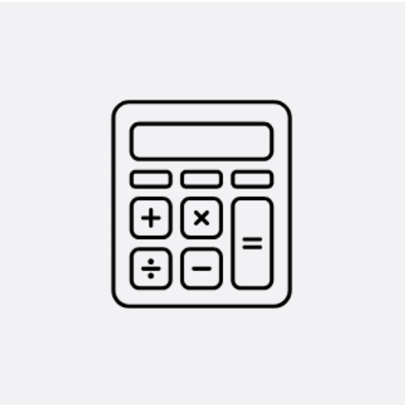
Screen 3: Poll Question #2
Content
[Title – / 65]
If you had to declare a major for your investment funds, what would it be?

[Answers – 80]
- Retirement: Building long-term wealth and security for retirement.
- Savings: Growing my capital to support future goals (e.g. house, child’s education).
- Freedom: Creating more financial independence and peace of mind.
- Undecided: I haven’t defined my investing goals yet.
Design direction
Screen 4: Poll Question #3
Content
[Title – / 65]
What kind of student are you when it comes to investment risk?

[Answers – 80]

- The Science Fair Daredevil: I’m comfortable taking bold risks if the potential payoff is high.
- The Studious High Achiever: I like a good mix of risk and stability in my portfolio.
- The Safety-First Hall Monitor: I prefer to play it safe, even if it means lower returns.
- The Undeclared Major: I’m still exploring what works best for me.
Design direction
Screen 5: Poll Question #4
Content
[Title – / 65]
How would you describe your investment habits in class participation terms?

[Answers – 80]

- Front Row Enthusiast: I’m always raising my hand and tracking performance.
- Middle Row Moderator: I like a consistent rhythm without overdoing it.
- Back Row Observer: I pay attention when something interesting pops up.
- Hallway Wanderer: I prefer a hands-off approach and let things run.
Design direction
Screen 6: Context Screen #2
Content
[Title – / 45]
Keep showing up for class

[Paragraph 1 – / 147]
Whether you're a hall monitor or a valedictorian, your investment journey is valid. Everyone learns at their own pace—and growth is possible.

[Paragraph 2 – / 147]
Stay curious, keep exploring, and remember: every step you take builds your confidence and maturity—semester by semester.
Design direction


Suggestion drawer action cards
Title | n/a
P-text | n/a
Suggestion 1
Suggestion 2
Suggestion 3
Push notification

