June 2025 Poll
Poll concept: mid-year check-in

Screen 1: Context Template
Content
Paven Poll: In for a penny

[Title – / 45]
Checking in: Are you in for a penny?

[Paragraph 1 – / 147]
They say, “in for a penny, in for a pound”—and when it comes to your financial goals, that mindset can make all the difference. At the start of the year, you may have tossed in your metaphorical penny: a small step, a new habit, a fresh intention.

[Paragraph 2 – / 147]
Now that we’re halfway through the year, it’s the perfect time to check in. Are you still on track? Have your goals shifted? Or is it time to double down and go all in?
#C0E5FF
Design direction
Reuse from January poll:

Screen 2: Poll Question #1
Content
[Title – / 65]
Penny for your thoughts: How are you feeling about your finances?

[Description – / 145]
As you think about your personal finances halfway through 2025, how are you feeling?

[Answers – 80]

- Confident; I’ve got this!

- Optimistic, but I need to keep up the good work.
- Unsure, but I have an idea of what I need to do.
- A mixture of emotions. It’s complicated.

Design direction
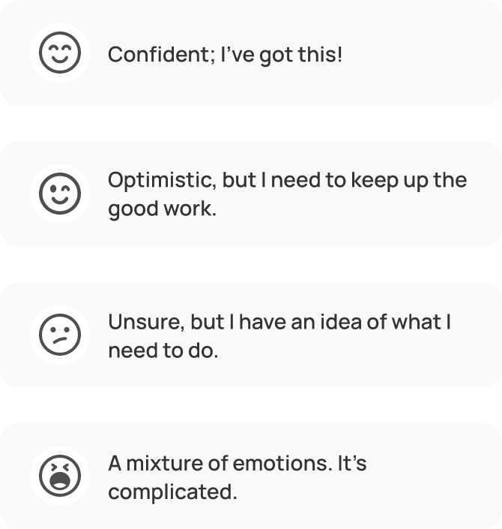
Screen 3: Context Screen #1
Content
[Title – / 45]
Thanks for your thoughts! Here’s a penny.

[Paragraph 1 – / 147]
Our penny payment comes in the form of this tip: The first step toward financial freedom is managing a healthy budget.

[Paragraph 2 – / 147]
By taking control of your finances and tracking your spending and saving habits, you’ll be better able to handle fluctuations and uncertainty.

[TIP]
Need help budgeting?
Use the Paven budget tool to track your spending and saving. Pick a timeframe to update it regularly. (Monthly or quarterly work for most.)

Design direction
Reuse from January poll:

Screen 4: Poll Question #2
Content
[Title – / 65]
Penny jukebox: What song are you playing?

[Description – / 145]
Which song best describes your financial concerns throughout the rest of 2025?

[Answers – 80]
- “Walking on Sunshine” – Everything’s great! My goals are on track.
- “Eye of the Tiger” – I’m determined to get some wins.
- “Sittin’ on the Dock of the Bay” – Not confident; waiting for inspiration.
- “Under Pressure” – I’m feeling stressed and anxious.
Design direction
 (Use same icons throughout)
Screen 5: Context Screen #2
Content
[Title – / 45]
Be your own jukebox hero

[Paragraph 1 – / 147]
The nice thing about jukeboxes is that you can change your tune at any time. You can also course-correct your finances on a dime (or “on a penny!”)

[Paragraph 2 – / 147]
The melody you sing later this year might have a totally different vibe than today's refrain. Keep those pennies handy to select your next theme song!
Design direction
Reuse from January poll:
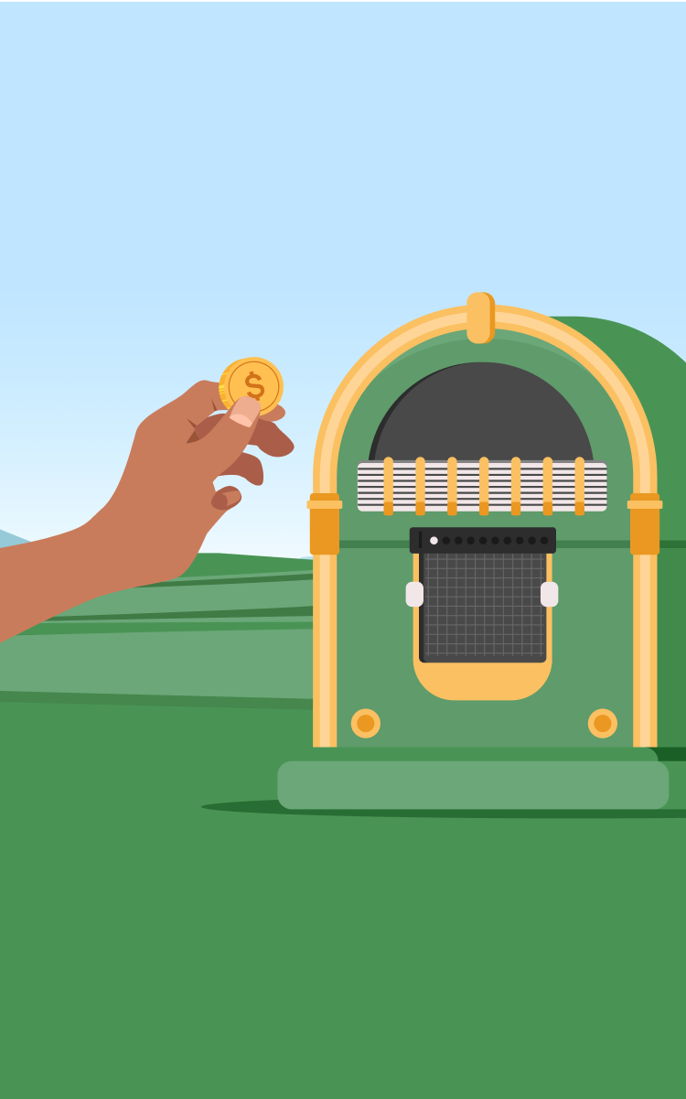
Screen 6: Poll Question #3
Content
[Title – / 65]
Pocket change: What’s in your financial pocket?

[Description – / 145]
Imagine your finances over the first half of 2025 as coins in your pocket. What would you find in it?

[Answers – 80]
- A shiny penny: Small but meaningful wins
- A lucky penny: An unexpected bit of good fortune
- A pile of mixed coins: Some gains, some setbacks
- Just lint: It’s been quiet on the money front
Design direction
Same icons as other questions/answers
Screen 7: Context Screen #3
Content
[Title – / 45]
Brass in pocket

[Paragraph 1 – / 147]
Whatever’s in your pocket—small wins, lucky breaks, ups and downs, or just lint—it all matters. Checking in means you’re staying aware, and that’s a powerful step.

[Paragraph 2 – / 147]
The year’s only halfway through, and there’s still time to grow, reset, or keep building on what you’ve started.

Design direction

Screen 8: Poll Question #4
Content
[Title – / 65]
Place your bet: Which play has the biggest win?

[Description – / 145]
If you had to guess, which of the following would most help you hit your financial goals over the rest of the year?

[Answers – 80]
- Knowledge: Making informed financial choices
- Confidence: Trusting myself with money decisions
- Reflection: Reassessing what I need and want
- Action: No more procrastination
Design direction
Same icons as other questions/answers
Screen 9: Context Screen #4
Content
[Title – / 45]
Your winning play is in motion

[Paragraph 1 – / 147]
Whether it’s knowledge, confidence, reflection, or action, you’ve picked the strategy that feels right for you. That’s how jackpots are won: one smart play at a time.

[Paragraph 2 – / 147]
The year’s not over, and your biggest win could still be ahead. Stay focused, trust your instincts, and keep spinning the wheel—your financial goals are within reach.

Design direction
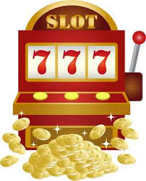
Screen 10: Full screen image
Content
[Title – 45]
Full pound finish

[Paragraph 1 – 160]
This mid-year check-in was your chance to reflect, reset, and recommit. You’ve put in a penny—now go the full pound and make the rest of the year count.

Design direction
Finish line with coins and cash as confetti.


Suggestion drawer action cards
Title | n/a
P-text | n/a
Suggestion 1 | Know your budget  Get started
Suggestion 2 | Navigating a choppy economy  Start reading
Suggestion 3 | Your feedback matters!  Share your voice
Push notification
🟤 Heads or tails? Time to check in!
Flip a coin, take the poll, and find out where your money mindset lands at mid-year. 🪙🧠

Penny for your mid-year thoughts?
We’re halfway through 2025—drop a penny in the poll and see how your finances are stacking up! 🎯💸

