Team working agreement
The Paven product team is a cross-functional, international group of strategic and creative professionals with a wide variety of skills, experience, and working styles. (Review our team activity Figjam for examples of our differences and similarities.)
This document captures our shared agreements as a team for how we collaborate and work together. It is a living document that can and should be updated as our needs and team culture evolve.

Team members
Name | Role | Location | Timezone
Angie King | Lead content strategist | Florida, United States | Eastern Time
Gloria Shugleva | Illustrator | [TBD], Bulgaria | Eastern European Time
Jolene Haley | Content strategist | California, United States | Pacific Time
Leif Drake | Lead product manager | California, United States | Pacific Time
Mariano Coni | Product manager | Neuquen, Argentina | Argentina Time
Michael Stephenson | Content strategist | California, United States | Pacific Time
Mladen Kliska | Lead engineer | Ontario, Canada | Eastern Time
Nadia Tovar Cordova | Animator | Mexico City, Mexico | Central Time
Scotty Kall | Researcher | Massachusetts, United States | Eastern Time
Vitto Calvetti | UI designer | Montevideo, Uruguay | Uruguay Time

Working hours across time zones
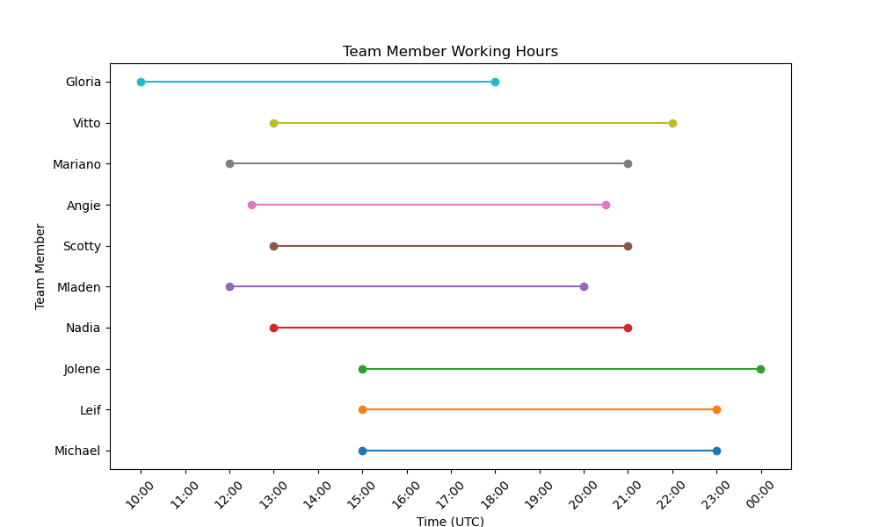
Convert UTC to your local time zone

Team Norms & Preferences
As a team working toward the same shared goals for our product, we agree to:
- Respect each other’s differences. With varying time zones, cultures, languages, and personal lives, our team has a wide range of personalities and preferences. We welcome the diversity of perspective this brings. We treat each other respectfully—even when we have differing ideas—by assuming positive intent and leading with curiosity.

- Work schedules that allow collaboration across time zones. See Working Hours Across Time Zones chart above for everyone’s typical availability, keeping in mind that our schedules may flex day-to-day. (Review the “What are our working hours expectations?” section in the team activity Figjam for individual factors that may affect working hours.)

- Schedule meetings at appropriate times for each other’s time zones.
  - Consult the Working Hours Across Time Zones chart and everyone’s Outlook calendars for availability and schedule accordingly.
  - All-team meetings should take place between 15:00 and 18:00 UTC to ensure everyone’s availability.
  - Smaller group or 1:1 meetings can occur anytime within the overlapping times that all attendees are available. In other words, don’t schedule something outside of someone’s normal working hours.
  - If the need is urgent and we cannot wait until an appropriate time is available for all, the meeting facilitator will record the meeting and/or provide an update to anyone not in attendance.

- Communicate our planned time off to the team via the Paven PTO calendar. If you do not have access to that in Outlook, ask Leif Drake to add you. In addition to marking your time off on the Paven PTO calendar, it’s also a best practice to:
  - Mark your own calendar with an all-day invite set to “Out of Office” in Outlook. This will block your calendar to show purple for your availability. That way, when others try to schedule meetings with you, they’ll know you’re out of office.
  - Send an all-day invite set to “Free” in Outlook to the full Paven team and any other partners you work with regularly. This will ensure everyone is aware of your time off without having to go to the Paven PTO calendar.
  - Set an Automatic Reply in Outlook for the days you plan to be away. Include the timeframe of your absence and who to contact for urgent needs while you are out.

- Use Teams for everyday collaboration outside of meetings. Use email sparingly for daily needs.
  - Use the Paven Standup meeting chat on Teams for topics that apply to or require help from the entire team. Otherwise, message folks directly or in smaller groups.
  - Remember that everyone works in different time zones and their responses may be delayed or sent in hours outside of your normal working hours.
  - That in mind, we can generally expect a response from someone within 1 hour of sending a Teams message.
  - If using email to communicate something more complex outside of Teams, our expected ETA for a response is within 1 day.

- Plan and track our work using a shared system, based on individual capacity over a 2-week sprint. (Right now, we use Jira and Confluence. But soon that will change to Azure DevOps.)
  - Unplanned work over a 2-week sprint can be brought in but may require prioritization over planned work. Discuss as a team and/or with your manager before taking on unplanned work about what to de-prioritize, if needed.
  - Individual team members are responsible for creating and moving their own stories across the board for each sprint.
  - We consult the sprint board every standup to stay aware of each other’s workstreams and help each other with blockers as needed.

- Help each other remove blockers and collaborate to get sprint work done. This requires timely and active communication! As a team, we agree to raise blockers, questions, support needs, offer help, provide answers, etc. to each other quickly and effectively via Teams, standup, or other meetings.

- Attend and actively participate in all required team meetings:
  - Standup
  - Sprint review
  - Sprint planning
  - Ad-hoc project meetings as they arise
  - Monthly retrospectives
  - Quarterly planning

Meeting etiquette (general)
To create the best conditions for a productive and collaborative meeting, we agree to follow these meeting etiquette practices as much as possible.
When scheduling meetings:
- Find a time that works for each attendee’s time zone (Working Hours Across Time Zones) and work around their existing meetings.
- Include a descriptive name for the meeting in the subject line.
- Include a brief agenda and/or objective for the meeting.
- Link or attach any necessary documents for context.
- Take notes or arrange to have an attendee take notes during the meeting.
- Record the call if needed.
- Turn on your camera to share both visual and verbal communication with attendees.
- Track the time and prompt people to move on to the next topic as needed.
- End the meeting on time to allow participants to get to their next meeting or task.
- Send meeting notes out to the attendees with necessary action items/next steps, if necessary. (Whenever a key decision is made or there are many action items, it’s best to document them for reference.)
When invited to meetings:
- RSVP your attendance as soon as possible to let the organizer know if you can make it. Please do not wait until the day of the meeting to give the host ample time to reschedule or prepare alternatives for you.
- If you can’t make the meeting, do one of the following:
  - Suggest a new time that works better for you using the Propose New Time feature on the Outlook invitation.
  - Direct message the meeting organizer to discuss alternative times, sending a proxy in your place, or determine if you can get caught up afterwards via meeting notes or a recording.
- Join meetings punctually. Message the host if you are running late with an ETA for your arrival.
- Turn on your camera to share both visual and verbal communication with the host and/or other attendees.
- Actively listen and participate during meetings.
- Leave meetings running long if you have other obligations to attend to, making sure to follow up with the host to request meeting notes and any action items for yourself.

