|  |
| --- |
|  |
| Project Initiation Document |
| KeyNorthNet Project |
|  |
| **Client: Sam North** |
|  |

|  |
| --- |
|  |

1. **Document Information**
   1. **Document Authors**

|  |
| --- |
| Author’s Name |
| Bokyung Moon |
| Dayoung Lee |
| Hongback Son |
|  |
| Professor’s Name |
| Mark Buchner |

* 1. **Revision History**

|  |  |  |
| --- | --- | --- |
| Version | Date | Note |
| V1 | 21-DEC-2017 | First Draft |
| Final | 04-JAN-2017 | Final |
|  |  |  |

* 1. **Document Approvals**

**Date: 21-DEC-2017**

X Sam North .

Name of Client/Rep

Company Name

* 1. **Document Purpose**

The purpose of this document is to define the project, in order to form the basis for its management and the assessment of its overall success.

1. **Project Overview**
   1. **Project Description (including Project Background)**

This project has been initiated since it has been recognized that SYS366 course project to support all processes and information would deliver benefits.

* 1. **Positioning**
     1. **Problem Statement**

|  |  |
| --- | --- |
| **Problem of** | Extended business will require centralized management system which would be able to support increased workload for employees, customer service, and balance out financial situations. |
| **Affects** | Customers, customer service, project management, finance management, and employees. |
| **The Impact of which is** | Inability to pay bills, unordered and abstract database, and overwhelming workload. |
| **A successful solution would** | Provide a centralized computer system that would handle the increase of workload and client-friendly customer database. Also, this solution would solve financial difficulty that the company is currently facing. |

* 1. **Stakeholders and Users**
     1. **Stakeholders**

|  |  |
| --- | --- |
| **Stakeholder** | **Category** |
| Owners | Technology Adopters |
| Project Manager | Standard User |
| Customer Service Manager | Standard User |
| Human Resource Manager | Standard User |
| Finance Manager | Standard User |
| Technicians | Standard User |
| Seasonal Staff | Standard User |
| Inventory Manager | Standard User |
| Class Manager | Standard User |
| System Developers | Developer/Authority |
| Centralized Computer System | Non-Human User |
| Customers | Customer |
| Government | Authority |

* + 1. **Stakeholder and User Needs**

|  |  |
| --- | --- |
| **Actor** | **Description** |
| Owners | * Efficient communication with employees * Business supervision * Assignment of duties employees |
| Project Manager | * Support project design |
| Finance Manager | * Process expense reports * Create profit reports * Schedule payrolls |
| Inventory Manager | * Ensures stock of product/equipment * Keep track of supplies level |
| Class Manager | * Manage classes for customers |
| Human Resource Manager | * Manage employees’ status * Hire/Fire employees |

* + 1. **Product Position Statement**

|  |  |
| --- | --- |
| ***For*** | Key North Cottage Supply |
| ***Who*** | Require a centralized computer system to aid in finance, customer service, and project management. |
| ***The*** | Centralized Computer System is an integrated management system |
| ***That*** | Aids in finance, customer service and project management. The new system will be able to solve workload in the process of extending company. |
| ***Unlike*** | Previous system has difficulty handling increased customer database, financial workload and project management. |
| ***Our product*** | New system provides durability, flexibility, and reliability for many years. |

1. **Scope of System Being Developed**

|  |  |  |
| --- | --- | --- |
| **Feature** | **Functionality of the Feature** | **Use Case Name** |
| Recruit Employees | Fire and hire employees | RecruitEmployee |
| Submit Expense | Submit expense reports | SubmitExpenseReport |
| Manage Employee Information | Add, update or delete employee’s information in database | ManageEmployeeInformation |
| Manage Office Activity | Support for efficient management regarding customer service | SupportCustomerService |
| Schedule Marketing Activity | Schedule marketing activities | ScheduleMarketingActivity |
| Maintain Equipment | Keep track of requests for equipment maintenance support | MaintainEquipment |
| Manage Expense | Process expense reports | ManageExpenseReport |
| Manage Class | Schedule classes | ManageClassSchedule |
| Manage Class Equipment | Manage equipment/supplies for class | MaintainClassroomSupplies |

1. **Design**
   1. **Business Rules**

|  |  |  |
| --- | --- | --- |
| **Rule #** | **Description** | **Use Case Cross Reference** |
|  | Each employee has to have unique identification number which is four digits. | **UC01, UC02,**  **UC05, UC06** |
|  | An employee must have a valid SIN number. | **UC02** |
|  | An employee must have a valid email. | **UC02, UC06** |
|  | KeyNorthNet is the name of Centralized Computer System regarding KNCS’s business. | **UC01, UC02, UC03, UC04, UC05, UC06** |
|  | All employees must have an ID on KeyNorthNet which is identical with employee number. | **UC01, UC02, UC03, UC04, UC05, UC06** |
|  | Permission type consists of Authority, Standard user, Customer, Technician. | **UC01, UC02, UC03, UC04, UC05, UC06** |
|  | The users to be created on KeyNorthNet have to fill up the following fields as mandatory: First name, Department relation, and Permission type. | **UC01, UC02, UC03, UC04, UC05, UC06** |
|  | Company credit cards may only be used for business expenses and may not be used for expenses of a personal nature. | **UC01, UC03, UC06** |
|  | Every expense report must have identification number; identification number of expense report is generated automatically from system. | **UC01, UC03** |
|  | Equipment should not have any defects that may cause difficulties during work. | **UC05, UC06** |
|  | The price of the equipment should not exceed the budget of the firm. | **UC03, UC04, UC06** |
|  | Customer’s information must be valid. | **UC05, UC06** |
|  | Customers must provide his/her identification number and phone number. | **UC05** |
|  | Each expense must have the payment information. | **UC02, UC03, UC04,** |
|  | Attached files are readable. | **UC03, UC04,** |
|  | Each customer must have a request or need. | **UC05, UC06** |

* 1. 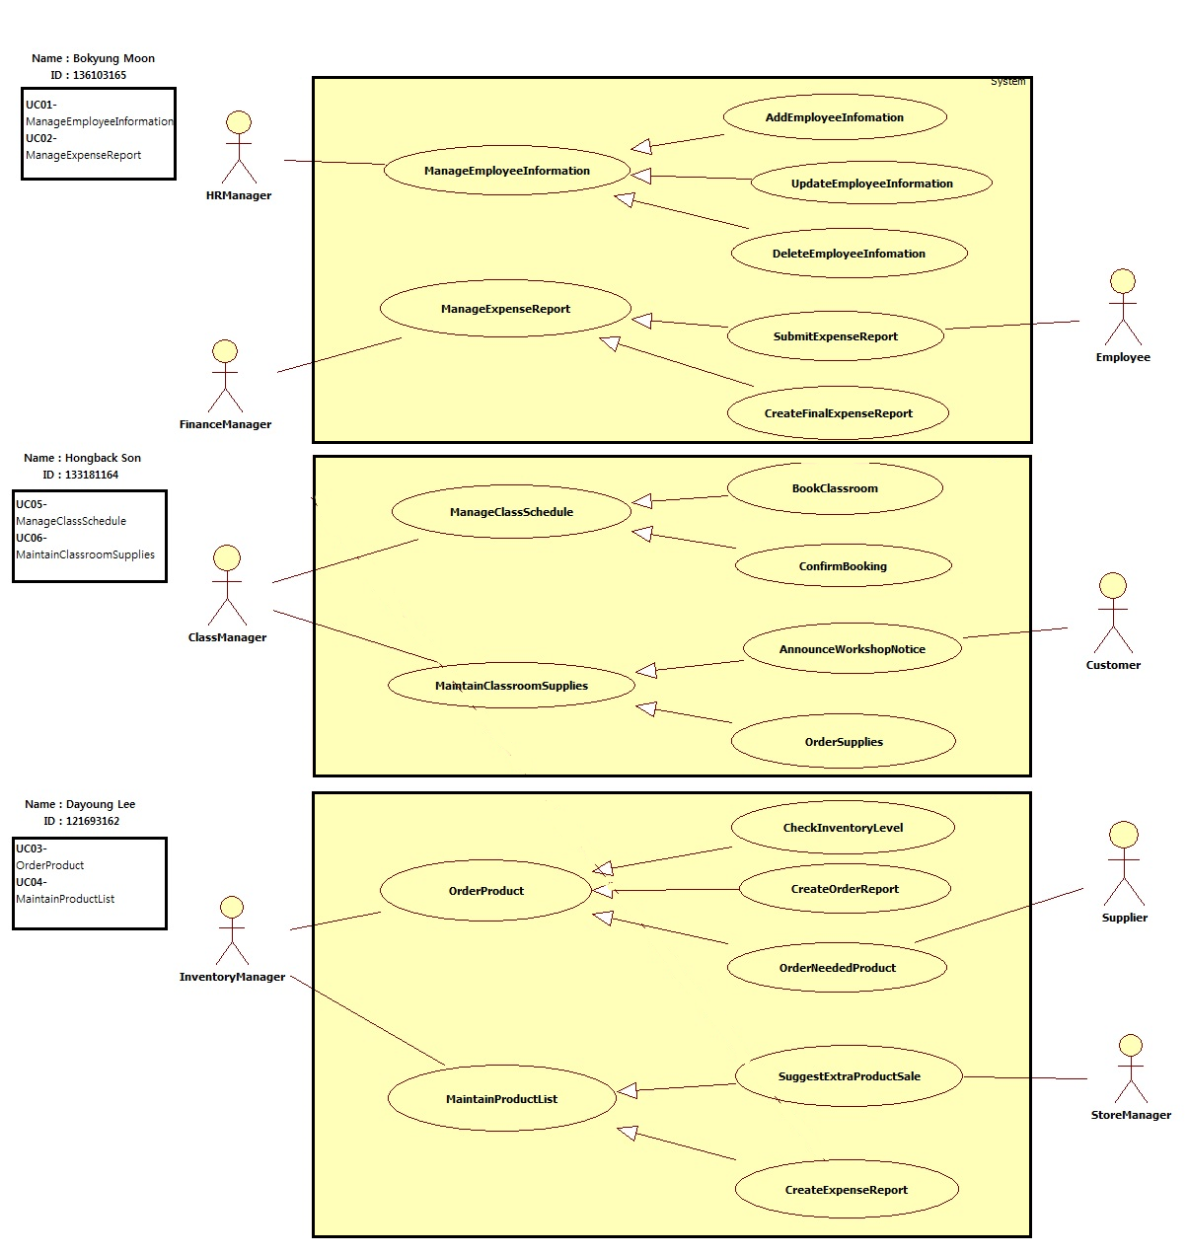**Business Use Case Diagram**
  2. **Use Case Specifications**

**4.3.1 Use Case Specification:**

**Identifier: UC01- ManageEmployeeInformation**

**Brief Description:**  This use case enables HR Manager to add the new employee information and change previous employee information in database.

**Section 1: Business Rule(s):**

**BR 01:** Each employee has to have unique identification number which is four digits.

**BR 02:** An employee must have a valid SIN number.

**BR 03:** An employee must have a valid email.

**BR 04:** KeyNorthNet is the name of Centralized Computer System regarding KNCS’s business.

**BR 05:** All employees must have an ID on KeyNorthNet which is identical with an employee number.

**BR 06:** Permission type consists of Authority, Standard user, Customer, Technician.

**BR 07:** The users to be created on KeyNorthNet have to fill up the following fields as mandatory:

First name, Department relation, and Permission type.

**Section 2: All Scenarios:**

**Scenario 1: Add employee information without errors**

Precondition:

1. At the moment when the use case begins, the system is displaying the Manage Employee Menu.
2. HR Manager must be logged-in to KeyNorthNet as Authority in order to access previous employee records.
3. Following filed is mandatory: First name, Department relation, Permission type, SIN number, Email

|  |  |  |
| --- | --- | --- |
| **Actor (HR Manager)** | **System** | **Data Used** |
| Click to add a new employee. | Display a list of employees including an employee ID and first name with a prompt to create the new employee information | List of Employees,  Employee ID,  First name |
| Enter employee information in detail on the fields | Displays fields which employee has to fill up as well as red signal for mandatory fields. | First name, Department relation, Permission type, SIN number, Email |
| Validate an employee first name and identification number | Validates first name and identification number have been entered. Adds an employee to the database and displays the employee list |  |
| Save the information | Saves employee records as protected record |  |
| Chooses to exit | Displays the other menu |  |

Successful Post Conditions:

1. Employee information is in database added properly.
2. Employee information in database is readable, accessible and editable to Authority permission, so Standard User cannot access the information.

**Scenario 2:**

Precondition:

1. At the moment when the use case begins, the system is displaying the Manage Employee Menu.
2. HR Manager must be logged-in to KeyNorthNet as Authority in order to access previous employee record.
3. Following filed is mandatory: First name, Department relation, Permission type

|  |  |  |
| --- | --- | --- |
| **Actor(HR Manager)** | **System** | **Data Used** |
| Select the edit an employee | Display a list of employee including an employee ID and first name with a prompt to create the new employee information | List of Employees, an Employee ID, First name |
| Select the employee ID that should be changed | Displays an employee input screen with the employee ID and first name filled in. |  |
| Input employee information should be changed in detail on the fields | Displays fields which an employee has to fill up as well as red signal for mandatory fields. | First name, Department relation, Permission type, *SIN number, Email* |
| Validate first name and identification number | Validates first name and identification number have been entered. Changed the employee information to KeyNorthNet database and displays the employee list |  |
| Save the information | Saves employee record as protected record |  |

Successful Post Conditions:

1. Employee information is in database changed properly.
2. Employee information is in database readable, accessible and editable to Authority permission, so Standard User cannot access the information.

**Identifier: UC03- OrderProducts**

**Brief Description:**  This use case enables the Inventory Manager to order products and get them from suppliers.

**Section 1: Business Rule(s):**

**BR 4**: KeyNorthNet is the name of Centralized Computer System regarding KNCS’s business.

**BR 5:** All employees must have an ID on KeyNorthNet which is identical with employee number.

**BR 6:** Permission type consists of Authority, Standard user, Customer, Technician.

**BR 7:** The users to be created on KeyNorthNet have to fill up the following fields as mandatory:

First name, Department relation, and Permission type.

**BR 9:** Every expense report must have identification number; identification number of expense report is

generated automatically from system.

**BR 11:** The price of the equipment should not exceed the budget of the firm.

**BR 14:** Each expense must have the payment information.

**BR 15:** Attached files are readable.

**Section 2: All Scenarios:**

**Scenario 1: Check inventory levels in the store and the warehouse**

Precondition:

1. Inventory Manager is logged into KeyNorthNet as Authority.
2. To begin with, the system shows the current inventory level.
3. The system displays how many products in the store and warehouse.

|  |  |  |
| --- | --- | --- |
| **Actor (HR Manager)** | **System** | **Data Used** |
| Click to inventory level | Display a list of the current inventory including an inventory number, name and quantity | An inventory number, Product quantity, Product name, Product order date |
| Check the quantity | Compare the current quantity of products and how many quantity customers need. | Product quantity, Product name |
| Make a report | Input how many products the company need to order | Product quantity, Product name |
| Save and submit | The system shows "save" and "submit" button. After the report (Step 3) finished, the user save it and submit. |  |
| Exit | If the user complete the report (Step 3) and do (Step 4), he click "leave this page", exit |  |

Successful Post Conditions:

1. The new order report is sent to Inventory Manager.

2. Final order report is saved as protected file, so it can be lost by any chance and makes the user only access the information.

**Identifier: UC05- ManageClassesSchedule**

**Brief Description:**  This use case enables the class manager receives classes facility reservation and accepts them after checking.

**Section 1: Business Rule(s):**

**BR 01:** Each employee has to have unique identification number which is four digits.

**BR 04:** KeyNorthNet is the name of Centralized Computer System regarding KNCS’s business.

**BR 05:** All employees must have an ID on KeyNorthNet which is identical with an employee number.

**BR 06:** Permission type consists of Authority, Standard user, Customer, Technician.

**BR 07:** The users to be created on KeyNorthNet have to fill up the following fields as mandatory:

First name, Department relation, and Permission type.

**BR 12:**Customer’s information must be valid.

**BR 13:**Customers must provide his/her identification number and phone number.

**BR 16:**Each customer must have a request or need.

**Section 2: All Scenarios:**

**Scenario 1: Book the classroom facility without double booking**

Precondition:

1. When this use case begins, Employees must be logged in on KeyNorthNet with their own ID for classes booking.
2. If, customers want to book classes, they must request ID for booking and then customers can book with temporary ID provided by class manager**.**

|  |  |  |
| --- | --- | --- |
| **Actor (classManager)** | **System** | **Data Used** |
| Log in on KeyNorthNet and customer click customer help menu. | Display a list of menus with login message | Employee ID |
| Customer enter private information and receive customer ID. | Display field which customer has to fill in | Customer name, phone number. |
| Enter employee ID or customer ID and choose booking date | Display digital calendar | Employee ID,Customer ID |
| Save and submit | Display message box “ contents is saved” |  |
| Logout | Display message box” log out? “ and “ yes or no” |  |

Successful Post Conditions:

1. Customer made a reservation for classes successfully.
   1. **Data Used List**

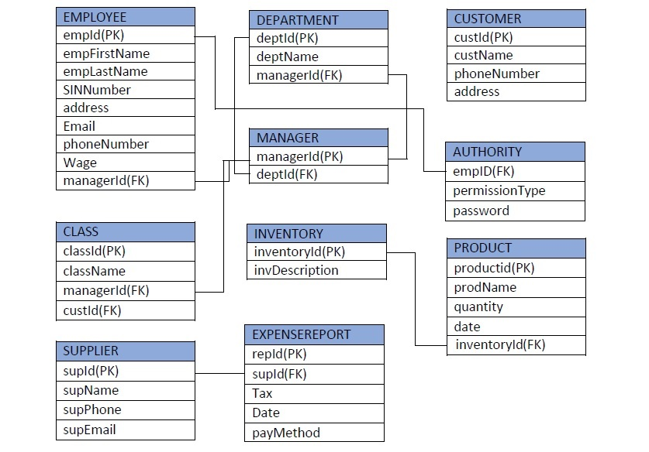

**Signatures: Date 04-JAN-2018**

Bokyung Moon

Dayoung Lee

Hongback Son