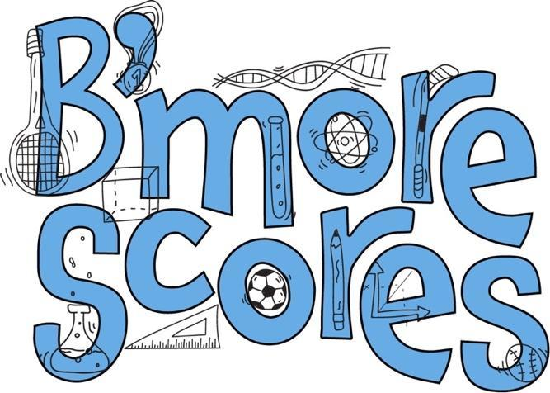

Baltimore Scores in STEM Scholarship Application
Spring 2026

Baltimore Scores in STEM was created to support students in Baltimore City County Public Schools who are pursuing careers in STEM fields (science, technology, engineering, and math). The goal of Baltimore Scores in STEM is to provide an annual scholarship award in addition to mentorship to Baltimore student-athletes who are enrolled or are planning to enroll in a STEM program at an accredited institution of higher education. To be considered for this, please send this completed application in addition to a transcript and resume to bmorescoresinstem@gmail.com with the subject “2026 Scholarship Application - Your Name.”

This award includes a scholarship of $2,000 towards the student's education in STEM ($500 per year for up to 4 years). In addition to this award, the recipient will have access to a network of professionals in STEM fields through which they can explore various career opportunities in STEM.

The application will close on 05/31/2026, and the award recipient will be announced in mid June 2026.

Please reach out to the email above with any questions!

Application Form

Please TYPE or PRINT your responses. If application is illegible, it will not be considered.
Last Name: |  |  |  |  | First Name:
Mail Address
 | Street:
 | City: |  |  |  | State: |  |  | Zip:
Personal
 | Email:
 | Phone Number:
 | Date of Birth (month/day/year):
 | High School:
 | GPA (on a 4.0 scale):
 | Anticipated High School Graduation Date (month/year):
College (enrolled or planning to enroll at):
 | Anticipated College Graduation Date (month/year):

Please respond to the following small essay prompts:

How have sports shaped your life both in and out of the classroom? (300 word limit)

Please share a personal anecdote that highlights your passion for STEM and illustrates why you are committed to pursuing it. (500 word limit)

