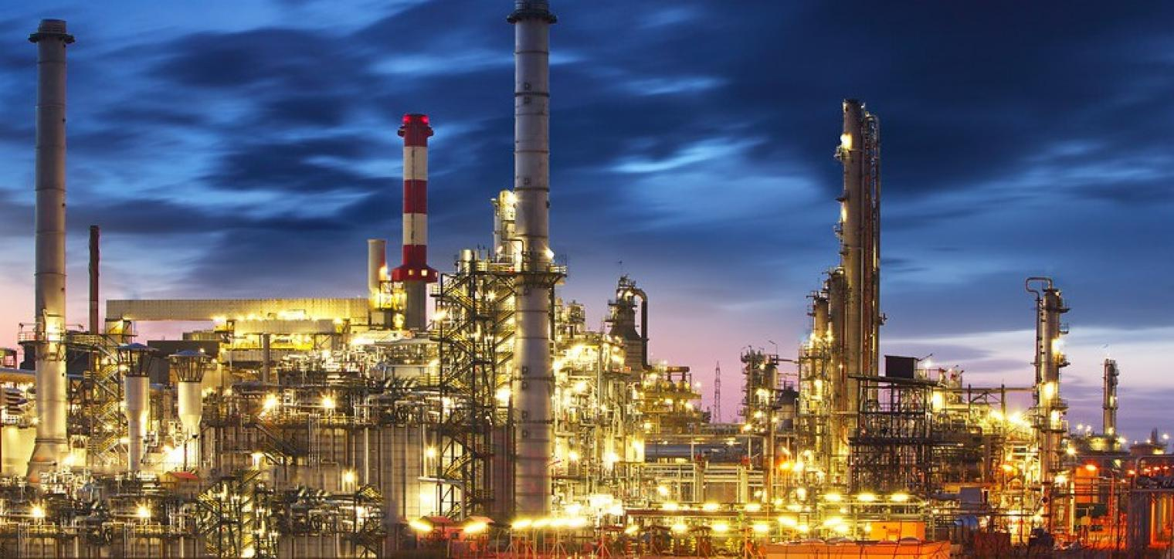

498Captial – Project Goals

Overview

The main objective of the project is to model the price movements and forecasts of energy commodities, including gasoline, heating oil, crude (WTI and Brent) and natural gas. We will be developing a proprietary data source derived from publicly available information published to the primary commodity exchanges. Using this bespoke dataset, our research efforts will be focused on using our domain-knowledge as well as our analytical and quantitative technical capabilities to develop predictive models as they relate to understanding the financial markets for energy commodities.

Our goal here is to not only model and predict the behavior of the commodity’s financial markets, but to successfully derive active market strategies that are able to consistently generate a profit, at a lower risk premium, than corresponding passively traded investment vehicles that are available to the public investment. If successful, we would have a product that would serve as an attractive alternative to the public passive investment options that currently account for 45% of the US stock market, or about $3.7 *trillion* dollars3.

Project Outline

Problem Statement / Project Proposal

Required background knowledge to bring problem into context / why our solution matters and is relevant to the problem at hand. An overview of our view of the current marketplace, and its limitations and a detailed look into our proposed solution, and what we want to achieve.

Working Assumptions

It is possible to predict the future price of gasoline and heating oil with the data given and the project team has the required technology and available information to build a mobile application.

Constraints

Managing resources are the key to success in any project, and this one is no exception. The CEO has given only 10 weeks for the project to finish. Additionally, we are budget conscious and will not purchase any additional data from Bloomberg, Morningstar, MSCI, etcetera to supplement our current dataset. Instead, we will rely on our domain expertise and technical prowess to overcompensate for lack of material resources.

Dependencies

Availability of resources across the necessary core team will impact the timeliness and quality of the final deliverables. The modeling is dependent on finding statistically significant relationships in the base data. The recommended trading strategies are dependent on finding meaningful outcomes from the predictive model.

Problem Statement / Background

Commodities are highly speculative and offer massive potential upside along with the prospect of staggering losses. As an example, a Tampa-based firm, Optionseller.com, recently reported a volatility spike in natural gas and crude oil trading that lead to $150MM in market value getting erased in a single session; causing all of the firm’s open positions to be closed due to margin requirements and all associated investment accounts to be liquidated1 .

While this should be considered a “Black Swan” type of event, we point this out as both an example and a warning of the implications lacking full understanding of one’s market exposure and tail risk; both of which will be paramount to the success of our fund.

Frequently, commodities pricing is heavily linked to uncertain government policies, inaccurate data and producer reporting, poor research as well as structurally flawed investment products (described below) of the environment. In aggregate, these challenges have led to several people moving assets into managed accounts, or passive investment vehicles, which coincidently, have seen an explosion on the equity side3.

These types of managed accounts are like investment vehicles, such as exchange traded funds (ETF’s) and exchange traded notes (ETN’s), and are, for derivative markets. In the next section, we will offer an actively traded alternative as a solution to this oversaturation of the passive investment marketplace. Not only is the passive market suffering from a lack of attractive investment vehicles, the equal weighted nature of these vehicles inherently means that they massively underperform the underlying commodities over time due to their fix asset allocation and lack of dynamic rebalancing. Despite all the challenges there seems to be renewed interest in commodity investing.

Opportunity / Project Proposal

Our solution to the insufficient and inefficient choices for passive investments offered in the marketplace is to develop an alternative investment vehicle that exploits the inherit structural constraints of passive investment products. The nature of passive products is to buy (long) and hold, and this is due to the regulatory / risk constraints that are imposed on investment products offered to the public4. The risk adverse nature of these funds limits their ability to trade in the derivatives market due to liquidity concerns, and additionally short-selling is prohibited as it is seen as “too risky” for main-street investment profiles. The lack of both derivative products and short selling in general is a major limitation is managing one’s risks, as these are the two primary tactics use to offset risk by process of hedging5 to offset the extreme levels of volatility in commodities.

At a high-level, our strategy can be summarized by looking at the one-year price change in heating oil seen below:

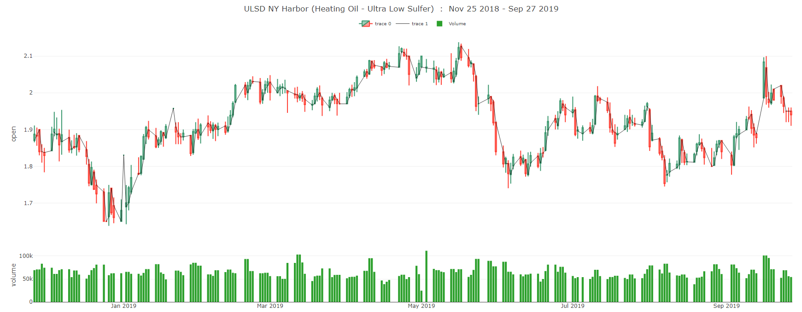

On a one-year basis, the actual price of the commodity moved a relatively small amount, finishing in total up about a quarter cent. However, even though the overall net price movements over the period were small, they were meet with extreme periods of volatility, with a maximum peak-to-trough of 1.65 to 2.12, or 22.17%, from Dec ’18 to May ’19. Additionally, there was another swing of 1.78 to 2.12 in the back-half of ’19. If one were to either successfully enter-and exit at optimal price points, or execute a long-short strategy over these periods instead of maintaining a long-only net exposure, we would have seen a time-weighted cumulative growth of over 15% for the period, relative to an actually negative return from being long-only (negative due to the time-value of money, even though the absolute return was positive).

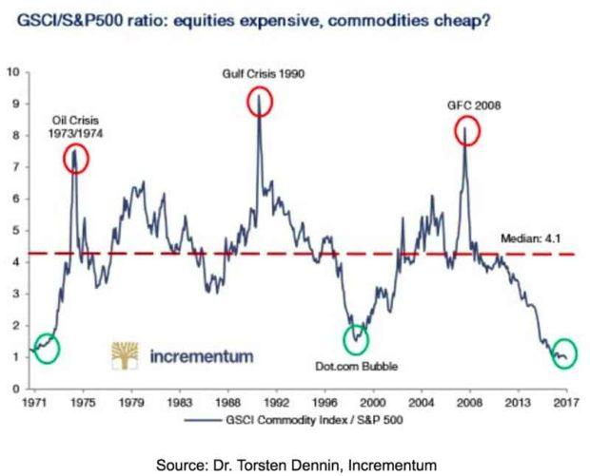Another recent example of such volatility occurred last month (September 2019) when there were attacks on Saudi oil fields. *However*, a lot of research likes to exhibit charts like the one in *Figure 2*, below. It shows the relative relationship between the levels of the S&P GSCI commodity index and the S&P 500 index of US stocks.

The idea is that when the line is ultra-low, such as now, it's a signal that commodities are cheap relative to stocks. The problem is that this is a ratio. It could just be signaling that stocks are expensive overall.

A popular way to invest in commodities is via index fund, such as an ETF or ETN. The commodity indices are all very different. Between different types of commodities, the supply and demand dynamics have nothing in common. However, speculative money flows can push all prices up or down, as investors pile into index funds, or dash for the exits. In the same day, one person makes a great case for why oil is heading higher while another uses solid reasoning to explain why it's going lower. Too often, commodities investing just seems like guesswork.

It's beyond the scope of this project to explain the full, technical details. However, the problem is that index-tracking ETFs and ETNs do it by way of the futures market, a type of financial derivative. A future is a contract to buy something later at an agreed price.

Investment funds don't want to take delivery of physical commodities, so they roll over the futures contracts before they expire. This means they sell the contracts that are close to expiry and buy longer-dated ones. Futures prices bake in something called "basis" on top of the current "spot" price of the underlying asset. Basis is the difference between the cost of owning an underlying asset (e.g. lost interest on foregone cash deposits invested and any storage costs) less the benefits of owning something directly (e.g. dividends on stocks and coupons on bonds).

In the case of commodity futures, there's no foregone income yield from owning the future instead of the physical. So, basis mainly consists of the cost side, or "cost of carry." This is because investors in commodities have a choice. They can either own the physical commodity, paying out cash and taking on storage expenses. Or they can enter into a futures contract, keeping the cash and any interest on it, and avoiding the storage costs. The basis element of the future's price keeps the economic pros and cons of both situations in balance.

Basis shrinks over time, as a future approaches expiry. As a result, the price of the future gets closer to the spot price, being the price to buy the underlying asset straight away.

When the commodity funds roll over their futures positions, this means they sell something with little basis in the price and buy something with more basis in the price. This means the funds are constantly locking in small losses at each rollover.It's more complex than that, involving things called "contango" and "backwardation." Therefore, funds that rely on futures contracts have a flawed structure that accumulates losses over time.

The project team will use a variety of cutting edge and sophisticated machine learning algorithms along with comprehensive technical and fundamental review of the energy markets. The first goal is to produce a simple technical chart forecasting the trading ranges of energy futures products. Given the time constraints, we will focus only on gasoline and heating oil futures. A dashboard will be created to not only give resistance guidelines on price, but trend indicators such as bullish or bearish. Below, in *Figure 3*, is a possible example of a future dashboard:

*Figure 3*

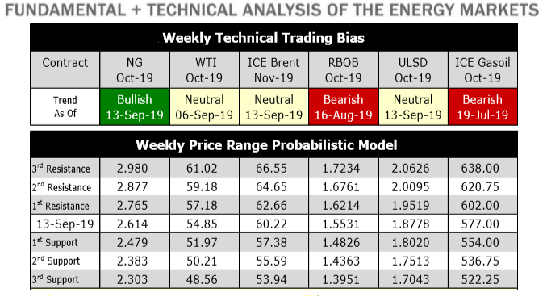

The next step will be to create a manageable number of different trading strategies with the inputs being the probabilistic models developed and creating a back-testing harness to evaluate. The main goal is to deliver a strategy that is both quantifiable in terms of profitability, but also within risk guidelines.

Appendix

The initial workflow is outlined as follows but is subject to change based on complexity and our initial findings.

1. Acquire the data
2. Preprocess the data
3. Process the data
4. Build the models – Linear regression and neural network (LSTM) seems to be popular on this type of data set.  Random forest to potentially classify the direction of the move in prices (bearish/bullish).
5. Test the model – train/test data sets
6. Build some type of back-testing system to test out a simple trading scenario.
7. Dashboard build
8. Build application

Scope

Functions in Scope

1. Exploratory data analysis
2. Model development in R, Python, and/or Excel
3. Model testing and validation
4. Trading strategy recommendation(s)
5. Trading strategy benchmarking versus relevant indices/benchmarks
6. Dashboard development using R
7. Application development using R

Functions Out of Scope

1. A plan for updating the base data over time (no API’s or data automation efforts)
2. Predicting the impact of potential future macroeconomic factors (such as changes in elected officials, potential military conflicts, etcetera)
3. Text analytics, such as scraping electronic news articles and/or websites to formulate a target price

References

1. <https://www.bloomberg.com/news/articles/2018-11-19/hedge-fund-s-accounts-liquidated-amid-energy-market-volatility>
2. <https://seekingalpha.com/article/4174551-problems-commodity-funds>
3. <https://www.cnbc.com/2019/03/19/passive-investing-now-controls-nearly-half-the-us-stock-market.html>
4. https://www.cfainstitute.org/-/media/documents/support/programs/investment-foundations/14-investment-vehicles.ashx?la=en&hash=5EAC60626C6439B462AED93EBA3D341EAB2E5FE4
5. https://www.sec.gov/investor/alerts/ib_hedgefunds.pdf