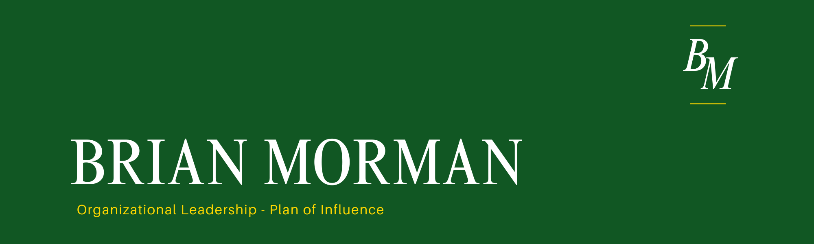

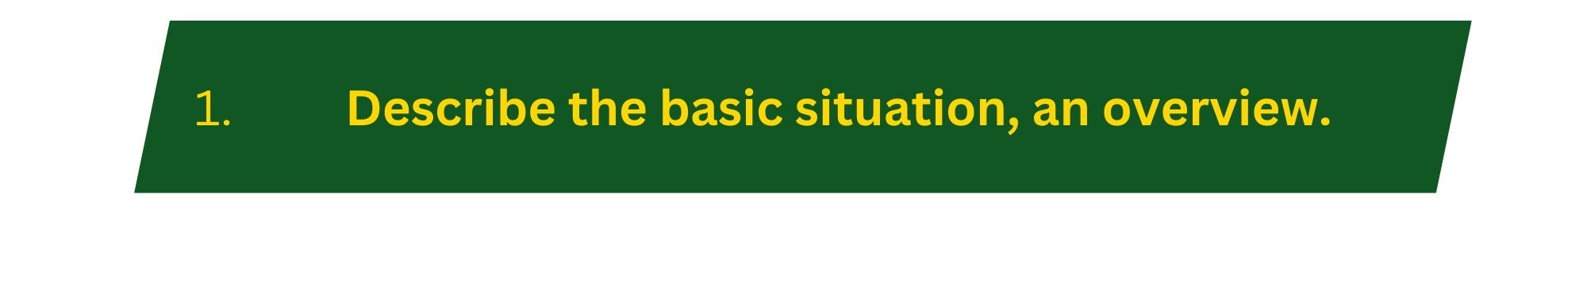
I support a classified development project at Boeing but one of the details I can share is that our group is working in new and interesting ways that are more digital and agile than programs in the past. Some of that digitization and Agile structure is already in place but some of it is developing while we work. This “how we work” problem creates a bit of a political situation as we begin our work. Our program management group uses a tool called Earned Value Management (EVM) to track work; our engineering team uses Agile to achieve our digitization goals. These two processes don’t mix well. EVM’s goal is to predict and plan for every piece of work while Agile prefers to plan less and adjust quickly to changes of plans. I feel that I have the skills to influence the process creation in a way that will mix with little waste. I was hired in part for my history in both systems. For the purposes of this paper, we will call my proposed process “Rolling wave” in which we plan every detail of the project a few months at a time to find a middle ground between EVM and Agile. Politics get difficult here because the software leads want to work fully Agile, finance wants to work in EVM, I will get to play a part in the decision making but I am brand new to my role and have little political capital to influence members of either team. I will need to quickly build capital, bring in individuals who already have capital, and build a coalition in order to influence this situation. I will own part of the result regardless of how much influence I am able to leverage due to my new role and title.

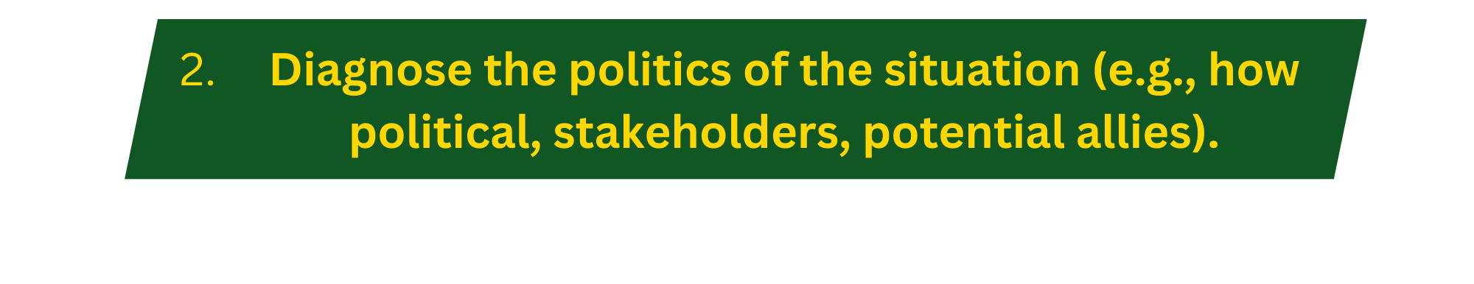

 | Low | Medium | High
Disagreement: To what extent will people disagree with or be opposed to your objective? | 1 | 2 | 3
Interdependence: To what extent does achieving this objective affect other individuals or groups? | 1 | 2 | 3
Resource scarcity: To what extent are resources scarce such that allocating them to this objective means taking them away from somewhere else? | 1 | 2 | 3
Stakes: How high are the stakes for the involved parties? | 1 | 2 | 3
Likelihood of Politics  (add all circled numbers, divide by 4, plot the result) | 1 -------------- 2 -----2.5----- 3

Explanation:
Disagreement: Boeing works very collaboratively. This is good because all voices are heard but ultimately this decision will be made in a room with as many as 20 individuals actively contributing to the plan. My idea is new to most of the room so if we had that meeting today the level of disagreement is high. My voice does not carry the weight that would be needed to convince these many experts to try something new.
Interdependence: However we choose to work, all the project teams will be working on the same process and that process will define how each team’s performance is scored. It determines who scored well and who isn’t. Each group will want a solution that works for their team.
Resource scarcity: Resources aren’t really in play with this question other than staffing plans that are already set. A manager could conceive that this idea adds work in a way they aren’t staffed for, but I believe that risk is low.
Stakes: The stakes are very high. EVM or Agile are both effort and progress tracking systems. These will provide visible score cards for how a team is working. All managers are in charge of keeping their team’s score and those metrics are very visible at the executive level as well as to our customers.

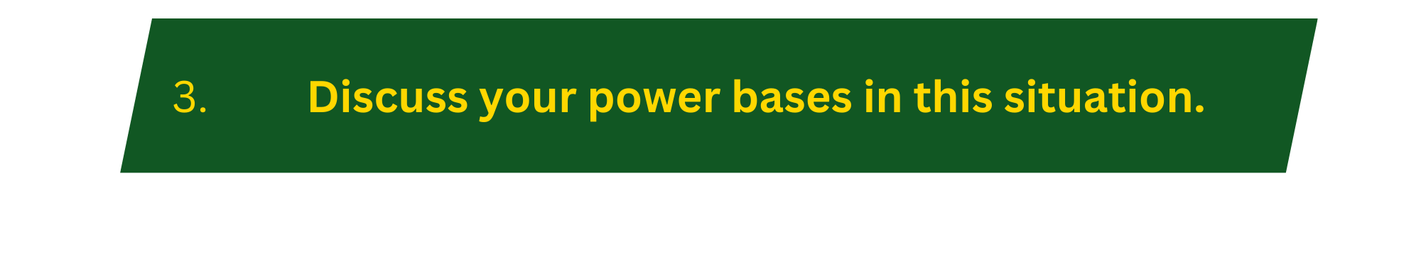

Stakeholder | Stakes  (-5 to 5) | Power  (0 to 5) | Pot. Force  (stk * pow)
Finance | -4 | 3 | -12
Customer | 1 | 5 | 5
My Manager | 2 | 3 | 6
Software | 2 | 2 | 4
Systems Engineering | -2 | 3 | -6
Program Management | -2 | 4 | -8
Me | 5 | 2 | 10
Total force against (sum of negative force) = a |  |  |  | -26
Total force for (sum of positive force) = b |  |  |  | 25
Net political force = b – a |  |  |  | -1

Explanation:
The current state of the stakeholder analysis shows the challenge I am facing in implementing my idea. Since the idea is new to all of these parties the positive stakes are pretty limited. This will need to be improved for this idea to stand a chance of achieving success and finding broad usage.
My analysis shows that I currently have a net political force deficit for my idea. In recognizing the deficit I face, I know it will be critical to improve the strength of the coalition for my idea to take root. The upside to this analysis is the fact that no one group holds a strong stake against my idea (aside from finance). This is because no group loves the way we are planning to progress now. As I review this table, I am seeing some key members to influence as allies. 1) My manager holds some power and can be easy to bring onside. 2) Program management is currently against but if I can gain some political capital and reputation quickly (maybe through my manager) I can bring onside a powerful ally who can outweigh the finance opposition. The customer has the ultimate power, but it will be the hardest party to move.

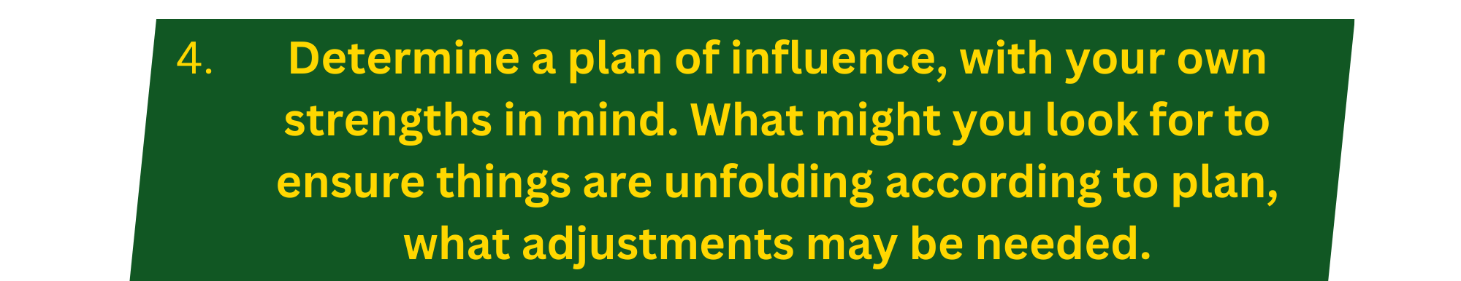
The first step is to bring on board my manager. If I can get his strong support, I can force multiply my influence using an individual who already has stature with all of these members. The less obvious second step is for me to network with PM in order to prepare a future ally and build my reputation with a key stakeholder. I plan to have my manager pitch the idea to PM. If I can improve my relationship with that group and convince my manager of the tech savvy of my idea, I will have the coalition I need to convince the rest. The key strategy I will employee to create buy in from my manager begins with involvement. This strategy has two purposes, 1 it creates buy in, but 2nd and more importantly it will allow me to work collaboratively to tweak my approach with his inputs to better work for our team and project. I will ask my manager for his advice on how my project management strategy should be adjusted to fit our project. In the meantime, I will be working on building my coalition and support base to improve my power bases all around. My reputation is undecided within my group. To set off on a strong foot, I will listen first and focus on building relationships with my team members. Where appropriate I will employe many of these strategies from ingratiation to carrot and more. I will be gathering information about my team and stakeholders to understand what motivates them and which tactics will work to improve buy-in all around.



