Team B – EMBA 60 – Precision Worldwide, Inc.

- Based on several data points resulting from computing information with the information provided, we can determine that switching as soon as possible to production of plastic rings is the best option Hans Thorborg can implement for several reasons:
  - The cost of the plastic ring is 25% lower than the steel at only $2.80
  - Direct costs for the plastic ring are lower, having a direct impact on profitability and contribution margin while being more cost-efficient
  - They have a faster break-even so that the company can recover fixed costs at a faster pace, almost 5 to 1
  - This also allows flexibility and more room to play with price when other competitors enter the market
  - They require fewer labor hours, allowing for efficiencies in overtime
  - Steel rings will be out of market eventually, as plastic continues to win demand

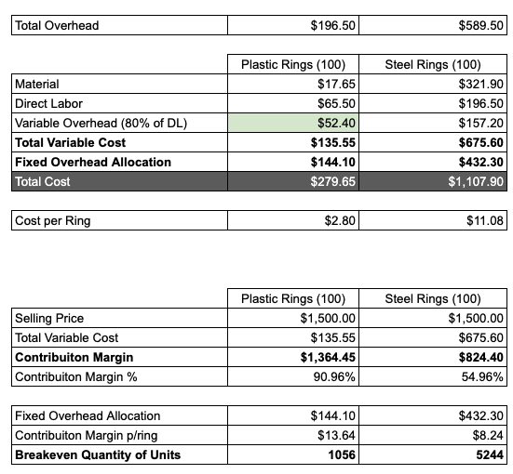

- Regarding the existing inventory, he should continue to sell it in the 90% of the market where he’s not facing Henri Poulenc direct competition
  - Even at 70% regular wages, the raw material wouldn’t be as profitable and cost efficient to have workers produce more steel rings rather than to get ahead and make more plastic rings
  - Producing steel rings is very labor-consuming, however, it would need to be further analyzed versus the cost of recruiting and training existing workers that might be laid off otherwise

