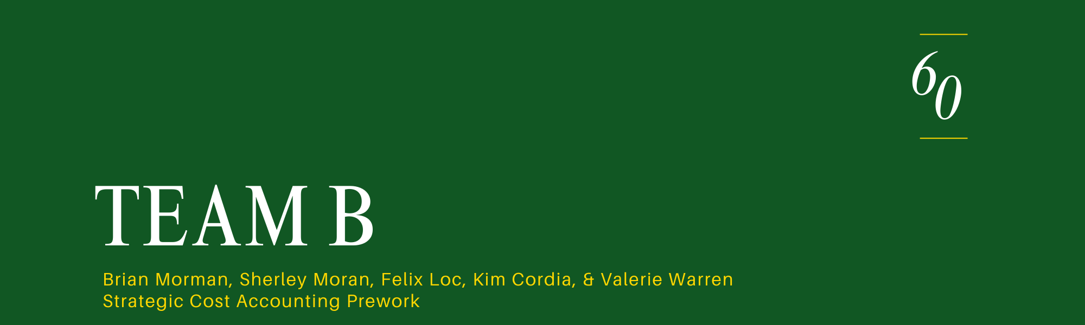


The table below outlines the P&L for Fasteners and Attachment machines. The embedded xls includes more columns to describe the thought process for each cost decision made.
$000 |  | Fasteners | Attachment | Total
 |  |  | Machines
Revenue |  | $96,000.00 | $7,000.00 | $103,000
CGS
Material |  | $31,000.00 | $0.00 | $31,000
Dir. Labor |  | $1,610.00 | $0.00 | $1,610
Machine Ohd. |  | $4,500.00 | $0.00 | $4,500
Total |  | $37,110.00 | $0.00 | $37,110
General Ohd.
Fac. Support |  | $3,020.00 | $0.00 | $3,020
Fac. Supplies |  | $470.00 | $0.00 | $470
Tech. Adm. |  | $1,400.00 | $5,100.00 | $6,500
Support Dep. |  | $6,500.00 | $0.00 | $6,500
Machining Dep. |  | $2,390.00 | $10,960.00 | $13,350
Tooling Dep. |  | $3,050.00 | $0.00 | $3,050
Total |  | $16,830.00 | $16,060.00 | $32,890
SG&A
R&D |  | $3,874.00 | $1,936.00 | $5,810
Admin. |  | $2,572.00 | $188.00 | $2,760
Marketing |  | $7,391.00 | $539.00 | $7,930
Shipping |  | $2,955.00 | $215.00 | $3,170
Commission |  | $3,830.00 | $0.00 | $3,830
Total |  | $20,622.00 | $2,878.00 | $23,500
Total Cost |  | $74,562.00 | $18,938.00 | $93,500
Profits |  | $21,438.00 | -$11,938.00 | $9,500


After reviewing the case carefully, we would suggest M-L keep much of their business operation the same. They are winning on quality. Their tooling group is where most of their expenses come from, but it is also the one thing that differentiates them from their Japanese competition who have them beat with economies of scale. They have a problem that their customers can see a lower price tag with the Japanese product at time of purchase, but the hidden costs of that product include, lower quality products, possibly more machine downtime from less qualified companies handling their fastening tool service, probably more scrap, and other hidden costs. To combat this phenomenon, we would recommend that M-L offer to sell their automatic fastening tools directly as an alternative to rentals. If a customer should choose to buy a tool, they can offer service at a cost and offer some kind of discount (maybe 10%) to keep customers using their fasteners with those machines. In doing this, they can greatly reduce their expense from service or increase revenue to that cost center. Since it is costly to switch manufactures, customers will not actively look to jump to the Japanese competition and this model allows those customers who are enticed by the Japanese model to try it out while sticking with M-L. To us this added offer allows M-L to continue to leverage their product differentiation while fending off the threat from their Japanese competition. M-L’s biggest problem is cost driven by their attachment machine business. There are ultimately several ways to improve their P&L but they will ultimately reduce the cost by stopping their machine offering or by creating more income by changing the sales strategy they are currently employing that gives so many services free to the customer.



