LEADERSHIP CONTEXT STATEMENT
Submit a 3-page statement of your leadership context and the challenges/opportunities it offers. The purpose of this statement is to contextualize your development efforts, and to provide the necessary background for leadership coaching. Your context statement should include the following:
- Briefly describe your role and key responsibilities. How do you fit into your organization (include an organization chart)?
In my current role, I am a senior electronics systems engineer in Defense Mission Computing at the Boeing Company. Our team’s job is to design the computers that run the mission systems for defense aviation. Our group is at an interesting pivot point. The 2020 pandemic and its economic impact pushed Boeing to grant a large number of early retirements that removed a lot of experienced engineers. That lead to a waive of promotions to backfill chief engineers and managers and opened many jobs at Boeing at the middle career level for people like me. I joined Boeing in April 2024 after spending 10 years at GE Appliances in Louisville, Kentucky. At GEA I was a high performing young leader and management was giving me opportunities to apply for some stretch roles in management or as a chief engineer myself. I thought I would stay at GEA for a very long time and utilize the reputation I built and job skills in the appliance industry to grow there. After the birth of my second born my wife, Annie and I decided it was time for us to leave Ky and move somewhere with some family support. While I loved my job at GEA it was no sacrifice for me to leave there. Family is my first priority, and I embrace change and new adventures easily. I joined Boeing with a lot of excitement and joined a team of young engineers, many close in age to myself and was hired in as an Engineer 4. In my team, this makes me the most senior individual contributor in the group. 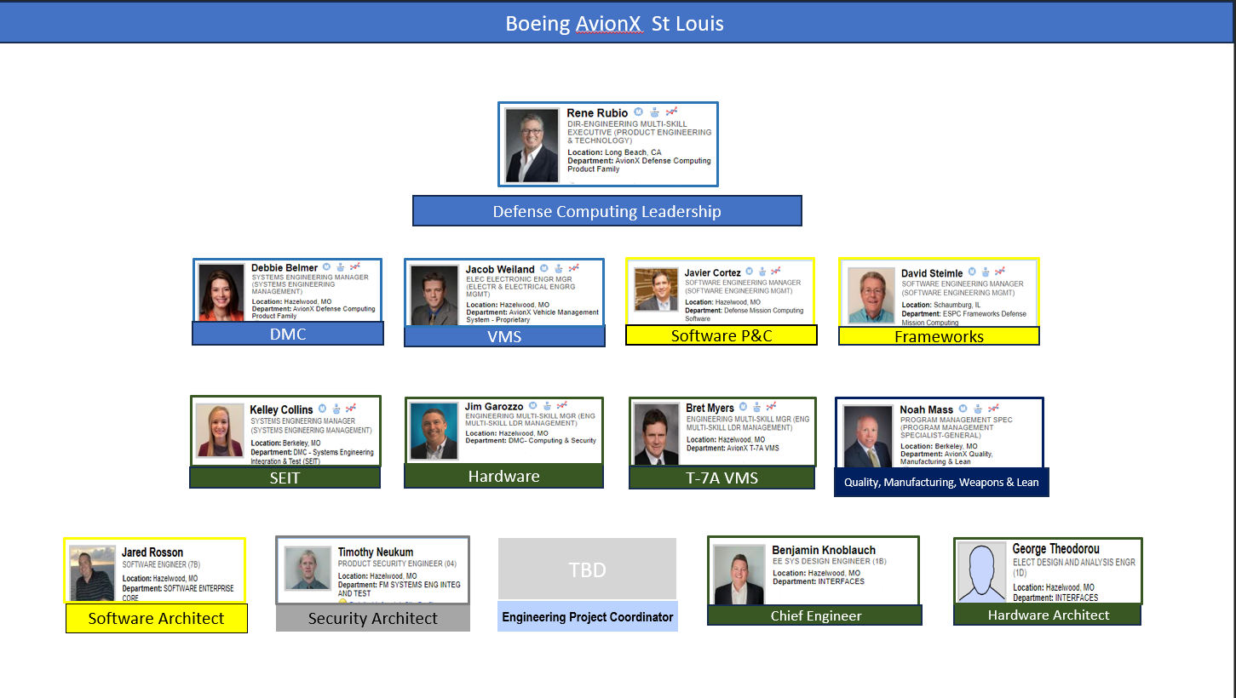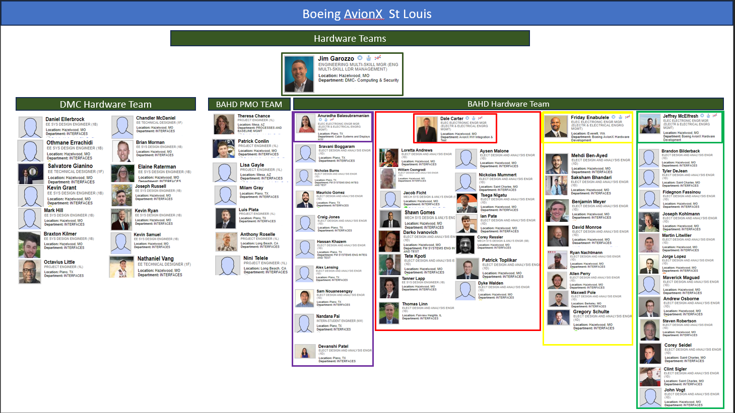
- What is working well for you now in your current role? What are the challenges associated with your current role?
In my new role, I have found it somewhat difficult to gain traction and feel like I am making a great impact. I struggle to identify if that challenge comes from the learning curve of any new role or if it’s the team, I find myself on specifically that causes my frustration. Defense contracting has a hiring challenge that is unique in someways. Since our group is bidding on government contracts, we often need to hire well in advance of work packages that can’t fully be accessed until after the contract is awarded. DMC has found ways to keep me busy in the short term, but I have been hired for one such potential contract and I was not aware of that situation at the time I was hired. In the meantime, I have been used as an engineer for loan to a commercial project and offered some research and development work that really doesn’t fit my expertise. I am hungry and eager to grow in my role and start creating the reputation I had at GEA but currently I feel that the work I am assigned is not valuable to my team. I find myself reflecting on the intrinsic motivation I feel in my current work, and I find it to be thus far, much lower than I enjoyed in my previous work. Additionally, I am faced with some cultural challenges in my new role. My team is low diversity and traditional in some ways that are in conflict of my values. I will discuss how I am dealing with these challenges in a later paragraph but in short, I attempt to embrace a Stoic philosophy about these struggles and view them as opportunities to better myself.
- Where would you like to be professionally in 3-5 years?
In 3-5 years, I hope to have built a reputation for myself as a highly accountable problem solver in my career with great skill and compassion in leadership. I have a lot of growing to do technically speaking if I plan to grow into leadership within my organization so on paper my five year plan says I will build my skills as an individual contributor over the next 2-3 years to grow to a systems lead with greater expertise than just my electronics background and in 3-5 years to leverage technical capabilities along with my natural leadership style into my first people leadership role. From there I have career aspirations to direct a group one day and take on a large-scale formal leadership role in the next 10.
- What strengths do you see as necessary to reach your goals?
In the world of engineering my personality and soft skills have been my superpower. In many ways I do not fit the engineer’s mold. I am people focused and energized by daily interactions. I also have a great depth of technical knowledge and diverse insights to share as an engineer from two industries. I came to engineering with a passion for infusing creativity into products by facilitating personal connections between individuals with deep knowledge and skill and I still believe that is one of the biggest parts of my value as a contributor.
- What weaknesses might hinder your progress?
I think its common to feel that our greatest strengths also reflect our biggest weaknesses. For me at least, this is certainly true. I find that my love of human connection and drive to make friends in the workplace also leaves me vulnerable to negative feedback and allowing it to cause me a high level of stress. I have often taken negative feedback very personally which can slow my progress when trying to address the issues that may have caused that feedback. Conflict in the workplace is not comfortable for me which has really been highlighted when my values have been challenged in my new role. To become a great leader I will certainly need to deal with conflict in a more confident way and to strengthen my values backbone to be able to convey them respectfully and draw the lines I find uncrossable without fear of how others will react. Thirdly, I feel that despite working in two industries and with individuals from all different backgrounds, my employment horizons are small. I have only worked for large scale legacy US employers with long histories. I need an understanding of how the rest of the world operates to build on my network and see if the places I have looked for work are really the best places for me to succeed.
- What core values do you aspire to live by as a leader/manager?
After some reflection my core values as a leader are: kindness, growth, humor, reputation, and competency. First and foremost in my list is kindness. I find that each person brings their life experiences with them to work every day and as the saying goes, each of us has no idea of the burden another carries. If we can start our interactions from a place of kindness and care, we each offer one another a bit of grace in our mistakes and look to uplift one another and support success for each individual. Growth is a personal value that I try to share with colleagues, and I am always interested to see where others are choosing to grow. I believe in encouraging a growth mindset to take on new challenges and stretch ourselves constantly. I find great satisfaction to push myself to do more or do better physically in the gym, mentally in school and work, and emotionally by doing self-reflection and reading Stoic philosophy.

