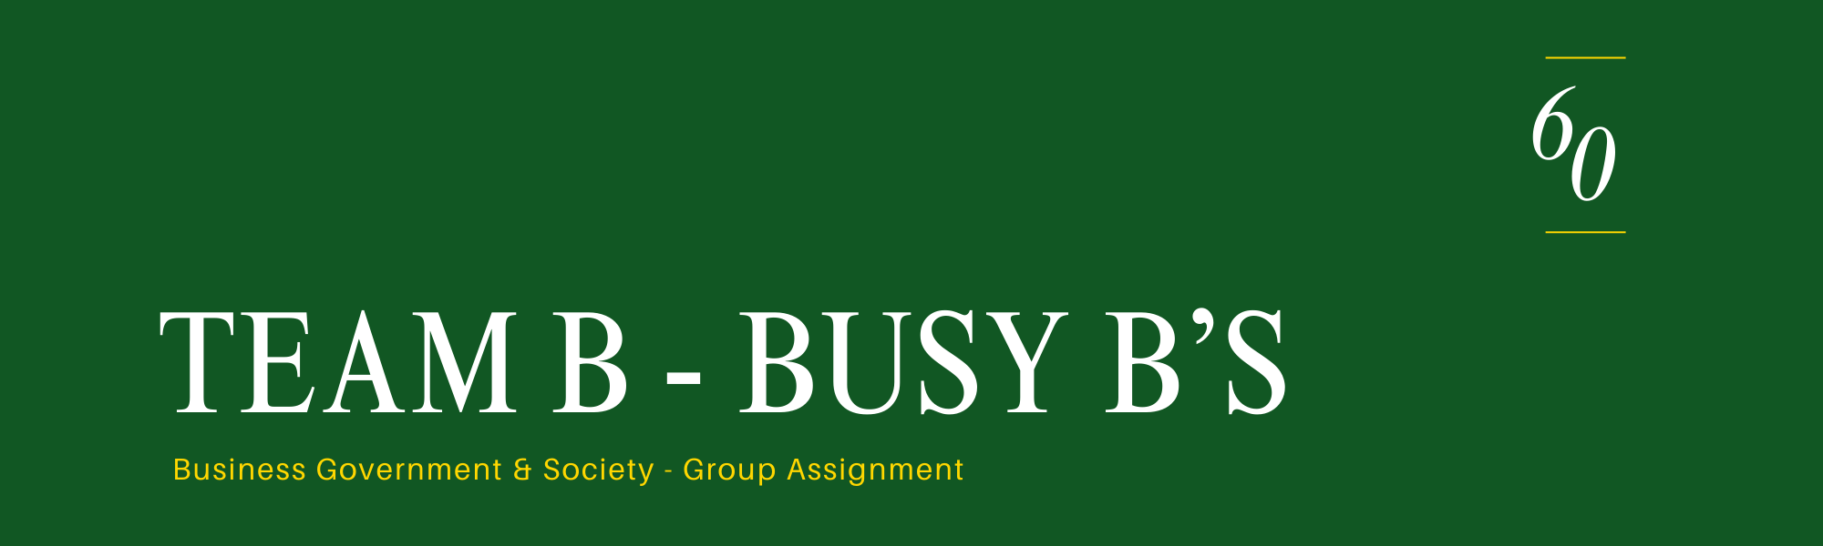
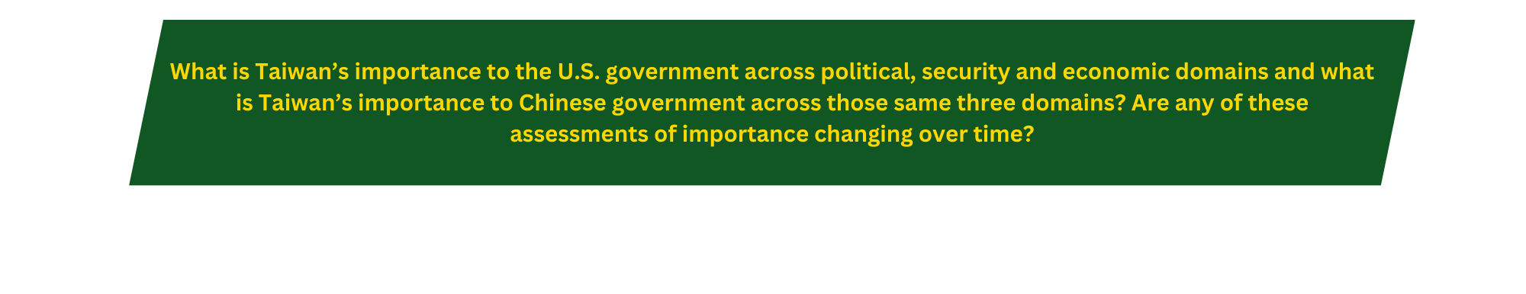
Taiwan is a critical partner to the US for several reasons. The first that comes to mind is technological and economic. In the late 20th century globalization and technological advancements allowed the US to step away from a manufacturing-based economy to one that leads in integration and services. With this shift many US companies began to insource many manufactured goods from the Asian continent. The Taiwanese government heavily encourages foreign direct investment which has attracted many manufacturers to have key US goods built in Taiwan. Key items from Nike shoes to iPhones and many other popular products are assembled in Taiwan. But possibly even more importantly, Taiwan is home to the leading semiconductor fabrication company in the world, Taiwan Semiconductor Company (TSMC). The growth of TSMC is closely linked to the growth of US computing companies (such as NVIDIA) and technological growth. Through TSMC, Taiwan fabricates nearly one third of all computing capacity around the globe each year. For decades now, industry in Taiwan and the US has become more and more intertwined. Legislation like the Chips Act take aim at reducing US reliance on semiconductor fabrication abroad but the US is far from ready to support itself if cut off from supply from China or Taiwan. Politically, Taiwan remains an example of how the US and the West stand up for and protect democracies from authoritarian regimes across the globe. It helps to show other developing countries that democracies are powerful and worth the difficulty it takes to create and uphold one. From a global defense perspective this may stand as a deterrent to other authoritarian countries from taking aim at regional democracies to bring under their power.

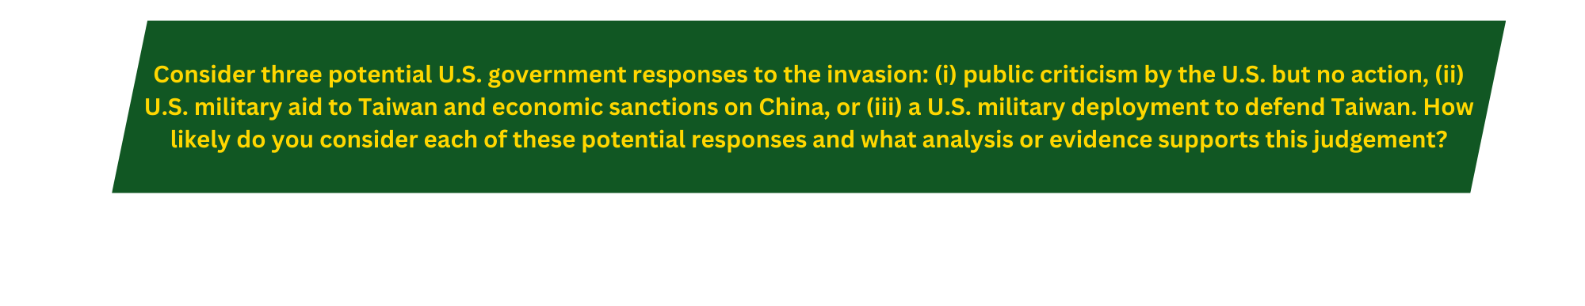
US military aid to Taiwan and economic sanctions on China – I view this as the most likely scenario in response to a Chinese invasion of Taiwan. For one reason, US policy makers have already proposed legislation that would mandate the placing of economic sanctions on China in the event of an invasion of Taiwan. (per the article “Sanctioning China in a Taiwan Crisis Scenarios and Risks”) Secondly, the US response to the Russian invasion of Ukraine has already included military aid for years which creates a blueprint for how the US could respond to this crisis situation. I recognize the situations are different. China has long claimed that Taiwan is a part of China. The US has never officially recognized the independence of Taiwan. But the most modern example of a similar situation has had this outcome. All things considered, I believe this would be the US and a minority of the G7’s primary course of action. After this step is taken, I would view the risk of further escalation as slightly less than a coin toss.
Public criticism from the US but no action – I would view this as the least likely course of action. China’s leader has warned that any action taken by the US that shows a lack of respect for China’s claim to Taiwan would be met with military action and considered an act of war. Tensions have tightened over recent years as both the US and China walk closer and closer to the line of a direct conflict. In a game of chicken with potentially world ending implications and all the history between China and Taiwan I could easily understand why the US response to this significant step over the line might be to step back and allow the invasion to take place at great detriment to the US economy. But I believe in a different kind of America that does not back down to bullies and easily give away its power as a world superpower.
US military deployment to defend Taiwan – A war with China would obviously be a terrifying turn in world history but for better or worse, I believe that Americans still believe in our role as the “good guys” to protect the rights of all human beings when they are existentially challenged. For this reason, I believe that the US would more likely take military action to defend Taiwan than they would to allow it to go unchallenged. While this war would be terrible for the world, I believe a great generation of Americans would again rise to the challenge of protecting the globe rather than allow China to replace the US and G7 as the world’s military and economic superpower.

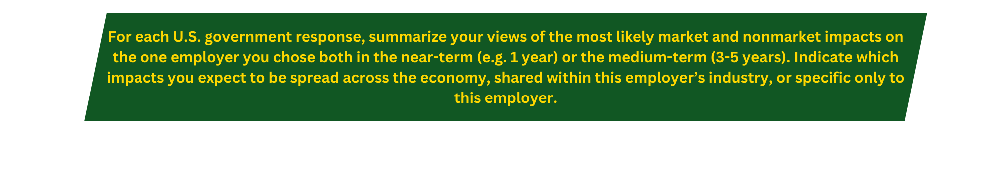
The impacts of each of these options bring about the same response from the Boeing Company but the key differences would be in scale of the response. In any of these cases the defense spend and incoming contracts would grow. Boeing would, and likely already is, focus on technological innovations in air defense and weapons defenses to serve the needs of the US military. The article “Swarms over the Strait” describe how drone technology is expected to play a role in any US China conflict over Taiwan’s freedom and lay out what innovations the US would likely need to see from its defense contractors. The article calls out a need for light, high endurance, low-cost drones paired with highly technical drone technology to participate in a conflict with China who already have amassed a large drone fighting force. Boeing would be included in the efforts to innovate and create this technology as well as the tech needed to quickly train the operators of these new drones. Industry experts anticipate that next generation fighter technology for both the Airforce and Navy would be expected to include the same high endurance upgrades based on the geography of the conflict and how it would likely play out (source 1945 see citation below). The commercial business would be hit hard by the cut off of supply of goods coming from China. While Boeing products already have a ban from using any technology built in China, the small electronic manufacturers Boeing currently uses in other countries would be slammed with high demand which would quickly overwhelm the moderate demand of an aerospace application. The Boeing Defense response would likely remain the same over time as the conflict continued but the commercial response would likely drive some creative thinking for how to keep the Airplane assembly plants running. Boeing R&D would work to find replacements for the now hard-to-source technologies. They may even turn to fabricating their own semiconductor devices if the supply chain is not expected to return to normal over several years.

With 90% confidence of some action taken by China against Taiwan, I think Boeing Defense Systems (BDS) would change very little of what it is doing now. Changes would come to the scale of the work they are doing but not to the scope of work. This sort of conflict is a market issue for BDS that drives direct demand. The more interesting conversation is likely around how Boeing Commercial Airlines (BCA) would respond. First, I anticipate design activities around creating new electronic commercial technologies would be halted as non-essential business while labor hours were redirected towards redesign efforts for critical products with risk of any supply chain disruption. Inventories would surge for those same supplies as efforts would be made to build a nest egg of any devices with risk of stock shortages. Since the disruptions would be uncertain, I expect that purchasing would be done through a third-party company that would procure and hold the parts in the US at an upcharge based on the risk the parts won’t be needed. BCA may also look at this as an opportunity to forge a stronger relationship with the US government or to leverage the demand for defense products at low cost against the sanctions and fines placed on the commercial business. They could argue that the manufacturing restrictions currently levied against the commercial business tie up cash that is needed to quickly respond to this upcoming crisis. I anticipate the US government would not be likely to agree to this deal but it’s one that could be attempted. Ultimately none of these strategies are really actionable at a 10% risk of conflict. At 10% risk of conflict any of these changes drive cost into Boeing’s product design which takes away from their ability to compete with key competitors to win the contracts that Boeing would be pursuing (and likely already are) at a 10% risk.
Citations:
19FortyFive. (2025, March). F/A-XX: The Navy's new 6th generation fighter is a giant question mark
https://www.19fortyfive.com/2025/03/f-a-xx-the-navys-new-6th-generation-fighter-is-a-giant-question-mark/?_gl=1*1bffyhh*_ga*MzM2MDExNjg4LjE3NDQ2NTE1MDI.*_up*MQ..
Center for a New American Security. (2023). Swarms over the Strait.
https://www.cnas.org/publications/reports/swarms-over-the-strait
Center for Strategic and International Studies. (2023). Silicon Island: Assessing Taiwan's importance to U.S. economic growth and security.
https://www.csis.org/analysis/silicon-island-assessing-taiwans-importance-us-economic-growth-and-security
Atlantic Council. (2023). Sanctioning China in a Taiwan crisis: Scenarios and risks
https://www.atlanticcouncil.org/in-depth-research-reports/report/sanctioning-china-in-a-taiwan-crisis-scenarios-and-risks/



