


Since ~ April 2nd (aka “Liberation Day”), there have changes to global trade policy from small tweaks to dramatic shifts. Tariffs come and go with the whims of the administration on executive order. As these plates continue to shift it can be hard to pin down what the real effect will be of the changes to trade policy. For now, there are two things we can be sure of: one our initial fears of massive hits to the US economy were (for now) over emphasized, and two no one can be certain of what changes will come next. With those two notes in mind, the simplest description of the shift in our global trade system is “unpredictability and chaos”. With the assertion that global trade has changed from predictable to unpredictable, I present the hypothesis that China and India are the most likely to benefit and Europe is the most likely to suffer from an injection of chaos into the global trade market. For China, and its closest ally (Russia) economic pressures have been mounting from without and within as a result of economic sanctions, tariffs, and an aging workforce. But China has been carefully diversifying its trade to developed and developing countries ever since its 2001 entry to the World Trade Organization. Sanctions against Russia and oil embargos by the west against Russia drive down energy costs in China as demand for Russian oil drops. China’s economy relies heavily still on exports but their careful relationship building should allow them to redirect their export strategy towards other trade partners (especially India). Their network allows them to adapt quickly to the demand drop coming from US tariffs. Chinese prices and freer trade may also draw the attention of European countries like Germany that are feeling the pressure of the same tariffs and cannot purchase their oil from Russia. Because China can redirect its export flow and energy prices are dropping, they stand to grow despite the pressure from US tariffs.
European countries have fewer options to deal with the changing trade environment. With fewer resources than in China, the European countries with specialized often high-quality products are not poised to redirect demand to emerging markets in the same way the Chinese can. If Europe can look inwards to the EU, they may be able to find efficiencies that make up for the tariff hit, they cannot avoid but cultural differences and a wave of Populist Nationalistic movements across the EU provide a strong cross wind to finding these efficiencies. To make my case more simply, what we see from US economics is a pullback from the policy of free trade that has been so successful for the US over the last 70 years. As the US takes its large import wallet and “goes home” the countries who have played a smaller role in the market gain the opportunity to fill in that supply and demand hole. For the US, the best-case scenario is that its traditional allies take a large economic hit, a handful of employers bring highly automated factories back to the states further broadening the wealth disparity in the States, and the stock market continues to grow. In the worst case, trade pressure weakens relationships between the US and its allies. Economic pressures internal to European countries make them turn their heads west to combat raising energy costs and are forced to pull back on sanctions against Russia and make trade agreements with China shifting economic benefit from US allies to its enemies directly.

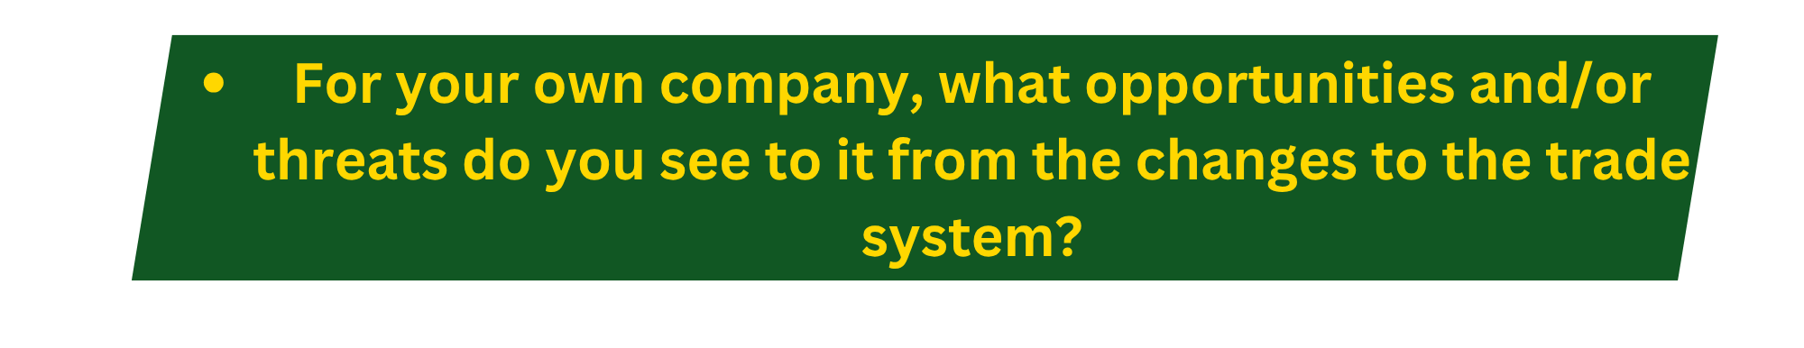
As an employee of Boeing Defense, Space, and Security, greater uncertainty in the world does unfortunately drive sales. Tariff pressure does not hurt BDS as directly as many other companies as all our components must be manufactured largely within the US. We will still pay the cost of tariffs on commodity goods and rare earth metals, but these costs won’t hurt the bottom line like it does in lower Gross Margin industries. To Boeing’s benefit, one way to avoid the ire of the current administration appears to be spending on US products. Boeing planes appear to be a favorite purchase for a country who wants to remain in the good graces of the United States leadership. For BDS, the benefits of these changes largely outweigh the negatives. But if my predictions from the paragraph above are correct, the same is not true for much the rest of the US economy.



