

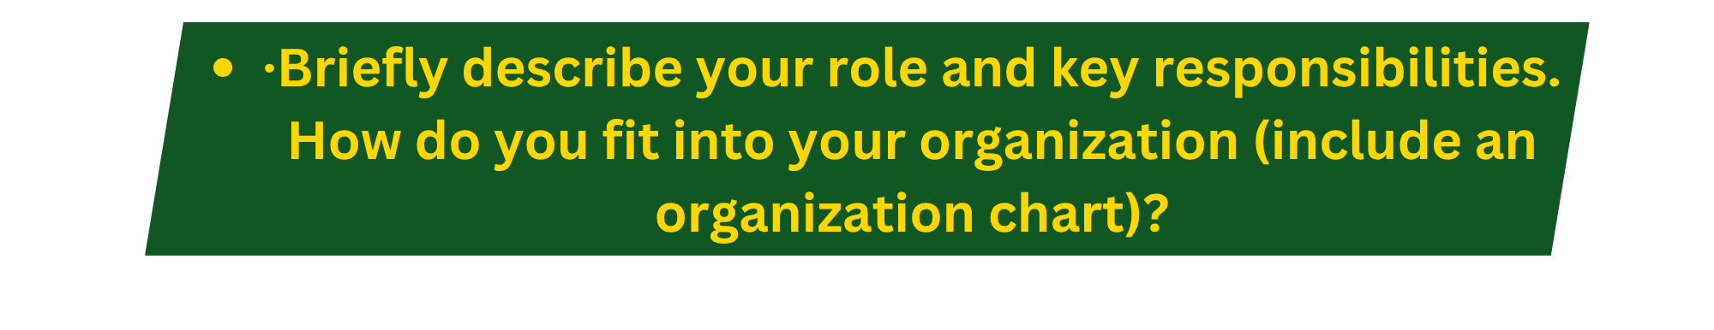
As of one week ago, my title is Manager, Phantom Works - Analysis and Architecture at the Boeing Company. In my new role I lead a team of 10 engineers of mixed disciplines who will be writing requirements, and solving complex problems with the Mission Systems of one of Boeing’s proprietary platforms. This is a brand new role for me and my first job in people management. I will own the career development, HR responsibilities, and project outcomes for the individuals who report to me. As I get started, my initial responsibility will be in hiring another 10 engineers to grow my team from 10 to 20 individual contributors.
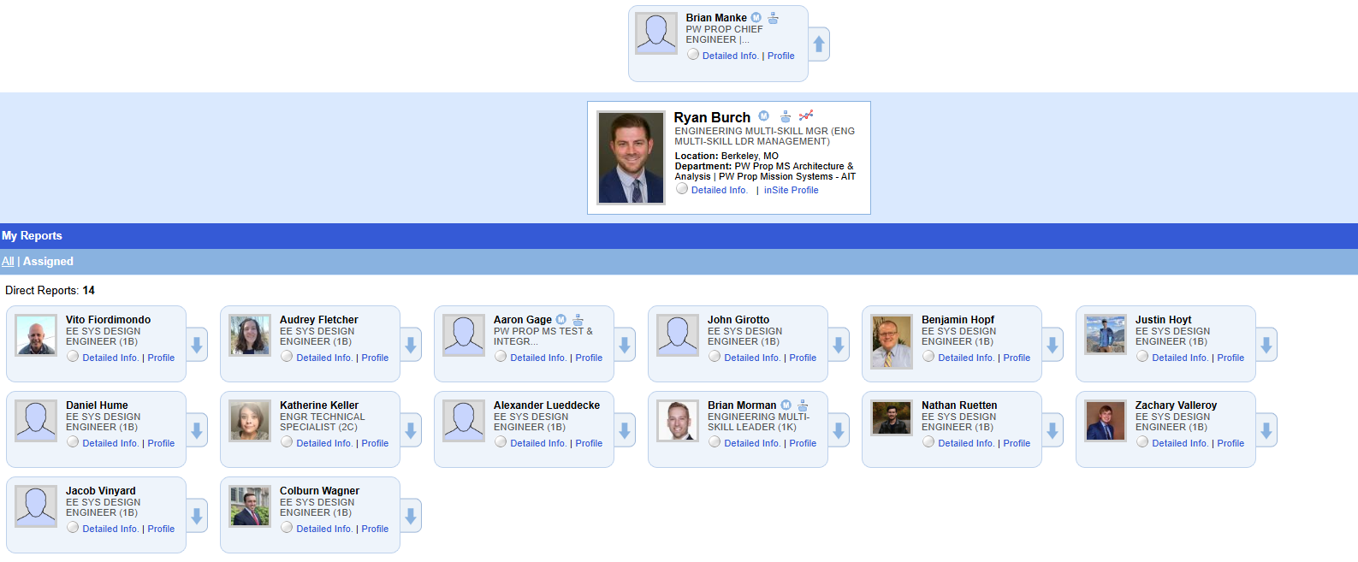
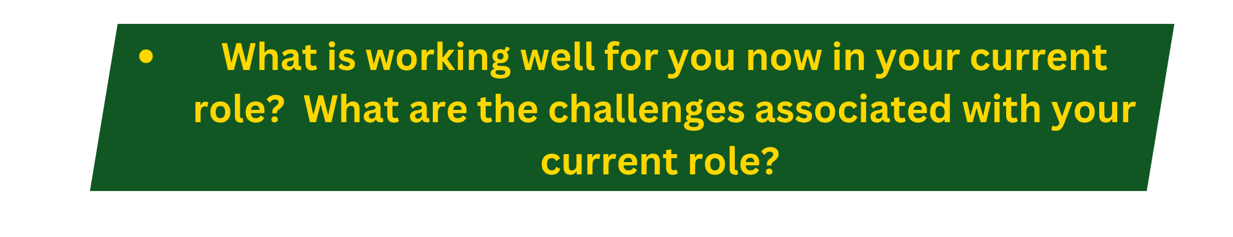
In my most recent role, I have been a product team lead coordinating and planning the effort of a small team of engineers in designing airplane avionics systems. I have been a high performer for my team doing good work technically and building strong relationships and I have gained respect as a leader within the org I am leaving. But ultimately, I have only been with Boeing for one year so in some ways, I am taking over a new team, in a new division, of what is still a new company to me. The org chart above shows my team but this version still shows all my reports pointing to my direct manager Ryan. Things are too new to say what’s working well in my new role, but in the context of my career, I have been very successful in networking, building teams with a strong sense of connection and motivation, and leading with a focus on growth and making change simpler. I hope these skills will make my new role a fast success but all the change factors make my leadership transition crucial.

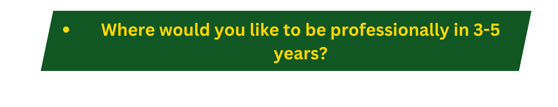
In my career so far I have been a fast riser, I have been promoted every 2.5 years on average. This trend is likely to slow as promotions become harder to come by, but I hope in 3-5 years to have been promoted beyond the first level manager role I am in now to an L or M manager and have made my name as a proficient people leader with a strong technical background.

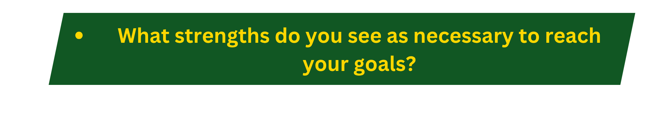
In the world of engineering my personality and soft skills have been my superpower. In many ways I do not fit the engineer’s mold. I am people focused and energized by daily interactions. I also have a great depth of technical knowledge and diverse insights to share as an engineer from two industries. I came to engineering with a passion for infusing creativity into products by facilitating personal connections between individuals with deep knowledge and skill and I still believe that is one of the biggest parts of my value as a leader.
 I think its common to feel that our greatest strengths also reflect our biggest weaknesses. For me at least, this is certainly true. I find that my love of human connection and drive to make friends in the workplace also leaves me vulnerable to negative feedback and allowing it to cause me a high level of stress. I have often taken negative feedback very personally which can slow my progress when trying to address the issues that may have caused that feedback. Conflict in the workplace is not comfortable for me which has really been highlighted when my values have been challenged in my new role. To become a great leader I will certainly need to deal with conflict in a more confident way and to strengthen my values backbone to be able to convey them respectfully and draw the lines I find uncrossable without fear of how others will react. Thirdly, I feel that despite working in two industries and with individuals from all different backgrounds, my employment horizons are small. I have only worked for large scale legacy US employers with long histories. I need an understanding of how the rest of the world operates to build on my network and see if the places I have looked for work are really the best places for me to succeed.

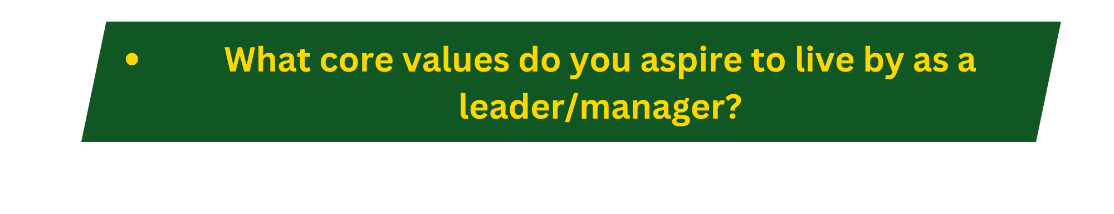
After some reflection my core values as a leader are: kindness, growth, humor, reputation, and competency. First and foremost in my list is kindness. I find that each person brings their life experiences with them to work every day and as the saying goes, each of us has no idea of the burden another carries. If we can start our interactions from a place of kindness and care, we each offer one another a bit of grace in our mistakes and look to uplift one another and support success for each individual. Growth is a personal value that I try to share with colleagues, and I am always interested to see where others are choosing to grow. I believe in encouraging a growth mindset to take on new challenges and stretch ourselves constantly. I find great satisfaction to push myself to do more or do better physically in the gym, mentally in school and work, and emotionally by doing self-reflection and reading Stoic philosophy.



