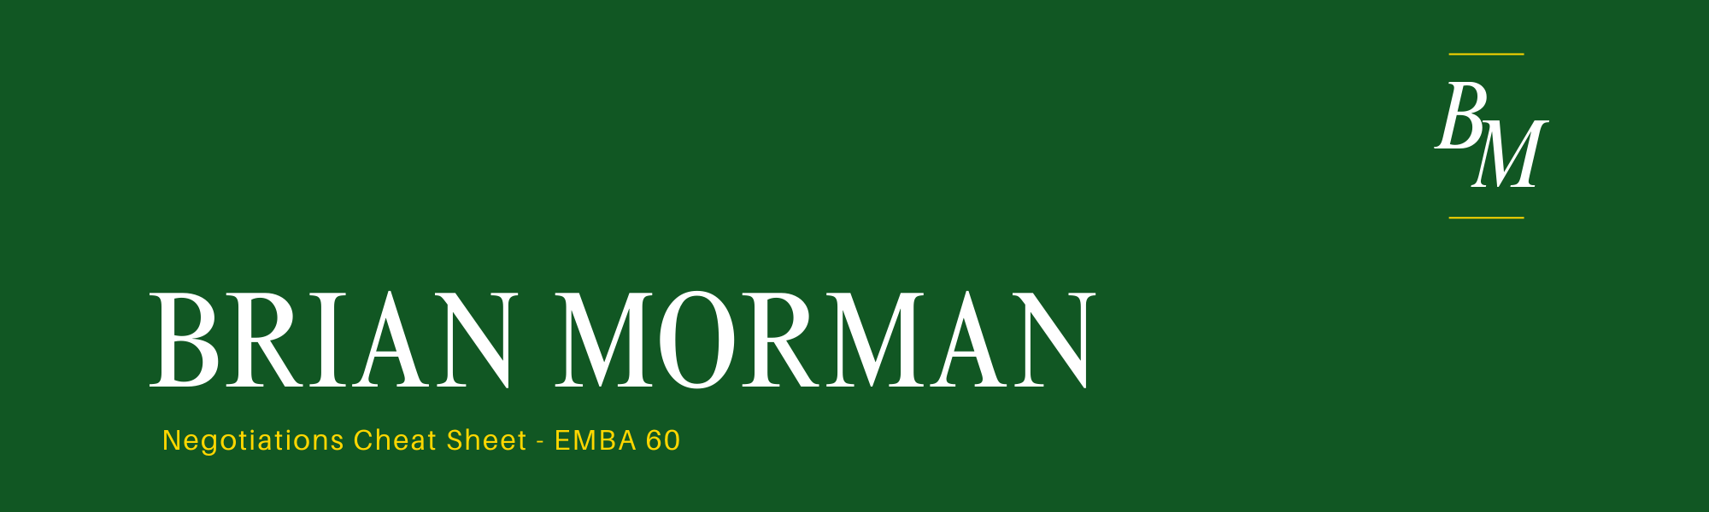
- 3D Negotiations – begin by setting the table. If you don’t like the way a deal is unfolding reset the table. Change the game.
- BATNA – Best alternative to a negotiated agreement – build yours reduce theirs.
- Referring to it can create pressure. Revealing some can improve trust. Don’t share it directly.
- Remember YAHOO – you always have other options
- 3 key numbers – walk-away amount, target point, aspiration point
- ZOPA – zone of possible agreement – sus out if one exists and claim the most you can of it.
- Look for opportunities to negotiate diagonally and increase value for both parties. Create value (Integrative bargaining) and claim value (Distributive bargaining)
- Appeal to fairness and tell a story of why the deal works. Build a “Golden Bridge” so they can explain their deal to their team.
- First offer when you have more information than the other party. If you cant counter fast and don’t fall for even split. Set your anchor point.
- Don’t argue about the future. Bet on it. Provide incentive for post- settlement efforts.
- Strategy: Log rolling – trade something of lower value for something of higher value.
- Differences in values create opportunities for logrolling.
- Bob White teaches us to use emotion intentionally.
- With more parties involved, set explicit decision rules, use coalitions and avoid communication breakdown. Remember not everyone may want an agreement.


