
At Boeing, I work for a group we call AvionX. AvionX has been existed for less than a decade (which is very new for Boeing) and we exist as a center of excellence in avionics design for our customers. Our customers are all internal to the Boeing company and our funding comes typically from an airplane product team who will quote us against external competition to compete for the design and build contracts for all sorts of airborne electronic devices. In Rebecca Goldberg’s The Lean Anthology, the author names six criteria that she calls the “Order Winning Criteria” (OWC). These criteria include: cost, quality, speed, flexibility, innovation, and information.
The process I have considered for task one is the bidding process we go through to win a contract with an internal customer. In our business, understanding the Voice of the Customer begins in Business Development (BD). Our BD group keep close relationships with the military branches, different commercial world airlines, privet jet makers, and any other customer who might be looking for something new in aviation. Understanding the VOC comes from understanding the driving forces behind a project proposal. Some of that info is in the proposal itself but the rest comes from knowledge of geo politics, air commerce, and the individual decision makers who review the proposals. In the military space, cost and speed often go hand in hand. Our order quantities are low and our engineering teams are big so engineering hours are closely accounted for and quoted in bidding process. Hours quickly can become the largest expense in a new design for a military product. For this reason, my team focuses on internal research and design funded products that try to estimate a customer’s needs to test and have ready to quickly bring to market. Designing product ahead of the bidding process means we don’t have exactly what the customer may want but we are likely able to provide it cheaper and sooner than our competition. We trade flexibility for speed and cost. For other customers we may know the customer wants the most cutting edge product available. In this case we trade cost and speed for innovation and quality.
By understanding the VOC and our market segmentation we can focus IRAD dollars towards the products where cost is king and provide higher cost design build solutions for customers who need the most up to date technology at the time of purchase. Our processes for BD and IRAD give us the control we need of what OWC will lead the day for any individual program bid and allow us to prep ahead to compete and win.

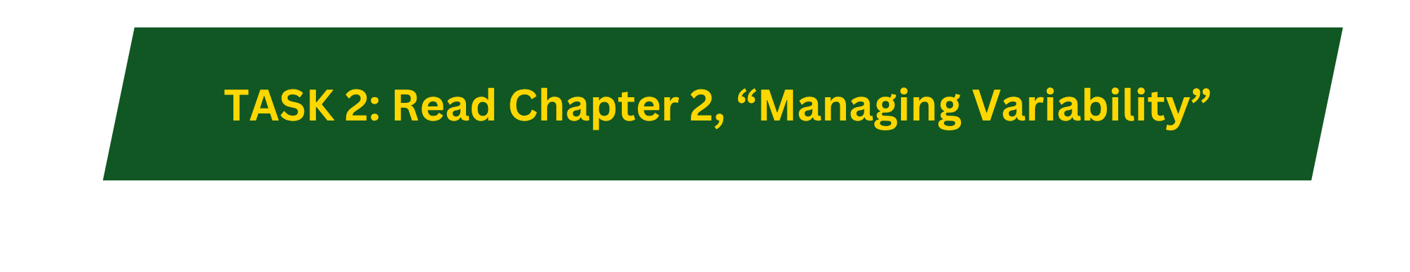
As discussed in class the three levers for managing variability are time buffers, inventory buffers, and capacity buffers. This means to control your production in a lean way to not stop production or miss out on sales we can manage our inventory levels by: managing order lead times, managing orders of incoming inventory, or managing throughput to control the speed with which inventory is used up. Within AvinoX production orders are pretty small and parts costs can be extremely high. For this reason, managing variability is critical to the success of our enterprise. My team’s primary product are mission computers for military applications. Like building a personal computer from parts our team designs the computers that power the most advanced warfighters in the world. Since our order quantities are small and part costs are high it is critical that we manage our inventory as accurately as possible. We use intensive data analysis to predict failure rates to order enough parts for our expected repairs. For our product production time is inexpensive in comparison to the product we build for that reason, our capacity utilization is typically very low. For these two reasons we typically rely heavily on lead time to manage any variability. Product delivery can be slow and lead times long if variability grows above our expectations for parts on hand. For this reason we negotiate with our customers for very clear service contracts about how many orders are expected and what kind of lead times are acceptable based on demand probability. When calculations go wrong and variability causes reality to mismatch with prepwork the customer supplier relationship can get strained quickly. The good news for Boeing is that this complexity is real for our competitors as well.

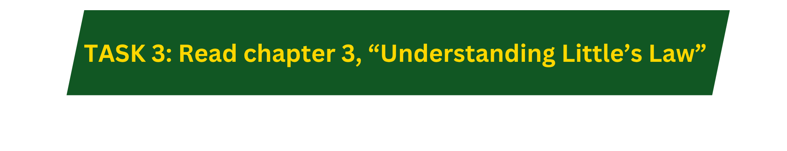
If I apply the flow process thinking to the process of designing a new product within AvionX then what flows through the process are design documents that the aerospace industry refers to as “artifacts”. These artifacts can be design drawings, test plans, test results, or product documentation. Our inventory for creating these artifacts are the man hours and non-recurring engineering dollars granted to our design team to generate those artifacts. Our throughput rate will be a function of the number of design teams AvionX employs at any given time and the complexity of the projects we take on but typically we are delivering, as an enterprise, two to three new products each year. The throughput time for an individual major project is typically eighteen months to two years.

Lean projects are a priority at Boeing, and for that reason, I benefit from having completed a value stream map recently at work for the procurement process we use to purchase a build to print Printed Circuit Board Design. Please see the appendix at the end of this assignment for the full value stream map of that process, which is long, slow, and full of the waste that comes with processes inside a company as large as ours. In our process, purchase requisitions are created by engineers to procure a build to print design. They become purchase orders and eventually parts on dock for the build process that is likely in need of its own leaning out. For this question, our inventory are the human hours that are consumed in the effort to review, negotiate, and approve purchases. As the charts shows, our procurement process is plagued with some extreme variability. In the best case timeline, the full process could play out in 159 manufacturing days. In the worst conceivable case, that time can be as long as 332 manufacturing days. To find the muda within this workflow, my attention is first drawn to the steps I have labeled as “high variance”. In most cases these can be low effort work that can spend long hours in an individual’s review queue. Reviews are in general a place I plan to approach with suggestions to improve this process. We hold multiple reviews throughout our process. My first suggestion would be to schedule a weekly procurement board meeting with all required reviewers to be in a room together for a single meeting vote rather than using the automated review system we do now that manages reviewers through email notifications that get lost in inboxes or over prioritized by other daily tasks. By doing this our reviewers will be one in place to have the necessary conversations that can take weeks on their own. It would improve communication and variability by allowing reviewers to know when to look at approvals. There are several other steps in this process that could be placed in parallel but our improvement project will be ongoing for sometime as we find ways to shorten this chain of events.

APPENDIX BELOW
Appendix: Lean Team Procurement Workflow