Brian Morman
Operations Management – The Goal Book Report
EMBA 60
- Throughout Goldratt’s novel, his characters work to redefine many terms native to business operations with a spin that puts the focus of the definition on to what really matters. It redirects classic definitions to point them towards what the real goal of any for profit business should be in the simplest terms possible. Below are the definitions Goldratt gives in his book along with a more traditional definition which we can compare to understand the purpose of Goldratt’s redefinitions:

“Throughput is the money coming in. Inventory is the money currently inside the system. And operational expense is the money we have to pay out to make throughput happen. One measurement for the incoming money, one for the money still stuck inside, and one for the money going out.” – The Goal

Traditional Throughput – “The amount of a product or service that a company can produce and deliver within a specified period of time”.
Traditional Inventory – stock of items or parts intended for sale.
Traditional Operational Expense – the ongoing costs a business incurs to run its operations.

Comparison: Goldratt’s definition of throughput ties this ops metric directly to profitability and reaches past the point of delivery to include when cash is received by the business. His definition of inventory is a reminder that inventory is not necessarily a benefit. It directly reflects that inventory represents cash that is tied up and unavailable for other uses. By pointing the definition in this direction, it reminds the operations team to focus on lean management of inventories to prevent needlessly tying up investable capital. The benefit of all Goldratt’s redefinitions is the focus it brings to the reason each of these metrics is important.

- A Bottleneck (or Herbie) is a step in a process that has the lowest capacity for throughput. It is the limiting factor of performance for a system and the point where flow is restricted. When working in the dishwasher factory at GE appliances, I got to see the bottleneck up close and personal when designing a new manufacturing line. To illustrate this concept, I look back at our line and its design. Our manufacturing process included more than 200 employees to build a single machine, but our pitches and jobs were designed for each operator to have 13 seconds with a machine from first touch to the last. After assembly, the machine went to test which was a conveyor loop with automated tests designed to the right length to output one machine every 13 seconds with a completed bill of quality. Next, the machine went to pack via a large and expensive tape machine that would fold down box flaps and tape them closed to be ready to go up the production conveyor. This machine was purchased from a third-party vendor who tuned the machine to run as fast as possible. Its total processing time was 13 seconds. Knowing the capability of the machine would set our bottleneck, we designed the upstream operations to match the throughput speed of our tape machine. By changing job content around via time studies and designing our test loop right we had designed the most efficient line we could given the technology available at our bottleneck. It is important to note, our bottleneck was not an inefficient operation. It ran with tremendous up times and ran at nearly 100% utilization with planned down times for repair. It was run extremely efficiently since its importance was recognized and designed into all plans.
There are three keyways in which bottlenecks can be identified: Process mapping, Data analysis, and simulation. At GE we used all three options, process mapping was used along with time studies to determine the time needed and work content of each operation. Data analysis was done with cloud computing and many sensors paired with a system we called brilliant factory to keep accurate data on process times and yield to ensure things were flowing as designed. Simulation was heavily relied upon in the initial stages of planning a production line to design pitch sizes, line lengths, and test assumptions of how a new line might run.
The tape machine example shows us how a simple bottleneck can be identified on a production line but the bottleneck on any given day was rarely our slowest equipment. Variability and inventory are two things that can move the bottleneck around. If resources run short or if demand volume surges past expectations our bottlenecks may move off the line entirely.
- 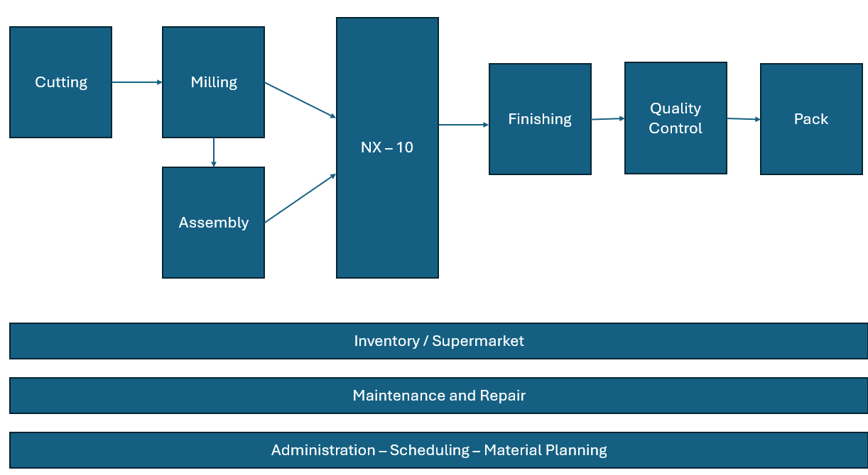
- Five production-scheduling principles:
  - “An hour saved at the bottleneck is an hour saved for the whole system” – since the bottleneck is our process limiter improving efficiency here improves throughput to the full system.
  - “The Goal of a manufacturing process is to make money” – This is really the key reminder of Goldratt’s book, and it is ultimately the book’s namesake. This is a reminder that production decisions should always be aligned with financial outcomes.
  - “Balance flow, not capacity” - traditional manufacturing thinking would balance capacity of machines and processes and aim to keep all processes level loaded. High utilization is not necessarily a problem in a manufacturing process. By focusing on capacity and not flow bottlenecks can be incorrectly identified.
  - “Utilize the capacity of the bottleneck fully” – adding to that point above, it is critical that the bottleneck in the system operate at 100% or near 100% utilization. This step sets the throughput for the entire system.
  - “Subordinate everything else to the bottleneck” – all other parts of the system should be adjusted to support the output capacity of the bottleneck.
- In The Goal, the pitfalls of using traditional accounting data to make decisions in manufacturing are highlighted through events that play out in Alex’s factory. When the factory purchases robots, the team expects improved metrics since they would reduce labor costs and increase efficiency. They don’t address the factory’s bottlenecks, so they end up creating more work in progress inventory but don’t increase total throughput. Using traditional accounting can cause decisions to be made without understanding of the full picture as with the purchase of automation in Rogo’s factory.
- Rogo’s plant produces several distinct products but clearly isn’t working on individual orders based on the need for process improvements. That said, Alex’s plant is not well optimized to maximize the throughput of these batches. Given the state of the factories’ manufacturing processes and high variation in operation time the plant is set up to win in quality and customization. Availability, price, and speed are places the factory would struggle to win. Fortunately, Jonah’s advice should improve all aspects of the factory’s performance and focus more on how they want to carve out their competitive advantage.
- Dependent events are situations in which the outcome of one step affects another. Statistical fluctuations are the standard variability within any process. In perhaps the most memorable anecdote in the Goal, Rogo takes a group of scouts hiking and notices the troop is not moving as quickly as he expected they could. The statistical fluctuation involved is the speed of each scout based on their stamina or fatigue or load. The dependent event is the fact that the full troops speed is determined by its slowest member Herbie. This unlocks Alex’s ultimate understanding of the bottleneck concept.

  - Best practices in supply processes – safety stock – maintaining some excess inventory to be prepared for potential disruptions in the supply chain. Supplier Diversification – Using multiple suppliers means that a disruption at one supplier won’t cause a complete shut down in your production process.
  - Best practices in Internal Operations – Lean manufacturing – eliminating waste and reducing unnecessary variability streamlines production and reduces the impact of our dependent variables. Standardized work – creates less variation in a job operation and reduces human error.
  - Best practices in Market Demand – Agile development – by launching quickly with a minimum viable product we inject consumer feedback quickly in the design cycle to find the errors fast and fix them. Demand forecasting – by using available analytics we can design our process to run most effectively at the demand levels we expect to see.
- By putting Herbie at the start of the line, he prevents a work in progress stock build up and allows a constant pace for the rest of the troops. This will reduce the wasted energy of speeding up and slowing down from his troops or wasted effort in a production setting. If this option is not available, buffers will be needed to protect the bottleneck from over utilization and creating waste. The bottleneck could run longer hours to prevent build up or more resources could be added to decrease the bottlenecks load. In classic Lean Theory, the bottleneck should be as close to the end of the process as possible. This prevents the bottleneck from creating waste and guarantees the bottleneck can be fully utilized since the faster steps should be creating a safety stock of inputs to that process.
- The note: “Do not focus on balancing capacities, focus on synchronizing the flow”, points out that the process must be looked at as a whole rather than individual tasks. It is not nearly as important to focus on capacity and utilization as it is to look at how long it takes for something to flow through the process. As an example, a process may have 100% utilization at one station and 20% at another. If the 100% utilized station is the bottleneck flow may already be optimized.
- “Resources must be utilized not simply activated” means that processes are not simply being employed but used in a way that is contributing to the overall performance of the full production system. The introduction of robots in the factory is a perfect example of activation but not utilization. The robots were purchased with enthusiasm that their efficiency would help resolve the plants problem but as we know, the robots make ultimately little difference to plant performance.
- Cutting batch sizes by half at the non-bottleneck processes is the right solution for Rogo’s plant for several reasons. By reducing the batch size, the factory becomes more flexible to producing more varied products. It creates a faster feedback look for problems with a batch. The tradeoff of making this change is that our non-bottleneck processes will be slowed down. As long as our bottleneck doesn’t get moved the system can handle the reduction in speed. If process times start to stretch such that they start to become the bottleneck we can no longer cut batch sizes or risk even worse overall performance.
- Rogo’s plant’s traditional accounting measures will show up as real problems when batch sizes are reduced due to their increased costs. Setup time costs will go up; inventory management can become more complex and therefore more expensive. But the benefits or the above response from question 12 are not easily reflected in the traditional accounting system.
- The red tag green tag system was designed in an attempt to improve flow through the production bottleneck in Rogo’s plant. Green tags identify priority jobs that will utilize the bottleneck process. It allows managers to identify which jobs are higher priority to ensure they aren’t waiting at the bottleneck job. But in chapter 25, the team identifies the problem with their tagging system. The added complexity and lack of clarity around what gave a job priority made it impossible to keep the system straight. Added confusion made the scheduling process more complicated and harder to align with goals. To streamline the process, the team needed to simplify the system, firm up the definitions about what give a job priority and improve the in-system feedback to keep up communication inside the plant.

