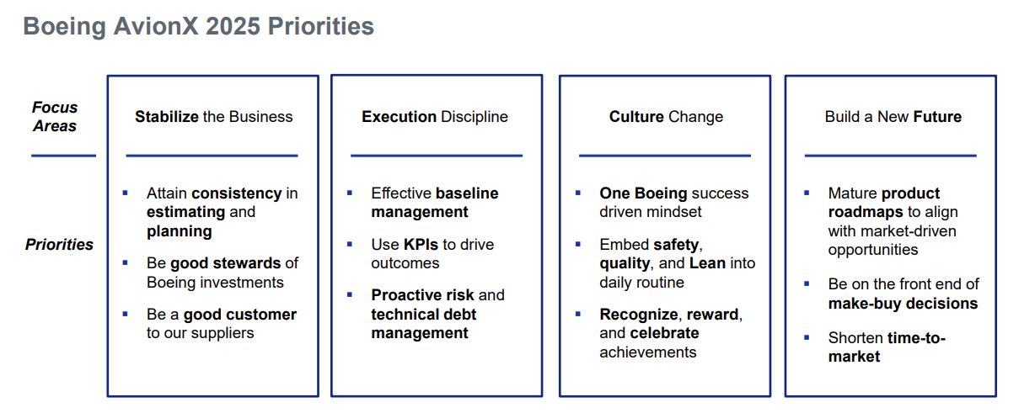

Electrical Systems Design | 6B1BI5 (622)
Individual Contributor - 5
Leads work with customers to develop and document electronic and electrical system requirements on complex multi-tiered projects. Leads analysis and translation of complex requirements into system architecture, hardware and software designs and interface specifications. Leads testing and validation work on complex system designs to assure that operational and functional requirements are met. Works with other to develop program test strategies. Manages performance of critical suppliers to ensure system integration and compliance with requirements. Conducts program independent reviews and reports results to program leadership. Provides critical support of fielded hardware and software over the entire product lifecycle. Leads research into technology advances for potential application to company business needs. Makes recommendations for technology investments. Recognized as a business unit-wide expert in process development and qualification, physical and functional integration and installation design and resolving supplier technical issues.

- Manager - K (6B1AMK) | Level Guide
U.S. Exemption Status
Exempt
Competencies for SMC: Electr & Electrical Engrg Mgmt (6A1)
Manages employees performing engineering and technical activities in the areas of Electronic and Electrical Engineering. Develops and executes project and process plans, implements policies and procedures and sets operational goals. Acquires resources for projects and processes, provides technical management of suppliers and leads process improvements. Develops and maintains relationships and partnerships with customers, stakeholders, peers, partners and direct reports. Provides oversight and approval of technical approaches, products and processes. Manages, develops and motivates employees.


Electrical Systems Design | 6B1BI5 (622)
Individual Contributor - 5
“Leads testing and validation work on complex system designs to assure that operational and functional requirements are met. Works with other to develop program test strategies”.
- Since my last performance conversation, I have developed the test plan for iWASU. Having experience in wireless design, I drove the team to investigate mesh network testing to meet requirements the team and Chief Engineer had no experience in. By highlighting the need for testing I enabled the team to quickly define a test method to verify requirements that will be done at prequal rather than relying on datasheet lookups.
- I developed a plan for STE usage along with a proposed schedule for impacts based on cost reduction options. This plan and presentation were used as I delivered it, to present at the VP level to secure critical capital funding.
Manager - K (6B1AMK) | Level Guide
U.S. Exemption Status
Exempt
Competencies for SMC: Electr & Electrical Engrg Mgmt (6A1)
“Manages employees performing engineering and technical activities in the areas of Electronic and Electrical Engineering. Develops and executes project and process plans, implements policies and procedures and sets operational goals”.
- I’ve taken an active role in mentoring a level three engineer. I help him align his daily tasks to project goals and have developed a ticketing system using Gitlab and the IMS to drive our efforts towards critical project tasks. My efforts in doing this, even remotely have received positive feedback by the engineer, their manager, and the chief engineer on the project.
- I lead weekly US hardware meetings to keep team efforts focused on mission critical tasks.


- I have leveraged my experience in schedule making and effective planning to create inchstones schedules that allow measurable progress towards the IMS and lean efficient effort tracking. As our iWASU team begins using EVM these skills will become more critical. My estimating skills will grow through this effort to make my estimation ability more accurate and efficient.
- I am focused on building my understanding of avionics qualification. While 90% of the qualification tests and processes match my experience outside of Boeing but I have worked with my Chief engineer and DMC architect to understand the DMC product architecture, the avionics EMI suite, and the environmental impacts of altitude on electronics.
- I am one quarter of the way through my executive MBA through Washington University to help me see a more complete view of the business and understand how my org interacts with others to achieve our AvionX goals.


- Over the last year I have reached out to several Boeing leaders to gain knowledge gather best practices from leaders, and to create a network that helps drive the “One Boeing Mentality. In the last year I have met with: Dan Carrol, Phil Matthews, STF Keith Rebello, Tim Toba, Adam Gregory, and scheduled to meet next with Edward Nigro. In building these relationships in advance of any professional exchange I am building personal relationships that build trust and enable clear conversations with mutual understanding.
- I have scheduled a visit to the MQ manufacturing facility this month as well and a chance to put eyes on the avionics bay of an MQ to get direct experience with installers and to see the product environment first hand.
- While visiting Plano at cards on the wall, I learned about the connected cargo project "Edge" and utilized my learnings and connections from that week to file my first Boeing patent.

