Product
Mira Vos Drink Company manufactures high-quality exercise supplement powders and drinks with a real science-based focus on health and wellness. Our flagship drink “Mira Vos” is made with caffeine from Yerba Matte tea leaves from the heart of Argentina. Our products are made to support health-conscious people with the motivation to start new habits and the energy to maintain them.
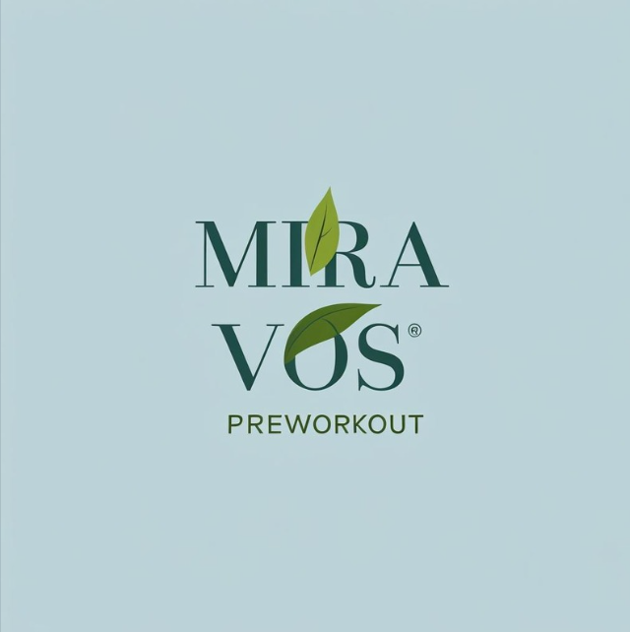

Future of the Company
Although the exercise supplement industry is highly competitive, we believe that there is a place for high-quality, attractive, science based, and natural supplements. Our product creates an alternative to the overfilled shelves of pre-workout products that is clear in what it contains and why. This creates an opportunity to bring in new customers to the market and engage them in ways they haven’t been previously engaged. Our goal is to build and market supplements and drinks that will encourage more people to get moving, make progress, and have the endurance to keep that good habit for life.

Mission Statement
To get people moving and provide them the clean energy to become their best selves.

Industry
Mira Vos will be a part of the exercise supplement industry. The exercise supplement industry currently consists of 19.58b in revenue with a CAGR of 5.9 into 2030. 35.1% of that market is US-based with 88% in powder and xx% in ready-to-drink. The growing market is associated with a growing understanding of the importance of exercise for men and women. A trend towards simpler eating and increased focus on processed ingredients creates an opening for a pre-workout supplement drink with simple and natural ingredients.

The Competition
The closest competitors to the Mira Vos model are: Celcius, Alani Nu, and Naked Energy. Each of these are competitors in the clean energy preworkout space. Each of these is differentiated in ways similar to the Mira Vos model. Celcius is sold in different locations (i.e. Costco shelves). Alani is marketed heavily in social media and targeted towards women. Naked Energy focuses on third party testing and natural ingredients. None of these approaches the problem in the same way as Mira Vos. None of these includes the same ingredient mix and marketing story Mira Vos can tell.

Company Advantages
Mira Vos has the following advantages compared to competitors:
- Simple transparent ingredients
- Natural caffeine sourced from premium plants
- Sustainable faming processes
