# 3D Data Visualizations Using ParaView

Brandon L Morrow

November 22, 2023

# Introduction

Creating effective 3D data visualizations is a crucial skill for both researchers and medical professionals, enabling them to analyze data more efficiently. In this analysis we will discuss and analyze the implementation of three different data visualizations on two different datasets. The two datasets we will analyze will be of a human head from a brain MRI, and the second dataset will be a 3D representation of the comet 67P/Churyumov-Gerasimenko which was the historic first comet to be landed on by a robotic spacecraft from Earth

(“67P/Churyumov-Gerasimenko - NASA Science”).

# Datasets

**Human Head/Brain**

The first data source we will be analyzing interestingly comes from my own brain MRI which was conducted on November 23, 2023, at the Atlanta Neuroscience Institute. The brain MRI is to monitor a condition that I have (the results came back great). They were able to give me a copy of the data, and I took the raw 2D images from the DICOM medical data folder, and attempted to read this into ParaView. This did not work so I utilized 3D slicer to convert the DICOM folder to a VTK file for use in ParaView, and is what was utilized for my visualizations.

# Comet

The data for the comet 67P/Churyumov-Gerasimenko was published in a research article and claims to be meter scale accurate. This paper utilizes 3D surface rendering to map the different regions of the comet. This dataset contains the mapping for both the surface as well as the regions of the comet in vtk file format (Thomas, N., Kuehrt).

# Head Visualizations

**Volume Rendering**

For our first representation of our MRI data we will utilize volume rendering to be able to be able to see a 3D representation of the head MRI data. To do this we utilize the volume rendering selection in ParaView, and make tweaks to the color and lighting. Our final visualization:

# Figure 1

*Processed Brain MRI Volumetric Visualization*

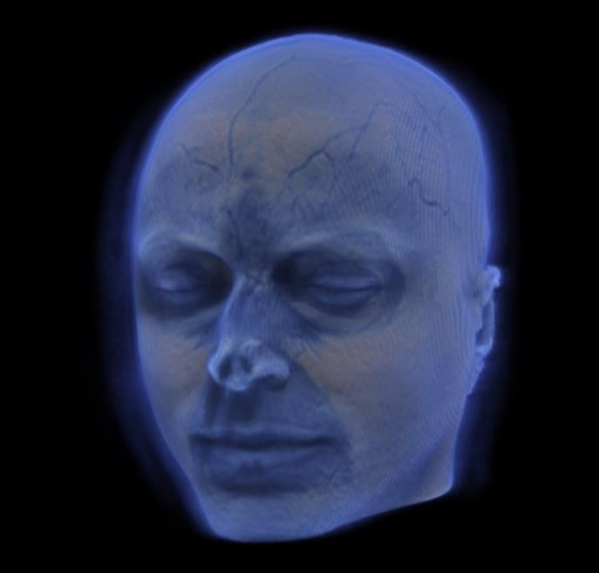 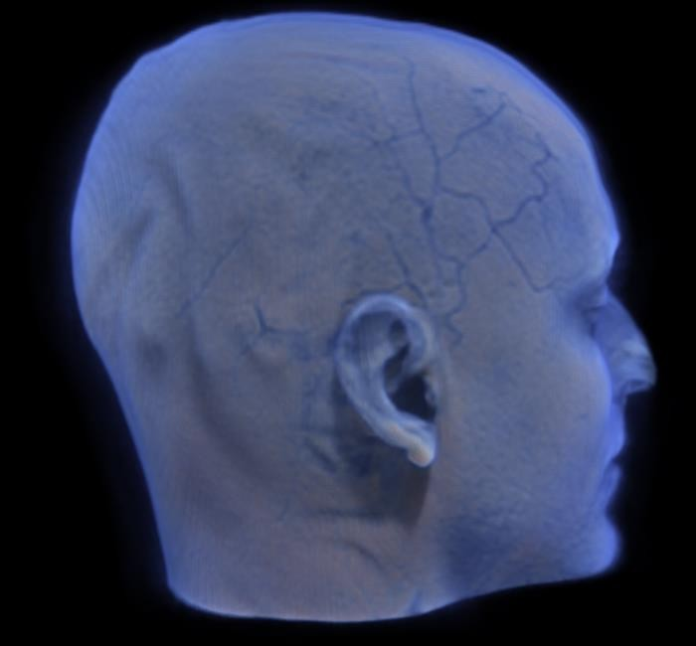

In this visualization I opted to utilize the default color scheme as this provided the clearest view of our MRI data. Next, I needed to change the Global Illumination Reach as well as the Volumetric Scattering Blending to give a much clearer visualization. The Global Illumination Reach was set to 0.49, and this setting was chosen because it increases the amount of light bouncing off our 3D visualization which increases the level of detail that we can see. The Volumetric Scattering Blending was turned to 1.56, which blends the light that scatters after hitting the 3D volume. To see the drastic difference these changes made from our raw data here is what the image looked like before our changes:

# Figure 2

*UnProcessed Brain MRI Volumetric Visualization*

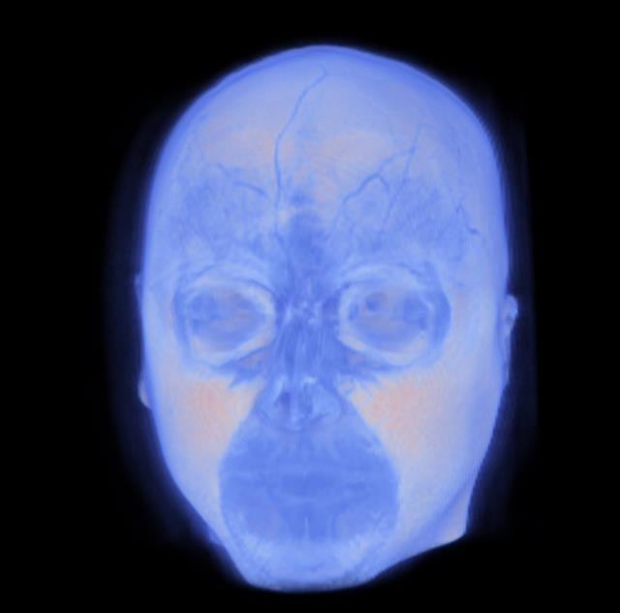

We see from this the importance of controlling how the lighting interacts with our volumetric visualization. Luckily through setting in ParaView we can control how the lighting interacts with our 3D visualization allowing us to refine our visualizations.

# Clipping/Slicing

In our second visualization we take a slice of our volumetric visualization. This allows us to see inside of our 3D model, and is a very useful tool. In this visualization we manipulate the colors to ensure that it is readable. With slicing we are able to control which layer of our visualization we want to see all the way through our 3D model. In this model I changed the color scheme to be on the blue scale for added clarity since it made the image darker with more clear contrast. This image below is of a slice in the middle of the model.

# Figure 3

*Brain MRI Slice Visualization*

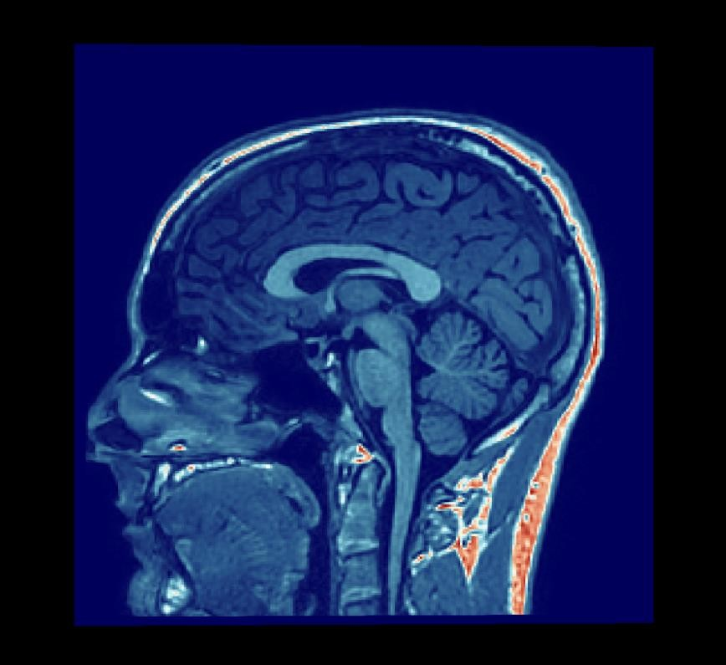

# Volume Rendering with Opacity

In my final MRI visualization instead of creating a contour surface map (which gave me difficulty due to the skull having inconsistent depth) I created an x-ray visualization of the volume where you can see the teeth, eyes, brain and spinal cord through the outer layer of the image. This was achieved by changing the volume scalar opacity unit distance to 25, and then adjusting the color mapping to highlight specific layers in the model. This resulted in an x-ray like image that can be adjusted to highlight the different layers inside of the volumetric model. Below are two screenshots showing how we can adjust the coloring per layer and get the image to appear like an x-ray.

# Figure 4

*Brain MRI Volumetric X-Ray*

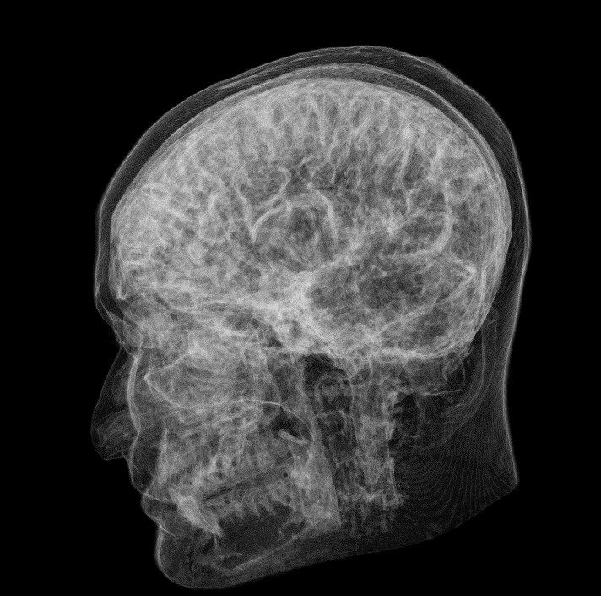 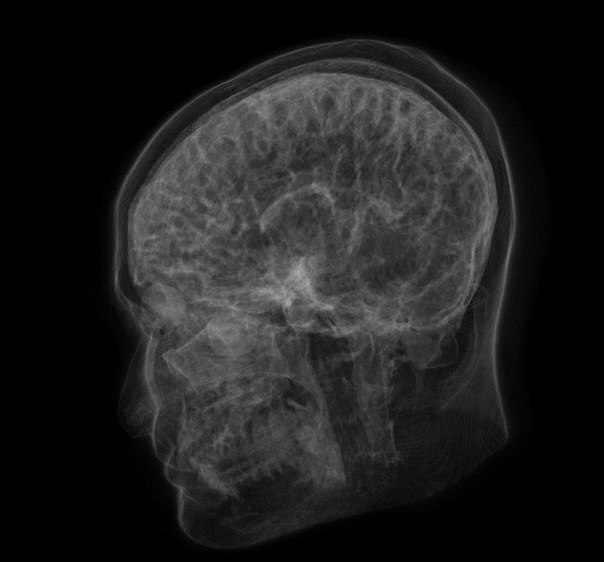

# 67P/Churyumov-Gerasimenko Comet Visualizations

**Surface Mapping**

The first visualization that we will create for the comet will be a simple surface map representation of the comet to be able to visualize the comet’s terrain. We are able to set the surface map to a grey color to imitate the comets true color and are able to set the background color to black to imitate space. I utilized a feature edge to highlight the ridges and emphasize the terrain here which can be toggled on and off.

# Figure 5

*Comet Surface Map*

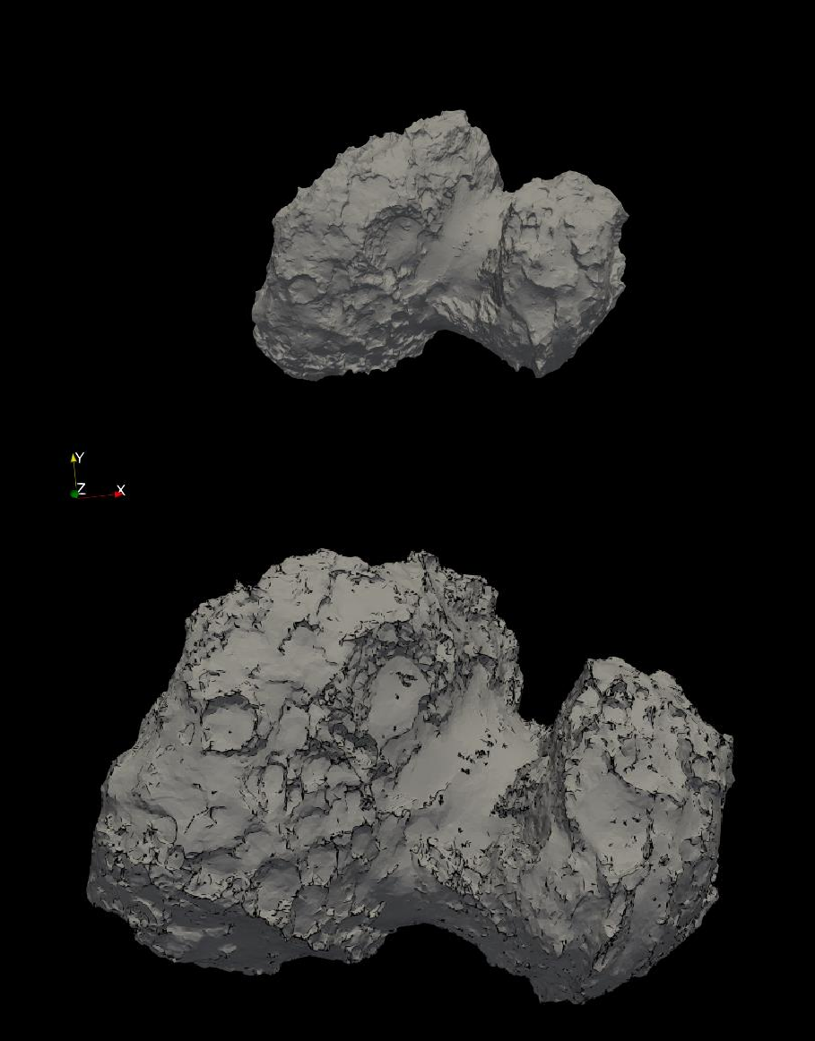

# Glyph Filter Comet Trial

In this 3D visualization we will utilize a glyph filter to create a comet trail, which would be the dust that trails the comet as it orbits the sun. For this we create vectors using the glyph feature, and then turn down the opacity to 0.01 to give this a cloud like appearance. This allows the viewer to see what the comet trail looks like for this particular comet.

# Figure 6

*Comet with Tail*

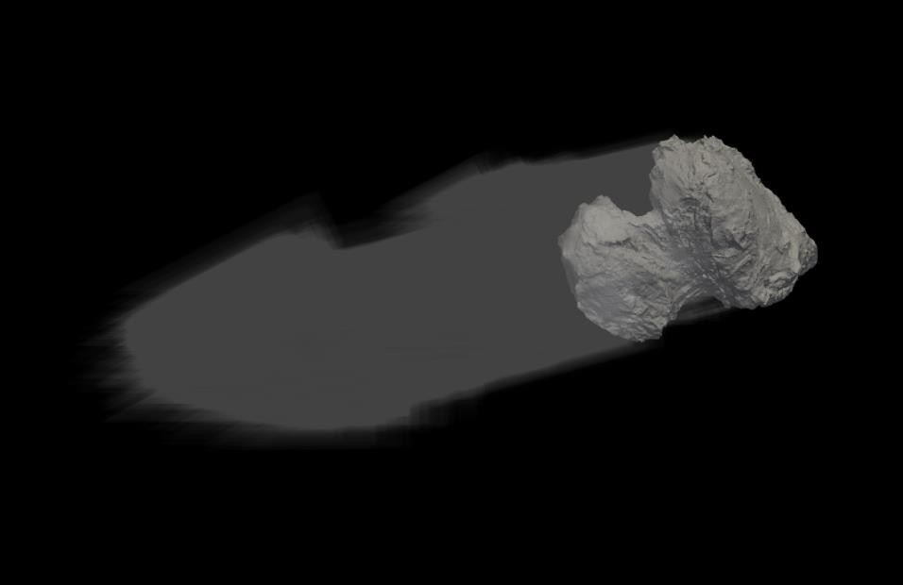

# Point Cloud with Regions

In our final visualization we represent the comet using a point cloud that is color coded to the different regions of the comet. The benefit of the point cloud is that it allows for transparency to the other color coded regions, and allows the viewer to see where that region wraps around to in the visualization. This point cloud can easily be changed to a surface visualization to see the comet with the color coded regions. For ease of viewing, I have put the surface graphic below the point cloud to easily see both options.

# Figure 7

*Comet Point Cloud and Surface with Regions*

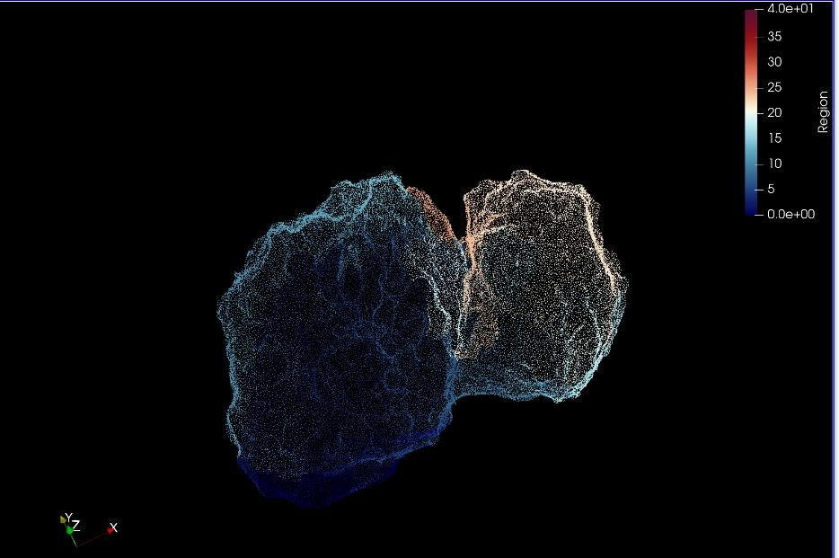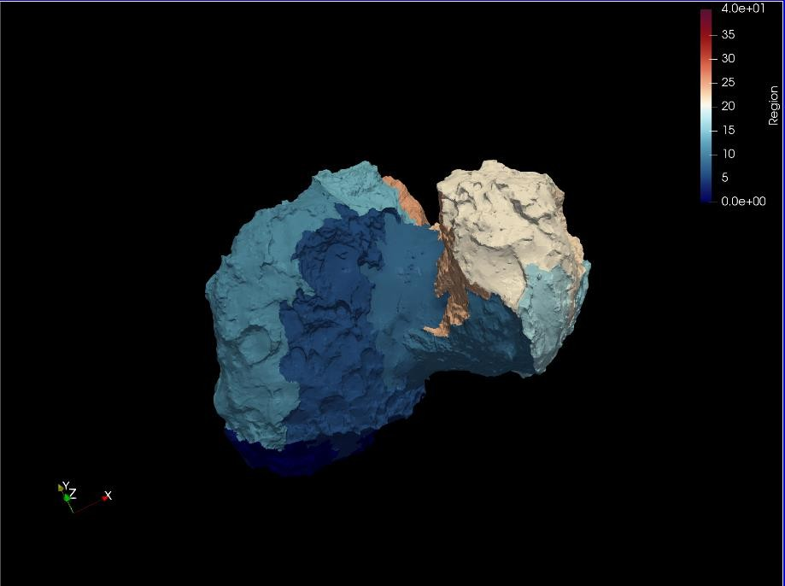

# Conclusion

Through these many visualizations we have seen the power and value of 3D data visualizations. Using varied techniques ranging from volume rendering to surface mapping, we've seen how each method unveils unique aspects of our subjects, offering a deeper understanding of the source data. These visualizations have allowed for the interpretation of extremely complex information in a digestible way.

# References

67P/Churyumov-Gerasimenko - NASA Science. (n.d.). *Science.nasa.gov*. <https://science.nasa.gov/solar-system/comets/67p-churyumov-gerasimenko/>

Thomas, N., Kuehrt, E., Hviid, S. F., Tubiana, C., Theologou, P., El-Maarry, M. R., Debei, S., Guettler, C., Marschall, R., Lopez-Moreno, J., Sierks, H., de Cecco, M., Gutierrez, P., Cremonese, G., Da Deppo, V., Bertaux, J.-L., Fornasier, S., Bertini, I., Lazzarin, M., & Scholten, F. (2018). Data for: Regional unit definition for the nucleus of comet 67P/Churyumov-Gerasimenko on the SHAP7 model. *Data.mendeley.com*, 1. <https://doi.org/10.17632/2845znt54k.1>, <https://doi.org/10.1016/j.pss.2018.05.019>.