**Classwork – 4 Due July – 3rd.**

Test the Page links (relative, absolute) with 3 html files.

You need 3 pages.

1. manipage.html
2. page2.html
3. page3.html

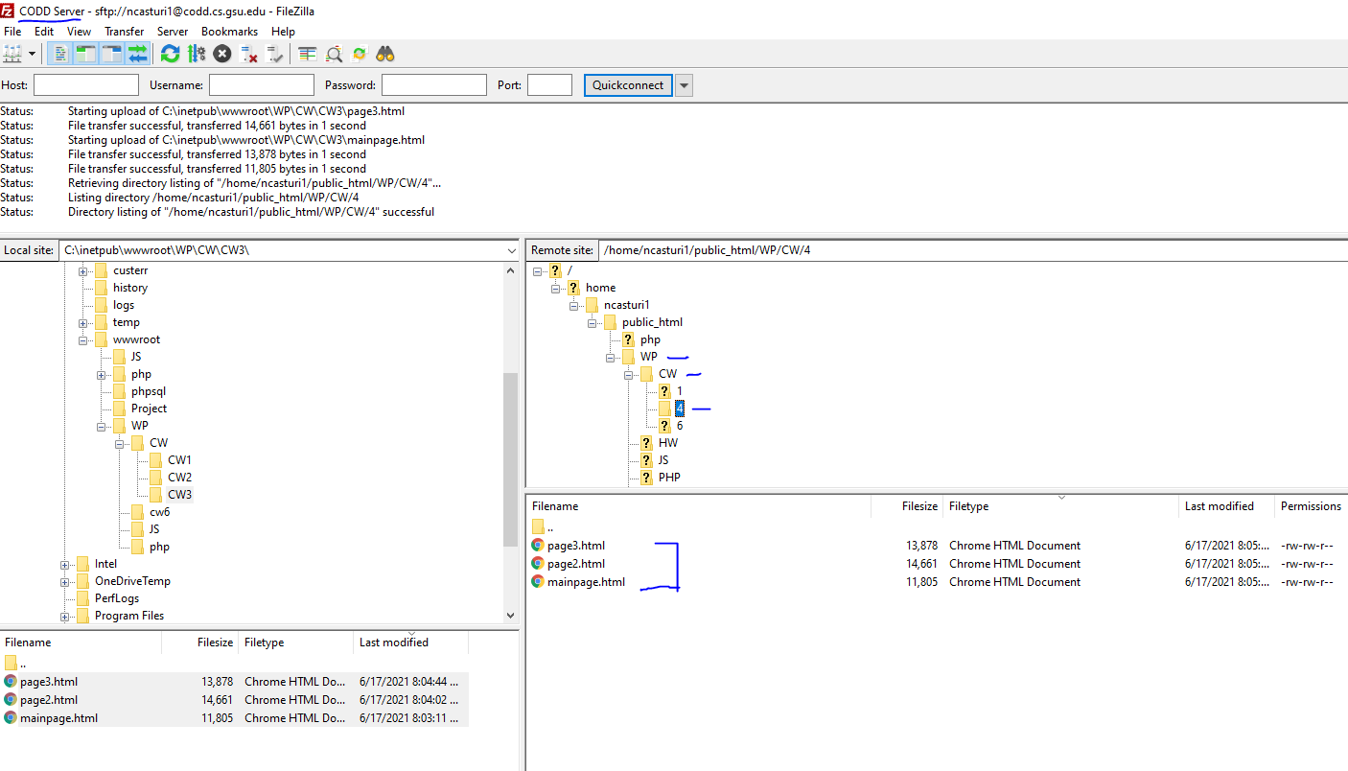

The submission link should be: [**https://codd.cs.gsu.edu/~ncasturi1/WP/CW/4/mainpage.html**](https://codd.cs.gsu.edu/~ncasturi1/WP/CW/4/mainpage.html)

You should substitute your id with mine (~ncasturti1)

You can check the sample page I created (mainpage.html) on codd server.

**Output should be like this. Ignore the scratch main section**.

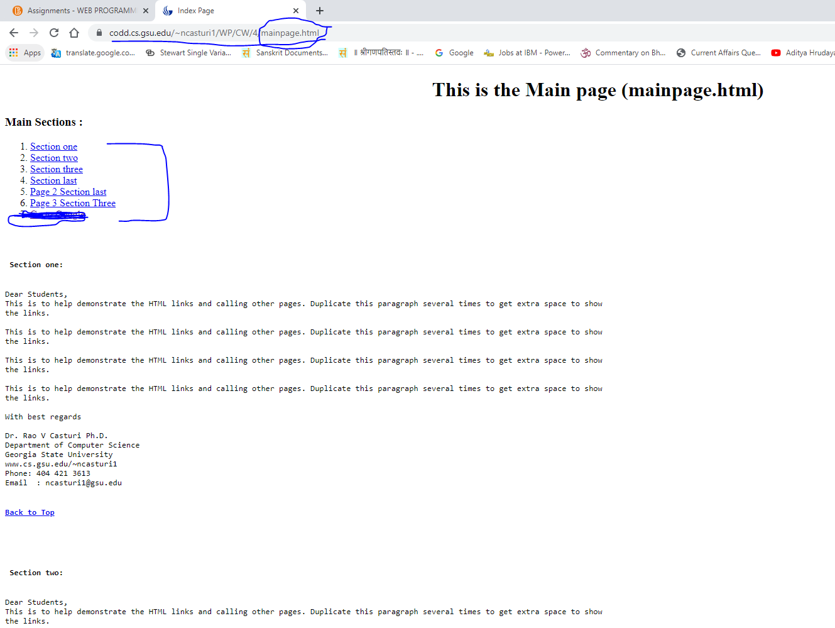

**The following page gives you the idea how to implement.**

