**C105 Prediction, Probability, and Pigskin  
Midterm Exam  
Fall 2014**

1. During most of the 1800s, the game of collegiate football was most similar to _________, because __________.
   1. Rugby; both sports involved an attempt to get the ball into an end zone, called a “try.”
   2. Soccer; both soccer and football were extremely violent
   3. **Rugby; both sports only involved carrying the ball.**
   4. Cuju; both were played by for fitness training, and for the entertainment of aristocrats.
2. Which of the following improvements to the game of football was *not* pioneered by Walter Camp in the 1880 standardization of collegiate football?
   1. 11 players on the field per team (decreased from 15).
   2. Establishment of the line of scrimmage.
   3. **The field goal kick over an elevated crossbar.**
   4. Required minimum progress within a series of downs before a turnover.
3. In 1906, the _____________ threatened to prohibit the game of football if dramatic changes weren’t made to the safety of play.
   1. **President of the United States of America**
   2. President of Princeton University
   3. Commissioner of the Ohio League
   4. Intercollegiate Athletic Association of the United States
4. Value based drafting suggests that managers should choose players based on their value over the next available player at each position. Which of the following would be a reasonable measure of Eddie Lacy’s value over the next available running back? (note: Eddie Lacy is a running back)
   1. Eddie Lacy's fantasy projection divided by the standard deviation of all available running backs.
   2. Eddie Lacy's projected fantasy points in 2014, divided by his total fantasy points in 2013.
   3. Eddie Lacy’s fantasy projection, divided by the next available quarterback’s fantasy projection.
   4. **Lacy’s fantasy projection, minus the next available RB’s fantasy projection.**
5. If the standard deviation of fantasy points for the top 5 QBs is lower than for the top 5 RBs, this would indicate…
   1. …that the top 5 QBs score more fantasy points than the top 5 RBs.
   2. …that the top 5 QBs score fewer fantasy points than the top 5 RBs.
   3. **…that the top 5 QBs are more consistent than the top 5 RBs.**
   4. …that there is a strong correlation between the top 5 QB and RB fantasy points.
6. According to Matthew Berry, what does PGO measure?
   1. The number of times in a season when a player will earn more than the average points for their position.
   2. **The number of times in a season when a player was ranked as a plausible starter before their game, and then performed better than a player who would've been benched.**
   3. The number of undrafted players who are owned by at least 25% of leagues at the end of the season.
   4. The number of times in a season when a player earns more than twice the average points for their position.
7. Which of the following is true about PGOs?
   1. There're no differences in PGOs between different positions.
   2. RBs have the lowest number of PGOs.
   3. **WRs have the lowest number of PGOs.**
   4. QBs have the lowest number of PGOs.
8. What is the purpose of a snaking draft?
   1. **So that all managers have the same average draft pick.**
   2. So that all managers are guaranteed a shot at a top player from each position.
   3. So that all managers can place a bid on each available player.
   4. So that there aren’t any mice problems in fantasy football.
9. Each cell in an Excel worksheet can be blank or it can contain a number, formula, or a ______.
   1. color
   2. date
   3. function
   4. **text string**
10. Which of the following would earn the most fantasy points for the respective player?
    1. **A wide receiver makes a 40-yard reception for a touchdown.**
    2. A place kicker makes a 55-yard field goal in overtime to win the game.
    3. A quarterback completes a 40-yard pass for a touchdown.
    4. A defense intercepts a pass and returns it 40-yards before stepping out of bounds.
11. Is it possible for a player to have negative fantasy points (in our C105 leagues)?
    1. No
    2. **Yes**

For the next 3 questions, consider the following Excel spreadsheet, listing week 1 games from the 2006 season:

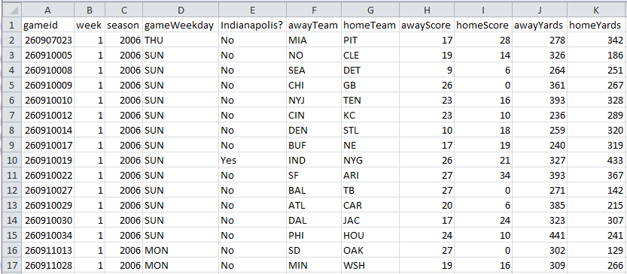

1. Which formula will return the team that won each game (assuming there are no ties)?
   1. =IF([@awayScore] < [@homeScore], [@awayTeam], [@homeTeam])
   2. =IF([@awayTeam] > [@homeTeam], [@awayTeam], [@homeTeam])
   3. **=IF([@awayScore] > [@homeScore], [@awayTeam], [@homeTeam])**
   4. =IF([@awayTeam] > [@homeTeam], [@awayScore], [@homeScore])
2. Column E contains a formula that returns “Yes” if Indianapolis is playing, and “No” otherwise. What might the formula be?
   1. =IF([@awayTeam]=“IND” OR [@homeTeam]=“IND”, Yes, No)
   2. =IF([@awayTeam]:[@homeTeam] = “IND”)
   3. =([@awayTeam]=“IND” OR [@homeTeam]=“IND”)
   4. **=IF(OR([@awayTeam]=“IND” , [@homeTeam]=“IND”), “Yes”, “No”)**
3. For the IND vs. NYG game, describe this formula: = J10/(J10+K10)
   1. The index of IND’s yards gained.
   2. **The percent of total yards (from both teams) that were earned by IND.**
   3. The percent of total yards (from both teams) that were earned by NYG.
   4. The difference between IND’s yards and NYG’s yards

For the next 3 questions, consider the following simple Excel spreadsheet:

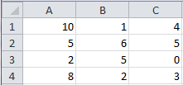

1. =(C4+B1)/B4+(A3+B4^2)
   1. **8**
   2. 18
   3. #DIV/0
   4. 2
2. =MIN(A1:A4)+MIN(B1:B4)*MIN(C1:C4)
   1. 0
   2. **2**
   3. 4
   4. 1
3. =SUM(A1:C1)/MAX(C1:C4)
   1. 5
   2. 1.5
   3. 10
   4. **3**
4. The formula =B2+A3 is located in cell B3. If this cell were copied and pasted into cell D4, the resulting formula evaluate to:  
   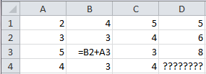
   1. 8
   2. 11
   3. **12**
   4. 20

For the next four questions, consider the PivotTable field list shown to the right (for the offense table), and the PivotTable shown below. Notice that the four areas in the field list are labeled A, B, C, and D.



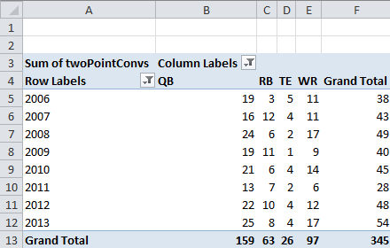

1. Where is the field “season”?
   1. **A**
   2. B
   3. C
   4. D
2. What is in the area labeled “D” in the PivotTable field list?
   1. Average of fantasyPoints
   2. Season
   3. **Sum of twoPointConvs**
   4. Cannot be determined from the information shown.
3. What is in the area labeled “B” in the PivotTable field list?
   1. Season
   2. Sum of twoPointConvs
   3. Sum of fumblesLost
   4. **Position**
4. Which of the following can be determined from the PivotTable shown above?
   1. QBs generally earn more fantasy points than RBs, TEs, or WRs.
   2. **The majority of successful 2pt conversions are either QB passing or QB rushing plays.**
   3. The majority of lost fumbles are committed by the QB.
   4. TEs are have the lowest-value fantasy position.
5. What is the difference between the COUNT and the SUM functions?
   1. SUM will tell you the number of values, and COUNT will add the values together.
   2. **COUNT will tell you the number of values, and SUM will add the values together.**
   3. Both add values together, but SUM returns an error if there are blank cells, and COUNT won’t.
   4. SUM works in PivotTables, and COUNT only works in cell formulas.

For the next three questions, consider the graph of passer ratings shown to the right.

1. What is 92.1?
   1. **Average**
   2. StDev
   3. Count
   4. Max
2. What is 30.0?
   1. Average
   2. **StDev**
   3. Count
   4. Max
3. What is 158.3?
   1. Average
   2. StDev
   3. Count
   4. **Max**
4. Why does the following formula return an error? =(D7+B4*C4)/(C5-C5)
   1. Because Excel doesn’t know whether to add D7 to B4, or to multiply B4 by C4.
   2. Because D7 is blank.
   3. **Because you can’t divide by zero.**
   4. Because the parentheses are unbalanced.
5. Which formula will return “True” if and only if A1 is less than 100?
   1. =IF(A1>100, “True”, “False”)
   2. =LESSTHAN(A1,100, “True”, “False”)
   3. **=A1<100**
   4. =A1<>100

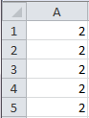For the next three questions, consider the set of numbers shown to the right:

1. =SUM(A1:A5)
   1. 2
   2. 5
   3. **10**
   4. This formula will return an error.
2. =AVERAGE(A1:A5)
   1. **2**
   2. 5
   3. 10
   4. This formula will return an error.
3. =STDEV(A1:A5)
   1. 2
   2. **0**
   3. 5
   4. This formula will return an error.
4. In relationship to later dates, earlier dates are _________.
   1. …much more awkward, because you’re still exploring your own identity, and it’s really hard to form intimate relationships when you might be insecure about yourself.   
      [note: this option is a joke, and not the right answer]
   2. Smaller text strings
   3. More inconsistent.
   4. **Smaller numbers.**
5. =AND(2>1,OR(1=2,NOT(1=2)))
   1. **True**
   2. False
   3. 2
   4. This will return an error
6. What is the first argument in an IF function?
   1. What to do when the IF function is True.
   2. What to do when the IF function is False.
   3. **A logical statement**
   4. An equals sign (e.g., “=”)
7. =IF(OR(1<>2,1>2), “Gangnam”, “Style”)
   1. **Gangnam**
   2. Style
   3. False
   4. Gangnam Style

For the next two questions, consider the following situation: I want to do an analysis of whether a kicker’s fantasy points in the first few weeks of this season are somehow related to the number of points earned by his team’s traditional offensive positions (QB, RB, WR, and TE). I’ve created the tables as shown below…

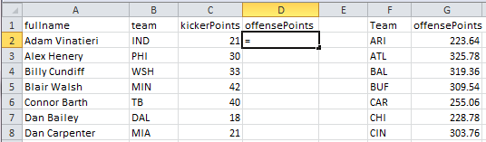

… and I need to get the offense points that correspond to each team to line up with the corresponding kicker. To do this, I need to use a VLOOKUP function.

1. Which of the following would be the appropriate VLOOKUP function (to put in cell D2)?
   1. =VLOOKUP(A2,F$2:G$33, 1, FALSE)
   2. **=VLOOKUP(B2,F$2:G$33, 2, FALSE)**
   3. =VLOOKUP(F$2:G$33,B2, 1, FALSE)
   4. =VLOOKUP(A2,F$2:G$33, 2, FALSE)
2. What would happen if the "$" symbol *weren't* included in the reference to the table F$2:G$33 in the previous answer?
   1. The VLOOKUP function would return an error.
   2. The VLOOKUP function would return the team name instead of the offensePoints.
   3. The VLOOKUP function would return data from the wrong column.
   4. **The VLOOKUP function would return data from the wrong row.**

For the next three questions, consider the following blog post, written by a fictional student:

Being from New Orleans, I have a certain affinity toward the Saints. I've been a loyal fan throughout their ups and downs, I have a poster of the Louisiana Superdome in my dorm room, and I'm forever hopeful that they'll return to the top of the NFL (like when they beat the Colts in the Superbowl!). So considering my love of the Saints, when it came time to choose players for my fantasy team, I couldn't help but select Saints stars! I'm really enthusiastic that I now have Khiry Robinson as my leading running back, and Brandin Cooks as my one of my wide receivers.

Watching their stats over the past five weeks has been really interesting. Even though he's a wide receiver, Brandin Cooks has actually made a few rushing attempts! And when I started looking deeper into these stats, I observed something that seemed strange: Brandin Cooks actually gets a larger number of rushing yards to each of his attempts than the running backs:

|  |  |  |  |  |
| --- | --- | --- | --- | --- |
| Fullname | position | rushYds | rushAtt | Yds/Att |
| Mark Ingram | RB | 143 | 24 | 5.96 |
| Khiry Robinson | RB | 304 | 61 | 4.98 |
| Brandin Cooks | WR | 64 | 5 | 12.80 |

Data from 2014 combined.

So really: WRs tend to get more yards on each of their carries than a RB. It makes you wonder why the QB is always handing-off the ball to the running back, when he could probably get more yards on the play if he'd hand it off to the wide receiver. Clearly football isn't a rational sport, and teams could do much better if they'd pay more attention to statistics. Players listed as wide receivers do a much better job as ball carriers than running backs.

1. Does this blog post sufficiently consider variance in football statistics?
   1. **No. The post should've looked at all RB and WR rushing Yds/Att.**
   2. Yes. The post collected data from 5 weeks of football games.
   3. No. The post needed to include standard deviations.
   4. Yes. The post included data from 3 different players.
2. The five steps of thinking empirically are: (1) Being observant; (2) Recognizing the need for data; (3) Considering variation; (4) Synthesis; and (5) Skepticism. Based on your reading of the blog post above, which of these steps did the fictional student perform, and which did they skip?
   1. The student did all 5 steps.
   2. The student did 1, 2, 3, and 5, but skipped 4.
   3. The student did 1 and 2, but skipped 3, 4, and 5.
   4. **The student did 1, 2, and 4, but skipped 3 and 5.**
3. Which of the following field lists might've generated the PivotTable that the student used in the blog post? (there are multiple ways to format a PivotTable, but only one of these could possibly be correct)

|  |  |  |  |
| --- | --- | --- | --- |
| **a.** |  | b. |  |
|  |  |  |  |
| c. |  | d. |  |

1. Which of the following would be the best support for the claim "*Trent Richardson is going to score very few fantasy points this season.*"?
   1. A very well-educated Cleveland Browns fan's belief that Trent Richardson is not a good running back.
   2. Data describing Trent Richardson's poor performance in the beginning of the 2014 season.
   3. **Data describing all previous running backs who are similar to Trent Richardson, and demonstrating that these similar running backs went on to have poor fantasy seasons.**
   4. A magic 8-ball's response to the question "How will Trent Richardson perform in 2014?"
2. Which of the following is a primary key in the pigskin database?
   1. fantasyPoints
   2. **playerid**
   3. gameDate
   4. season
3. Which VLOOKUP function might correctly append player birthdays to the offense table?
   1. =VLOOKUP([@playerid], Table_pigskin_games, 4, FALSE)
   2. =VLOOKUP([@fullname], Table_pigskin_players, FALSE, 4)
   3. =VLOOKUP([@fullname], Table_pigskin_players, 4, FALSE)
   4. **=VLOOKUP([@playerid], Table_pigskin_players, 4, FALSE)**
4. Consider the table below, indicating possible answers to the question "What does the fox say?", and an equation in cell B11…

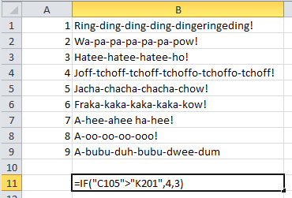

What would the following VLOOKUP function return?

= VLOOKUP(B11,A1:B9,2,FALSE)

* 1. **Hatee-hatee-hatee-ho!**
  2. Joff-tchoff-tchoff-tchoffo-tchoffo-tchoff!
  3. A-bubu-duh-bubu-dwee-dum
  4. It would return an error

1. For one bonus point, mark “C” (for #45).

Remember that we don’t have class on Thursday. C105 will resume on Tuesday, Oct. 21.