**Pre-Game Warm-up: Getting Data from the Pigskin Database**

1. Open Microsoft Excel.
2. Click on the “Data” tab:

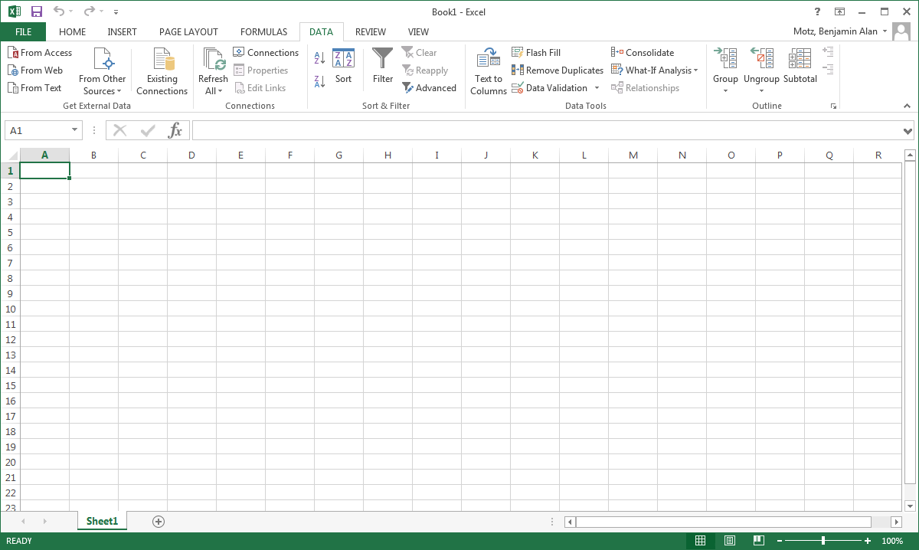

1. In the “From Other Sources” drop down menu, select “From Data Connection Wizard”:

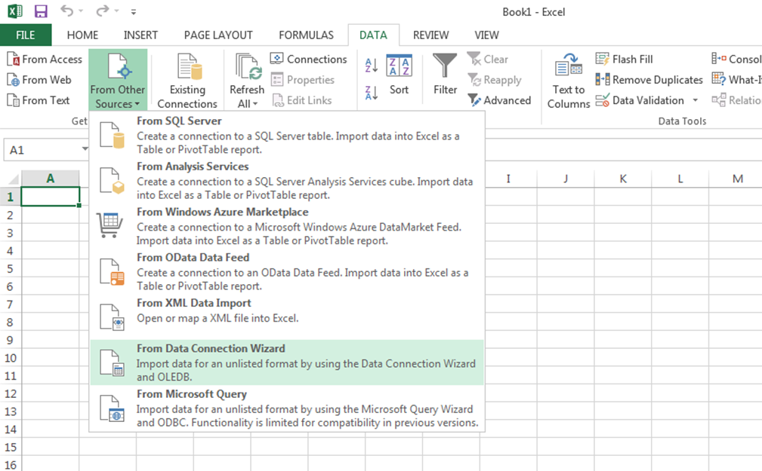

1. In the window that pops-up, select ODBC DSN, and click Next:



1. Select “pigskin” and click Next:

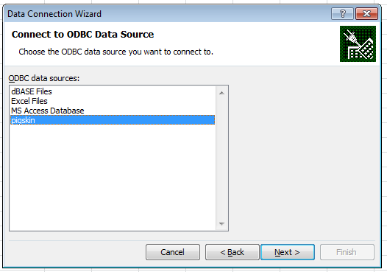

1. Select the table that you want to access. In this case, we’ll select the “games” table. Then click Next:

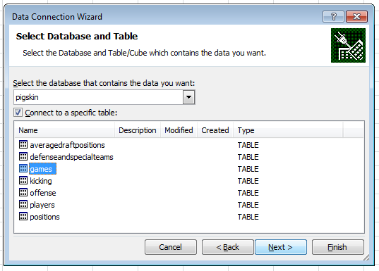

1. The Data Connection wizard will ask to create a new data connection file. You do not need to change any of these settings. Just click “Finish.”  
   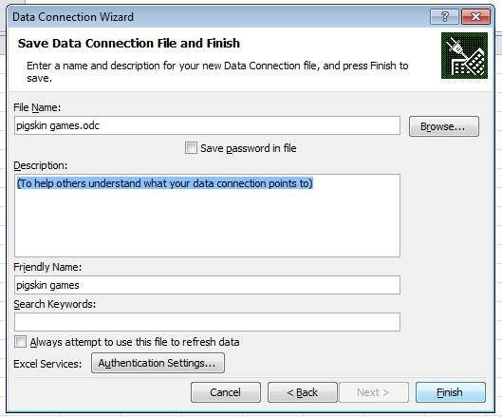

*If you’ve already connected to the table before*, the system will already have a data connection file for this table, and it will ask whether you want to replace the existing connection. Just click “Yes.”  
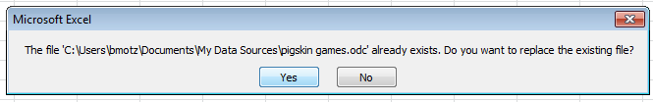

1. Now Excel needs to know how you want to view the data. For the purposes of these exercises, we just want to retrieve the data as a Table, in the existing worksheet, starting at cell $A$1. Just click “OK”:

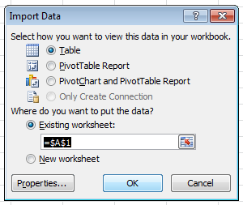

Now you’ve successfully retrieved data from the pigskin database!

**First Half: Describe the best wide-receivers in the database.**

1. Follow the instructions above (in *Pre-Game Warm-up: Getting Data from the Pigskin Database*) to retrieve the “**offense**” table into an Excel worksheet. When you’re done, it should look kinda like this:

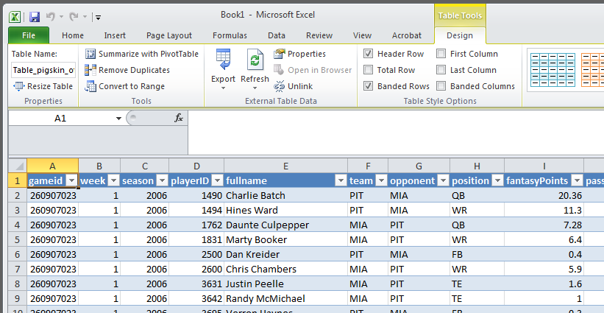

1. Select only the wide receivers by clicking the downward arrow next to “position,” unchecking “Select All” and checking “WR”:

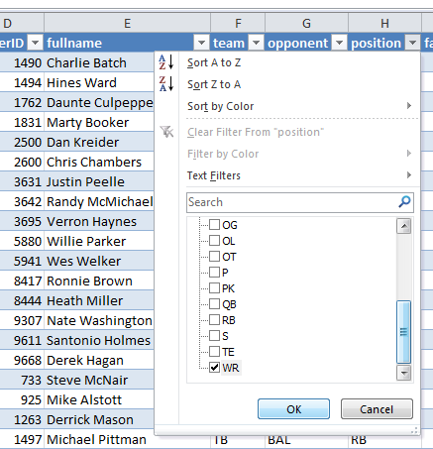

1. Now sort by number of fantasy points, decending (the most fantasy points are on top, and the least fantasy points are on bottom). Click on the downward arrow next to “fantasyPoints,” and click “Sort Z to A.”
2. Start to answer the questions on the Week 2 Lab Exercises worksheet.

**Name: ___________________________________**

**First Half Questions:**

1. Which WR got the most fantasy points in a single game (since 2006)? Eric Decker
2. How many fantasy points were obtained by that player, in that game? 41.4
3. How many times have each of the following WRs earned **30 or more** fantasy points in a single game (since 2006)?

Chad Ochocinco (now Johnson): 3 Calvin Johnson: 2

Anquan Boldin: 3 Roddy White: 2

1. Of the five WRs who’ve earned at least 40 points in a   
   single game (since 2006), only one of them has had   
   multiple games earning at least 30 points. Who is that? Andre Johnson
2. Now sort by receiving yards. Which player had the most   
   receiving yards in a game without getting a touchdown?  
   (including players who earned fewer than 30 fantasy points) Calvin Johnson
3. How many **fantasy points** were obtained by the player  
   you identified in the previous question, in that game? 20.5

Now do the same analyses with **tight ends**. Start by selecting only “TE” in the “position” column, and then sorting by fantasyPoints.

1. Which TE got the most fantasy points in a single game (since 2006)? Vernon Davis
2. How many fantasy points were obtained by that player, in that game? 30
3. How many times have each of the following TEs earned at least **20** fantasy points in a single game (since 2006)?

Antonio Gates: 7 Dallas Clark: 5

Rob Gronkowski: 10 Vernon Davis: 4

1. Now sort by *receptions*. Which TE had the most   
   receptions in a game without getting a touchdown?  
   (including players who earned fewer than 20 fantasy points) Jason Witten
2. How many fantasy points were obtained by the player  
   you identified in the previous question, in that game? 16.7

Now we’re gonna look at some **quarterback** stats. Start by selecting only “QB” in the “position” column.

1. In how many games has the quarterback fumbled for a loss 3 times? 5
2. Only one NFL team (since 2006) has both *caused* the   
   opposing quarterback to fumble the ball 3 times, and has  
   had their quarterback *commit* 3 fumbles in a single game.  
   Which team is this? New York Jets
3. The NFL record for most interceptions thrown in a single  
   game is 7, although this hasn’t happened since 2001. In the  
   pigskin database, going back to 2006, which quarterback  
   has thrown the most interceptions in a single game? Peyton Manning
4. The quarterback you identified in the previous question  
   also shares another passing record in the pigskin database.  
   What column is this player tied for having the most of  
   in a single game? Passing touchdowns

**Second Half Questions:**

Open a new blank worksheet, and follow the previous instructions to access the pigskin database (Data Connection Wizard >> ODBC DSN >> pigskin), but this time, import the “games” table.

1. Which stadium has the highest attendance? Cowboys Stadium
2. The team that plays at the stadium identified in the  
   previous question has a rivalry that tends to draw  
   pretty strong crowds. What visiting team tends  
   to draw large crowds to the above stadium? NYG
3. What was the highest score observed in a  
   regular-season NFL game since 2006? What  
   team got this score? 62 points to New Orleans Saints
4. In which quarter (Q1, Q2, Q3, or Q4) of the game   
   did the team in the previous question earn the   
   highest score? Q1

Okay now it’s gonna get a little tricky.

Right click on the cell that says “gameLocation” (which should be J1), and in the “Insert” menu, select “Table Columns to the Left”.  
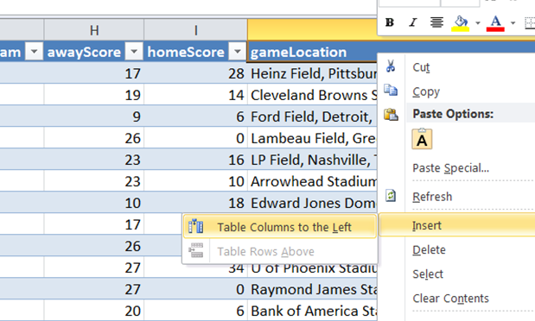

… in this new column, we’re gonna create a new variable: the point difference between the home and away teams’ scores. In the cell where it says “Column1” (should be J1), type “scoreDifference” and press Enter. In the cell just below where you wrote “scoreDifference” (should be J2), make the following formula: =ABS([@homeScore]-[@awayScore]) …and press Enter.

1. What game had the highest scoreDifference   
   in the database? Week 6, 2009, TEN at NE
2. That game was brutal for the visiting team.  
   How many passing yards, in total, did the   
   visiting team throw? -2
3. How regular season NFL games have ended   
   in a tie since 2006? 3

**The Game-Winning Drive:**

Has any team (since 2006) ever successfully   
converted all of its 3rd down attempts in a single game? No. (closest was NO: 91.6% in 2008 v. DET)

To answer this question, you’ll probably want to make two new columns, following the instructions in the previous few questions. One column should be the 3rd down conversion rate for the home team (=[@home3rdDownConv]/[@home3rdDownAtt]) and the other should be the 3rd down conversion rate for the away team. Then sort each column from largest to smallest to see if any team (in the database) has ever achieved this miraculous feat.

And finally, overtime:

Explore the other tables in the database, and below, write one thing that you found that isn’t related to the questions above:

__________________________________________________________________________

__________________________________________________________________________

__________________________________________________________________________