**Pre-Game Warm-Up:** Creating a PivotTable

1. Open Microsoft Excel.

2. Access the **games** table in the pigskin database as you did two weeks ago:

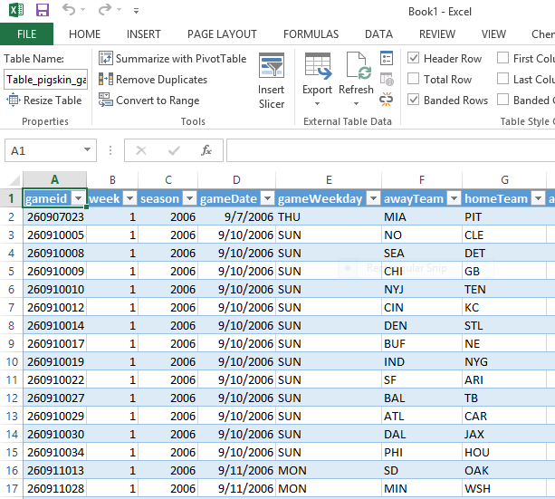

3. Click on the “Insert” tab at the top of the Microsoft Excel window, and click PivotTable, the first option in the toolbar on the far left:

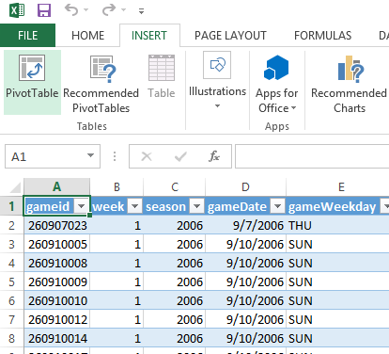

4. When the “Create PivotTable” window appears, just click “OK”:

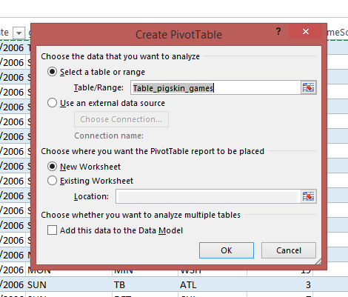

5. Great! Now we’ve got a PivotTable that includes all the variables in the **games** table:

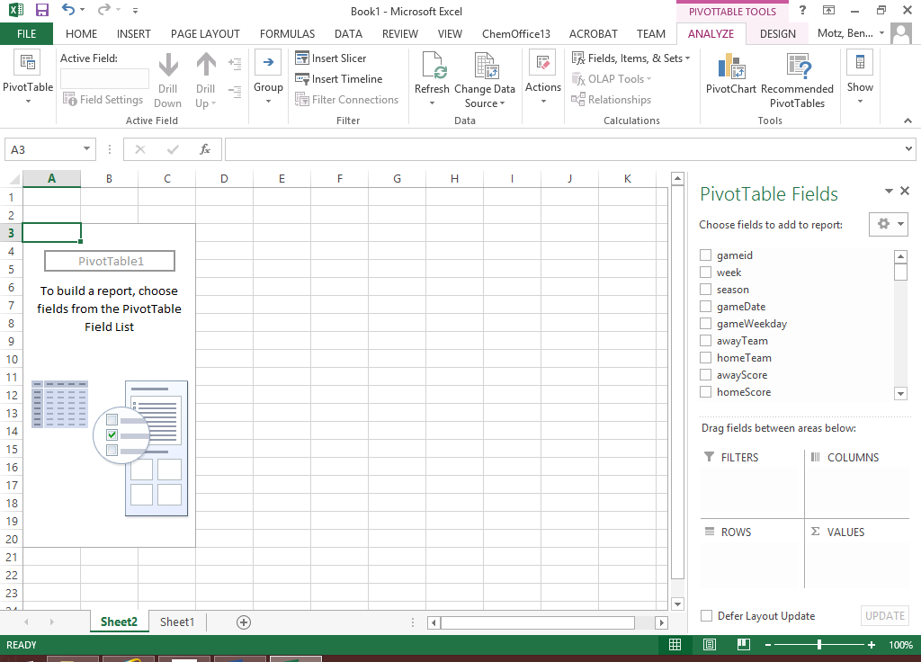

Quick cross-tabs of the **games** table using Excel PivotTables: **The Home Field Advantage**.

1. If there were no home-field advantage in the NFL, the home team would win exactly 50% of the time, and the away team would win exactly 50% of the time. This is because each team plays an equal number of home/away games in a season. Let’s see what percent of the time the home team wins.
   1. Go back to the raw “games” table, which is probably on “Sheet1” of your Excel workbook:



* 1. Move over to column J, and right click on column J (as shown below), and select “Insert” to create a new column between homeScore and gameLocation:

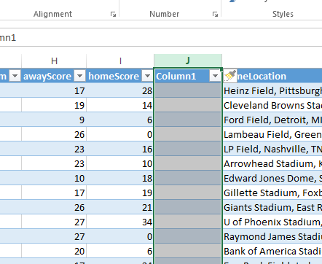

* 1. Click where it says “Column1” and rename it to “gameWinner”:

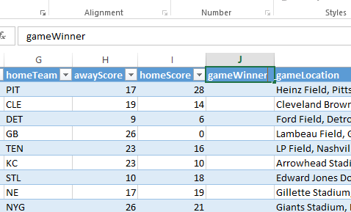

* 1. In cell J2, type the following formula:

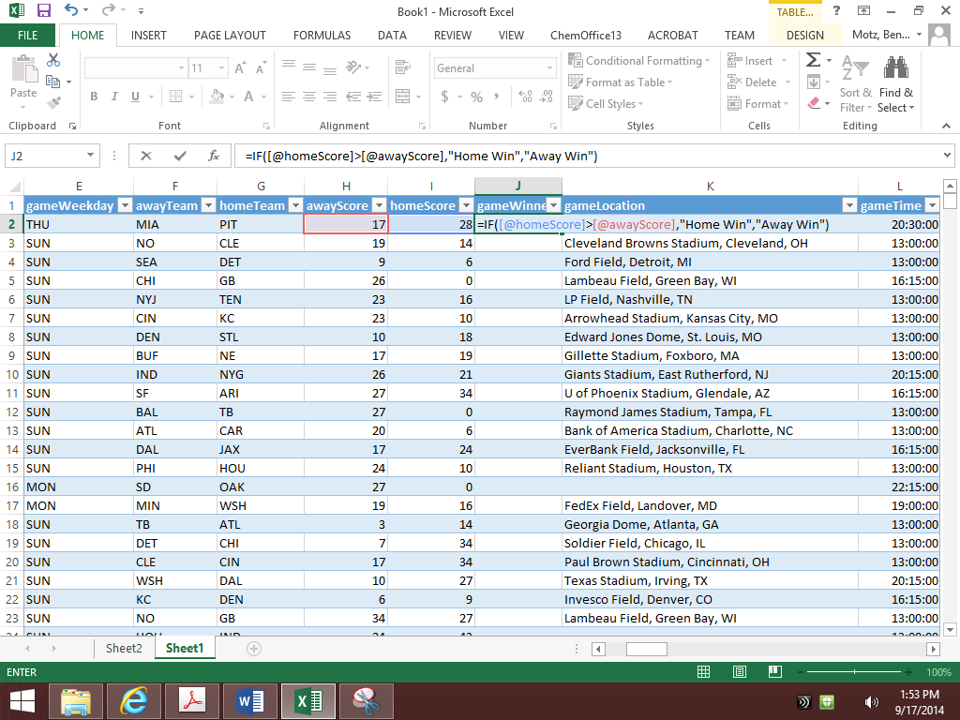…and press “Enter” so that the formula calculates all the way down the table. What you’ve just done is created a column that will display “Home Win” whenever the homeScore is greater than the awayScore, and will display “Away Win” otherwise. (This ignores the three games since 2006 that ended in a tie, but that’s okay.)

* 1. Go back to your PivotTable. It’s probably on “Sheet2” of your Excel workbook, and RIGHT CLICK somewhere in your PivotTable (like on cell A3), and click “Refresh”:

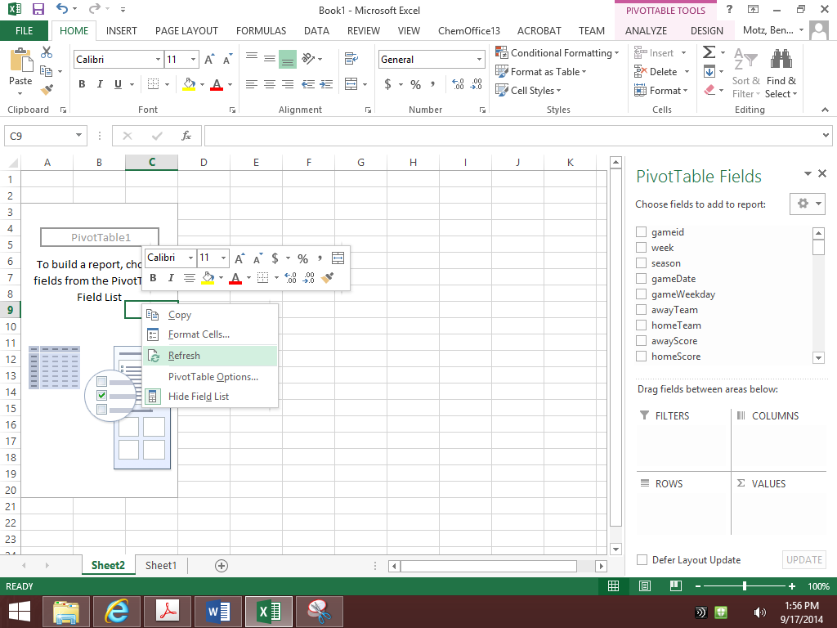

… now your new gameWinner column should appear in the PivotTable Field List on the right.

* 1. Drag the *gameWinner* field into the “Row Labels” area of your PivotTable Field List:

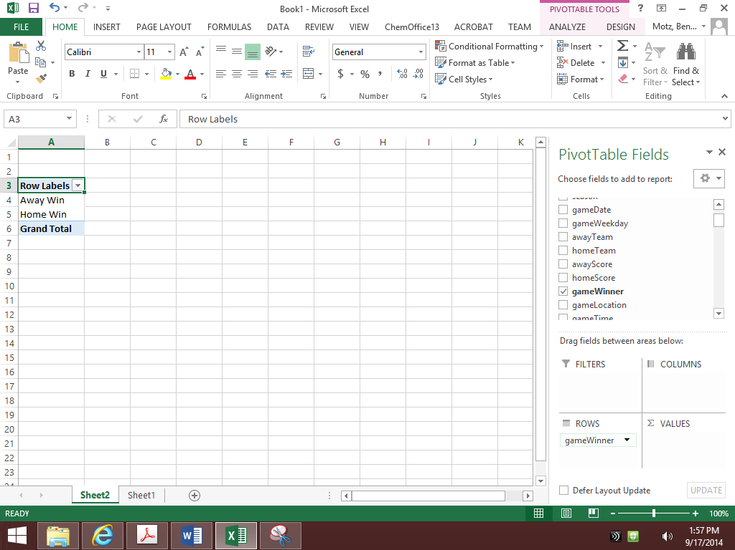

* 1. Now drag the gameid field into the “Values” area of your PivotTable Field List, since we want to count the number of games that the home team won, compared with the away team:

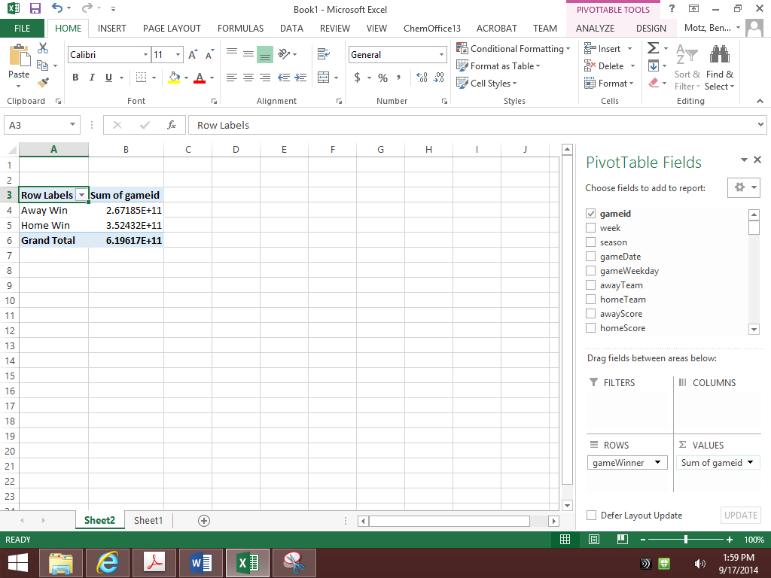

* 1. That’s not quite right. It’s *summing* the gameids, but we want it to *count* the gameids. Click the downward arrow to the right of gameid in the “Values” area, and select Value Field Settings:

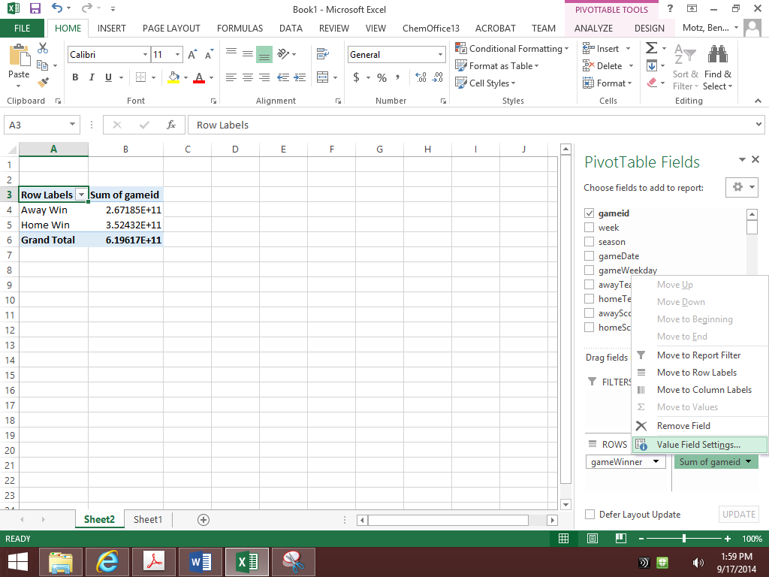

* 1. In the window that pops-up, select “Count”and click “OK”:

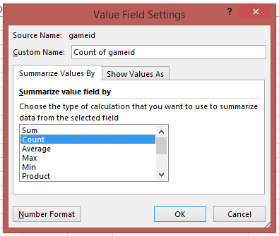

* 1. *Great!* We now can see how many games were won by the home team (and how many games were won by the away team) each season. But what would be really nice would be to see these expressed as percentages, so that we could know the percent of games won by the home team. To do this, RIGHT CLICK on the cell that has the count of away wins, go down to the “Show Values As” menu, and select “% of Column Total”:  
     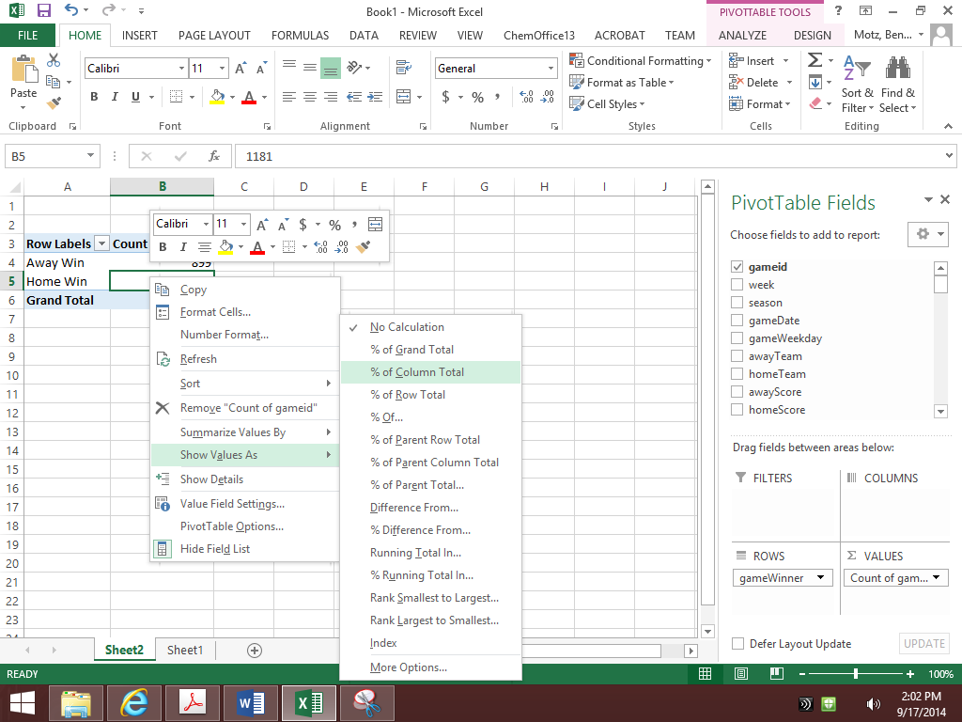
  2. Hooray!

1. Now that you’ve gotten this far, you can start answering some of the questions on today’s worksheet.

Name: ___________________________________________

**Week 4 Lab Part 1: Pivot-ing the Home Field Advantage**

1. What are the %’s of games won by home and away teams: ___________ ___________

Home Away

1. Drag the "season" field into the column list. Since 2006,  
   has there ever been a season when the home team  
   won less than 55% of the time? If so, what season was that? ______________________
2. Remove the “season” field from the Column Labels area, drag “gameWinner” to the Column Labels area, and drag the “gameLocation” field into the Row Labels area. Change the table so that the values are summarized by “% of Row Total.” Right click on the first value in the “Home Win” column, and in Sort options, click “Sort Largest to Smallest.” Which field has the highest percentage of home wins?

_______________________________________

1. Would it be fair to say that the home field advantage is “biggest” at the stadium above? (or conversely, would it be fair to say that the “opposite” of the home field advantage exists at Cleveland Browns Stadium?) Why or why not?

______________________________________________________________________________

______________________________________________________________________________

______________________________________________________________________________

1. In their book, Scorecasting, Moskowitz and Wertheim argue that the home field advantage in the NFL (that is, the tendency for home teams to win more than away teams), is caused by officiating biases. In other words, officials make it easier for the home team to win because referees are reacting to the crowd. If that’s the case, we should observe more penalty yards for away teams than for home teams. What is the average   
   number of penalty yards per game assessed against   
   the home and away teams (e.g., homePenaltyYards): ___________ ___________  
    Home Away
2. For the team that plays in the stadium you identified in question 3, above, it’s still possible that there’s a home field advantage. We’d just need to find out whether they’re more likely to win when they’re at home or when they’re away. With “Count of gameid” in the Values area, and gameWinner in the Row Labels, try to find the percent of games won when that team is playing at home, and the percent when that team is playing away.

___________ ___________  
 Home Away

Attempt to find evidence for the home field advantage in the following variables:

1. Average of homePassingYards: _____________ awayPassingYards: _____________
2. Average of homeRushingYards: ____________ awayRushingYards: ____________
3. Average of homeTurnovers: _______________ awayTurnovers: _______________
4. Average of homeInterceptionsThrown: _________ awayInterceptionsThrown: _________

**Week 3 Lab Part 2: Pivot-ing the Offense Table**

Now that you’ve had some practice manipulating PivotTables, open a new sheet (or a new workbook), and make a PivotTable from the “offense” table in pigskin. Try to answer the following questions to the best of your ability. Ask questions if you get stuck! Don’t worry if you can’t finish them all.

1. Which team gives up the highest average number of fantasy points per game? ____________
2. For the team in #11 above, what’s the average fantasy points scored against it? ____________
3. Fill-in the values in the table below:

|  |  |  |
| --- | --- | --- |
| **Row Labels** | **Average of fantasyPoints** | **StdDev of fantasyPoints** |
| QB |  |  |
| RB |  |  |
| TE |  |  |
| WR |  |  |
| **Grand Total** |  |  |

1. How many players have had at least 1 rushing attempt, at least 1 passing   
   attempt, and at least one reception in a single game? (Hint: Be careful of   
   players who might’ve done this more than once) _________________
2. How many times has this   
   happened to a player at each ___________ __________ ____________   
   of the following positions: QB RB WR
3. The average running back has a rushYards-to-   
   receivingYards ratio of about 3.0 (for every receiving   
   yard, they earn 3 rushing yards). Which NFL teams   
   have the highest and lowest average rush-to- ____________ ____________   
   receiving ratio for running backs? highest lowest