Supplementary Information
Nutrient limitation suppresses the temperature dependence of phytoplankton metabolic rates
E. Marañón¹ (em@uvigo.es), M. P. Lorenzo¹, P. Cermeño², B. Mouriño-Carballido¹
¹Departamento de Ecología y Biología Animal, Universidade de Vigo, 36310 Vigo, Spain
²Instituto de Ciencias del Mar, CSIC, Passeig Maritim de la Barceloneta 37-49, 08003 Barcelona, Spain

Table S1. Multiple regression analysis with temperature (Temp, °C) and dilution rate (D, d⁻¹) as independent variables and normalized carbon-specific photosynthesis (nP^{C}, h⁻¹), normalized carbon-specific respiration (nR^{C}, h⁻¹), the respiration to photosynthesis ratio (R:P) and the molar carbon to nitrogen ratio (C:N) as dependent variables. The analysis was conducted with data from all species pooled together. For each species, P^{C} and R^{C} values were normalized by dividing them by the mean value measured at a dilution rate of 0.35 d⁻¹ (S. costatum), 0.34 d⁻¹ (E. huxleyi) and 0.30 d⁻¹ (Synechococcus). To ensure that the regression coefficients for each independent variable (effect sizes) are comparable, temperature and dilution rate values were standardized by calculating the difference with the mean and then dividing by the standard deviation. The multiple regression model is y = b₀ + b₁ x₁ + b₂ x₂ + b₃ x₁ x₂ where y is the metabolic rate, x₁ and x₂ are temperature and dilution rate, respectively, and b₀, b₁, b₂ and b₃ are the coefficients. 95% confidence intervals for the standardized coefficient estimates are given in parentheses. Also shown are the coefficient of determination of the multiple regression model (R²), the ANOVA F and p values, and the number of observations.

Dependent variable | Temp.  b₁ | p | D  b₂ | p | Temp. × D  b₃ | p | R² | F | p | n
nP^{C} | 0.094  (-0.014, 0.203) | 0.08 | 0.355  (0.247-0.462) | <0.0001 | -0.005  (-0.124, 0.113) | 0.92 | 0.66 | 16.4 | <0.0001 | 29
nRC | 0.012  (-0.086, 0.110) | 0.80 | 0.236  (0.137, 0.335) | <0.0001 | -0.065  (-0.179, 0.049) | 0.25 | 0.54 | 9.8 | 0.0002 | 29
R:P | 0.023  (-0.023, 0.071) | 0.31 | -0.098  (-0.146, -0.049) | 0.0003 | -0.060  (-0.115, -0.005) | 0.04 | 0.54 | 8.5 | 0.0006 | 26
C:N | -0.271  (-1.331, 0.789) | 0.61 | -1.815  (-2.870, -0.761) | 0.0014 | 0.197  (-0.959, 1.355) | 0.73 | 0.33 | 4.5 | 0.0105 | 32

Table S2. Multiple regression analysis with natural logarithm of carbon-specific photosynthesis (lnP^{C}, h⁻¹) as dependent variable and inverse temperature (1/kT, °K) and natural logarithm of dilution rate (lnD, d⁻¹) as independent variables. The analysis was conducted separately for S. costatum (Scos), E. huxleyi (Ehux) and Synechococcus (Syne). The multiple regression model is lnP^{C} = c₁ + c₂ lnD - E_{a} (1/kT). 95% confidence intervals for the standardized coefficient estimates are given in parentheses. Also shown are the coefficient of determination of the multiple regression model (R²), the ANOVA F and p values, and the number of observations.
 | c₁ | p | c₂ | p | -E_{a} | p | R² | F | p | n
Scos | 1.94  (-12.90, 16.79) | 0.77 | 0.84  (0.45-1.22) | <0.001 | -0.10  (-0.47, 0.26) | 0.55 | 0.73 | 12.4 | 0.003 | 12
Ehux | 2.71  (-16.1, 21.5) | 0.74 | 0.87  (0.61, 1.13) | <0.001 | -0.09  (-0.56, 0.37) | 0.65 | 0.92 | 33.4 | <0.001 | 9
Syne | 2.55  (-5.9, 11.0) | 0.45 | 0.52  (0.30, 0.73) | 0.003 | -0.14  (-0.36, 0.07) | 0.14 | 0.92 | 22.7 | 0.007 | 7

Table S3. Slope (-E_{a}, eV) of the ordinary least squares linear regression between 1/kT and the natural logarithm of carbon-specific photosynthesis (P^{C}) and respiration (R^{C}) for each species under each dilution rate (D). The 95% confidence interval of -E_{a} and the p-value are also given.

 | D, d⁻¹ | -E_{a} | 95% CI | p
P^{C}
Skeletonema costatum | 0.14 | -0.36 | -0.86, 0.15 | 0.09
 | 0.35 | 0.22 | -1.77, 2.21 | 0.68
 | 0.60 | -0.16 | -0.94, 0.62 | 0.46
Emiliania huxleyi | 0.09 | -0.03 | -0.20, 0.14 | 0.54
 | 0.34 | -0.02 | -2.42, 2.38 | 0.93
 | 0.60 | -0.21 | -0.56, 0.67 | 0.67
Synechococcus | 0.10 | -0.28 | -2.10, 1.54 | 0.29
 | 0.30 | -0.08 | -0.44, 0.27 | 0.44
R^{C}
Skeletonema costatum | 0.14 | -0.13 | -0.67, 0.40 | 0.19
 | 0.35 | -0.29 | -0.48, -0.10 | 0.02
 | 0.60 | 0.10 | -0.32, 0.53 | 0.39
Emiliania huxleyi | 0.09 | -0.22 | -2.49, 2.04 | 0.43
 | 0.34 | 0.14 | -0.41, 0.68 | 0.41
 | 0.60 | -0.13 | -0.86, 0.59 | 0.51
Synechococcus | 0.10 | 0.15 | -1.77, 2.07 | 0.51
 | 0.30 | 0.05 | -0.03, 0.14 | 0.12

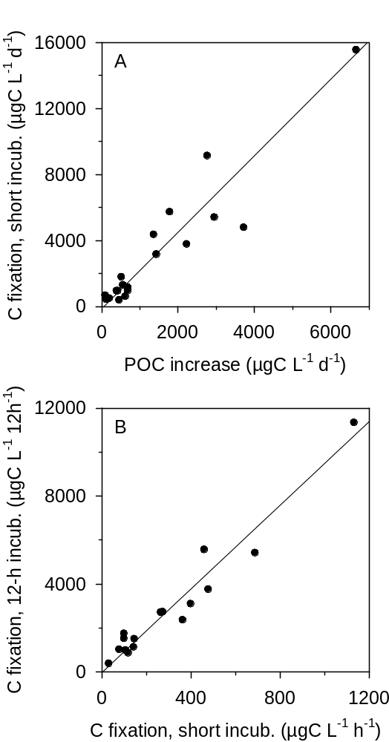

Fig. S1. A) Relationship between the daily increase in particulate organic carbon (POC) and the daily rate of C fixation estimated from short (2-3 h) ¹⁴C incubations in batch cultures of 20 phytoplankton species including S. costatum, E. huxleyi and Synechococcus. Each datapoint corresponds to a different species. The daily C fixation rate was calculated by multiplying the hourly rate, measured during a short incubation, by 12 h (the duration of the light phase of the photoperiod). The reduced major axis (r. m. a.) regression line is y = -131.5 + 2.3 x (r² = 0.88, p < 0.001, n = 20). B) Relationship between the hourly rate of C fixation in short ¹⁴C incubations and C fixation measured during 12-h incubations. The r. m. a. regression line is y = -19.5 + 9.5 x (r² = 0.94, p < 0.001, n = 16).

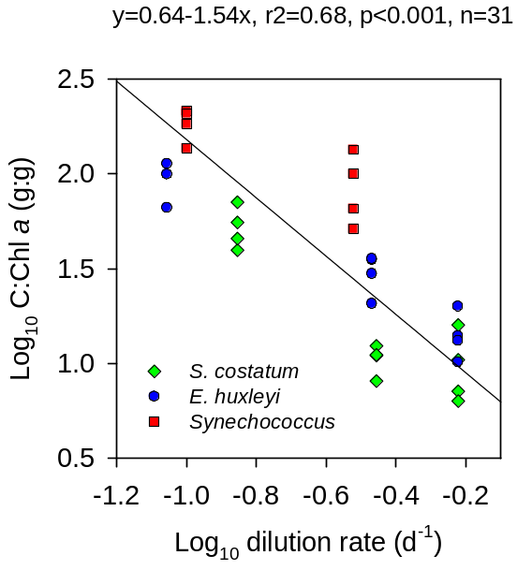

Fig. S2. Log-log relationship between dilution rate and the carbon to chlorophyll a ratio in S. costatum, E. huxleyi and Synechococcus. The OLS regression fit for all data combined is y = 0.64 - 1.54 x (r² = 0.68, p < 0.001, n = 31).

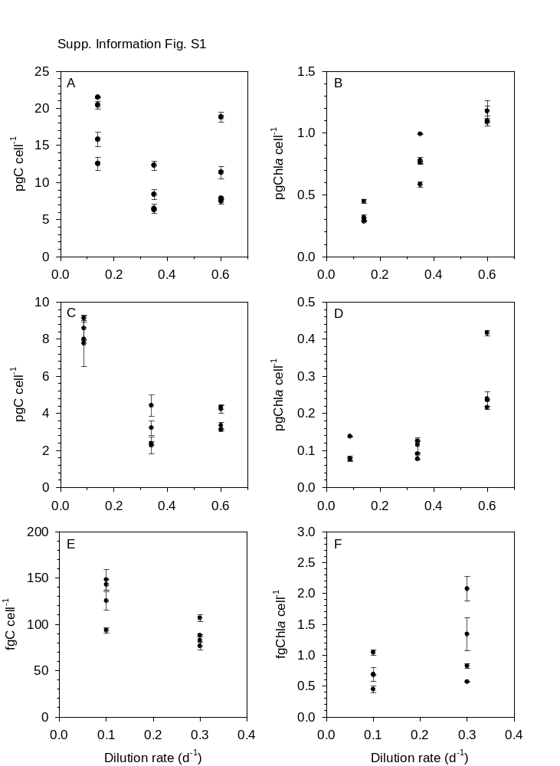

Fig. S3. Relationship between dilution rate and the cellular content of (left) carbon and (right) chlorophyll a in A,B) S. costatum, C,D) E. huxleyi and E,F) Synechococcus. Bars indicate standard deviation.

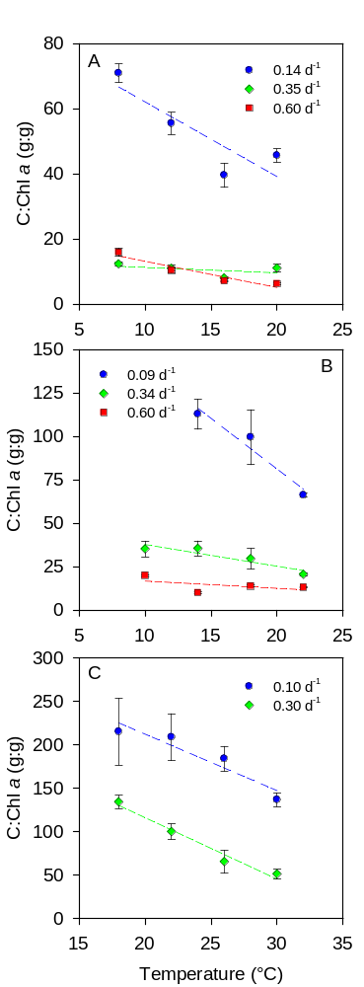

Fig. S4. Temperature dependence of the carbon to chlorophyll a ratio (C:Chl a) in A) S. costatum, B) E. huxleyi and C) Synechococcus under N-limited continuous growth at different dilution rates. Bars indicate standard deviation and dashed lines are the OLS regression fits.

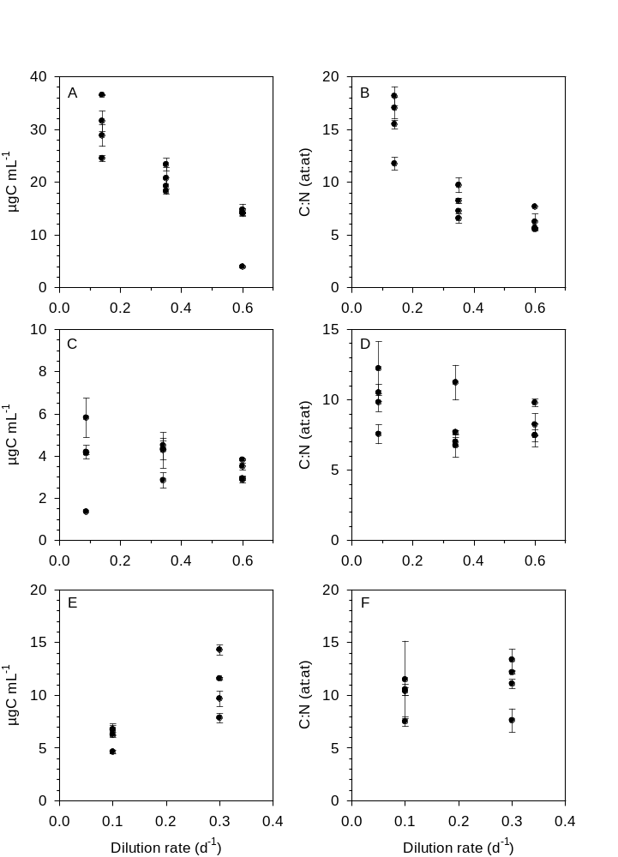

Fig. S5. Relationship between dilution rate and (left) the concentration of particulate organic carbon and (right) the C:N ratio of suspended organic matter in A,B) S. costatum, C,D) E. huxleyi and E,F) Synechococcus. Bars indicate standard deviation.
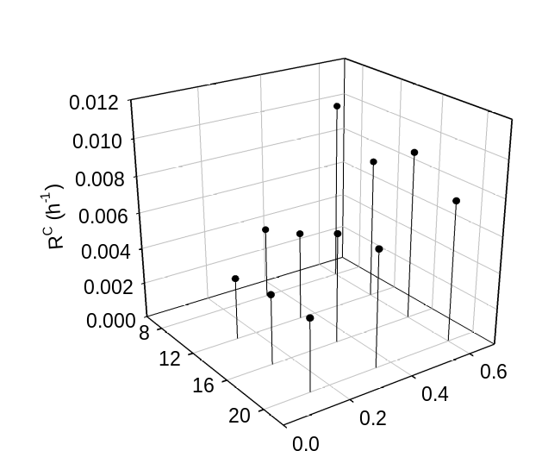
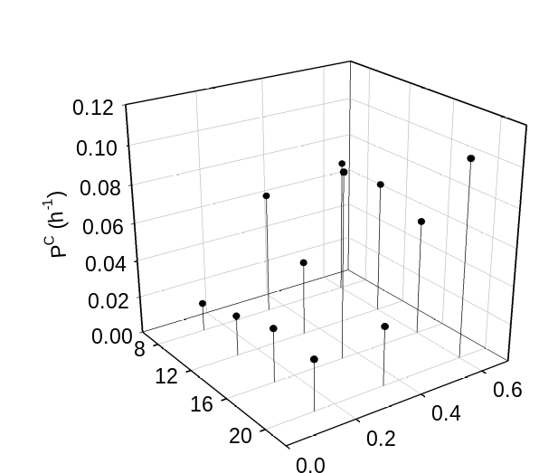
A
B

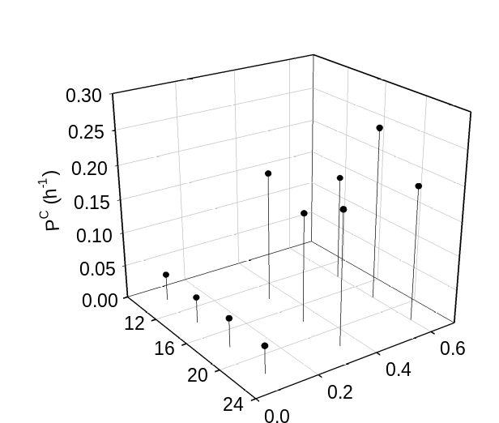
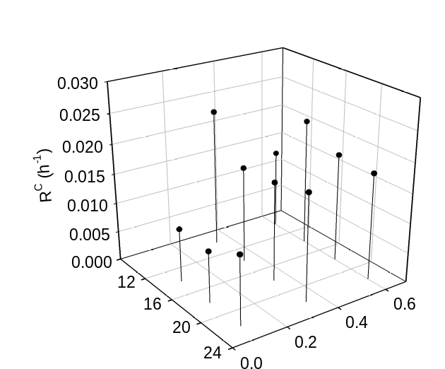
C
D

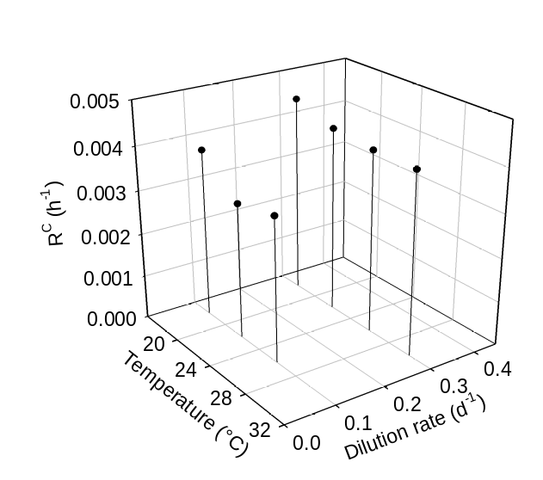
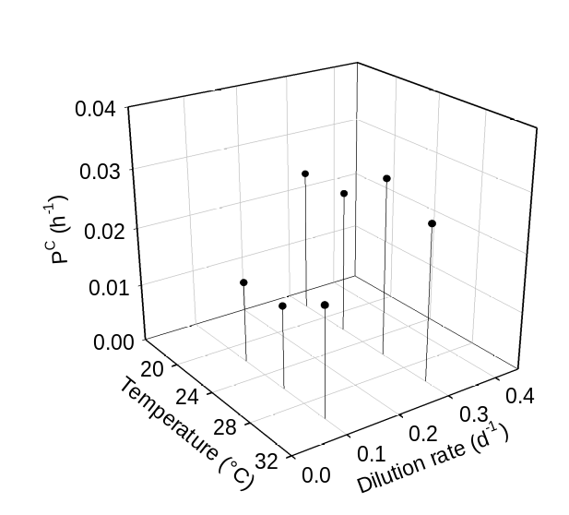
E
F

Fig. S6. Carbon-specific photosynthesis (P^{C}) and respiration (R^{C}) in S. costatum (top), E. huxleyi (middle) and Synechococcus (bottom) under different temperatures and dilution rates. Left: carbon-specific photosynthesis; right: carbon-specific respiration.

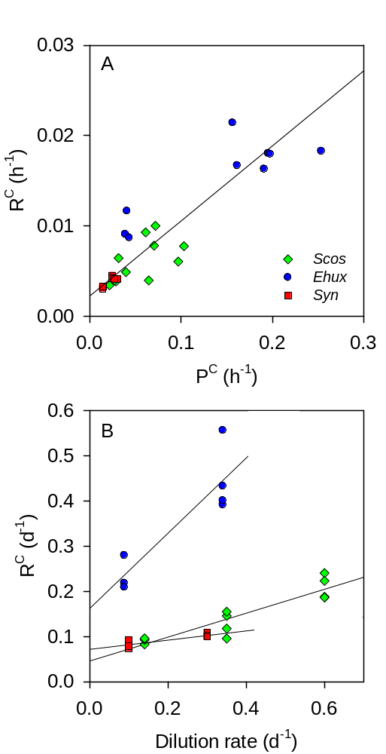

Fig. S7. A) Relationship between hourly rates of carbon-specific photosynthesis (P^{C}) and respiration (R^{C}) in S. costatum, E. huxleyi and Synechococcus growing at different temperatures and dilution rates. The linear fit (reduced major axis regression) is y = 0.083 x + 0.0023 (r² = 0.81, p < 0.0001, n = 26). B) Relationship between dilution rate and daily R^{C}. Daily R^{C} was computed as hourly R^{C} × 24. Lines are the OLS regression fits. The y-intercepts, which represent the basal metabolic rate, are 0.046 (SE = 0.017; 95% CI = 0.008, 0.084) for S. costatum, 0.163 (SE = 0.051; CI = 0.032, 0.293) for E. huxleyi and 0.072 (SE = 0.006; CI = 0.056, 0.088) for Synechococcus.

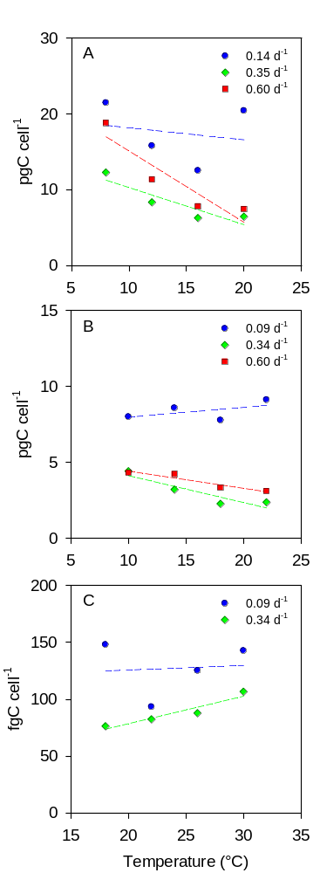

Fig. S8. Relationship between temperature and cellular carbon in N-limited chemostats of A) S. costatum, B) E. huxleyi and C) Synechococcus at different dilution rates. Lines are the OLS regression fits.

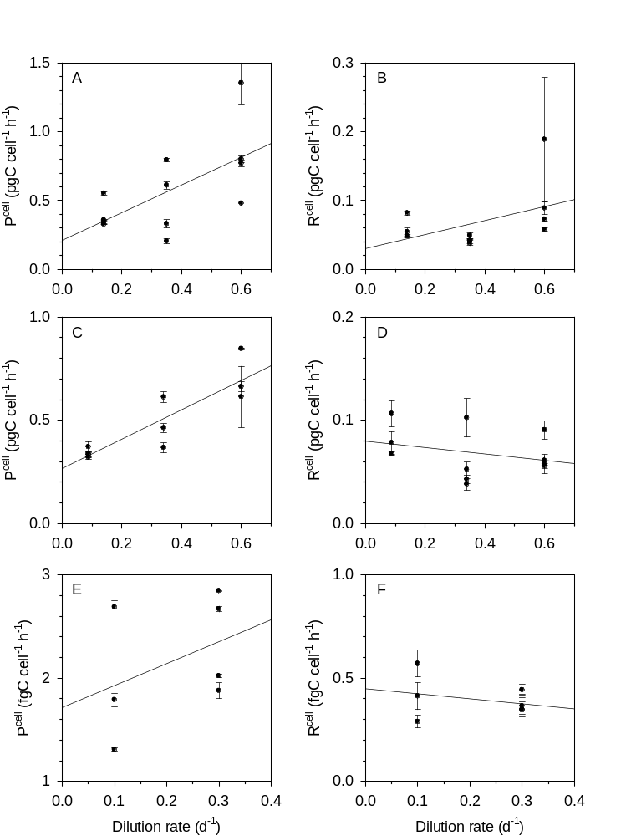

Fig. S9. Relationship between dilution rate and cell-specific rates of (left) photosynthesis and (right) respiration in A,B) S. costatum, C,D) E. huxleyi and E,F) Synechococcus. Bars indicate standard deviation and lines are the OLS regression fits.

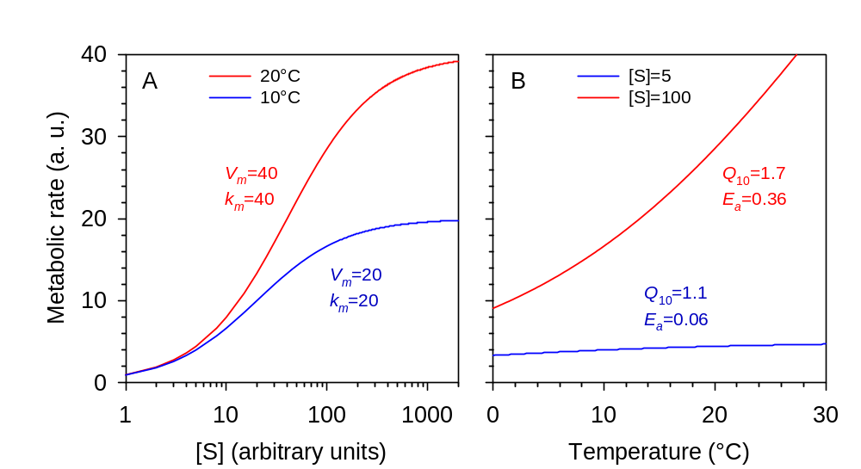

Fig. S10. Idealised example of the interaction between temperature and resource availability in the control of enzymatic kinetics and metabolic rates. Metabolic rate (V) is calculated according to Michaelis-Menten kinetics as V=V_{m}[S]/([S]+k_{m}) where V_{m} is the maximum, nutrient-saturated rate, [S] is the substrate concentration, and k_{m} is the Michaelis-Menten or half-saturation constant. A) Relationship between [S] and V at 10°C and 20°C assuming that both V_{m} and k_{m} double with a 10°C increase in temperature (Q₁₀ = 2). B) Relationship between temperature and V for a low ([S]=5) and a high ([S]=100) concentration of substrate, assuming that both V_{m} and k_{m} have a Q₁₀ of 2 (equivalent to E_{a}=0.49 eV). The resulting temperature dependence of metabolic rate is much stronger under high (Q₁₀=1.7, E_{a}=0.36) than under low (Q₁₀=1.1, E_{a}=0.06) substrate concentration.

