Evidence before build
A work order earns an agent turn only after scope, evidence, safety, workspace, and cost boundaries are visible.
The flow moves from a bounded work order through a deterministic evidence-and-safety preflight to one of three explicit outcomes: proceed, narrow the work, or request human review. The work order remains the accountability boundary in both directions.
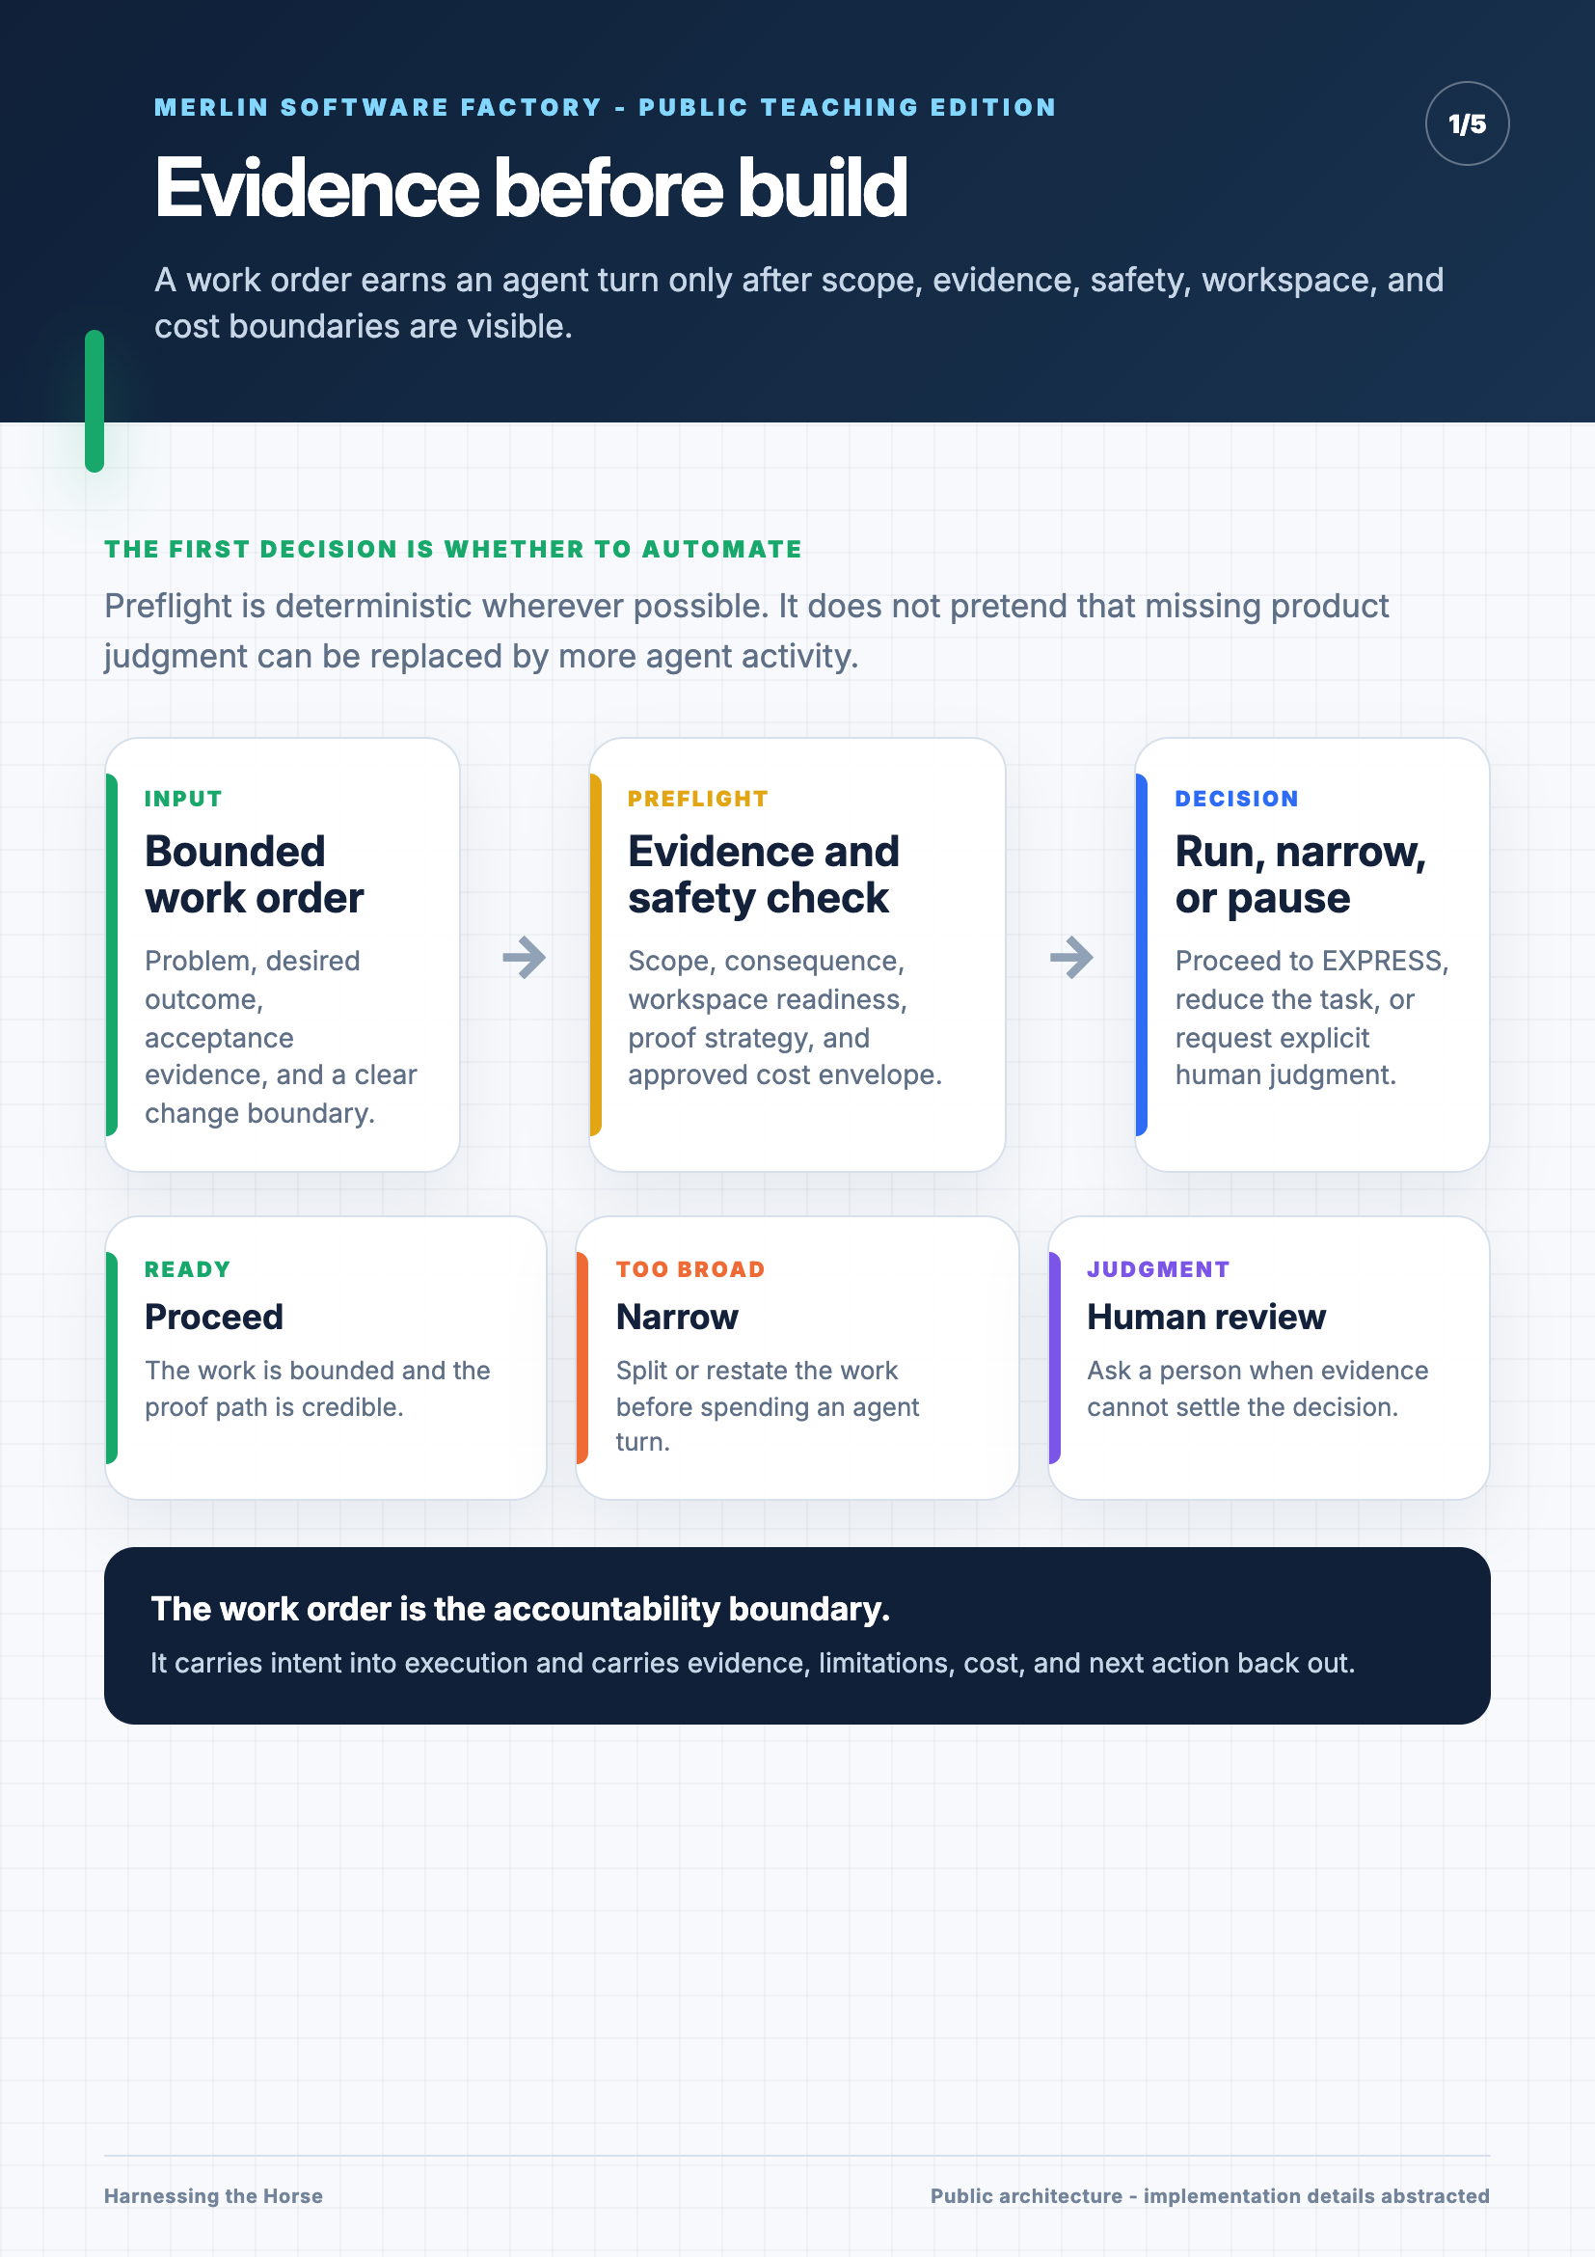

One agent. Six disciplined phases.
The EXPRESS delivery arc preserves intent by keeping one accountable agent responsible from understanding through self-audit.
The six phases are Understand, Investigate, Plan, Test, Implement, and Self-audit. Continuity protects design intent and local context, but it does not replace deterministic checks, independent verification, cost boundaries, or human judgment.
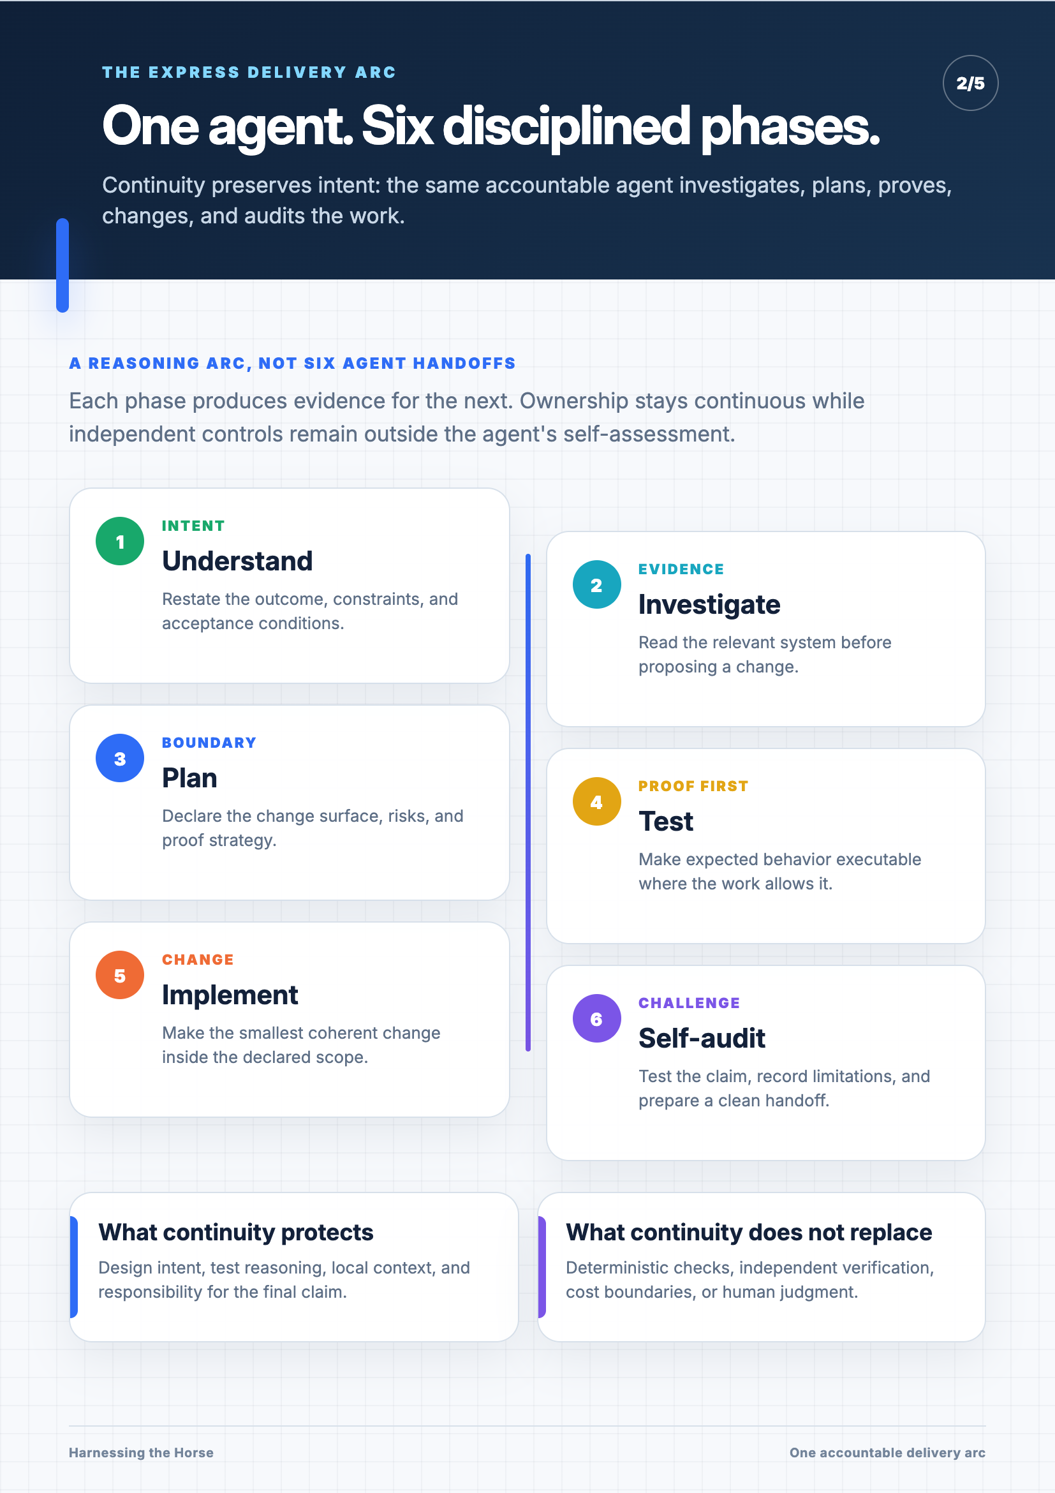

Proof is not one undifferentiated gate
Verification is classified by consequence so rigor increases trust without turning every signal into critical-path ceremony.
Blocking checks stop unsafe work; conditional checks become blocking when relevant; advisory checks inform judgment; asynchronous checks improve later work. Independent challenge and bounded repair keep the implementer from being the only judge of its own claim.
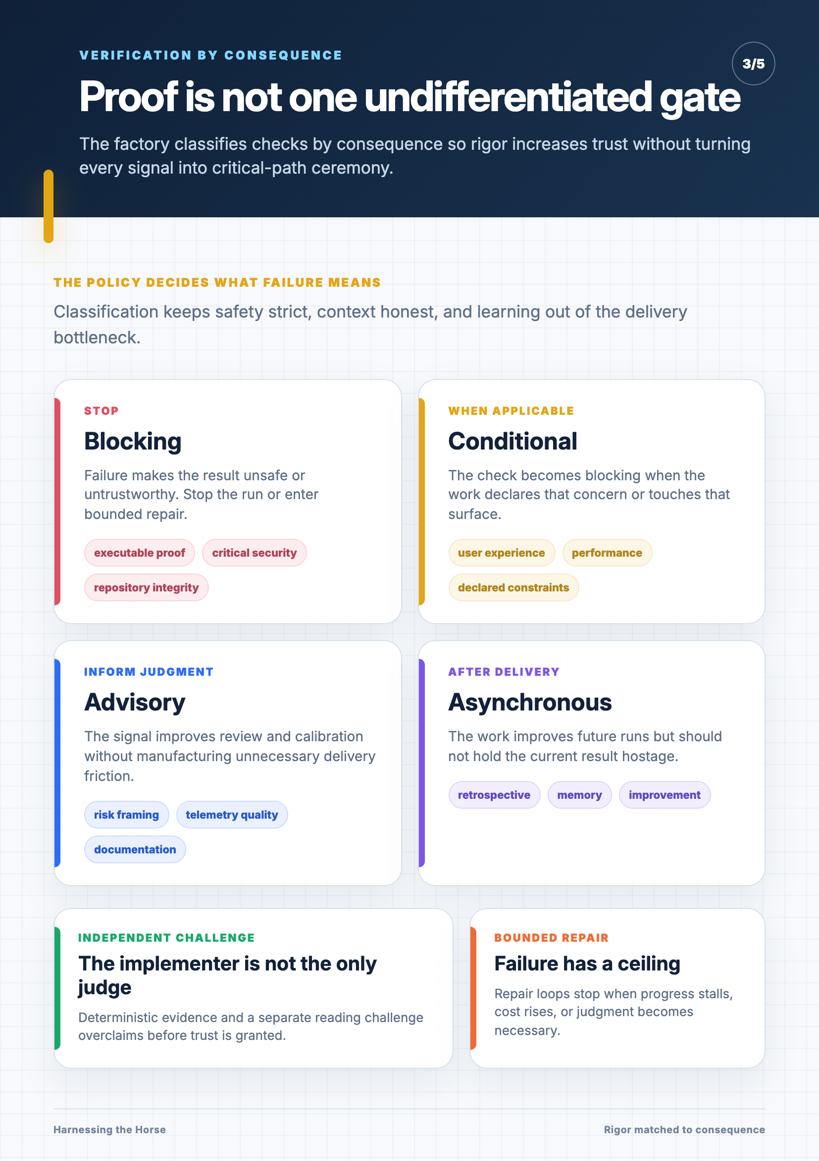

Automation earns trust by showing its work
State, evidence, cost, failures, and next actions remain visible so a person can intervene without reconstructing the run.
The agent produces evidence, the control plane keeps work convergent, and the operator decides with context. Durable state, observability, cost safety, and workspace isolation make human review a healthy architectural outcome rather than a hidden failure.
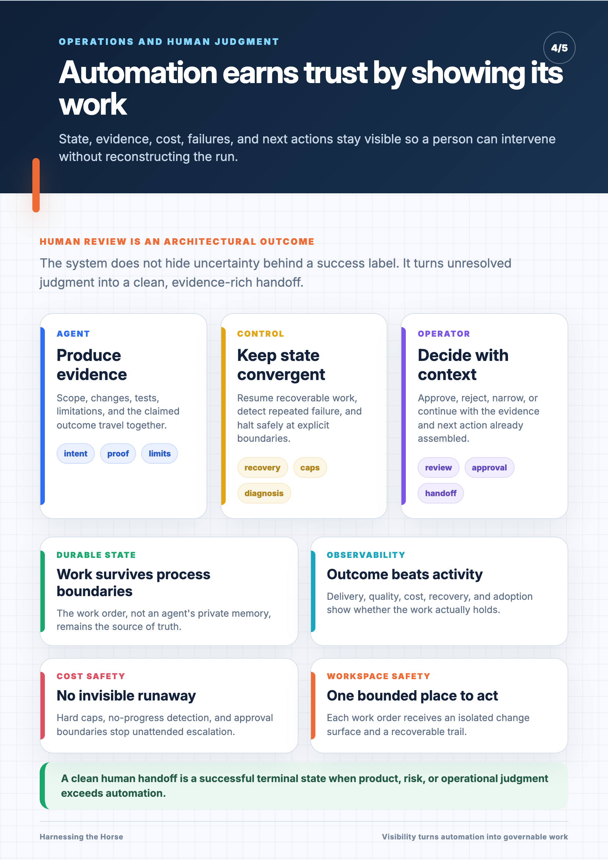

Every run can improve the next
Learning compounds only when it is verified, traceable, measured, and kept outside the delivery path whenever possible.
Outcome signals become verified memory, which can propose a bounded improvement. Each candidate must be evaluated and either promoted, discarded, or rolled back. The reusable rules are to bound work, preserve accountability, classify proof, escalate judgment, expose state and cost, and promote learning only after evidence.
