Harnessing the Horse
  - Reader Quick Start
Move from a request to an evidence-backed SHIP, REVISE, or STOP decision - with scope, gates, evidence, and human judgment intact.
John Briggs
Companion release v2.1.2 | August 29, 2026

Your 30-Minute Orientation
Do not browse everything. Build a mental map, choose one task, and leave with a next action.
0-5 min: Read START-HERE.md and choose the governed-session path.
5-10 min: Scan the Twelve Standards quick reference. Notice which controls are blocking, asynchronous, or advisory.
10-15 min: Read the Complete Session Loop. Identify the artifact produced at each transition.
15-22 min: Open the fictional worked example. Follow its Work Order, SPEC, DESIGN, generation prompt, implementation notes, review, and learning record.
22-27 min: Choose one prompt and inspect its expected output in prompts/manifest.json.
27-30 min: Pick one low-risk repository task and write its Work Order. Stop before generation if acceptance criteria cannot be verified.
Success is not reading every asset. Success is knowing which artifact to use next and what evidence will let a human approve the change.

One Governed Agent Session
The loop turns model output into an engineering decision trail.
1. Orient: Load project rules, permissions, architecture, and the relevant source.
2. Contract: Write the Work Order and verifiable acceptance criteria before code generation.
3. Design: Define interfaces, blast radius, risks, and rollback expectations.
4. Generate: Give the agent a bounded contract and require explicit assumptions and verification markers.
5. Falsify: Run automated gates, then use a fresh review pass to try to disprove correctness.
6. Decide and learn: A human records SHIP, REVISE, or STOP; durable lessons update project memory.
- Before generation: the contract, exclusions, risks, and required evidence are visible.
- Before merge: automated results and an independent falsification review are attached.
- After the decision: implementation notes and durable learning preserve why the result can be trusted.
Human judgment is a control surface, not ceremonial approval. Consequential ambiguity returns to a named owner.

From a Governed Loop Toward a Factory
Book 2 establishes one trustworthy delivery loop. Book 3 takes up durable accountability across teams and systems.
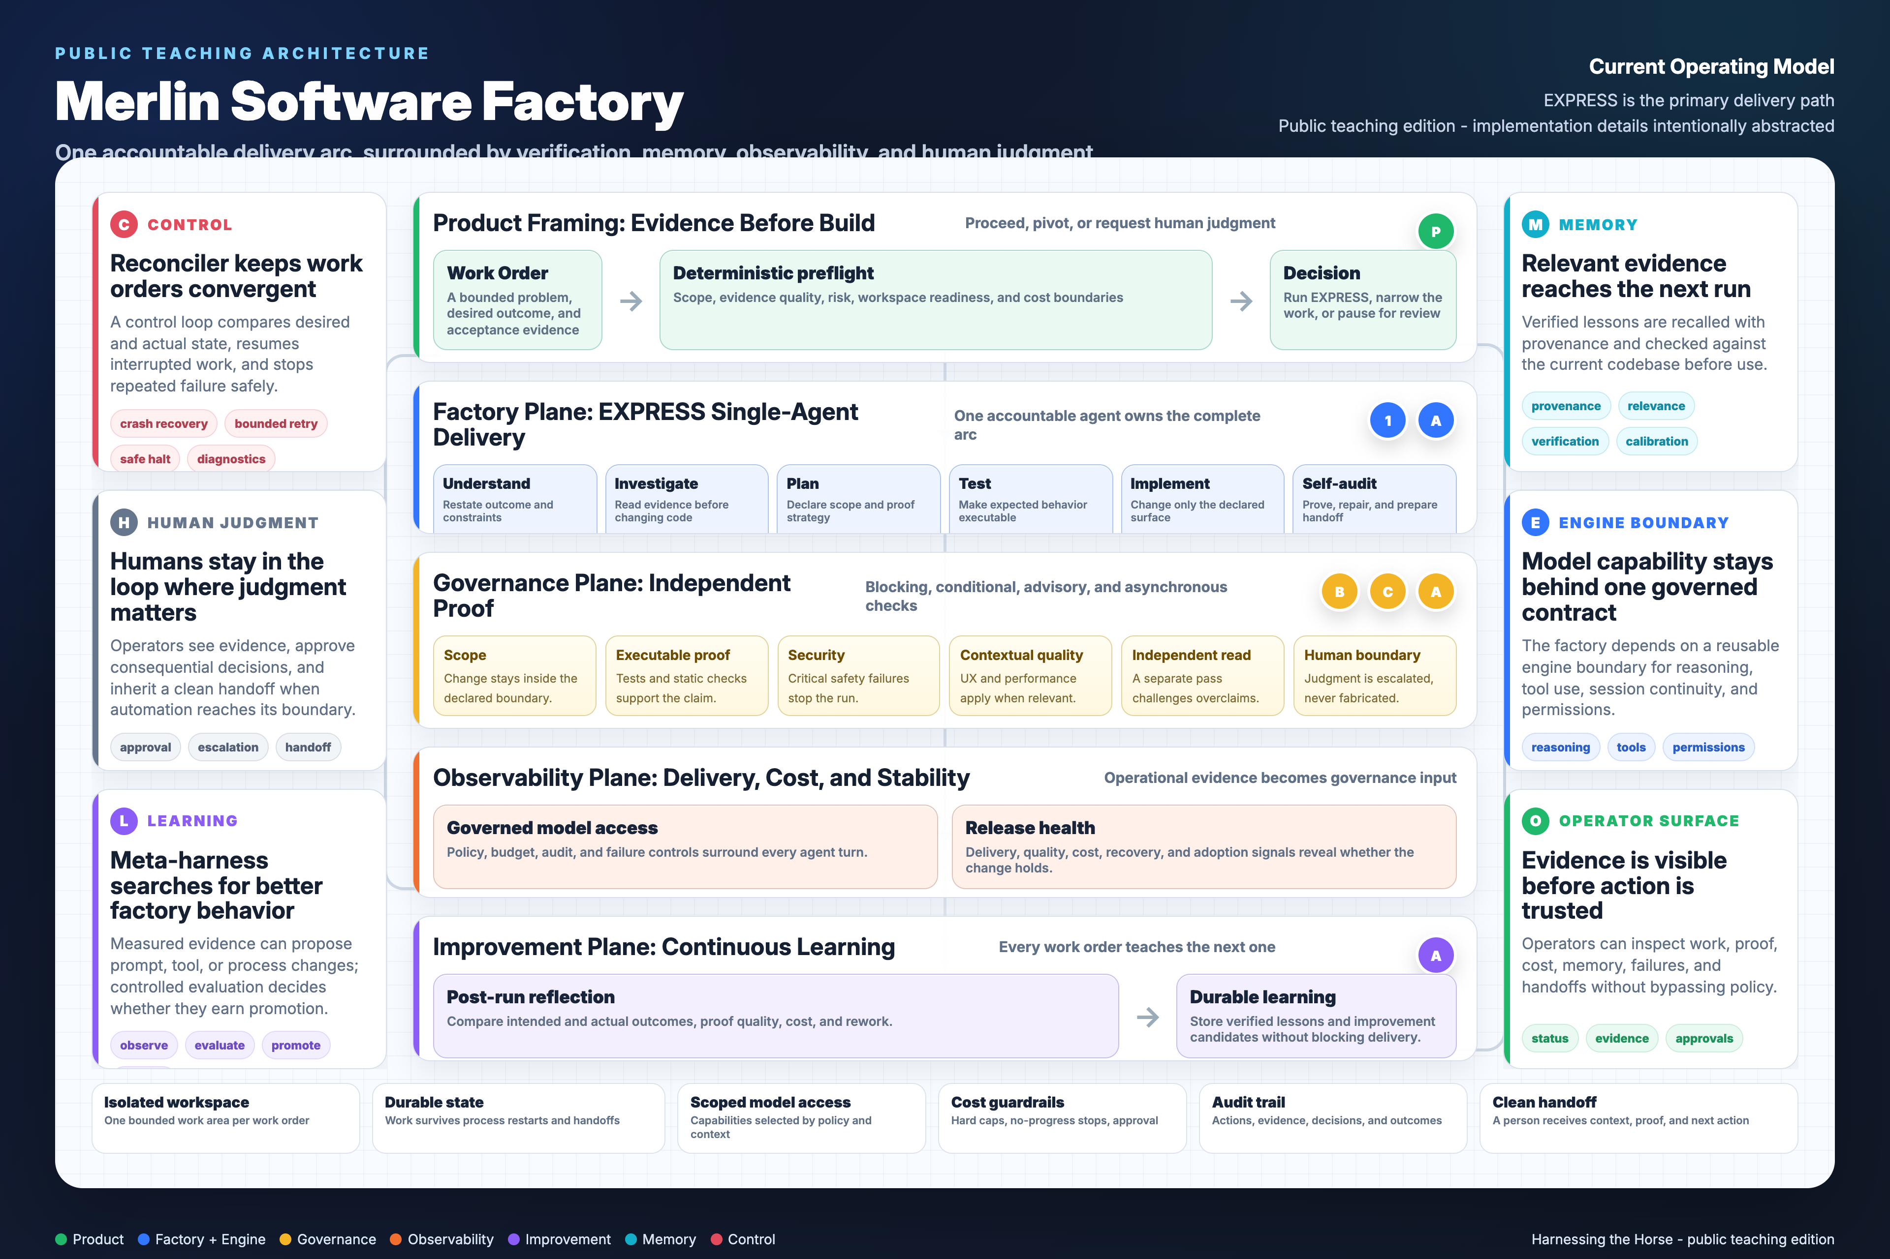
- Intake becomes a bounded Work Order before agents act.
- Preflight verifies context, permissions, risk, and readiness.
- EXPRESS provides a fast path only when evidence supports the classification.
- Generation and verification remain separate responsibilities.
- Quality gates produce evidence; humans retain consequential decisions.
- Learning improves durable context without permitting uncontrolled self-modification.
Public diagrams teach lifecycle, gates, memory, and judgment. Exact filenames, inventories, backend priorities, database internals, and deployment topology remain private.

Choose the Smallest Useful Artifact
Start at the decision you need to make, not at the directory tree.
Need | Start with | Evidence of completion
Scope a change | Work Order + SPEC | Testable acceptance criteria and explicit exclusions
Generate safely | Structured prompt | Bounded output with assumptions and verification markers
Challenge a result | Disprove-only review | Concrete counterexamples or an evidence-backed pass
Handle a failed gate | Escalation protocol | Named owner, options, decision, and audit trail
Bootstrap a governed loop | Delivery-loop workbook + worked example | One end-to-end governed task, not an orchestration platform
Teach the lifecycle | Teaching panels + study guides | A learner can explain where gates and humans intervene
Copy the pattern, not the fictional domain. Replace every project fact, permission, threshold, and risk classification with evidence from your environment.

A Safe 30-Day Adoption Sequence
Earn autonomy through evidence. Do not begin with a fleet.
Week 1 - Baseline: Choose one repository and low-risk task class. Record current lead time, rework, defects, and review load.
Week 2 - Govern: Add context, Work Orders, acceptance criteria, and existing CI gates. Run the session loop manually.
Week 3 - Falsify: Separate generation from review, capture escaped defects and false confidence, and tighten the weakest artifact.
Week 4 - Decide: Compare against baseline. Expand only if quality, control, and team comprehension improved together.
- Stop if the team cannot explain why a gate exists.
- Stop if approval lacks inspectable evidence.
- Stop if private data or production authority exceeds the task's need.
- Stop if speed rises while rework, incidents, or reviewer distrust also rises.
The goal is compounding engineering discipline: faster delivery because the system makes good decisions repeatable, visible, and correctable.

Continue with the stable resources
Companion repository - https://github.com/bmozi/harnessing-the-horse-companion
Stable v2.1.2 release - https://github.com/bmozi/harnessing-the-horse-companion/releases/tag/v2.1.2
Start Here - https://github.com/bmozi/harnessing-the-horse-companion/blob/v2.1.2/START-HERE.md
Errata - https://github.com/bmozi/harnessing-the-horse-companion/blob/v2.1.2/ERRATA.md
Written content © 2026 John Briggs. Licensed under CC BY-NC-SA 4.0.

