**Freedom Fone Advocacy & User Guide update - Version 2S7/8**

Last update: August 07, 2014

**Contents**

What’s new? 2

What else has been improved? 2

What’s the difference between FFv2S7 and FFv2S8? 2

1.1 The SMS Centre 3

1.1.1 Receiving SMS - Inboxes 3

1.1.2 Sending SMSs 7

1.1.3 Create SMS Batch 9

1.1.4 Viewing SMS Batches and delivery status 10

1.2 Improved Hardware management 11

1.2.1 Buying USB GSM voice enabled dongles – some advice 11

1.2.2 Configuration options 11

1.2.3 Hardware detection and setup of USB GSM dongles 12

1.3 OfficeRoute SIP security options 13

1.4 Reporting – Graphics reporting tool 13

## What’s new?

* SMS sending via OfficeRoutes, Huawei dongles and Clickatell Bulk SMS gateway
* The new ‘SMS Centre’ menu option brings SMS sending and receiving under one menu – the original ‘Message centre’ is now exclusively for voice messages and LAM IVR
* SMSs can either be received into one global Inbox or separated into a different Inbox for each sim card
* SMSs can be received via multiple OfficeRoute devices
* Improved Hardware management
  + New USB dongle detection and management wizards/scripts
  + New *Dashboard → Service Mapping* option for connecting voice enabled dongles to IVR menus. No need to edit configuration files if you add additional Leave a message IVRs or other IVRs.
  + The *Dashboard → Active GSM channels* page will now show details for multiple connected OfficeRoute devices
  + *Dashboard → GSM channels* page renamed to *Active GSM channels* and now displays additional device information
* The Graphic Reporting tool has been integrated into the System data menu as *System data → Call graphs*
* Additional security for OfficeRoute devices has been added in the form of an optional firewall whitelist
* Logs are now displayed in descending chronological order
* **Default user and password for FFv2S7 and FFv2S8 servers are:**  
  user: sharicus  
  password: sharicus

## What else has been improved?

* We’ve updated the development framework to CakePHP v2.4
* Fixed a variety of bugs
* Clarified the normalization settings required for the OfficeRoute
* We’ve written a Developer’s guide that covers additions and improvements made in FFv2S7. Download the latest version of the **Sharicus_2S7_developer_guide** from [www.freedomfone.org/page/documentation](http://www.freedomfone.org/page/documentation)

## What’s the difference between FFv2S7 and FFv2S8?

* FFv2S7 runs on Ubuntu 12.04LTS. Ubuntu 12.04LTS will be supported by Ubuntu with updated drivers until 2017.
* FFv2S8 runs on Ubuntu 14.04LTS. Ubuntu 14.04LTS is Ubuntu’s latest long term support release. Since this release was only made available in April 2014 there may be bugs in the operating system for some months to come. Try this version first. If Ubuntu bugs give you problems, revert to FFv2S7.

There are so many improvements we urge you to move onto either v2S7 or v2S8! Unfortunately there is no upgrade script (sorry!) so you will need to make a note of your statistics, export any important data for archive purposes and do a fresh install.

## The SMS Centre

The new SMS Centre menu provides links to all SMS related actions.

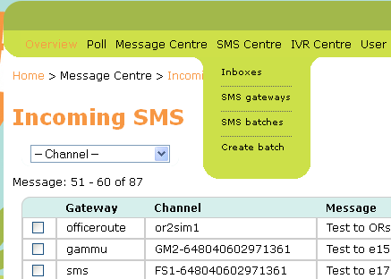

### Receiving SMS - Inboxes

By default, all SMSs received will be displayed in descending chronological sequence on the Incoming SMS page. You can use the Channel dropdown selector to filter SMSs based on the channel associated with each sim card registered with the Freedom Fone server over time. Even if a device is later removed, the channel originally associated with it will remain as an option within the Channel filter list.

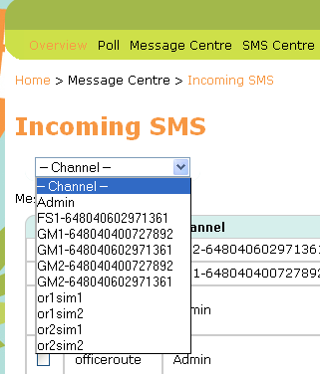

Filtered messages will look as follows:

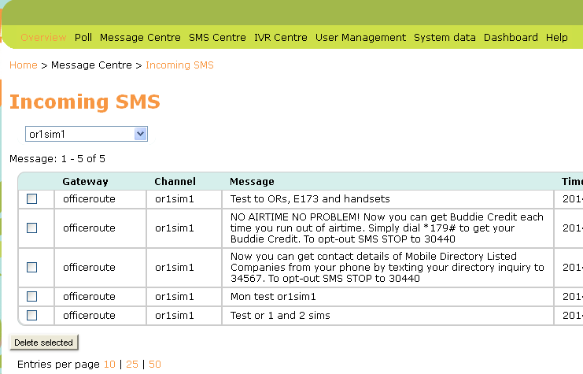

To redisplay all SMSs, select ‘- Channel -‘ from the Channel selector.

**SMSs received via the OfficeRoute**

We provide configuration files for the OfficeRoute to help you set the device up for use with Freedom Fone. Make sure your OfficeRoute firmware is updated to v2.3.22 using the OfficeRoute *Administration → Update* page before trying to load our configuration files. You can view the current firmware version on the OfficeRoute Network page under System Information.

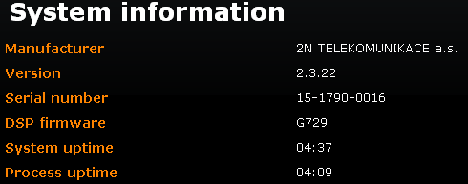

**Aggregate SMSs into one Admin Inbox**

Upload *backup_officeroute_2.3.22_140614.tgz* using the OfficeRoute *Administration → Configuration Backup → Upload config* page if you want to aggregate SMSs into one Admin Inbox for all sim cards in the OfficeRoute.

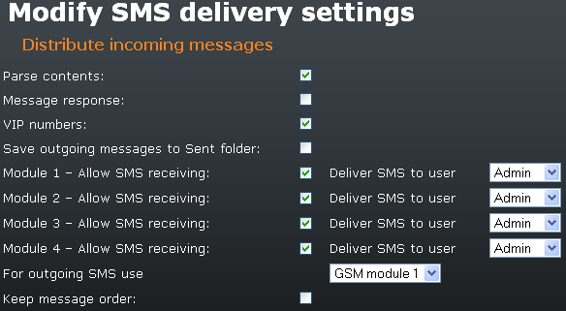

**Aggregate SMSs into different Inboxes for each sim card**

Upload *backup_officeroute_2.3.22_multiSMS_outSMS_140614.tgz* using the OfficeRoute *Administration → Configuration Backup → Upload config* page if you want to separate SMSs into different Inboxes for each sim card.

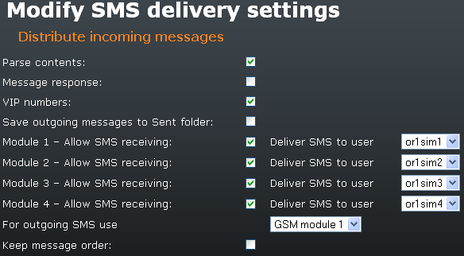

For more information on setting up the OfficeRoute for SMS receiving, please see the latest version of the **Sharicus_2S7_developer_guide**.

**SMSs received via Huawei dongles**

USB dongles can be set up in 3 different ways using the Hardware Wizards.

1. 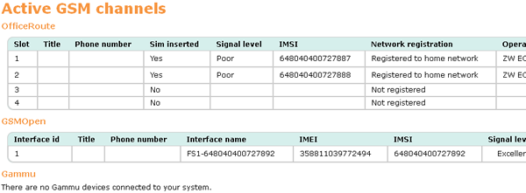To Receive voice calls & receive SMSs  
   The dongle will be displayed as a GSMOpen device on the *Dashboard → Active GSM channels* page. The Interface name (Channel) will be prefixed by FSn-
2. To only receive SMSs  
   The dongle will be displayed as a Gammu device on the *Dashboard → Active GSM channels* page. The Interface name (Channel) will be prefixed by GMn-
3. To receive and Send SMSs  
   The dongle will be displayed as a Gammu device on the *Dashboard → Active GSM channels* page. The Interface name (Channel) will be prefixed by GMn-

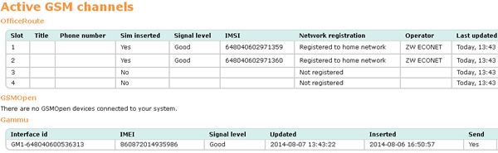

To redisplay all SMSs, select ‘- Channel -‘ from the Channel selector.

For more information on the Hardware Wizards and setting up Huawei dongles for SMS receiving, please see the latest version of the **Sharicus_2S7_developer_guide**.

### Sending SMSs

SMSs can be sent using the following channels:

* Clickatell’s Bulk SMS Gateway
* OfficeRoute SIP gateway
* Huawei E173 and E1550 dongles

#### SMS gateways - Clickatell

Visit <https://www.clickatell.com/register/> to set up a *Developers’ Central* account. Don’t forget to add credits to your account. Make a note of the following:

* Clickatell’s API URL – should be api.clickatell.com
* Clickatell username
* Clickatell password
* Clickatell API key

Create an SMS Gateway for your Clickatell Developers’ Central account in Freedom Fone using *SMS Centre → SMS gateways*. Click the *Create new* button in the top right hand corner of the page.

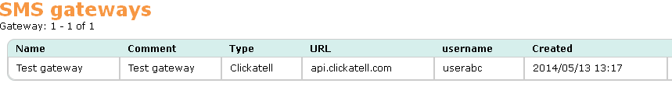

You will be presented with a form to complete for the SMS gateway. Enter the details provided for your Clickatell account.

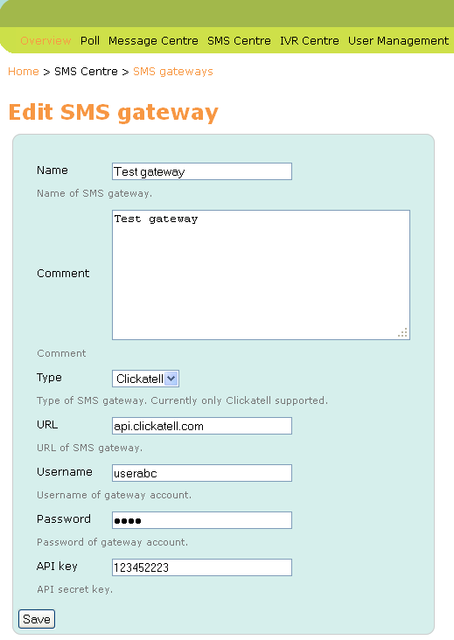

Read more about Interfacing with Clickatell in the **Sharicus_2S7_developer_guide.**

#### SMS gateways - OfficeRoute

See the latest version of the **Sharicus_2S7_developer_guide** for instructions on how to set up the OfficeRoute for sending SMSs. The Sharicus_2S7_developer_guide will also show you how to update the necessary Freedom Fone and Postfix configuration files.

Please also check your OfficeRoute Normalisation settings against the information provided in the latest version of the **Sharicus_2S7_developer_guide.**

**Firewall:** If your OfficeRoute is connected to the Internet it is recommended that you use the new Firewall Wizard to protect yourself from VoIP spammers. For more information on setting up your firewall and whitelist see the **Sharicus_2S7_developer_guide**.

#### SMS gateways - Huawei dongles

We have only tested the Huawei E173 and E1550 dongles with Freedom Fone. See the latest version of the **Sharicus_2S7_developer_guide** for instructions on how to use the Hardware Wizards to set up your Huawei dongle for sending SMS.

Note that a dongle cannot be used for voice and SMS sending. It must be designated for one or the other. Dongles are able to receive SMS regardless of whether or not they have been set for voice or SMS sending.

**Firewall:** Note that if you are using GSM dongles there is no need to worry about being targeted by VoIP scanners and other unauthorised users. You can leave the default settings as they are and need not worry about the firewall.

### Create SMS Batch

To send SMSs to one or more recipients, create a plain text document with one phone number per line. Do not end each line with any form of punctuation.

Go to *SMS Centre → Create batch* to send your message.

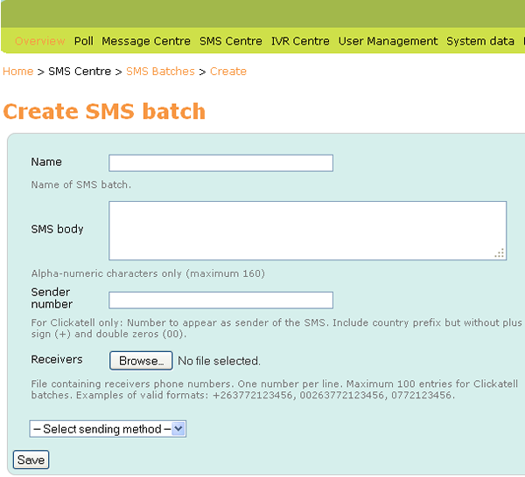

Name: Provide a descriptive name for the outbound SMS for administrative purposes.

SMS body: Enter your message text here. Max 160 characters

Sender number: This field is only used for Clickatell accounts. Enter the phone number you have registered with Clickatell for sending SMSs. Do not add any country prefix to the number.

Receivers: Browse for the text document that contains the phone numbers for your SMS recipients.

Select sending method: Valid options are

* SMS Gateway  
  Use this option if you’re sending via Clickatell
* GSM Channel  
  Use this option for OfficeRoute and Huawei dongles

Once you click the Save button, Freedom Fone will attempt to send your message to your recipient list.

### Viewing SMS Batches and delivery status

Go to *SMS Centre → SMS Batches* to view details of SMSs sent. Click the hand icon to view details of SMS batch recipients and the delivery status associated with the message sent to each recipient.

Note that delivery status messages are currently only available for SMSs sent via Clickatell and dongles.

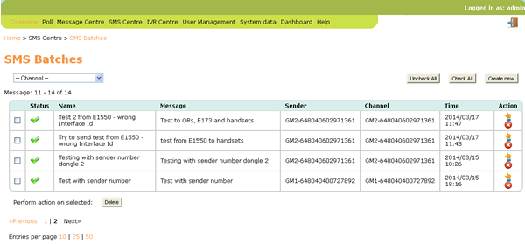

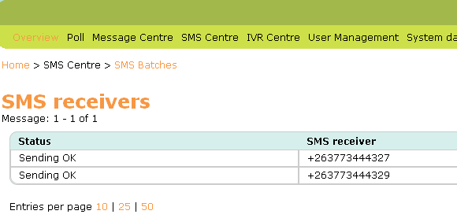

## Improved Hardware management

Now that we have added SMS Sending, providing tools to assist with device management has become a priority. The challenge is actually with detecting USB GSM dongles and configuring them correctly.

### Buying USB GSM voice enabled dongles – some advice

We have tested Freedom Fone with Huawei E173 and E1550 dongles. *These dongles must be unlocked and voice enabled.*

We have come across variations of these dongles which have the same or very similar model numbers but which have voice functionality disabled and do NOT work with Freedom Fone. Before you buy one of these dongles get the seller to confirm that they are unlocked and voice enabled.

DC-Unlocker is a useful free utility that can be used to detect a dongle’s settings/features – Download a copy from <https://www.dc-unlocker.com/downloads>.

### Configuration options

It is possible to configure:

* One or more OfficeRoute devices to send and receive SMSs and receive phone calls
* One or more Huawei dongles to send and receive SMSs only – this configuration is managed by an application called *Gammu*
* One or more Huawei dongles to receive SMSs and phone calls – this configuration is managed by an application called *GSMOpen*

It is not currently possible to configure a USB GSM dongle to handle incoming calls and send SMSs.

The Hardware Setup Wizard will associate your device(s) will the relevant applications based on your answers to the questions asked.

### Hardware detection and setup of USB GSM dongles

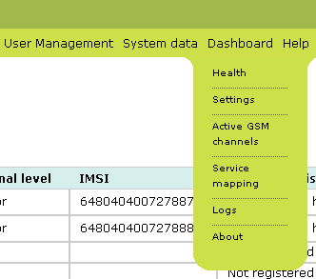

To assist with the complexity of managing and configuring USB GSM dongles, we have developed new guidelines and provided 2 new scripts.

For full details on how to use the Discovery & Setup Hardware Wizards please see the latest version of the **Sharicus_2S7_developer_guide**.

If things have become confused and you want to reset all Freedom Fone references to telephony devices in the system (as displayed on *Dashboard → Active GSM channels* and *Dashboard → Service mapping* pages in the Freedom Fone user interface), see **Reinitialising telephony device detection settings** in the **Sharicus_2S7_developer_guide**.

**Map device to service**

If you have configured one or more USB devices for Voice services (FreeSWITCH), you must map them to a voice service (IVR or LAM). Under *Dashboard → Service Mapping*, you can select an IVR or LAM for each voice-configured USB device. Once you have selected the services of your choice, you must press the ‘Create Dialplan’ button, and the FreeSWITCH dialplan will be updated with your choices.

**Test your devices**

If things don’t work as you expect, it may be that key services like FreeSWITCH, the Dispatcher or Gammu daemons haven’t been restarted. The easiest thing may be to restart your server and run your tests.

**Troubleshooting USB dongles**

See **Troubleshooting dongle settings** in the **Sharicus_2S7_developer_guide**.

## OfficeRoute SIP security options

Sadly, there are bad folks out in the world who try to take advantage of unprotected VoIP gateways to make free phone calls.

The default policy of Freedom Fone is to only allow authenticated SIP calls. However, in order to allow unauthorized users to call into Freedom Fone via SIP (which is free of charge and only requires an Internet connection), we have implemented a solution to facilitate this.

Furthermore, to block VoIP scanners and other unsolicited traffic hitting the platform, we have implemented a firewall that blocks unwanted traffic. For more information on setting up your firewall and whitelist see the **Sharicus_2S7_developer_guide**.

## Reporting – Graphics reporting tool

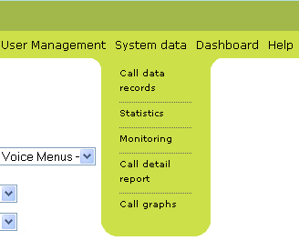

The Graphic Reporting tool, contributed by Olaf Dunn, has been integrated into the System data menu as *System data → Call graphs*. To export data for Call graphs, use reports generated by *System Data → Call detail report.*