M/S GOLDEN RICETECH INDUSTRIES

DETAILED PROJECT REPORT

ON

RICE MILL

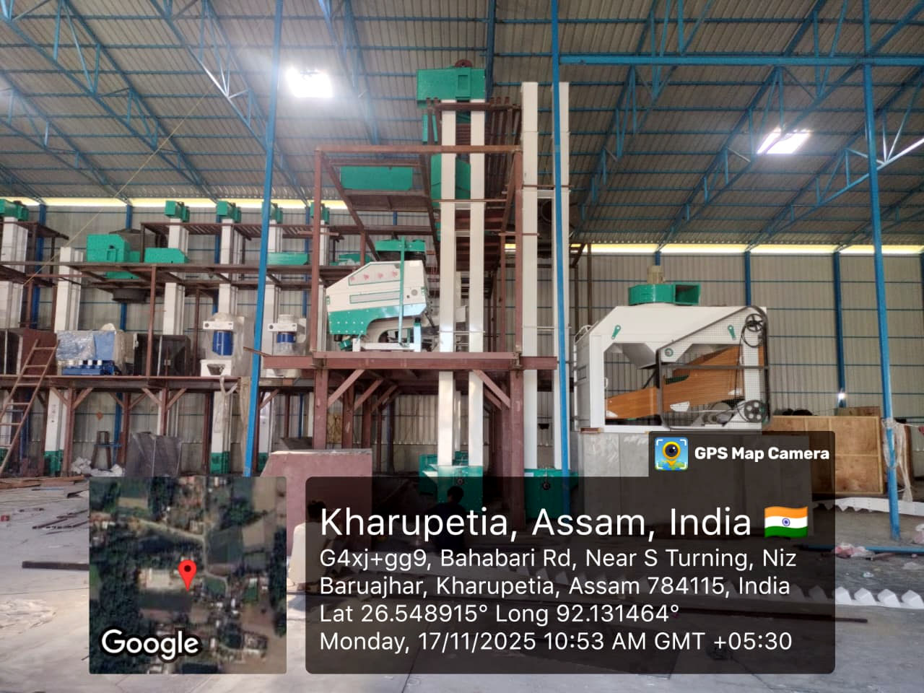

Prepared by
BMTAX INDIA (OPC) PRIVATE LIMITED
Email : bmprofca@gmail.com

CONTENTS

EXECUTIVE SUMMARY
  - Project Snapshot - Introduction and Overview
  - Entity Details
  - Profile of Promoters, Business Owners
  - Employment Details
  - Cost of Project
  - Means of Finance
  - Security Details
  - Existing Obligations
  - Subsidy

PROJECT VIABILITY & MARKET STUDIES
  - Feasibility Studies
  - Industry Analysis
  - Market Potential
  - Process
  - Current Scenario
  - Challenges and Solutions
  - SWOT Analysis

EXECUTIVE SUMMARY:

Project Snapshot - Introduction and Overview

India is one of the biggest producers of rice in the world next to China. It accounts for about 31 percent of the area and 41 percent of the total production of food grains in the country. It is a staple food of the people of the southern and Northern Western States coastal areas and hilly areas.

The crop is grown in almost all the states of the country but its cultivation is mostly concentrated in the states of Andhra Pradesh, West Bengal, Tamil Naidu Uttar Pradesh, Bihar, Orissa, Madhya Pradesh, Punjab, Karnataka and Assam which account for more than 66 per cent of the total paddy produced in the country.

Paddy milling industry is one of the largest agro based industries in the country. There are reported to be 91,154 rice-milling units spread through out the country. These units process 80 percent of the paddy produced in the country. The other 20 percent is processed by traditional methods or consumed in various form. With the introduction of high yielding varieties that improved economic practices, the production of paddy is expected to be increased in the years to come. There are still a larger number of units in the country using the outdated technology like old hullers. The Central Food Technological Research Institute Mysore has developed a technology for processing of rice to secure an improved out turn rations from paddy to rice a superior quality of milled products reduction of wastage, with better economic returns to producers and processors.

Rice is the staple food for almost 65% of the population in India. Paddy in its raw form cannot be consumed by human beings. It needs to be suitably processed for obtaining rice. Rice milling is the process which helps in removal of hulls and barns from paddy grains to produce polished rice. Rice forms the basic primary processed product obtained from paddy and this is further processed for obtaining various secondary and tertiary products.

Rice is one of the most important food crops of India in term of both area, production and consumer preference. India is the second largest producer and consumer of rice in the world. Rice production in India crossed the mark of 150 million MT in 2013-14 accounting for 22.81% of global production.

M/S GOLDEN RICETECH INDUSTRIES is a Proprietorship Firm. Business Owners have incorporated /formed an entity name M/S GOLEN RICETECH INDUSTRIES in November, 2025. and want to start M/S GOLDEN RICETECH INDUSTRIES activities. business will be start in Niz Baruajhar, Kuwari Pukhuri, Darrang, 784115 as a Manufacturing (Rice Mill) and associated with a well-known brand in this field.

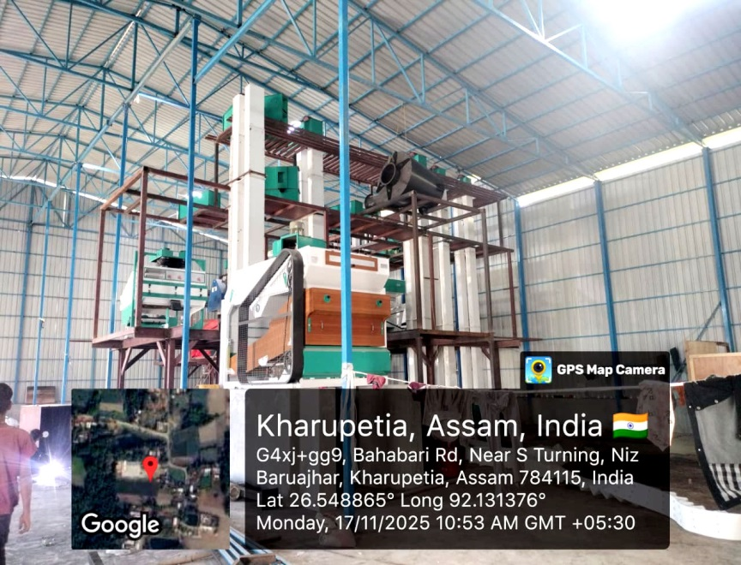

As the owners are having a good business connection in the locality and sales targeted area, it will be easier to gain good revenue from the business. The goodwill of the organization will be created at a greater extent. Once the business will start achieving higher sales, large scale economies will help the business to earn more profits. Such higher revenue will help the business in achieving higher Net Profit, Gross profit ratios and overall positive incremental revenue.

Entity Details

Entity & Owner Details:
Name of the Entity : | M/S GOLDEN RICETECH INDUSTRIES
Name of the Proprietors | Saydur Rahman
Pan Number | BDNPR2959A
GST Number | 18BDNPR2959A2Z8
Year of Establishment | November, 2025
Type of Entity | Proprietorship Firm
Business Description | RICE MILL
Address of the Entity | Niz baruajhar, Kuwari Pukhuri,Darrang, ASSAM, 784115

  - Profile of Promoters, Business Owners

Mr. Saydur Rahman is a dynamic first-generation entrepreneur and Graduate by qualification, having over 10 years of rich experience in the rice milling and allied agro-processing sector. He is presently the Managing Partner of Ayesha Rice Mill, where he has been actively involved in overall business operations, including procurement of paddy, production planning, quality control, marketing and financial management. Over the years, he has developed a strong reputation and goodwill in the local agro-commodity market, with excellent relationships among farmers, traders, suppliers and financial institutions. Mr. Rahman is also the Promoter of SR Enterprise and Golden Ricetech Industries, through which he has further strengthened his exposure in trading and value-added agro products, thereby deepening his understanding of the niche rice and agri-business ecosystem. His proven track record, domain expertise and strong local connect are expected to contribute significantly to the successful implementation and smooth running of the proposed project.

Statutory Compliances:

TAN : SHLS13955E

ITR Filling Records with Acknowledgement Number:
Assessment Year | Acknowledgement Number
2023-2024 | 385185491041023
2024-2025 | 561153100021024
2025-2026 | 650523460120825

Employment Details

One should insist to increase the employment levels of the country. In the light of this, entrepreneurs and business owners help the economy by generating employment in urban and rural areas.
In coming years and decades, India is expected to witness significant demographic growth and expansion in the working age population. To absorb such labor force in the future, all the sectors viz. manufacturing, service, trading and agriculture would need to play an important role. Currently manufacturing sector accounts for approximately 11% to 13% of the total employment in the country, which is well below its true potential. Small and medium enterprises (SMEs) and micro small and medium enterprises (MSMEs) account for 90%+ of the total industrial activity in India.
Estimates suggests, the SME and MSME sector offers maximum opportunities for self-employment as well as jobs, after the agricultural sector. Also, the labor-capital ratio tends to be higher for SMEs and MSMEs. M/S GOLDEN RICETECH INDUSTRIES will help the economy by way of employment generation, as it is going to generate employment to 25 people.
Total number of employees : 25
Incremental employees due to expansion of the business (if any) : 0

Cost of Project

Estimating the cost of a project varies based on the industry, the type and scope of the project undertaken and the time frame for completing the project. While the variables of any given project may change according to circumstances, there are 3 main elements of project costing found in most all project cost estimations.
Pre-Planning - Costs related to pre-project planning and preparation vary widely from industry to industry. Typical pre-planning costs include selecting potential project managers and employees, conducting market and project research.
Material Costs - All materials necessary for a project are included in material costs. Materials are anything the project manager purchases to aid in or conduct the project.
Operating Costs - The operating costs of a project include the fees associated with purchasing project supplies, paying rent and associated costs on a facility or location for the project to take place, the cost of permitting, inspections and daily operations.
Such costs can further be divided into 2 types viz. capital expenditure and revenue expenditure. For manufacturing industry, setting up the plant, installation of machinery, building/factory set up costs are the major costs.

Funds are required incidentally in a way of term loan of Rs.138.67 lakhs and for forming a business cycle of receivables & payables, Working Capital of Rs 70.00 lakhs is also required for the day to day business transactions, Fund from own sources Fixed Capital Rs. 156.97 & Rs. 61.60 Lakhs Working Capital.
Detailed particulars about the cost have been provided hereunder:

Purchase Asset Costs:

Sr. No. | Assets | Before Oct. (Rs. in lakhs) | After Oct. (Rs. in lakhs)
1 | Furniture & Fittings | 2.50 | 0.00
2 | Building Construction & Dacoration | 90.00 | 0.00
3 | APDCL Security Deposit | 10.33 | 0.00
4 | Electricity Connection Expenses | 07.17 | 0.00
5 | Plant & Machinery | 179.66 | 0.00
6 | Computer & Printer | 0.75 | 0.00
 | Sub Total | 290.41 | 0.00

Working Capital :
Sr. No. | Working Capital | (Rs. in lakhs)
1 | Working Capital+Others | 131.60

TOTAL COSTS OF PROJECT
Sr. No. | Particulars | (Rs. in lakhs)
1 | Asset Purchase Costs | 290.41
2 | Working Capital | 131.60
 | Total | 422.01

Means of Finance

M/S GOLDEN RICETECH INDUSTRIES needs total funds amounting to Rs. 422.01 lakhs. Out of total funds of Rs. 422.01 lakhs, Rs. 245.00 lakhs will be brought in by the promoters and/or business owners and for the balance amount they need a funding facility viz. Rs. 107.00 Lakhs (Term Loan). and Rs 70.00 Lakhs (Cash Credit).

SOURCES OF FINANCE | (Rs. in lakhs)
Term Loan | 107.00
Cash Credit | 70.00
Own Contribution (Asset Addition) | 183.41
Own Contribution (Working Capital) | 61.60
Total | 422.01

Security Details:

Sr. No. | Type of Security (e.g Flat, Plot, Industrial Land, etc.) | Value of the security offered (in rupees)
1 | Machinery | Rs. 179.66
  - Existing Obligations
The business owners are not having any heavy existing obligations, although, we have provided the documents such as Sanction letters and Bank statements of existing loans (if any), in order to assess the existing banking commitments.

  - List of Machinery :

ANNEXURE-I
Sl. No. | Date | Machinery Name / Description | Invoice No. |  | Total Value (₹)
1 | 18.08.2025 | MACHINERY USED FOR GRAIN CLEANNING, MILLING & SORTING :  - Tray Separator  - 3Hp :960RPM, FT.MTG; SIEM IE2-1LE7  - RICE WHITENER  - 50 HP,1500 RPM, FL MTG, SIEM  - BLOWER 25 HP NH DIRECT DRIVE  - CYCLONE SEPARATOR 1500-L  - BRAN DISCHARGER  - MAGNETIC SEPARATOR  - ROTARY SIFTER RSIC  - 2HP, 1500RPM, HEM IE2-1LE7  - GRAIN BLENDING WITH MIXER BIS | 97166553 |  | 38,99,278.00
2 | 18.08.2025 | MACHINERY USED FOR GRAIN CLEANNING, MILLING & SORTING :  - COLOR SORTER MEGA-480  - CENTRIFUGAL FAN-2HP | 97166538 |  | 30,56,467.00
3 | 18.08.2025 | MACHINERY USED FOR GRAIN CLEANNING, MILLING & SORTING :  - PNEUMATIC SHELLER  - 15 HP, 100 RPM, FT MTG, SIEM IE2- 1LE7 | 100149390 |  | 8,24,255.00
4 | 08.11.2025 | RICE SHELLER MACHINERY | 24 |  | 1,77,000.00
5 | 21.05.2025 | 8" PVC Bucket Length 25 Feet with Top Buttom Thickness 2.5mm & Date:- 21/05/2025 1.5mm Box Pipe/All accessories with 1.5 HP Gear Box Motor | BE/24-25/0029 |  | 13,62,900.00
6 | 21.05.2025 | 10" PVC Bucket Length 25 Feet with Top Buttom Thickness 3mm & 2mm Box Pipe/All accessories with 2 HP Gear Box Motor | BE/24-25/0029 |  | 8,26,000.00
7 | 21.05.2025 | Paddy Pre Cleaner Machine with Blower 7.5 HP with Base Motor 2 HP RF16(Capacity 8TPH Paddy) | BE/24-25/0029 |  | 7,67,000.00
8 | 21.05.2025 | Paddy Vibro Destoner Machine with 1 HPx2Nos vibrator Centrifugal Blower 15 HP with Cyclone Airlock 1HP Gear Box Motor | BE/24-25/0029 |  | 4,13,000.00
9 | 21.05.2025 | Husk Aspirator Machine with AC CG Motor 10 HP/ 1440 rpm | BE/24-25/0029 |  | 4,48,400.00
10 | 06.11.2025 | Penummic Sheller, 12.5 HP, Rice Whitener 50HP |  |  | 12,53,419.00
11 | 12.11.2025 | Plain board with Internal Components |  |  | 9,77,017.00
12 |  | Fabrication & Tools |  |  | 1,88,222.00
13 |  | Fabrication & Tools |  |  | 10,47,623.00
14 |  | Transformer |  |  | 9,55,000.00
15 | 17.02.2024 | Air Compressor |  |  | 9,00,000.00
16 |  | Installation Charge |  |  | 8,70,000.00
Total Amount |  |  |  | 1,79,65,581.00

MACHINERY

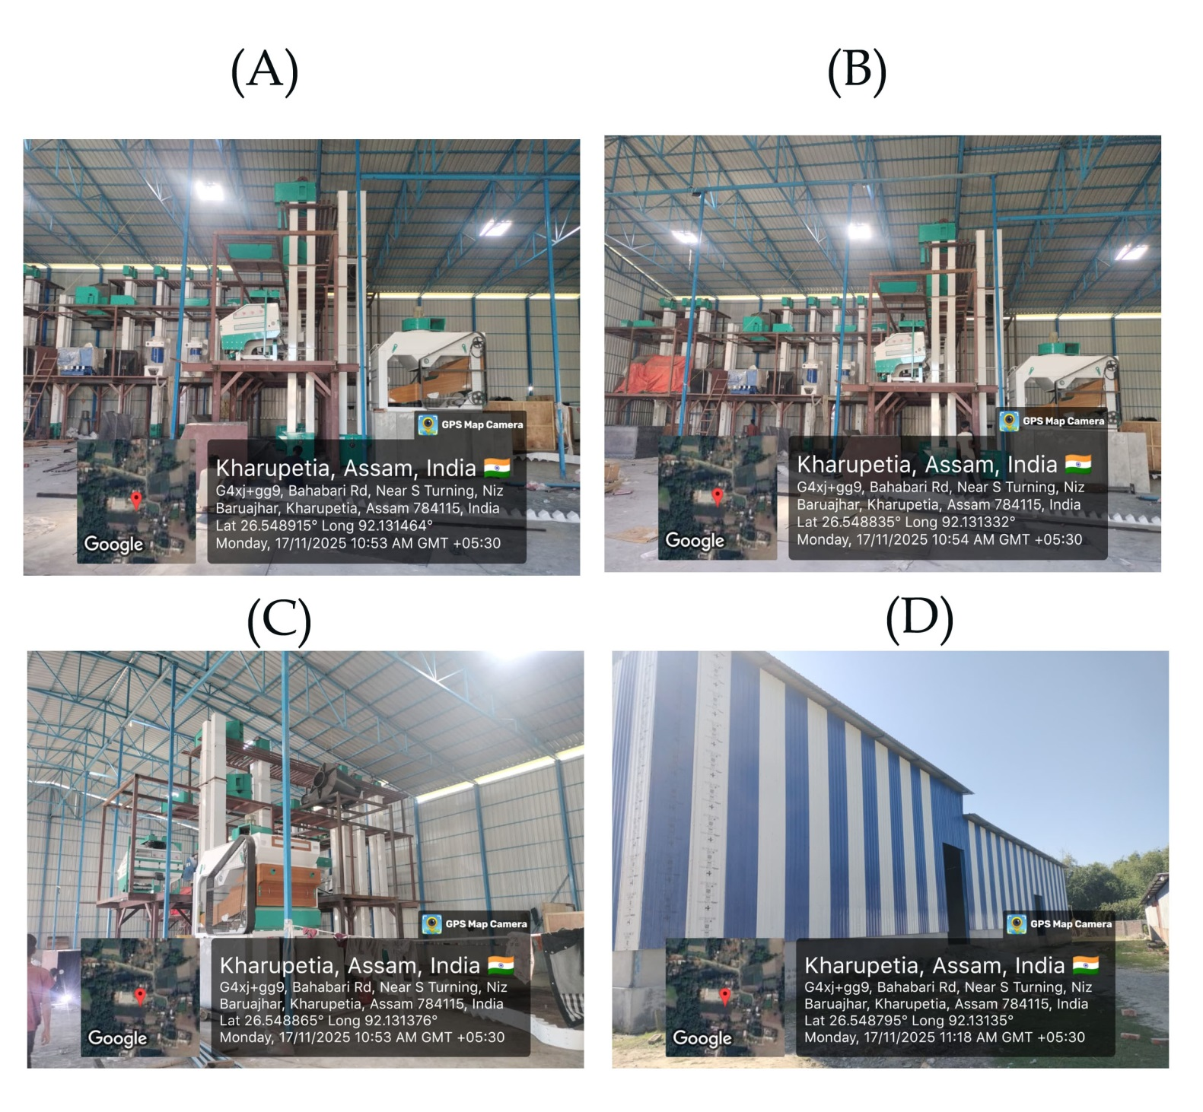

- Area of Rice Mill :

Rice mill capacity of 10-12 TPH 35000-40000 sq. ft. of constructed= area, including sections for raw paddy storage, processing machinery, finished goods warehouse, drying yard, and office facilities. Proper layout planning ensures smooth workflow, safety compliance, and efficient material handling across all stages of milling operations.

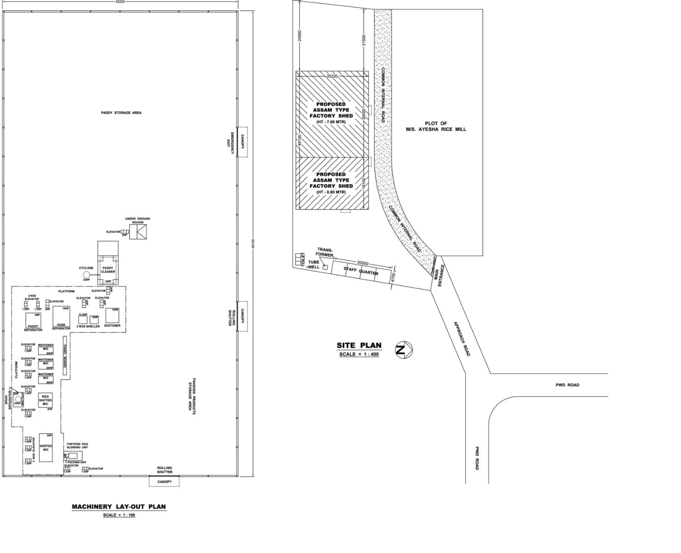

- Working Capital Assessment – Rice Milling Operations

1. Daily Milling & Paddy Requirement
- Capacity = 10 MT/hour
- Working = 8 hours/day
- Daily output = 10 × 8 = 80 MT/day
Convert MT to quintals:
- 1 MT = 10 quintals
- 80 MT = 80 × 10 = 800 quintals of paddy per day

2. Cost of Paddy per Day
- Cost per quintal of paddy = ₹2,300
- Daily paddy requirement = 800 quintals

3. Working Capital for Paddy (7-day cycle)
Working capital cycle = 7 days
For Paddy = 800Qt. x 2300 x 7 Days = 1,28,80,000.00

4. Add Extra Daily Expenses (already given)
- Extra expenses per day (power, wages, etc.) = ₹40,000
- For 7 days:
- Total = 2,80,0000.00

5. Total Working Capital Requirement (7 Days Cycle)

=1,28,80,0000+2,80,000 =1,31,60,000.00

Basic For Estimation Projection :

Milling Capacity :
Per Day | 800 Qtl
Working Day Per Year | 220 Days
Milling Capacity Per Year | 800*220=176000 Qtl.

Segregation of Milling Activities :

FCI Rice Milling | 80 % of Total Processing Performed
Market Selling | 20 % of Total Capacity Performed

Revenue Calculation in Three Months of Current Financial Year ( Jan, Feb & March-2026) :

Revenue from Milling Charges & Selling of by-Products :

Milling Qty. Amount |  |  | Rate Amount
Good | 65 | 36608.00 | 0 | -
Broken | 5 | 2816.00 | 2300 | 6476800.00
Hush | 20 | 11264.00 | 3 | 33792.00
Rice Bran | 7 | 3942.00 | 1900 | 7490560.00
Dust | 3 | 1689.00 | 0 | -
Total |  |  |  | 14001152.00
Add : Milling Charges |  |  |  | 3942400.00
Total |  |  |  | 17943552.00

3.2.Revenue for Product Selling in Market :
Milling Qty. Amount |  |  | Rate Amount
Good | 65 | 9152.00 | 2600 | 23795200.00
Broken | 5 | 704.00 | 2300 | 1619200.00
Hush | 20 | 2816.00 | 3 | 8448.00
Rice Bran | 7 | 985.60 | 1900 | 1872640.00
Dust | 3 | 422.40 | 0 | -
d Total |  |  |  | 27295488.00

  - Total Revenue =(3.1 + 3.2) =(17943552+27295488)
=45239040.00
(Note : For detailed calculation please refer Annexure-I)

Basic For Expenses Claimed in Profit & Loss Account:

  - Salaries & Wages (per month)*

S.No | Details of employees | No.of person | Salary p.m. | Total
1 | Supervisor / Skilled worker | 3 | 25,000.00 | 75,000.00
2 | Semi / Unskilled Worker | 7 | 17857.00 | 1,25,000.00
TOTAL |  | 10 |  | 2,00,000.00
* The expenses on salaries are increased @10% every year.

  - Raw Material (Own procurement)

S.No | Raw Material | Unit | Quantity in Qtls | Rate per Qtl | Total
1 | Paddy | Qtl | 14,149.00p.a | 2200.00 | 3,11,27,800.00

The Avg Raw material requirement per month = Rs. 1.4 lakh.(Apporx)

  - Utilities (Power /p.m.)

S.No | Description | Amount
1 | Power | 1,50,000.00
3 | TOTAL | 1,50,000.00
Rice Mill is in Operation Approximately 8 Months in a year.

  - Other Expenses per month:

S.No | Description | Amount
1 | Packing Materials | 1,50,000.00
2 | Transportation & Conveyance | 1,05,000.00
3 | Daily Wages | 35,420.00
4 | Repairs & Maintenance | 10,000.00
5 | Professional Fees | 10,000.00
6 | Misc. Expenses | 40,000.00
TOTAL |  | 3,50,420.00

Above Assumption is taken for Initial stage of operation, it will increased in future year of operation.

  - Working Capital Requirement per month:

S.No | Description | Amount
1 | Salaries & Wages | 2,00,000.00
2 | Raw Material | 1,24,59,580.00
3 | Utilities | 1,50,000.00
4 | Other Expenses | 3,50,420.00
TOTAL |  | 1,31,60,000.00

  - Assumptions & Notes:

1) The ‘cost per hour’ is assumed to include cash costs necessary to keep the plant running (e.g., paddy procurement, power, labour, and other variable overheads).
2) If supplier credit is available or if receivables/inventory holding differs from the stated cycle, the operating cycle should be adjusted to reflect the net cash conversion period.
3) Where applicable, separate assessments for inventory holding and receivable days may be added to refine the limit calculation.
4) The above is a cash‑cost working estimate intended for bank appraisal and can be further supported with historical statements and sales realization trends.

  - Processing Flow :

• Pre-Cleaning
- Raw paddy contains dust, soil, stones, straw, and other impurities.
- It passes through vibratory cleaners and aspirators to remove foreign matter.
• De-Stoning
- Paddy often carries small stones and heavy impurities.
- A destoner machine separates them using gravity and airflow.

• Parboiling (Optional)
- Paddy is soaked, steamed, and dried before milling.
- This strengthens the grain, reduces breakage, and improves nutrition.
• Husking (De-Husking)
- The husk (outer shell) of paddy is removed by rubber-roll shellers.
- This produces brown rice (rice with bran layers still intact).
• Husk Aspiration
- Air suction removes the husk from the mixture of brown rice and unhusked paddy.
• Paddy Separation
- Any remaining paddy is separated from brown rice using a paddy separator.
- Unhusked paddy is recycled back for husking.
• Whitening (De-Branning)
- Brown rice is passed through a whitener to remove bran layers.
- Produces white rice, but also generates rice bran (used for oil extraction).
• Polishing (Silky/Mist Polishing)
- Polishes the rice kernel to improve appearance, luster, and smoothness.
- Removes remaining bran particles.
• Grading & Length Separation
- Separates broken rice from full grains using graders and sifters.
- Head rice, medium brokens, and small brokens are classified.

• Color Sorting (Optional, Premium Quality)
- A color sorter removes discolored, chalky, or defective grains.
- Ensures high-quality rice for export and premium markets.
• Weighing & Bagging
- Final rice is weighed, packed in 25/50 kg bags, or bulk packaged.
- Bran and husk are stored separately for sale as by-products.

Subsidy

Government subsidies are monetary grants provided by the government to private institutions or other public entities, in order to stimulate economic activity or promote activities that are in the public good. Subsidies encourage companies to undertake economic activities and business ventures that the government sees as in the public's best interest. Like indirect taxes, they can alter relative prices and budget constraints and thereby affect decisions concerning production, consumption and allocation of resources.
There are 2 main types of subsidies: Direct subsidies and Indirect subsidies. Direct subsidies are those that involve an actual payment of funds toward a particular individual, group or industry. Indirect subsidies are those that do not hold a predetermined monetary value or involve actual cash outlays. They can include activities such as price reductions for required goods or services that can be government-supported. Other than that, there are various types of Subsidies viz. Cash subsidies, tax concessions, Government purchases policies, etc.
M/S GOLEN RICETECH INDUSTRIES is a business in manufacturing sector and is eligible for specified subsidies by the Government.

PROJECT VIABILITY & MARKET STUDIES

Feasibility Studies

A feasibility analysis evaluates the project’s potential for success; therefore, perceived objectivity is an essential factor in the credibility of the study for potential investors and lending institutions. One of the prerequisites for a successful business or unit is to have the technically feasible business model. A technical feasibility evaluates the details of how you propose to deliver a product or service to customers. Think materials, labour, transportation, where your business will be located, and the technology that will be necessary to bring all this together.
There are five types of feasibility studies—separate areas that feasibility study examines. Some major points out of them as explained below.
Technical Feasibility: This assessment focuses on the technical resources available to the organization. It helps organizations determine whether the technical resources meet capacity and whether the technical team is capable of converting the ideas into working systems. Technical feasibility also involves the evaluation of the hardware, software, and other technical requirements of the proposed system.
Economic Feasibility: This assessment typically involves a cost/ benefits analysis of the project, helping organizations determine the viability, cost, and benefits associated with a project before financial resources are allocated. It also serves as an independent project assessment and enhances project credibility—helping decision-makers determine the positive economic benefits to the organization that the proposed project will provide.
Operational Feasibility: This assessment involves undertaking a study to analyses and determines whether—and how well—the organization’s needs can be met by completing the project. Operational feasibility studies also examine how a project plan satisfies the requirements identified in the requirements analysis phase of system development.
Carrying on aforementioned feasibility studies is an essential part of pre-planning activities. As manufacturing is the process of converting raw materials and/or parts into finished goods that can be sold in wholesale or retail markets or exported for sale in other countries. It covers a wide range of industries, from food and beverages to pharmaceuticals, iron and steel to textiles, as well as lumber, tobacco, automobiles, aerospace, and petrochemicals.
After considering most of the aforementioned factors and points, a detailed feasibility study viz. Technical, economical and operational – have been carried out by the promoters / owners of the entity, and based on their personal due diligence and in-depth knowledge of the market, the project /company and its business operations are feasible in all the possible ways.
A detailed financial feasibility study has also been carried out based on the current demand – supply analysis and data & assumption-based projections ; which has been separately presented in the FINANCIAL FEASIBILITY section in (3) Financial Data & Ratios. ‘Sensitivity analysis’ and ‘assessed bank finance’ studies will help in ascertaining the financial viability of the project.
A rice mill is a food-processing facility where paddy is processed to rice to be sold in the market. The entire product is procured from paddy fields, milled and processed hygienically in modern machinery and dust-free environment and cleaned through sorting machines. The skilled & unskilled labour are required for the service of rice mills and Due to abundant availability of labour & land productivity of business rises. Thereby providing rice mill services in the market with a continuous service delivery. So business grow at very fast in the globe.
The working hours of service is 24 hours, so they grab more customer & earning more profit. They choose from numerous types of modern rice mill plant layouts. Rice milling involves the process of removal of husk, bran and then polishing. Husk is sold in the market as cattle feed and fuel. Bran is used for extracting oil. Broken rice is sold for a cheap price. Rice mill Service business, revenue- wise, has very good income potential. So, it would be feasible to setup a unit for the rice mill.

Below are some key benefits of conducting a feasibility study:
- Improves project teams' focus
- Identifies new opportunities
- Provides valuable information for a "go/no-go" decision
- Narrows the business alternatives
- Identifies a valid reason to undertake the project
- Enhances the success rate by evaluating multiple parameters
- Aids decision-making on the project
- Identifies reasons not to proceed

Apart from the approaches to feasibility study listed above, some projects also require other constraints to be analyzed -
- Internal Project Constraints: Technical, Technology, Budget, Resource, etc.
- Internal Corporate Constraints: Financial, Marketing, Export, etc.
- External Constraints: Logistics, Environment, Laws, and Regulations, etc.

After considering most of the aforementioned factors and points, a detailed feasibility study viz. Technical, economical and operational - have been carried out by the promoters / owners of the entity, and based on their personal due diligence and in-depth knowledge of the market, the project /company and its business operations are feasible in all the possible ways.

A detailed financial feasibility study has also been carried out based on the current demand - supply analysis and data & assumption-based projections ; which has been separately presented in the FINANCIAL FEASIBILITY section in (3) Financial Data & Ratios. 'Sensitivity analysis' and 'assessed bank finance' studies will help in ascertaining the financial viability of the project.

Industry Analysis

It is important to understand the operating environment of the business in this way can help the business holder to formulate an effective tactic, position the company for success, and make the most efficient use of the limited resources of the business.
Role of Manufacturing is changing as striving target has been set by the Government of India for increasing the contribution of manufacturing output to 25 percent of Gross Domestic Product (GDP) by 2025 from the current 16 percent.
Manufacturing has arisen as one of the high growth sectors in India. Prime Minister of India, Mr. Narendra Modi, propelled the ‘Make in India’ program to place India on the world map as a manufacturing center and give universal recognition to the Indian economy. Government purposes to create 100 million new employments in the sector by 2022.
The process of evolving as a global manufacturing hub has already started in India with global manufacturing majors setting up shop in India along with their domestic counterparts. A strong pipeline of existing projects from both global and domestic firms highlights the growing importance of the country as a market as well as a production hub.
Manufacturing industries are the chief wealth generating sectors of any economy. Manufacturing industries are important for an economy as they employ a huge share of the labor force and produce materials required by other sectors. Manufacturing sector in India has the potential to raise much of the Indian population above poverty by shifting majority of the workforce out of low-wage agriculture. In any country, manufacturing sector is the backbone of any economy as it improves growth, productivity, employment and strengthens agriculture and service sectors. Astrological growth in worldwide distribution systems and IT, coupled with opening of trade barriers, has led to increase growth of global manufacturing network. This has been designed to take advantage of low- waged with efficient work force of India.
In order to perform an industry analysis, one needs to assess the impact of Porter's five forces. "The collective strength of these forces determines the ultimate profit potential in the industry, where profit potential is measured in terms of long-term return on invested capital," Porter stated. Porter’s five forces for Industry analysis are:
- Ease of Entry

- Power of Suppliers

- Power of Buyers

- Availability of Substitutes

- Competitors

Manufacturing industry in India is a booming sector. Investments in the Indian manufacturing market are at an all-time high. Gross Fixed Capital Formation is currently at US $614.85 billion. Government initiatives ‘Make in India’ or ‘Vocal for Local’ are sector-specific & are aimed towards making India a global manufacturing center. Therefore, more global giants are turning towards Counselors for Manufacturing Industry in India for Manufacturing Industry Business Set up in India.
Today, globalization has carried manufacturing forward. Experts predict that the next revolution in

Manufacturing will be prompted by the increasing demand for customized products and smart devices, and be transformed by the development of technology.
The strong demand of manufacturing products has pushed the Indian manufacturing industry to a new level. It is expanding to meet the growing demands of the people. According to some economists, manufacturing industry is a wealth-producing sector of an economy.
The manufacturing industry in India contributes about 15% of the country’s GDP. Under the National Manufacturing Policy 2015, determined programs are under way to take this figure to 25 percent and the total output from this sector to $1 trillion by upcoming 2 years.
India’s manufactured exports are worth over $180 billion, or 45 percent of the country’s total exports, with the biggest exports being engineering goods, chemicals and related products, and leather goods.
On the basis various factors related to industry analysis, a detailed scrutiny was carried out by the promoters / business owners and to conclude, based on the SWOT and Porter’s five forces business model, they found the industry very demanding and scope for the business is unrestricted.

The high production of rice in this region and increasing demand for good quality rice are some key drivers for the growth of the rice milling market in India.
Although traditional methods are still prevalent in India, including for rice harvesting, rice millers are increasingly investing in modern, high-quality rice milling equipment to increase yield and quality of the final product. In addition to favorable policies, the government also offers various facilities and subsidies to promote modern agricultural activities. Foreign investors have recognized India's position as a global rice producer and have accordingly set up rice milling machinery manufacturing units to meet the demand and leverage cheap labor costs available in the region.
Improper storage and lack of appropriate warehouse facilities along with unpredictable crop failure are some of the challenges faced by this market. However, ongoing development in agriculture is expected to offer solutions and opportunities for expansion of the market in the coming years
The Indian rice milling market has been segmented into equipment, capacity, and region. By equipment, the market has been segmented into rice whitening machinery, pre-cleaner machinery, paddy separator machinery, length grader machinery, and others.
East India accounts for the largest share of the rice milling market. This is primarily due to the fact that rice has traditionally been grown in this region which naturally has high rainfall and the area is conducive to the growth of rice. This has prompted a high number of planned investments in rice milling, this facilitating growth for the market. The East India regional segment is poised to grow at a consistent CAGR of 3.97% during the forecast period.
Prominent market players who are operating the Indian rice milling market include Parker Engineers, Satake Corporation, Buhler Group, Mill Master Machinery Pvt. Ltd., G.G. Dandekar Machine Works Ltd., Perfect Equipment’s, Savco Sales Pvt Ltd., Fowler Westrup, and G.S International.
India and China have just signed an agreement to amend a pre-existing protocol on phytosanitary
Requirements. The signing of this agreement will allow India to export non-basmati rice to China. This offers high potential for expansion to rice millers in the country.
Rice milling machines offer one or two step procedure or a multiple step process. In a one-step rice milling process, bran and husk abstraction are performed in a single flow, and white rice is produced directly removed from paddy. In a two-step procedure, husk and bran are separately removed, and brown rice is derived. Rice Milling machines are used to produce an intermediate product. In multi- stage milling process, rice endures various procedure in each level of separation.
With the growing rice milling market in India, there is seen an increase in the demand of the rice milling machineries across the country. In last few years there has been an increase in the number of foreign players in the rice milling market in the country. The reason lies in the supportive policies and regulations, which promote new rice mills and the government offers various facilities to the new entrants in the market.

Market Potential

The India Rice Milling market is expected to reach market size of USD 392.6 Million by 2022. It is expected to grow at 3.51% CAGR during the forecast period 2022-2030.
A rice milling is food processing equipment where paddy is processed to rice. Paddy is collected from fields and is rechecked before the process begins. The rice product is procured from paddy fields, milled and hygienically processed in machinery with a dust free environment and cleaned using a sorting machines. This rice is further sold in the market to the end users. The basic objective of rice milling is to remove the husk and the bran layers to further produce edible, white rice.
This process of milling can be a one step, two-step process or a multi-stage process. In one step process husk and bran layers are removed in one pass, whereas in two-step process husk and bran layers are removed separately. Multi-stage milling process is mainly done in village or local consumption, where rice goes under different number of steps ranging from pre-cleaning to weighing of rice. This multi-stage milling process is used for marketing rice.
With the growing rice milling market in India, there is seen an increase in the demand of the rice milling machineries across the country. In last few years there has been an increase in the number of foreign players in the rice milling market in the country. The reason lies in the supportive policies and regulations, which promote new rice mills and the government offers various facilities to the new entrants in the market. This has offered flourishing market for the rice milling machinery manufacturers, both the national and international ones.
Furthermore the demographics of the country is such that rice is one of the most sort after food grain in the Indian agriculture. The monsoon and the terrain across the regions of North India, East India and South India support the rice cultivation of various grades and qualities. However there are few factors such as lack of proper storage and warehousing facilities along with crop failure restraint the market growth.
East India dominates the India rice milling market with 37.21% of share in 2016, in terms of value. It is expected to grow at a CAGR of 3.97% during the forecast period. The share is attributed to the increased government initiatives and planned investments in rice milling industries are driving the market. North India is expected to grow at a CAGR of 3.90% during the forecast period.
The increase in production of rice and the growing demand across the globe is the major factor influencing the growth of rice milling market. Moreover, the growth in agriculture, industrialization rate, increase of end-user application, and technology development has fueled the growth of rice milling market. The opportunity of handling paddy to rice through the rice milling machines has increased its demand in agriculture.
The rice mills services in India was reaches to USD $72.8 million in the year of 2018 and is projected to register a CAGR of 4.7% during the forecast period from the year of 2020-2025.
The rice mills service market is composed to grow by USD $119.84 million during the period from 2020-2023 progressing at a CAGR of 2% during the forecast period. At present, over 1, 30,000 rice mills services are available in India including modern rice mills.
Rice mills services is the oldest and the largest agro processing industry of the India. It has a turnover of more than Rs. 25,500 crore per annum. It processes about 85 million tones of paddy per year and provides staple food grain and other valuable products required by over 60% of the population.

Process

Paddy may contain up to 5 per cent of foreign matter such as lumps of soil, stones, stalk and chaff. Cleaning is done using vibratory screens and air. Two types of rice mills are in used viz., the huller type and the automatic Sheller type. The huller mill is less costly than sheller mill but it gives less yield of rice. Sheller mills essentially consists of Cleaning sieves sheller, aspirator, paddy separator, cone polisher and sorting sieve, Modern rice mills have rubber roller Sheller’s, which results in the least breakage of rice.

The clean paddy is conveyed to the sheller for dusking, using vertical bucket elevators. The husk is removed between the two rubber rollers or cast iron rollers coated with Cement of emery. Complete dushking does not take place here; about 5 to 20 percent Paddy remains unhusked.

Mixture is conveyed to the aspirator where the husk is sucked out using a suction fan. Rice grain is collected in a chamber and paddy is discharged at a third point and is sent Back to the sheller for further dusking.

Dusking rice is conveyed to cone polisher or whitener, consisting of an inverted truncated cone of cast iron coated with an abrasive emery cement mixtures. During the process a lasts of heat is generated resulting in breakage of grains. To prevent breakage the grains are usually passed through a series of pearling cones. The degree of polishing may be controlled to give partial or completely white rice. Now the Government of India has laid down the limit of 3-5 per cent removal of bran from unpolished or bran rice.

The polished rice is finally sieved to separate the bran from rice and to separate broken from head rice (full grains). The rice is then graded in various sizes for marketing. Apart from head rice (56%-65%) and broken rice (5-10%) the following are obtained during Milling of paddy, husk (15-25%) bran (5-10%) polish (1-4%) and other foreign matter. (1-3%).

During the paddy milling, rice is generally obtained about 60 to 70 percent; husk is obtained about 20 to 25 per cent, beside 5 per cent bran. The bran contains about 14 to 16 per cent oil, which can be obtained through solvent extraction process.

The basic rice milling processes consist of the following process.

Pre Cleaning: Removing all impurities and unfilled grains from paddy

De-stoning: Separating small stones from paddy

Parboiling (Optional): Helps in improving the nutritional quality by gelatinization of

Starch inside the rice grain. It improves the milling recovery percent during deshelling

And polishing / whitening operation

Husking: Removing husk from paddy

Husk Aspiration: Separating the husk from brown rice/ unhusked paddy

Paddy Separation: Separating the unhusked paddy from brown rice

Whitening: Removing all or part of the bran layer and germ from brown rice

Polishing: Improving the appearance of milled rice by removing the remaining bran particles and by polishing the exterior of the milled kernel

Length Grading: Separating small and large brokens from head rice

Blending: Mixing head rice with predetermined amount of brokens, as required by the customer

Weighing and bagging: Preparing the milled rice for transport to the customer

Current Scenario

    - The global rice milling services market is expected to register a CAGR of 1.94% during the forecast period from the year of 2020-2025.
    - The rice mills services market in India was USD $172.8 million in the year of 2018 and is projected to register a CAGR of 2.7% during the forecast period.
    - In the India the Revenue in the rice mill service segment is projected to reach USD $258.09 million in the year of 2020.
    - The average revenue per user in the rice mill service market segment is projected to amount to USD $32.15 in the year of 2020.
    - In the India most of revenue of the rice mill services will be generated from the local residency area with a projected market volume of USD $84.63 million by the year of 2021.
    - The Indian rice mill service market size was valued at USD $231.9 billion in the year of 2018 and is expected to register a CAGR of 2.4% over the forecast period.
    - The Indian rice mill service market was valued at USD $136.2 billion in the year of 2017.

    - The market size, measured by revenue, of the rice mill service industry in the India the CAGR is 3.8% in the year of 2019.
    - The Indian market size of the rice mill service market is expectedly to increase 4.6% in the year of 2020 to 2021.
    - The Indian market size of the rice mill services market has increase 6.2% per year on average between the years of 2018 to 2020.
    - The India rice milling service market is expected to value an estimated USD $392.6 million by the end of the year 2022 and witness a steady CAGR of 3.51% during the forecast period of the year 2016
- 2022.

    - The India Rice Milling service market is expected to reach market size of USD 486.43 million by the year of 2024. It is expected to grow at 5.73% CAGR during the forecast period from the year of 2020 to 2024.

Challenges & Solutions

- Under milled rice -

Under-milled rice is under-polished rice, or rice with bran streaks left in it. The bran contains much of the desired nutritious elements. Under milling will also yield higher milling recoveries. However, under-milled rice does not store well because of the high oil content of the bran. In addition, rice consumers almost universally desire well-milled rice because of its better appearance. Related to milling degree is the occurrence of red-streaked kernels, rice with part of the bran layer still sticking to the surface.

Broken grains -

Grain breakage is a result of fissuring, or the formation of cracks in the endosperm prior to milling. To a certain extent, fissuring in rice grain occurs naturally in the field due daily changes in temperature and relative humidity. More importantly, fissuring can be caused by improper management of grain at all post-harvest operations from harvesting through to milling. Improper drying techniques often lead to fissuring in grain, or rewetting of stored paddy, and improper milling techniques. Finally, not all fissured grain will break during milling, and medium or long grain varieties are more prone to breakage than short grain varieties.

Discoloration -

Although whiteness is a varietal characteristic, the natural color of white rice can be affected by post- harvest discoloration. A general discoloration of the entire rice kernel occurs if wet paddy is left undried for extended periods. The wet grain will heat up, causing the grains to turn yellow or tan.

Chalkiness -

If part of the milled rice kernel is opaque rather than glowing, it is characterized as chalky. Chalkiness disappears upon cooking and has no effect on taste or aroma, however it downgrades milled rice. Chalky grains are more brittle than non-chalky grains and can break more easily during milling. Cause of chalkiness is interruption during the final stages of grain filling.

Damaged grains -

Damaged rice kernels are those which are fully or partially darkened as a result of insect, mold, water, or heat damage. The presence of even a few damaged grain kernels can severely downgrade rice.

Impurities -

Layers in milled rice are a sign of improperly cleaned paddy prior to milling, or contaminate the rice during milling.

SWOT Analysis

A SWOT analysis is an incredibly simple, yet powerful tool to help you develop your business strategy, whether you’re building a start-up or guiding an existing company.
SWOT stands for Strengths, Weaknesses, Opportunities, and Threats.

SWOT Analysis is a strategic planning method used to evaluate strengths, weaknesses, opportunities, and threats, in a business project or a manufacturing business. These four factors are called SWOT (strengths, weaknesses, opportunities, and threats). This process involves the specific determination and objectives of a manufacturing or business project that identifies internal and external factors.
SWOT analysis can be applied by analyzing and observing the things that affect the four factors, then apply them in the picture in the SWOT matrix, apply the strengths map to take advantage of the opportunities, how to overcome the weaknesses that prevent the advantages of opportunities are able to deal with the threats that exist, and the last is how to overcome the weaknesses that can make threats become real or create a new threat. Determining the direction of development of a business is strongly influenced by many factors, namely internal and external factors.
One may think that they already know everything that they need to do, to succeed, but a SWOT analysis will force them to look at the business in new ways and from new directions.

Strengths

- Good product prototype and innovation

- Overall, manufacturing industry is relatively stable.

- Focus on value creation with leadership in product development leadership and high quality output

- Strong Research & Development Capabilities

- High level of Specialization

Weakness

- Employee skills need to be upgraded.

- Air pollution directly to the community.

- Lots of levies, unerring costs.

- Lack of finance

Opportunities

- Lot of scope for innovative products every now and then.

- Trends in increasing customer purchasing power.

- Opportunities in the manufacturing industry are in the technology and bio-technology areas. These are growing market segments with higher profit margins.

- New market opportunities and consolidation of the industry through Merger & Acquisition activities

Threats

- Regulation of government, regulations on tight industrial business

- Increasing freight transportation costs

- Competition from other manufacturing / process units

- Unnecessary changes in Government policies

- Geographical disadvantages

Notes to the Project Report

- Depreciation has been computed in accordance with the depreciation rates prescribed in the Income Tax Act. A separate depreciation schedule has been provided for reference and calculation purposes.

- The data presented, including sensitivity analysis and balance sheet synopsis, has been prepared utilizing standard financial assumptions and calculations.
- The financial projections and assessments are based on the assumption that there will be no changes in government policies and rules that may impact the loan applicant's business. Furthermore, it is assumed that no abnormal events will occur during the lifespan of the project or business.
- The financial projections and assessments are based on the assumption that there will be no changes in government policies and rules that may impact the loan applicant's business. Furthermore, it is assumed that no abnormal events will occur during the lifespan of the project or business.

- Provision for Income Tax has been made on the Rules and Regulations which are applicable for current scenario.

- The financial statements have been prepared under the standard assumption that the fiscal year-end occurs in March.

- The details of indirect expenses, break-even analysis, and security margin calculation have been provided in separate annexures for reference.

- The financial data pertaining to revenue from business operations, asset additions, existing obligations, etc., has been presented based on the information provided by the client.

- The projected data included in this report represents future-oriented financial information. It has been prepared based on the best judgment of the applicants, incorporating assumptions regarding the most probable set of economic conditions. However, it is important to note that this information should not be considered as a forecast.

- The information pertaining to the business entity, owner's profile, employment details, feasibility studies, industry analysis, market potential, current scenario, and challenges-solutions has been compiled based on discussions and inputs provided by the loan applicant.

