Smart advertising platform using Raspberry pi and push notifications

Authors Name/s per 1st Affiliation (Author)
line 1 (of Affiliation): dept. name of organization
line 2-name of organization, acronyms acceptable
line 3-City, Country
line 4-e-mail address if desired
Authors Name/s per 2nd Affiliation (Author)
line 1 (of Affiliation): dept. name of organization
line 2-name of organization, acronyms acceptable
line 3-City, Country
line 4-e-mail address if desired

Abstract— This paper is based on an advertising platform. Our proposed idea digitizes the advertisements of products. A php server is running on the raspberry pi which contains the database that includes all the offers uploaded. These offers are uploaded by the individual shop keepers. A dashboard is created which is used by the shop keeper to upload the offers to the database in the raspberry pi.
A wifi module connected to the raspberry pi is used to broadcast the offers to the customer’s Smartphone. Whenever the customers come into the wifi range of the shop, the customer’s smartphone gets the notification of the offers. An android application is installed in the customer’s Smartphone to get offers broadcasted through the wifi. This application does not use the internet nor GPS, only the wifi connection is sufficient.
Keywords— raspberry pi, Smartphone, wifi module, php server, notification.
Introduction (Heading 1)
Advertising is a means by which communication with the users of a product or service occurs. Advertising is always present, though people may not be aware of it. In present world, using every possible media advertising get’s its message through. It may do this via television, print (newspapers, magazines, journals etc), radio, press, internet, events, direct selling, hoardings, posters, mailers, contests, clothes, sounds, visuals sponsorships, and even people (endorsements). However today’s advertising platforms are relatively expensive in terms of creative, production and airtime costs making it difficult for targeting your market. A professional has to be hired to design an efficient, well-crafted and effective script.
Our proposed idea helps in making the advertising more efficient and cost effective. This helps in the targeted marketing strategy.
This paper describes how this proposed idea is more effective than the traditional advertising methods. The following section describes the requirements needed for the proposed idea and design of the proposed model. This is followed by the implementation of the model and the experimental results of the model.

system design and description
An effective advertising platform helps in effective marketing of the products. It should be cost effective and more responsive than the traditional methods. The following fig.1 shows the design of the proposed model for the effective advertising platform.

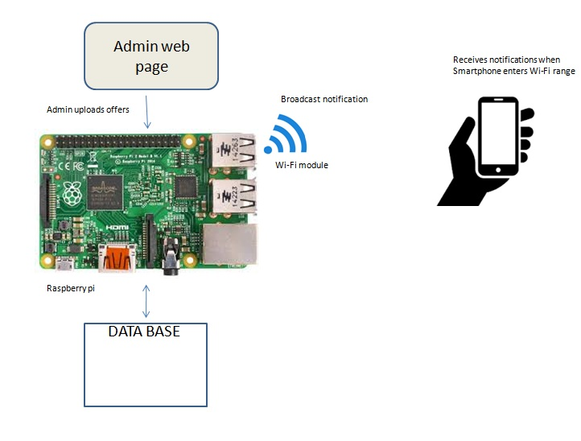
Fig.1 design of the proposed advertising platform.

In the design phase the software requirements for the proposed model is as follows:
The android studio is used for the development of the app for the customer’s smartphone. The raspbian OS is uploaded onto the raspberry pi. Php and mysql is used for designing the backend. The database which is used to store the information about offers is placed in the raspberry pi and php is used to upload and retrieve the data from it.HTML, CSS, bootstrap is used for designing the front end of the model. An admin page is used to upload the data.

The raspberry pi is used as a medium for storage and sending of the offer details. A mysql database is created on the raspberry pi to store the offer’s list. An admin web page or dashboard is used by the shop keeper to upload the data to the database. A Wi-Fi module is present in the raspberry pi which is used to broadcast the offers to the customer’s smatphone. An android app is installed in the customer’s smartphone and whenever the smartphone comes into the range of the shop keeper’s Wi-Fi, he gets a notification about the offers present.

implementation

experimental results
the following section shows the experimental results achieved by implementing the proposed model. whenever the customer’s smartphone comes into the the wifi range of the shop the customer gets an notification on his smartphone when the app is off. The following figure 2 shows the notification got on the customers smartphone.

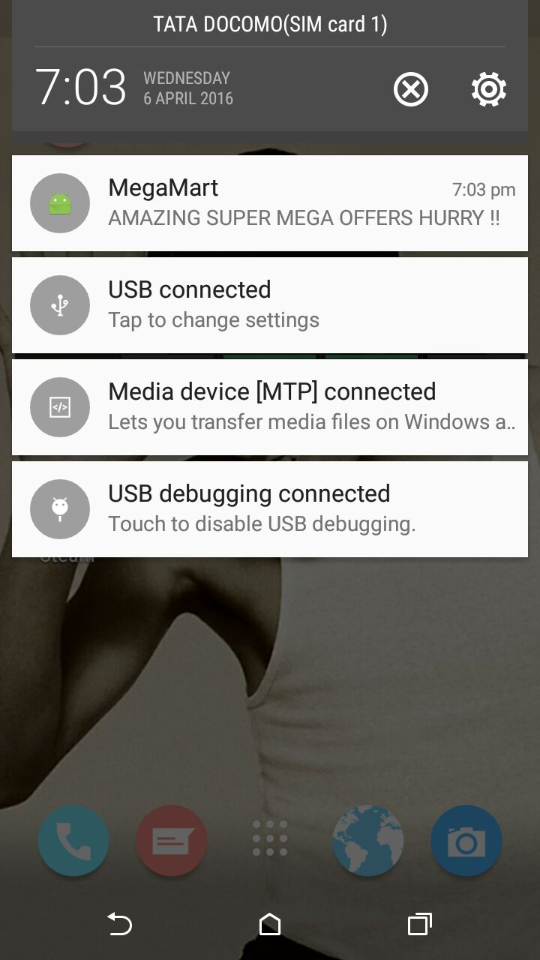

Fig.2 notification about offers

When the notification is received by the customer, he can go into the app to check for the details about the offer. An image of the product can also be broadcasted along with the offers details. The following figure 3 shows the content present inside the app when the offers is got from the shop.

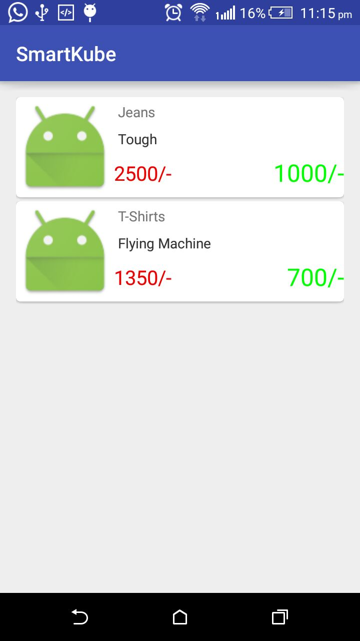

Fig.3 example output of offers
After the text edit has been completed, the paper is ready for the template. Duplicate the template file by using the Save As command, and use the naming convention prescribed by your conference for the name of your paper. In this newly created file, highlight all of the contents and import your prepared text file. You are now ready to style your paper; use the scroll down window on the left of the MS Word Formatting toolbar.

Authors and Affiliations
The template is designed so that author affiliations are not repeated each time for multiple authors of the same affiliation. Please keep your affiliations as succinct as possible (for example, do not differentiate among departments of the same organization). This template was designed for two affiliations.

For author/s of only one affiliation (Heading 3): To change the default, adjust the template as follows.

Selection (Heading 4): Highlight all author and affiliation lines.

Change number of columns: Select the Columns icon from the MS Word Standard toolbar and then select “1 Column” from the selection palette.

Deletion: Delete the author and affiliation lines for the second affiliation.

For author/s of more than two affiliations: To change the default, adjust the template as follows.

Selection: Highlight all author and affiliation lines.

Change number of columns: Select the “Columns” icon from the MS Word Standard toolbar and then select “1 Column” from the selection palette.

Highlight author and affiliation lines of affiliation 1 and copy this selection.

Formatting: Insert one hard return immediately after the last character of the last affiliation line. Then paste down the copy of affiliation 1. Repeat as necessary for each additional affiliation.

Reassign number of columns: Place your cursor to the right of the last character of the last affiliation line of an even numbered affiliation (e.g., if there are five affiliations, place your cursor at end of fourth affiliation). Drag the cursor up to highlight all of the above author and affiliation lines. Go to Column icon and select “2 Columns”. If you have an odd number of affiliations, the final affiliation will be centered on the page; all previous will be in two columns.

Identify the Headings
Headings, or heads, are organizational devices that guide the reader through your paper. There are two types: component heads and text heads.
Component heads identify the different components of your paper and are not topically subordinate to each other. Examples include ACKNOWLEDGMENTS and REFERENCES, and for these, the correct style to use is “Heading 5.” Use “figure caption” for your Figure captions, and “table head” for your table title. Run-in heads, such as “Abstract,” will require you to apply a style (in this case, italic) in addition to the style provided by the drop down menu to differentiate the head from the text.
Text heads organize the topics on a relational, hierarchical basis. For example, the paper title is the primary text head because all subsequent material relates and elaborates on this one topic. If there are two or more sub-topics, the next level head (uppercase Roman numerals) should be used and, conversely, if there are not at least two sub-topics, then no subheads should be introduced. Styles named “Heading 1,” “Heading 2,” “Heading 3,” and “Heading 4” are prescribed.

Figures and Tables

Positioning Figures and Tables: Place figures and tables at the top and bottom of columns. Avoid placing them in the middle of columns. Large figures and tables may span across both columns. Figure captions should be below the figures; table heads should appear above the tables. Insert figures and tables after they are cited in the text. Use the abbreviation “Fig. 1,” even at the beginning of a sentence.
- Table Styles
Table Head | Table Column Head
Table Head | Table column subhead | Subhead | Subhead
Copy | More table copyª
- Sample of a Table footnote. (Table footnote)

- Example of a figure caption. (figure caption)
Figure Labels: Use 8 point Times New Roman for Figure labels. Use words rather than symbols or abbreviations when writing Figure axis labels to avoid confusing the reader. As an example, write the quantity “Magnetization,” or “Magnetization, M,” not just “M.” If including units in the label, present them within parentheses. Do not label axes only with units. In the example, write “Magnetization (A/m)” or “Magnetization (A ( m(1),” not just “A/m.” Do not label axes with a ratio of quantities and units. For example, write “Temperature (K),” not “Temperature/K.”

Acknowledgment (Heading 5)
The preferred spelling of the word “acknowledgment” in America is without an “e” after the “g.” Avoid the stilted expression “one of us (R. B. G.) thanks ...”. Instead, try “R. B. G. thanks...”. Put sponsor acknowledgments in the unnumbered footnote on the first page.

References
The template will number citations consecutively within brackets [1]. The sentence punctuation follows the bracket [2]. Refer simply to the reference number, as in [3]—do not use “Ref. [3]” or “reference [3]” except at the beginning of a sentence: “Reference [3] was the first ...”
Number footnotes separately in superscripts. Place the actual footnote at the bottom of the column in which it was cited. Do not put footnotes in the reference list. Use letters for table footnotes.
Unless there are six authors or more give all authors’ names; do not use “et al.”. Papers that have not been published, even if they have been submitted for publication, should be cited as “unpublished” [4]. Papers that have been accepted for publication should be cited as “in press” [5]. Capitalize only the first word in a paper title, except for proper nouns and element symbols.
For papers published in translation journals, please give the English citation first, followed by the original foreign-language citation [6].

- G. Eason, B. Noble, and I.N. Sneddon, “On certain integrals of Lipschitz-Hankel type involving products of Bessel functions,” Phil. Trans. Roy. Soc. London, vol. A247, pp. 529-551, April 1955. (references)
We suggest that you use a text box to insert a graphic (which is ideally a 300 dpi resolution TIFF or EPS file with all fonts embedded) because this method is somewhat more stable than directly inserting a picture.
To have non-visible rules on your frame, use the MSWord “Format” pull-down menu, select Text Box > Colors and Lines to choose No Fill and No Line.
- J. Clerk Maxwell, A Treatise on Electricity and Magnetism, 3rd ed., vol. 2. Oxford: Clarendon, 1892, pp.68-73.
- I.S. Jacobs and C.P. Bean, “Fine particles, thin films and exchange anisotropy,” in Magnetism, vol. III, G.T. Rado and H. Suhl, Eds. New York: Academic, 1963, pp. 271-350.
- K. Elissa, “Title of paper if known,” unpublished.
- R. Nicole, “Title of paper with only first word capitalized,” J. Name Stand. Abbrev., in press.
- Y. Yorozu, M. Hirano, K. Oka, and Y. Tagawa, “Electron spectroscopy studies on magneto-optical media and plastic substrate interface,” IEEE Transl. J. Magn. Japan, vol. 2, pp. 740-741, August 1987 [Digests 9th Annual Conf. Magnetics Japan, p. 301, 1982].
- M. Young, The Technical Writer’s Handbook. Mill Valley, CA: University Science, 1989.

