GUILLOTINE GULAG INSURANCE OPTION CONTRACT
PARTIES:
- Option Buyer: Ben ("Buyer")
- Option Seller: Max ("Seller")
OPTION TERMS:
1. PREMIUM PAYMENT
- Buyer pays Seller $20 draft dollars immediately upon contract execution
2. OPTION RIGHTS
- Buyer receives the right (but not obligation) to invoke gulag substitution within the first 8 weeks of the league
- Weeks 2-5 Exercise cost: $200 FAAB paid to Seller
- Weeks 6-8 Exercise cost: $250 FAAB paid to Seller
- Option covers ONE (1) gulag appearance only
3. EXERCISE CONDITIONS The option may be exercised if and only if:
- Buyer notifies Seller within 24 hours of weekly results
- Buyer has sufficient FAAB to complete payment
4. EXERCISE PROCESS
- Buyer must text Seller AND Public Chat stating "I am exercising my gulag option"
- Seller enters gulag in Buyer's place and follows gulag penalty procedure
5. RESTRICTIONS & EDGE CASES
Cannot Exercise If:
- Buyer and Seller are BOTH in bottom 2 (both must enter gulag normally)
- Week 9 or later
Special Rules:

6. FAIR PLAY PROVISIONS
- Buyer must make reasonable effort to field a surviving team weekly (no tanking)
- Seller must not enter into another gulag insurance contract without buyers consent
- Seller must make reasonable effort to not enter gulag same week
7. TRANSFERABILITY
- This option is non-transferable without approval from Buyer and Seller
8. DISPUTE RESOLUTION
- Since the Commissioner is involved in the deal the League/Assistant Commish Ryland has final say on all disputes
CONFIRMATION: By responding "AGREED" in league chat, both parties accept these terms.

Seller Signature:
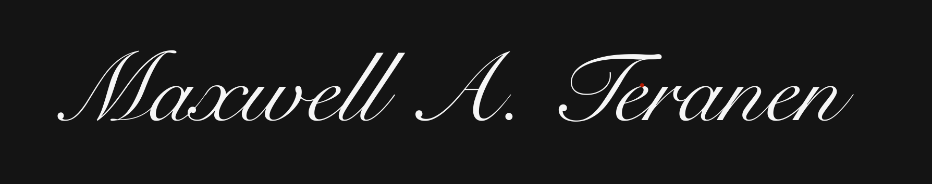
Buyer Signature:
Ben Ray

