ADIT-NMR Features
Historical Context:
- ADIT-NMR is a modification by BMRB of the ADIT system from PDB. It was originally designed to be a deposition system tailored to the data collected by NMR spectroscopy depositors at BMRB. (The original ADIT system was intended for X-ray crystallography depositors, with a few extra fields added along the way to accommodate NMR depositors.)
- The ADIT-NMR system has worked well enough that not only does BMRB use it, but now PDB now redirects all its NMR depositors to the BMRB ADIT-NMR site as well. The system can accommodate this dual function, allowing NMR depositors to deposit to both BMRB and PDB without entering their data twice. A mirror of this operation also exists at Osaka University in Japan, for both the BMRB and PDB sites.
- In November 2007, BMRB made available an additional ADIT-NMR system for use with molecular systems too small for PDB to accept, but that BMRB would accept, called SMSDep. This system runs on the same software as ADIT-NMR with dictionary changes to use a smaller subset of the NMR-STAR data tags.

Feature List (on next pages):

Tree Menu: The list of tags required for NMR depositions at BMRB is quite large compared to what was required for a PDB deposition. To help accommodate this, ADIT-NMR uses an exploding tree-menu of categories instead of a flat list.

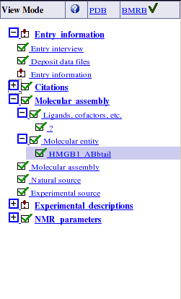

Conditional Mandatory system: In the original ADIT system, the configuration of which fields are hidden and which fields are mandatory is fixed according to a configuration file. In ADIT-NMR this configuration file was expanded to allow conditional rules that change depending on the data in the deposition. In this way fields that most depositors don't need can be hidden most of the time and become visible only under just the right conditions. (For example, for citations that come from a book, the editor becomes mandatory, but for other citations the editor fields are hidden.)

View Mode: The depositor can toggle which mode the system is in (a PDB deposition or a BMRB deposition), which changes which fields are hidden and which fields are mandatory, through the conditional mandatory system mentioned above. This toggle also changes which site will receive the deposition when it is submitted. By changing this toggle and resubmitting, a depositor can deposit to both BMRB and PDB.
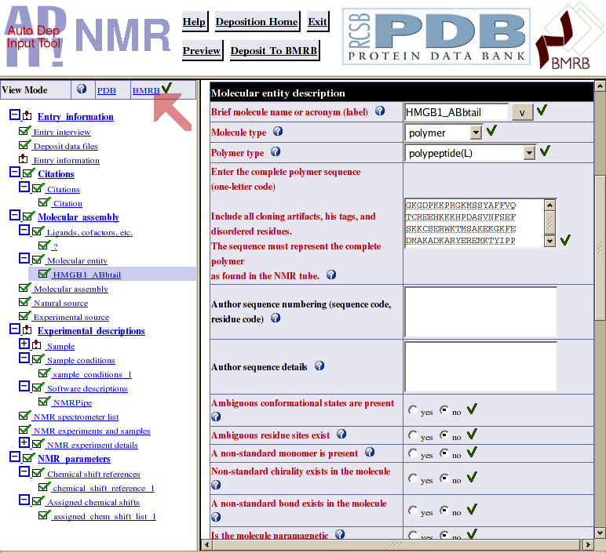

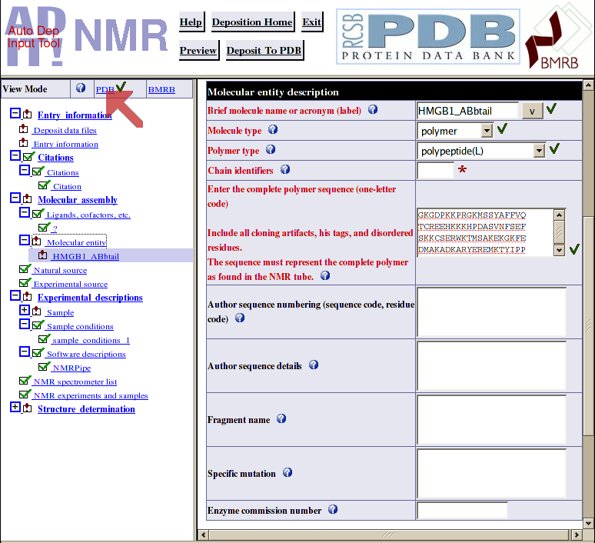

Conversion NMR-STAR/pdbx: As part of the collaboration between PDB and BMRB, the ADIT-NMR file upload system has been updated so it can accept PDB, mmCIF, and PDBX files as input as well as its own native NMR-STAR v2 and v3 formats. It converts output into pdbx for packaging to send to PDB as well.
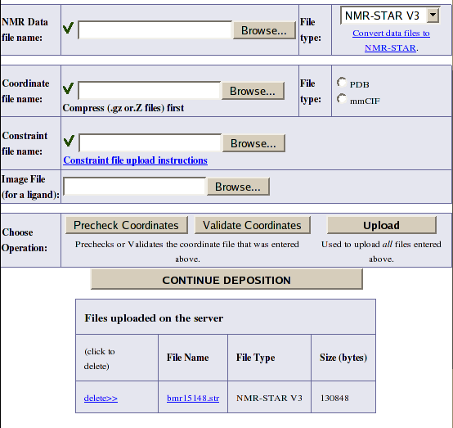

Auto-populating fields: A very recent update to ADIT-NMR provides the ability to, through the use of an AJAX query, populate the contact person's information from just the e-mail address if the e-mail address is recognized on the server as having been encountered before in a previous entry. This is the first of possibly several such auto-populating queries we can do.
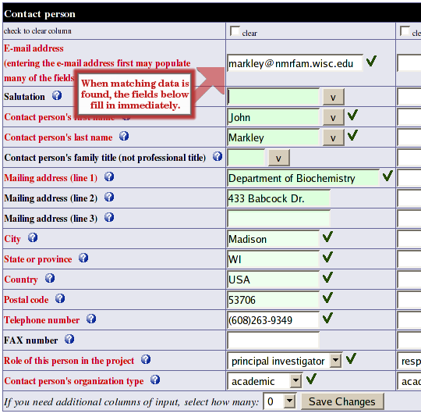

Processing ADIT-NMR data flow

[ TODO PASTE VISIO diagram HERE.]

