DEVise JavaScreen Views-to-Menus
2015-06-25

Introduction/motivation

We want to add the capability to convert “selection views” to menus in the JavaScreen. (“Selection views” are views that exist only to select what is shown in another view.)

An example of a “selection view” is the data select view below:

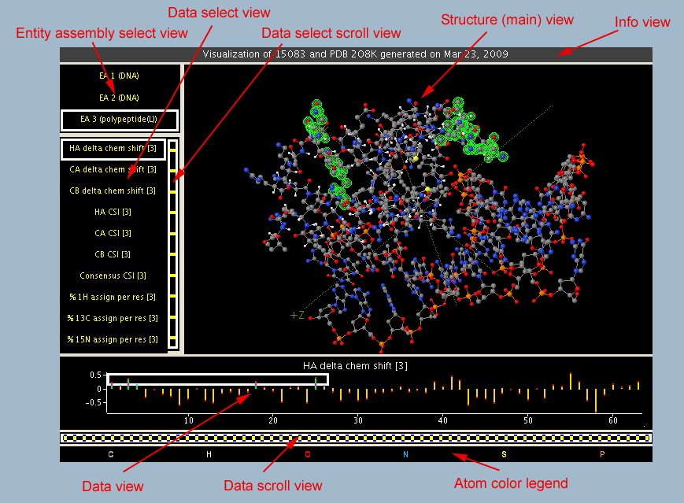
The user moves the cursor in the data select view to select the data set to be displayed in the data view. The data select scroll view scrolls the data select view if there are too many items to display at the same time. (In this visualization, it only makes sense to allow a single selection in the selection view, but in others that's not the case (see below).)

There are several advantages to converting “selection views” to menus:
- We will make more efficient use of screen real estate.
- Visualizations will appear cleaner and less cluttered (see mockup below).
- The user will have a more familiar selection mechanism.
- We may be able to expand the selection functionality to include the selection of multiple, discontinuous, items.

For example, in the simulated 1H-15N backbone HSQC spectrum visualization (see below), the user can currently select multiple amino acids in the amino acid view by enlarging the cursor. But, whatever set of amino acids they select must be continuous within that view. It would be useful to be able to select a discontinuous set of multiple amino acids (for example, the aromatic ones – phenylalanine, tryptophan, histidine and tyrosine).

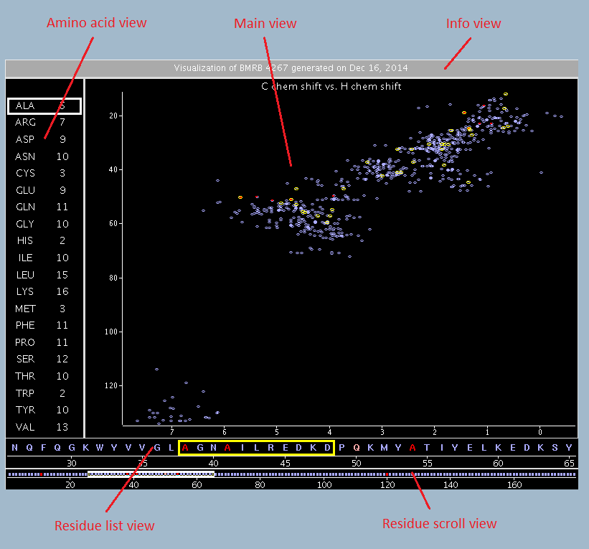

Phases

I see this feature being implemented in two phases, as follows:
- Phase 1: Menus allowing selection of a single item.
- Phase 2: Menus allowing selection of multiple, discontinuous items.
Phase 2 will be more work to implement (see below).

Implementation

Note: Views displayed as menus would obviously have to have the actual text items, as opposed to an image, sent to the client. But I think that most “selection views” are already using this mode, since text renders better on the client side. (Note: for most views, the server sends an image to the client, and the client just displays the image, rather than the client having the underlying data. The exceptions are the 3D views using JMol, and some text-only views.)

I think that phase 1 can be implemented reasonably easily. On the server end, I think we'll just need to add a flag to views that says, “Display this as a menu in the JavaScreen”. Then the JavaScreen would display the appropriate menu, and a menu selection would be sent back to the server as a “cursor move” command (which already exists). (Hmm – it may be that this will have to be changed a bit to deal with the case of a symbol being smaller than a pixel in the way the server interprets it. But I think we can avoid changes by having all but one symbol outside of the visual filter, and allowing the cursor to move to part of the view that are outside the visual filter.) (Note that the “visual filter” is the DEVise term for the range of the X and Y axes, which filters the data records that are displayed in the view.)

My plan is that visualizations using menus would be (manually) changed so that the “menu-ized” selection views would be shrunk to a small size, and then the menu (in the JavaScreen client) would be displayed in the location of the view. (The “menu-ized” views would be too small to be useful in non-menu form, but that shouldn't be an issue because users will never see that form. During session creation, I think the visualization can be successfully manipulated using hidden views that are not shown in the JavaScreen.)

For example, the coordinate visualization would look roughly like the following (with “Entity assembly” and “Data set” being menu buttons, of course):
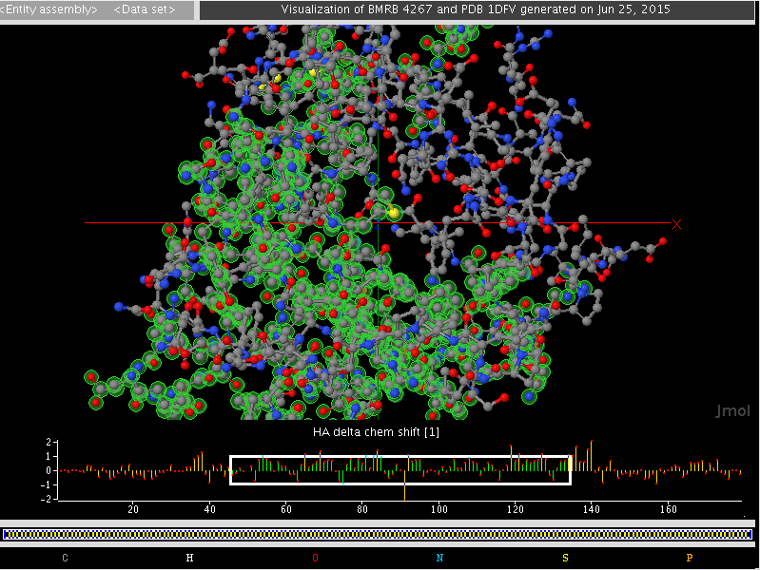
Phase 2 will require more changes to the server, because we can't implement it using the current cursor selection paradigm. My thought is that we'd have to implement a new selection mechanism to determine which records are displayed in a view, where we have the capability of explicitly listing the records to be displayed (probably by DEVise RecordID). When the user selects a set of items in the menu, the JavaScreen client would send that list back to the server. (My current thought is that the server would send the RecordIDs along with the strings, so that the client would be able to send back a list of the RecordIDs of the relevant items.)

(I obviously don't have all of the details of phase 2 fleshed out yet. But I think it makes sense to go ahead and implement phase 1 first, and then plan the details of phase 2 once phase 1 is working.)

