DEVise JavaScreen Visualizations with User Data
2015-08-03

Introduction/motivation

We discussed the possibility of creating visualizations that would have mostly pre-defined data, but in which the user could also add a few records of data that would then become part of the visualization. An example (with fake data) is shown below. The main view is a graph of hydrophobicity vs. molecular weight for each entry in the BMRB database (blue), plus the user's data (red). The idea is that the user could discover entries that have somewhat similar characteristics to the protein they are studying, and then find out information (such as spectrometer frequency, for example) to aid in designing their own experiments.

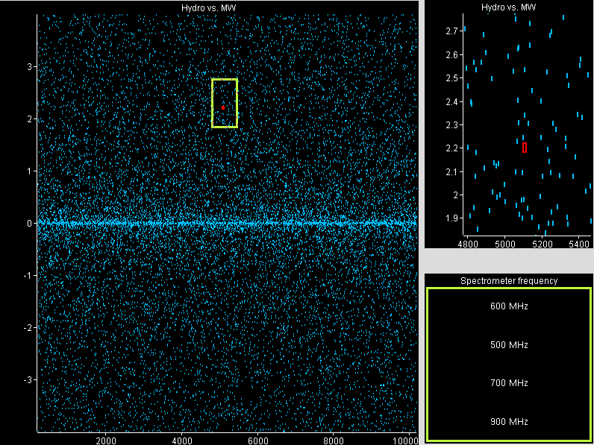

Issues
I see several issues that need to be addressed:
- The JavaScreen GUI and commands for getting data from the user and sending it to the server.
- The incorporation of the user's data into the visualization once it's been uploaded.
- Avoiding collisions if multiple users are simultaneously using the same visualization with user-supplied data.
- Allowing the user to save the visualization, including the user-supplied data.

For item 1, there are several sub-issues, such as:
- Will we allow multiple records?
- Can the user edit their data once they've entered it?

My thought is that the answer to both of these questions should be “yes”. I think we can do this by just bringing up a simple text editor, and transmitting whatever the user enters. Line separators in the text would become record separators, just as in the case of most DEVise text data.

If we allow the user to edit their data once they've entered it, we will need commands to both send the data to the server, and get the data from the server. This should be quite a simple extension to the existing JavaScreen command language, since we already have the capability to send data files from the server to the client.

A final question is whether the data-entry GUI should be within or without the JavaScreen. Entering the data and creating the visualization outside of the JavaScreen might be slightly easier to implement, but I think it will be less flexible and less intuitive for the user, so I would prefer to have the data-entry GUI contained within the JavaScreen. I think one advantage of this is that the user will be able to open the visualization, get an overall sense of the data, and then enter their data and see it immediately appear in the visualization.

For item 2, the main question is whether the user's data should be appended to an existing data file, or contained in its own data file. I think that the user's data should be in its own file. This will be easier to deal with in terms of creating and editing the data, and also in terms of setting up the visualization to distinguish between the user's data and the predefined data. I think that having the user's data in its own file will also be simpler for avoiding data collisions (item 3).

Having the user's data in a separate file means that we will have to use DEVise piles (multiple views occupying the same area) to display it in conjunction with the predefined data – this should not be a problem, as we already make extensive use of piles.

For item 3, we will obviously have to have unique data files for the user-supplied data for each instance of the given visualization. I see two basic options for this:
- All instances of a given visualization use the same session file, but define a unique data file name “on the fly” (in memory).
- When the user views the visualization, we create a unique session file that defines a unique data file.

I think that alternative #1 is better, since we won't have to open a new session file on the fly, and either way we have to have code that defines the unique data source/data file.

Either way the view(s) containing the user-supplied data would have to be flagged in the DEVise session file, so that the unique data source definitions would be created. My plan is that, when DEVise opens a session file set up for user-supplied data, it will (at session open time) create unique data source definitions for the relevant views, and create empty data files corresponding to those data source definitions. Then, when the user uploads data, the data will be saved to the appropriate file and the view will be updated.

I think that item 4 (saving the visualization and data) will be important – users will not want to have to re-enter the same data multiple times. A design for saving visualization state has already been proposed in another document. In order for the state-saving feature to work correctly with user-supplied data, the second phase (saving data and schema files) would have to be implemented.

Also, I think it would be a good idea to automatically do a save whenever the user supplies a data set.

Implementation phases
- Implement the unique data source definitions on session file open.
- Implement the GUI and commands to send/receive the data.
- Implement phases 1 and 2 of the state-saving feature (if not implemented already). (Phase 1 alone won't do us any good for user-supplied data.)

Note: I am inclined to implement the state-saving first because I think it adds a lot of value in and of itself, aside from contributing to visualizing user-supplied data.

