RBMRB

Kumaran Baskaran

July 29, 2016

# RBMRB

RBMRB is a library to fetch chemical shift data directly from [BMRB](http://bmrb.wisc.edu/) into R environment as a data frame in R. This facilitates access to BMRB data for statistical analysis and data visualization. It is using the [BMRB-API](https://github.com/uwbmrb/BMRB-API) in the back end to fetch the data from BMRB database.

## Installation

### Requirements

RBMRB library is developed and tested in R version 3.3. It requires the following R packages

**data.table** to import data from BMRB web server **httr** to format the imported data into a data frame in R. **rjson** to deal with BMRB-API **ggplot2** to simulate spectra **plotly** for interactive graphics in simulated spectra

Users should ensure the proper installtion of above packages, before proceeding to RMBRM insallation.

Here is the instruction to install those packages. Open your R and use the following command

Once the necessary packages has been installed, the source file can be downloaded from GitHub. Source package can be downloaded from this [link](https://github.com/uwbmrb/RBMRB/raw/master/RBMRB_1.0.tar.gz)

After downloading use the following command to install RBMRB

install.packages("~/Downloads/RBMRB_1.0.tar.gz",repos=NULL,type="source")

Note: provide the correct path to the downloaded file.

## Usage

RBMRB can be used in a similar way like any other library in R.

library(RBMRB)

To fetch chemical shift table of a specific entry

df<-fetch_entry_chemical_shifts(15060)

Imported data frame contains following columns

colnames(df)

## [1] "ID" "Assembly_atom_ID"   
## [3] "Entity_assembly_ID" "Entity_ID"   
## [5] "Comp_index_ID" "Seq_ID"   
## [7] "Comp_ID" "Atom_ID"   
## [9] "Atom_type" "Atom_isotope_number"   
## [11] "Val" "Val_err"   
## [13] "Assign_fig_of_merit" "Ambiguity_code"   
## [15] "Occupancy" "Resonance_ID"   
## [17] "Auth_entity_assembly_ID" "Auth_asym_ID"   
## [19] "Auth_seq_ID" "Auth_comp_ID"   
## [21] "Auth_atom_ID" "Details"   
## [23] "Entry_ID" "Assigned_chem_shift_list_ID"

Its also possible to load multiple entries as a single data frame

df<-fetch_entry_chemical_shifts(c(17074,17076,17077))

These data frames can be reformatted using the function **convert_cs_to_n15hsqc** to simulate HSQC spectrum from the data frame.

hsqc<-convert_cs_to_n15hsqc(df)

Now user can use his own plotting function to visualize HSQC spectrum for example

library(ggplot2)  
ggplot(hsqc)+  
 geom_point(aes(H,N,color=as.character(Entry_ID)))+  
 scale_x_reverse()+scale_y_reverse()+theme(legend.title=element_blank())

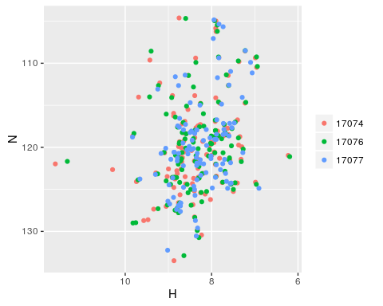

The entire chemical shift for a given atom can be downloaded usign the following command

df_cb2<-fetch_atom_chemical_shifts('CB2')

Once it is downloaded, then you have full chemical shift list of a given atom from all entries from the macromolecules databse.

colnames(df_cb2)

## [1] "Entry_ID" "Entity_ID"   
## [3] "Comp_index_ID" "Comp_ID"   
## [5] "Atom_ID" "Atom_type"   
## [7] "Val" "Val_err"   
## [9] "Ambiguity_code" "Assigned_chem_shift_list_ID"

Similarly chemical shift list from metabolites database can also be fetched usign the same command

df_c1<-fetch_atom_chemical_shifts('C1',db="metabolomics")

# Data Visualization

RBMRB library has a function to simulate 1H-15N HSQC spectrum directly from BMRB database.

## HSQC Spectra

spec1<-simulate_n15hsqc(c(17074,17076,17077))  
spec1

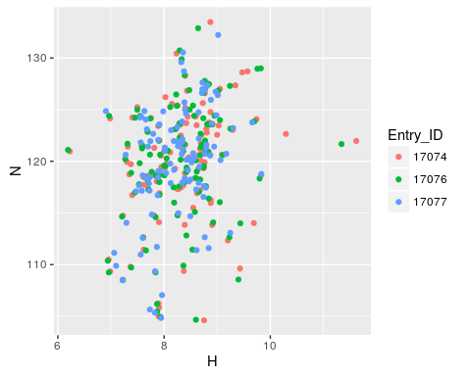

spec2<-simulate_n15hsqc(c(17074,17076,17077),type='line')  
spec2

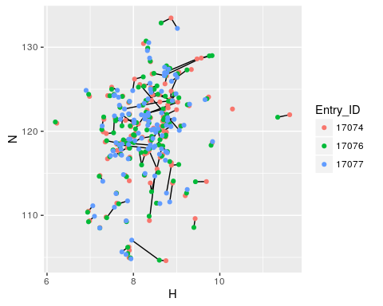

An interactive plot can also be created if the package **plotly** has been installed properly.

spec3<-simulate_n15hsqc(c(17074,17076,17077),type='line',interactive = T)  
spec3

Tool tip will show the dtails about the peak when you mouse over and can also be zoomed using mouse.