Bryan Santini

2/23/2022

CMSC 405 Spring

|  |  |  |
| --- | --- | --- |
| **Test #** | **Expected Output** | **Pass?** |
| 1. Does it run? | Provides a unique scene with 6 shapes. | Yes. |
| 1. Lighting | Provides different lighting effects. Radio buttons turn on lights. | Yes. There are three different colored lights in three different positions that can be toggled on via radio buttons. |
| 1. Sliders | Functional slider for the light intensity and another slider for the camera Z position. | Yes. |

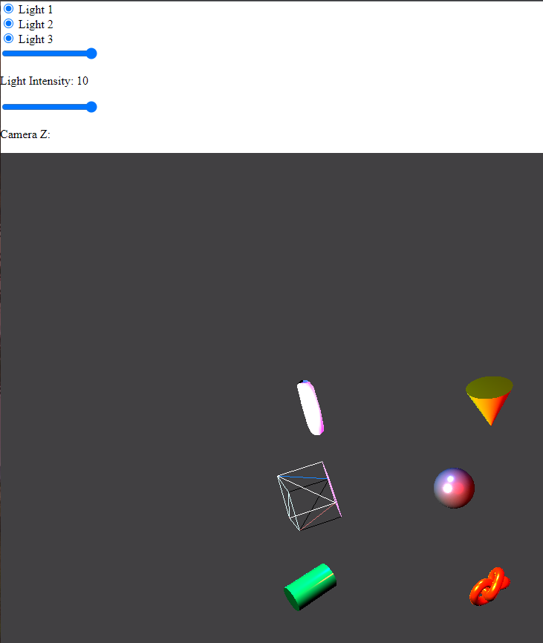**Test 1 Run:**

**Test 2 Lights:**

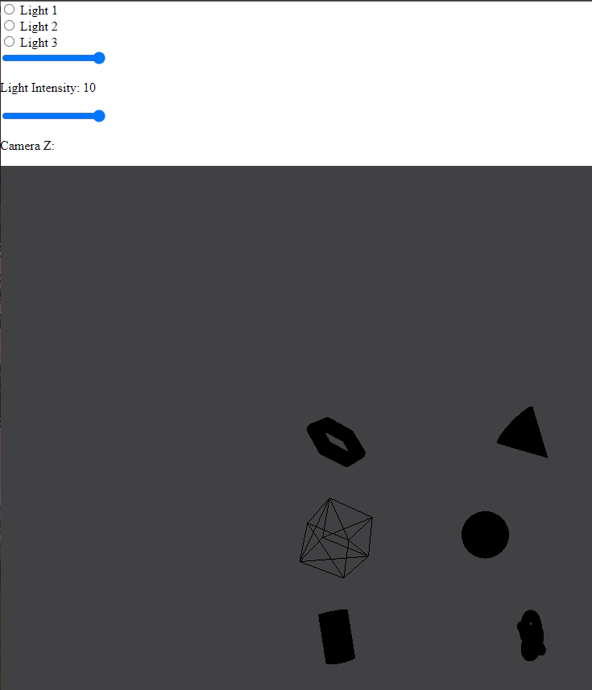

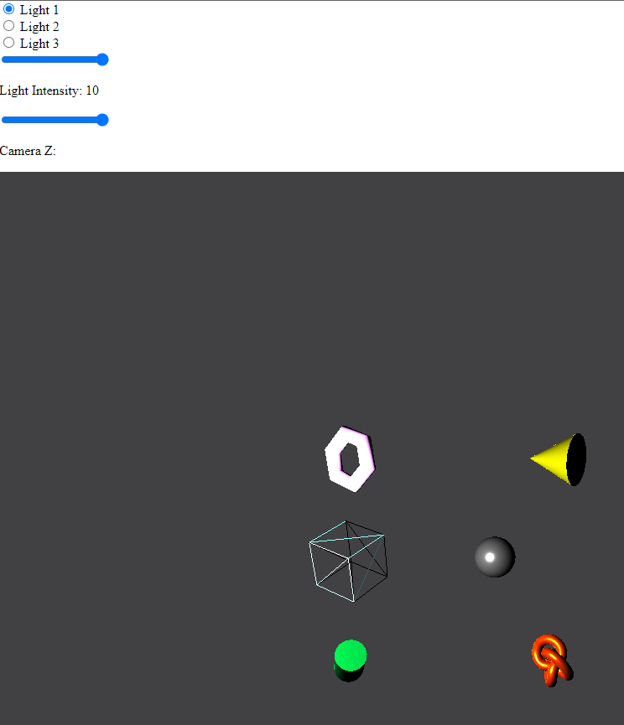

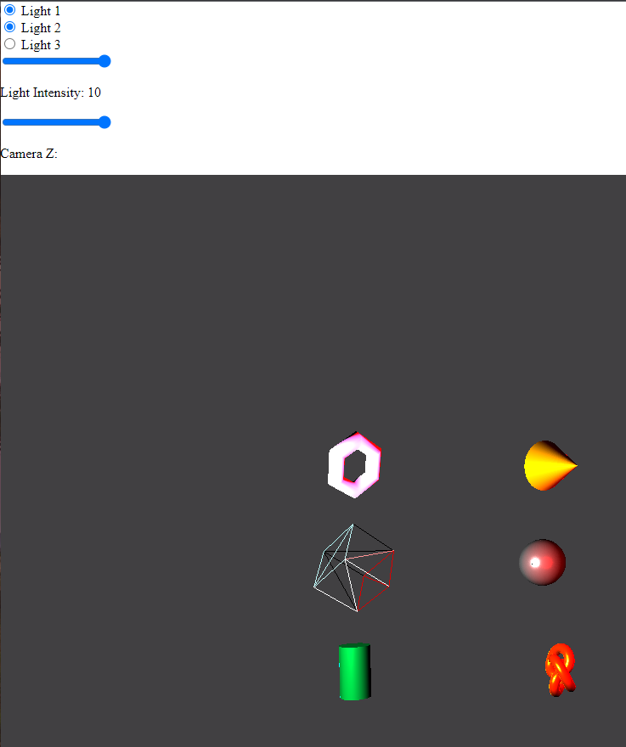

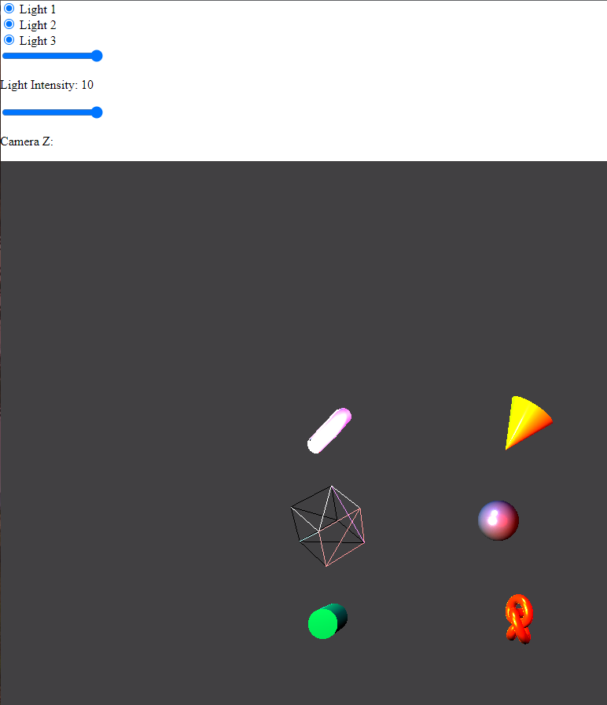

**Test 3 Sliders:**

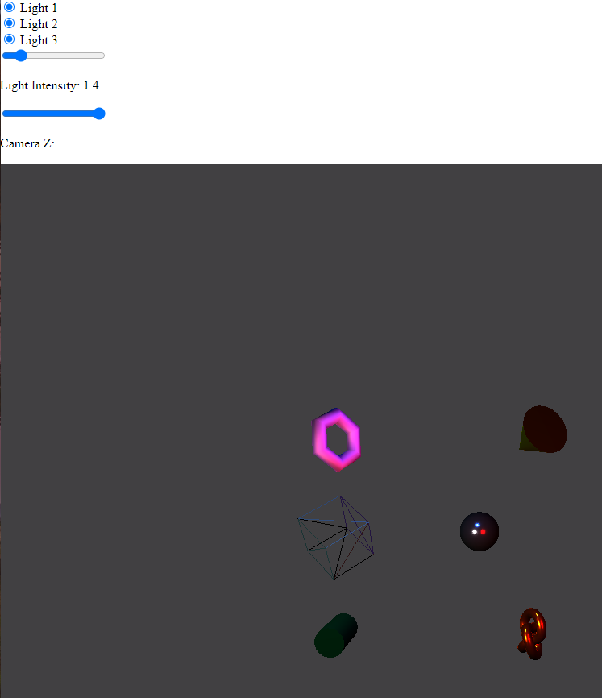

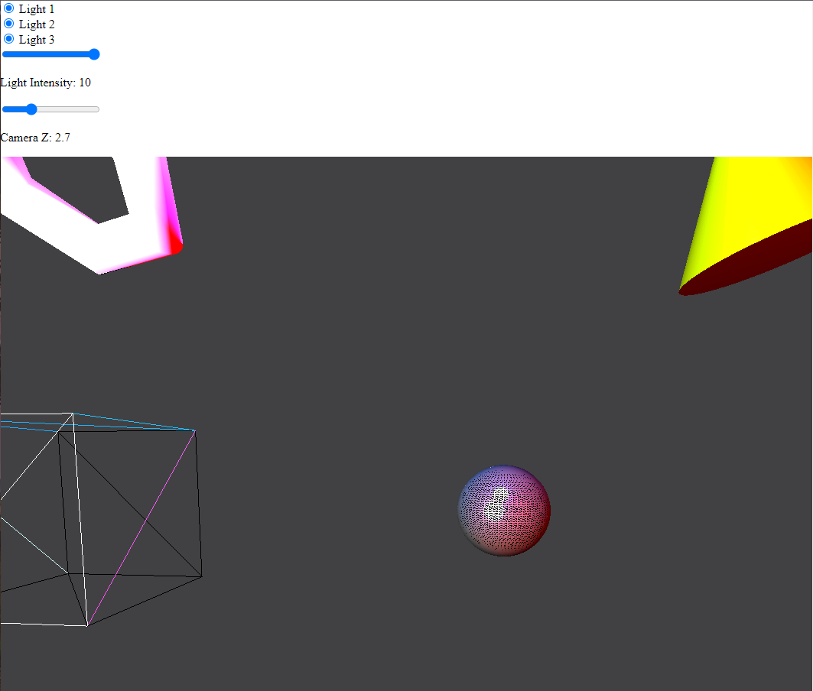

**Lessons learned:**

In my opinion, this was the most fun and intuitive project for this class so far. Learning ThreeJS was much easier than learning JOGL especially when it comes to setting up the environment. I haven’t worked much with web development so my HTML and Javascript isn’t of the highest quality, but I was still able to manage a 3D scene. The most difficult part of this project for me was adding an interface that a user can interact with, but this was due to me not being able to get external libraries to work. The interface was made with regular HTML and JS through DOM manipulation.