Bellabeat

Breanna Sayre

08/07/2022

## Phase 1: Ask

#### The Business Task:

In order to unlock new growth opportunities for their business, Bellabeat has asked me to analyze their smart device data to see how customers utilize their devices, so they can use this information to guide a new marketing strategy.

## Phase 2: Prepare

#### FitBit Fitness Tracker Data

The company provided me with the FitBit Fitness Tracker Data made available by Mobius and found on Kaggle under public domain found here: [link](https://www.kaggle.com/datasets/arashnic/fitbit).

The data was collected from thirty fitbit users between April and May of 2016. To meet the business task, I plan on utilizng the data from the daily steps, caloric intake, weight log, and sleep logs spreadsheets.

## Phase 3: Process

#### Excel then R

Because the datasets aren’t too large, I cleaned the data with Excel. For each of the four spreadsheets:

* The date columns were changed to the format MM/DD/YYYY, and their column name was changed to “Date” to make it more consistent.
* Duplicate rows were removed to prevent errors during analysis.

## Phase 4: Analyze

#### Running some explatory calculations on the data

First, I need to install the packages needed to analyze the data.

install.packages("tidyverse")  
library(tidyverse)  
library(dplyr)  
library(ggplot2)

Then, I’m going to create dataframes for all the datasets.

calories <- read.csv("capstone_calories.csv")  
steps <- read.csv("capstone_daily_steps.csv")  
sleep <- read.csv("capstone_sleep.csv")  
weight <- read.csv("capstone_weight_log.csv")

Let’s see how many participants we have for each data set.

n_distinct(calories$Id)

## [1] 33

n_distinct(steps$Id)

## [1] 33

n_distinct(sleep$Id)

## [1] 26

n_distinct(weight$Id)

## [1] 9

So there are 33 participants for both the calories and steps dataset, but there are only 26 for the sleep log data, and 8 participants included in the weight log data. The decrease in participants for the latter two datasets may have to do with having to input this data manually.

Let”s create a tibble to look at the average, maximumum, and minimum values for each participant in the datasets while filtering out zero values.

The mean, maximum, and minimum calories burned daily by each participant.

calories %>%  
 filter(Calories != 0) %>%  
 group_by(Id) %>%  
 summarize(mean(Calories),max(Calories), min(Calories))

## # A tibble: 33 × 4  
## Id `mean(Calories)` `max(Calories)` `min(Calories)`  
## <dbl> <dbl> <int> <int>  
## 1 1503960366 1877. 2159 1728  
## 2 1624580081 1483. 2690 1002  
## 3 1644430081 2811. 3846 1276  
## 4 1844505072 1573. 2130 665  
## 5 1927972279 2173. 2638 1383  
## 6 2022484408 2510. 3158 1848  
## 7 2026352035 1541. 1926 1141  
## 8 2320127002 1724. 2124 1125  
## 9 2347167796 2043. 2670 403  
## 10 2873212765 1917. 2241 1431  
## # … with 23 more rows  
## # ℹ Use `print(n = ...)` to see more rows

The mean, maximum, and minimum daily steps of each participant.

steps %>%  
 filter(StepTotal != 0) %>%  
 group_by(Id) %>%  
 summarize(mean(StepTotal),max(StepTotal), min(StepTotal))

## # A tibble: 33 × 4  
## Id `mean(StepTotal)` `max(StepTotal)` `min(StepTotal)`  
## <dbl> <dbl> <int> <int>  
## 1 1503960366 12521. 18134 9705  
## 2 1624580081 5744. 36019 1510  
## 3 1644430081 7283. 18213 1223  
## 4 1844505072 3809. 8054 4  
## 5 1927972279 1671. 3790 149  
## 6 2022484408 11371. 18387 3292  
## 7 2026352035 5567. 12357 254  
## 8 2320127002 4717. 10725 772  
## 9 2347167796 9520. 22244 42  
## 10 2873212765 7556. 9685 2524  
## # … with 23 more rows  
## # ℹ Use `print(n = ...)` to see more rows

There are a lot of zeros in this dataset that I filtered out, so the true mean of each participant’s steps could be found. These zeros likely mean that the person took off their device and didn’t wear it that day.

The mean, maximum, and minimum amount of daily sleep for each participant.

sleep %>%  
 filter(TotalMinutesAsleep != 0) %>%  
 group_by(Id) %>%  
 summarize(mean(TotalMinutesAsleep),max(TotalMinutesAsleep), min(TotalMinutesAsleep))

## # A tibble: 24 × 4  
## Id `mean(TotalMinutesAsleep)` `max(TotalMinutesAsleep)` min(TotalMi…¹  
## <dbl> <dbl> <int> <int>  
## 1 1503960366 360. 700 245  
## 2 1644430081 294 796 119  
## 3 1844505072 652 722 590  
## 4 1927972279 417 750 166  
## 5 2026352035 506. 573 357  
## 6 2320127002 61 61 61  
## 7 2347167796 447. 556 374  
## 8 3977333714 294. 424 152  
## 9 4020332650 349. 501 77  
## 10 4319703577 477. 692 59  
## # … with 14 more rows, and abbreviated variable name ¹​`min(TotalMinutesAsleep)`  
## # ℹ Use `print(n = ...)` to see more rows

The mean, maximum, and minimum amount of daily weight for each participant.

weight %>%  
 drop_na(WeightPounds) %>%  
 group_by(Id) %>%  
 summarize(mean(WeightPounds),max(WeightPounds), min(WeightPounds))

## # A tibble: 8 × 4  
## Id `mean(WeightPounds)` `max(WeightPounds)` `min(WeightPounds)`  
## <dbl> <dbl> <dbl> <dbl>  
## 1 1503960366 116. 116. 116.  
## 2 1927972279 294. 294. 294.  
## 3 2873212765 126. 126. 125.  
## 4 4319703577 160. 160. 159.  
## 5 4558609924 154. 155. 152.  
## 6 5577150313 200. 200. 200.  
## 7 6962181067 136. 138. 134.  
## 8 8877689391 188. 189. 185.

As can be seen, each participant’s weight stayed pretty consistent; however, these summaries don’t show the full picture. Participant 1503960366 only entered their weight twice, and only a day had passed, so their weight obviously would remain the same. In addition, participants 1927972279 and 5577150313 only entered their weight once. So their data was consistent only because they didn’t enter their weight over any time. Other participants either waited a few weeks to enter their weight in again, or they tracked it semi-regularly across multiple days. With this dataset, that really only leaves 5 participants with analyzable data, so I decided against analyzing this data to prevent creating false conclusions.

## Phase 5: Share

#### Now let’s get familiar with our data and discover new relationships between variables.

How many minutes do people spend in bed compared to how much they actually sleep?

ggplot(data=sleep)+geom_smooth(mapping=aes(x=TotalTimeInBed, y=TotalMinutesAsleep))+geom_point(mapping=aes(x=TotalTimeInBed, y=TotalMinutesAsleep, color=Id))+labs(title="Time in Bed vs Total Minutes Asleep")

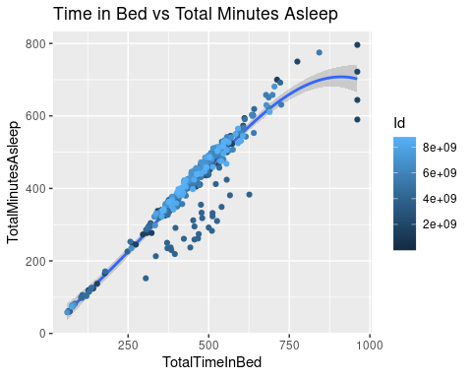

As assumed, there is a strong positive correlation between the amount of time people spent in bed compared to the amount of time people were actually asleep, but there are are some points were it’s obvious people were either having a difficult time falling asleep, or they may have been just laying down in bed on their phones or reading a book.

In addition, it seems the same people tend to have a similar sleeping pattern each night, but to see it more clearly, let’s create more scatter plots.

ggplot(data=sleep)+geom_point(mapping=aes(x=TotalTimeInBed, y=TotalMinutesAsleep, color=Id))+facet_wrap(~Id)+labs(title="Total Minutes Asleep vs Time in Bed")

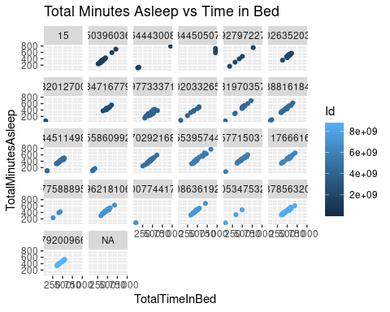

When looking closer at the data, it seems that some people have a more regular time in bed to sleeping time pattern than others.

Now I want to merge my data into larger tables in order to make calculations across the data.

merge_1 <- merge(calories, steps, by.Id = c("Date"))  
merge_2 <- merge(sleep, steps, by.Id = c("Date"))  
merge_3 <- merge(calories, sleep, by.Id = c("Date"))

Let’s see the correlation between the amount of sleep the participants get per night and if that affects their daily steps.

ggplot(data=merge_2)+geom_point(mapping=aes(x=TotalMinutesAsleep, y=StepTotal, color=Id))+labs(title="Daily Steps vs Total Minutes Asleep")

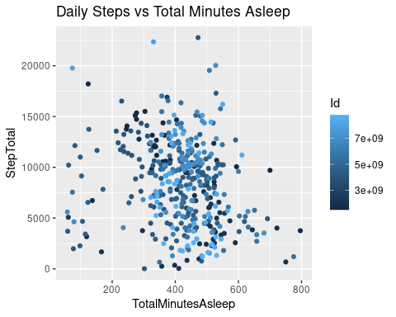

One would think that if a person received less sleep, they’d be more inclined to be less active, which would cause a decrease in daily steps. However, based on the graph, there is no correlation between how much sleep a person gets compared to how many steps they take in a day.

Now let’s see if the amount of sleep a person gets a night has an affect on the number of calories they burn in a day.

ggplot(data=merge_3)+geom_smooth(mapping=aes(x=TotalMinutesAsleep, y=Calories)) +geom_jitter(mapping=aes(x=TotalMinutesAsleep, y=Calories, color=Id))+labs(title="Calories vs Amount of Sleep")

## `geom_smooth()` using method = 'loess' and formula 'y ~ x'

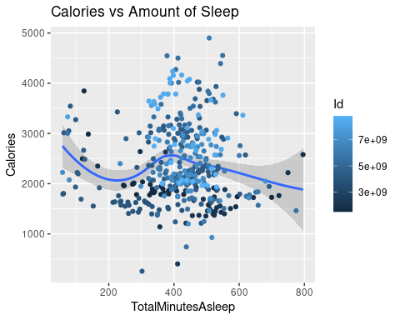

There is no correlation for a person’s sleep changing the amount of calories they burn in a day, but it does seem like those who get between 6 to 9 hours of sleep burn the most calories.

Finally, let’s see the relationship between the number of steps a person took, and the amount of calories they burned.

ggplot(data=merge_1)+geom_smooth(mapping=aes(x=StepTotal, y=Calories))+geom_jitter(mapping=aes(x=StepTotal, y=Calories, color=Id))+labs(title="Calories Burned vs Daily Steps")

## `geom_smooth()` using method = 'loess' and formula 'y ~ x'

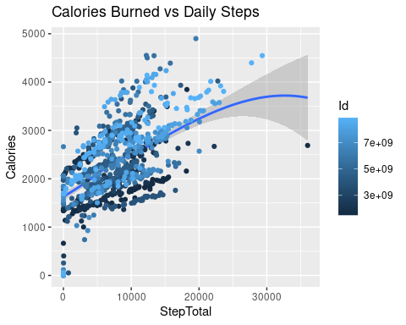

As expected, there is a pretty strong correlation bewteen the number of steps a person takes in a day and the number of calories they burn. Some people probably burn more calories with less steps most likely due to the fact that they’re running or jogging instead of walking. As stated previously, the zeros included in this data most likely show that the person wasn’t wearing their device that day.

## Phase 6: Act

#### My plan for a new marketing strategy.

Overall, there are many ways that people utilize their smart devices. These devices can track heart rate, number of daily steps, and calories burned without the user having to lift a finger. As long as they’re wearing their smart device, this data is automatically collected for them to view. However, as seen in the data, some users took their devices off, and they forgot to put them back on for days at a time.

In addition, there is some data that users can manually enter, such as their weight or sleep. However, these functions seem less popular as fewer people included in this dataset seemed to keep track of this data. This can be due to multiple reasons including they didn’t know it was a function their device was capable of, they didn’t know how to use it, or they just weren’t interested in tracking this information.

Based on these findings, I think that Bellabeat should market their device as lightweight and waterproof. As some participants may have taken it off when showering or swimming without knowing it is protected from water. In addition, marketing should focus on the features you have to manually enter. A sizable number of people in the dataset utilized the feature that kept track of their sleep, so it would be interesting to add a dream journal or mood feature to see how a sleep schedule affects these things, and to see if that increases the number of women who use these features. In order to increase the usage of the weight loss and sleep tracking feature, Bellabeat could add a notification to the device at night or early in the morning, so a person is reminded to input this data for the day.

Also, I think a feature that would be nice to have is a caloric intake tracker. With this feature, you’d input what you ate for the day in your phone, and then you can compare how many calories were taken in to how many calories you burned based on activity and steps! Given their market is women’s health, there should also be an option to track your menstrual cycle with their device, so women can always be prepared for that time of the month.