Humanities majors yikes

Ben Schmidt

August 8, 2018

People have been proclaiming the imminent extinction of the humanities for decades. [A bestselling volume in 1964](https://catalog.hathitrust.org/Record/001450049) warned that a science-focused world left no room for humane pursuits, even as baby boomers began to flood the English and history departments of new universities. Allan Bloom warned about academics putting liberal ideology before scholarship in 1987; humanities degrees quickly rose. While coverage of individual academic disciplines like musicology, history, or comparative literature often deals with the substance of scholarship, talk of the humanities in general *always* seems to focus on their imminent extinction. In 2010, Wayne Bivens-Tatum provided a [useful walk through the first 50 years of the humanities crisis, until about 1980](https://blogs.princeton.edu/librarian/2010/11/the_crisis_in_the_humanities/).

Because of this long history, I’ve always been skeptical of claims that the humanities are in retreat.

But something different has been happening with the humanities since the 2008 financial crisis. Five years ago, I argued that the humanities were [still near long-term norms in their number of majors.](http://www.chronicle.com/blognetwork/edgeofthewest/2013/06/10/the-humanities-crisis/) But since then, I’ve been watching the [numbers from the Department of Education](https://nces.ed.gov/ipeds/), and every year things look worse. Almost every humanities field has seen a rapid drop in majors: History is down about 45 percent from its 2007 peak, while the number of English majors has fallen by nearly half since the late 1990s. Student majors have dropped, rapidly, at a variety of types of institutions. Declines have hit almost every field in the humanities (with one interesting exception) and related social sciences, they have not stabilized with the economic recovery, and they appear to reflect a new set of student priorities, which are being formed even before they see the inside of a college classroom.

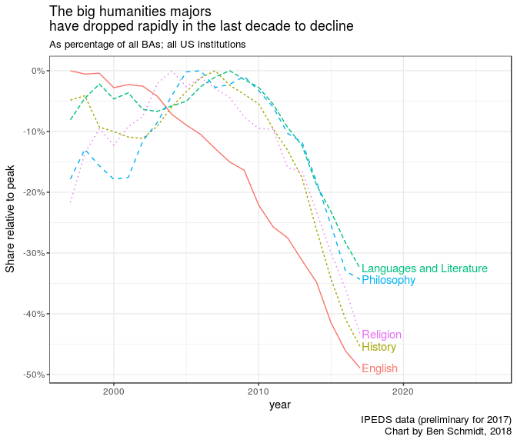

One thing I learned earning a history degree is that people usually announce a “crisis” so they can trot out solutions they came up with years earlier. I don’t have any right now. But the drop in majors since 2008 has been so intense that I now think there is, in the only meaningful sense of the word, a crisis. We are in a momentum of rapid change. The decisions we make now will be especially important and will have continuing ramifications for what American universities look like for years to come.

Right now, the biggest impediment to thinking about the future of the humanities is that, thanks to this entrenched narrative of decline—because we’ve been crying wolf for so long—we already think we know what’s going on. Because people care about the humanities and the university, a familiar set of suspects—skyrocketing student debt, postmodern relativism, disappearing jobs—are once again being trotted out. But the data suggest something different. In the wake of the 2008 economic meltdown, American students seem to have adopted new views about what they *should* be studying, in an ill-informed effort to guarantee success after graduation. And something essential is being lost in the process.

### The two crises of the humanities

The most reliable indicators about the humanities in American colleges are reports that all colleges and universities make to the Department of Education. These run back to about 1950. Since then, the humanities have seen three eras. The first ran from 1955 to 1985. As normal schools around the country, set up to educate teachers, transformed into comprehensive universities, men and women alike poured into English and History majors; then, when the economy soured and the growth of higher education slowed in the 1970s, the boom turned to bust, and humanities majors collapsed nationwide. The second phase began around 1985 and ran to 2008. This was a long period of stability; majors in the four largest (and easiest to track over the long term) humanities majors held steady, with modest fluctuations. Since 2008, the crisis of the humanities has resumed, with percentage drops that are beginning to approach those of 40 years ago. Unlike the drops of the 70s, though, there’s no pre-existing bubble to deflate. Nor is there a compelling demographic explanation. Five years ago, it was reasonable to look at these numbers and conclude [the long-term story is all about gender](https://www.theatlantic.com/education/archive/2013/12/the-real-reason-the-humanities-are-in-crisis/282441/). Men majored in humanities fields at the same rate in the 1990s as they had in the 1950s, while women, seeing more options in the workforce, increasingly turned to majors in business fields. But the drops since the financial crisis can be seen among men and women, across racial groups, and in a wide variety of universities.

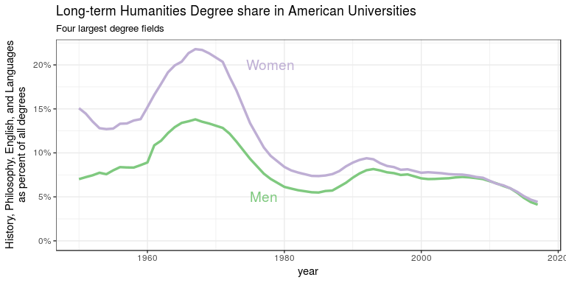

College degrees are a somewhat problematic metric: I’d rather see information about the type and level of courses that undergraduates take. This kind of data is hard to come by except at an anecdotal level. But where large scale enrollment numbers do exist, they are not especially reassuring: The American Historical Association surveyed history departments and found [course enrollments dropping by 7.7 from 2014 to 2017](https://www.historians.org/publications-and-directories/perspectives-on-history/february-2018/enrollment-declines-continue-aha-survey-again-shows-fewer-undergraduates-in-history-courses), with upper-level courses seeing greater declines than introductory ones. This is bad, but not as catastrophic as the numbers of history majors, which fell by 20 percent in the same period. That suggests that either the declines are beginning to stabilize, or that students are more willing to spend elective credits on humanities courses than to major in them.

There’s another way that calculating the humanities’ share of all four-year degrees is a bit strange. American higher education continuously expands to include new populations; perhaps the democratization of access has diluted the prominence of the humanities, even without eroding the absolute number of degrees . And the humanities are multiplying. There weren’t many Chicano Studies majors in 1968; perhaps students are simply shifting from traditional humanistic fields of study to new ones.

But even accounting for these factors, the humanities are in retreat. Looking at degrees as a share of the entire American 23-year-old population shows the humanities faring better at the turn of the century. But even after adding a raft of fields like ethnic and gender studies, musicology, art history, and religion, a lower share of newly-graduated Americans earn humanities degrees today than did so in 1970 or 1990. Even the absolute *number* is lower than in 1970: The big four humanities fields—philosophy, history, languages, and English—are at risk of dipping below 100,000 degrees for the first time in almost 20 years. (If you include mass communication and media studies, which mixes social science, humanities, and professional education together, things look a bit better, but increases in communication majors since 2008 nationwide can only offset a single year’s loss of English BAs.)

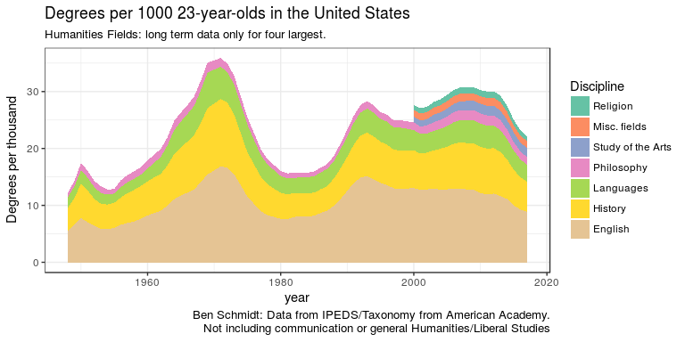

Perhaps most alarming is that the recent decline has hit liberal arts colleges and more elite universities–which avoided the worst of the plunge in the 70s–quite hard. While writers often worry too much about the most prestigious universities, they have always been one of the only places where the humanities were central to the mission of higher education. Elite liberal arts colleges have historically been about evenly divided between the sciences, social sciences, and humanities. But in the last decade, their humanities majors have fallen from a third to well under a quarter of all degrees. Elite research universities, too, have seen a drop to about 70 percent of their pre-crisis numbers. The rare schools *not* to have a seen a drop in humanities enrollments tend to be regional comprehensive universities that never had much of a specialty in the humanities to begin with.

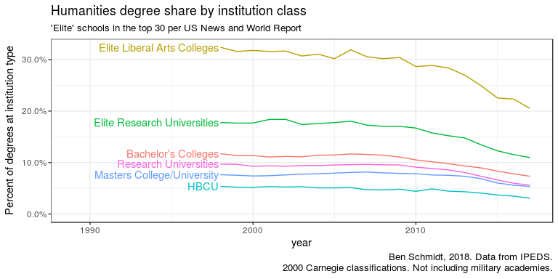

At these elite colleges, essentially every field of the humanities has fallen in share—even fields like classics and area studies, which grew through the 2000s. The only bright spot is linguistics, the rare field that directly bridges the humanities and the sciences.

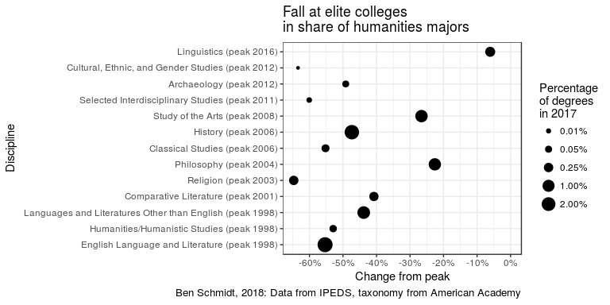

The timing and placement of the drops at a variety of institutions foils many common explanations for why the humanities are falling. Do you think students are put off by liberal pieties in the classroom? It’s difficult to square that argument with the two decades of stability that followed the beginning of the culture wars in the late 1980s; nor has postmodernism completely swept the field at schools like Brigham Young’s main campus (down 20 percent) or Bob Jones University (down 50 percent). Do you blame student loans and the cost of college? Then why has the decline been nearly as strong at schools where student debt is almost non-existent, like Princeton University (down 28 percent) and the College of the Ozarks (down 44 percent)?

One common explanation *does* line up with the data fairly well, at least in part: that students fled the humanities after the financial crisis because they became more fearful of the job market. The chart below shows, in individual panels, a few dozen of the most common majors. The fields that have risen in the past decade are almost entirely STEM majors, including nursing, engineering, computer science, and biology. Quantitative social sciences like economics and psychology have held steady, while fields in closer proximity to the humanities like political science, sociology, and anthropology have shown declines, especially since 2011.

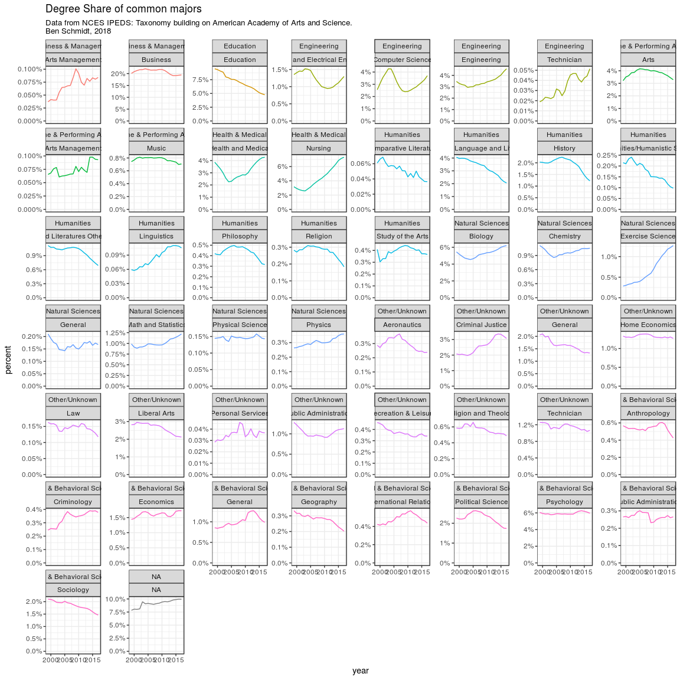

This may seem like a roundabout way to present the conventional wisdom that STEM majors are the only safe bet in the modern economy, and the humanities are dying out because kids no longer have the luxury of a useless major. But there’s an extremely important caveat: Students aren’t fleeing degrees with poor job prospects. They’re fleeing humanities and related fields, specifically, because they *think* they have poor job prospects. If the whole story were a market response to student debt and the great recession, students would have [read the 2011 census report naming communication and psychology among the lowest-earning degrees](https://www.census.gov/newsroom/releases/archives/education/cb12-196.html) and fled from them. Or they would have noticed that biology majors make less than the average college graduate, and favored the physical sciences.

For almost a decade, the census has been regularly asking a random sample of Americans about their college major. This gives us far rich information about career outcomes than the lists of starting salaries that occasionally circulate. Some commonly-held wisdom is true–engineers make more money than any other field—but the results are most surprising for how trivial the differences between most majors turn out to be. Humanities majors [have the highest medical school acceptance rates of any field](https://www.aamc.org/download/321496/data/factstablea17.pdf), show [lower rates of long-term underemployment that most fields](https://www.myajc.com/blog/get-schooled/opinion-you-can-make-more-than-lattes-with-that-humanities-degree/p63EL6SfM2o6DLd6exVnRM/), and [humanities majors under the age of 35 are](https://www.humanitiesindicators.org/content/indicatordoc.aspx?i=10919" \l "fig10922) *less* likely to be unemployed than life-science or social-science majors.

Still, the [balance of evidence](https://nces.ed.gov/programs/coe/pdf/coe_sbc.pdf) suggests that humanities majors are probably slightly worse off than average—maybe as much as one more point of unemployment and $5,000 to $10,000 a year in income. They aren’t alone, of course: while finance and computer science majors make more, biology and business majors make about the same, and psychology majors usually come out worse. Other factors, like gender, matter more: [Men with terminal humanities BAs make more money than women in any field but engineering.](https://www.humanitiesindicators.org/content/indicatordoc.aspx?i=64) Being the *type of person* inclined to view a college major in terms of return on investment will probably make a much bigger difference in your earnings than the actual major does.

In other areas of the economy, we view these kinds of differences with equanimity. The difference between humanities majors and science majors, in median income and unemployment, is roughly the same as the difference between residents of Virginia and North Carolina. If someone told to me not to move to Charlotte because no one there makes a living, I would never take them seriously. But worried relatives express the same concerns about classics majors every day, with no sounder evidence.

It would be better if students knew the actual data about majors—or, at least, if there were some psychology-major jokes to go along with the ones about art historians. But the idea that students should choose majors by trying to guess what the job market will reward several years later is often nuts. There are some consistent trends; nursing remains a solid bet for the risk-averse. Other majors, though, may prove greater gambles. As humanities degrees have fallen at elite schools, degrees in computer science have climbed much more quickly than at other schools. In the top 30 universities, according to *U.S. News*, there are now about as many degrees awarded in computer science and electrical engineering as in history, English, languages, philosophy, and area studies put together. Set aside fears about what this will do to cocktail conversation down at the yacht club; how are students supposed to know when the U.S. is precisely three years away from having the right number of Ivy League graduates who can code onto a whiteboard? Computer science degrees have already tumbled once in response to shifts in the job market, after the dot-com crash; I wouldn’t want to promise 18-year-olds today that a computer science degree will make them stand out on the job market in 2022.

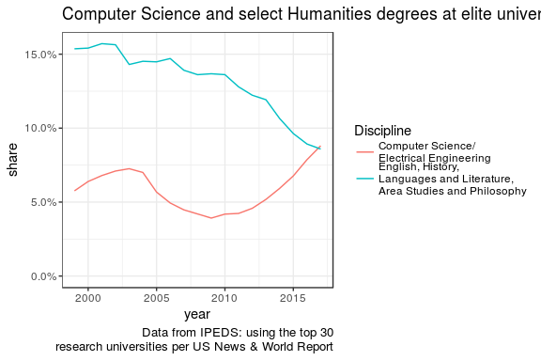

So does the crisis in the humanities actually reflect a shift in what students want to select as a major, or is it just a change in what they think they *should* choose as a major? If students legitimately find computers more interesting than history in the age of Facebook, the fall of the humanities might not be a bad thing. Suppose college tuition was free and every first-year had a guaranteed job lined up for after graduation. This parallel universe does exist at the military service academies—and at West Point, Annapolis, and Colorado Springs, humanities majors are at about the same level as they were in 2008.

There also doesn’t seem to be an extraordinary change in what students say they want to get out of a college education. Decades of studies of college freshman have asked incoming students how important various (and nonexclusive) life goals are to them in the context of their college decisions. The drop in humanities majors in the 1970s, [Dennis Ahlburg and Evan Roberts show in a soon-to-be-published book](https://www.routledge.com/The-Changing-Face-of-Higher-Education-Is-There-an-International-Crisis/Ahlburg/p/book/9781138244832), corresponded to a great inversion. In 1970, seven in 10 students thought it was very important or essential to “develop a meaningful philosophy of life” through education while about four in 10 (and five in 10 men) put a priority on using it to “make more money.” By the mid-’80s, these ratios had flipped. Of all the statistics on the humanities I’ve seen, I find this one the most depressing—for the past 40 years, the percentage of first-year college students who think highly enough of crafting a life philosophy in the course of their studies to muster the energy to fill out a bubble indicating as much has flatlined below half. It’s little wonder that so few major in the liberal arts in the end. But although Alburgh and Roberts find a slight tick down in their time series since 2008 (offsetting a post-2001 rise in students seeking the mysteries of life), the current numbers are safely within the range of the last decades.

A few signs suggest the decline might, eventually, end as quickly as it came on. [There are scattered stories of a return to history classes in the age of Trump](https://qz.com/1000017/donald-trump-saves-college-history/) (although nationwide enrollment numbers don’t yet bear it out). Thanks to an anti-affirmative action lawsuit against Harvard, that school released information on its applicant pool, 10,000 or so students who imperfectly track the students who will end up scattered across liberal arts colleges and universities. It showed that in the class of 2019, the rush out of humanities disciplines may have slowed for the first time in years. And the speed at which humanities majors are dropping has decreased in the last few years, after the freefall between 2011 and 2014.

The humanities, in other words, will almost certainly survive, even if they don’t return to being true peers of the social sciences and sciences in American higher education. To admit the humanities are in crisis doesn’t mean conceding that they are being driven extinct. It means, instead, that their place is diminishing, changing both them and the university as whole. The decisions and rhetoric around the humanities now have especial importance, as journals, libraries, and universities have to make new sets of decisions around what shape the new humanities will take.

What comes next will be different. The humanities of the boom years in the ’60s circled around a tightly constrained common core of English and history. At their best they helped to sustain, recreate, and improve a shared culture that enriched American life; at their worst, they served as a conduit for carefully controlled cultural capital, and ensured that whole classes of people would see that culture as not being for people like them. These fields have not completely abandoned the canon (yes, [colleges still teach Shakespeare](http://doctorcleveland.blogspot.com/2015/04/no-colleges-still-teach-shakespeare.html)), but few would still claim they serve as stewards of American civilization.

While history, English, and the rest have faded, only one set of humanities fields without a foot in the sciences has clearly held its own: the much newer (and smaller) disciplines the statistical agency joins together as ethnic, gender, and cultural studies. (It is possible that media studies has also retained share or grown, but hard to tell from the data.) Relatedly, I’ve only found one large class of schools where humanities enrollments have held steady: historically black colleges and universities. HBCUs are also the only institutional class where a majority of students say they’re dedicated to crafting a philosophy of life.

Even as the command of culture becomes less important to education at elite locations, some humanities may be demonstrating more usefulness than ever to students who seek to better understand culture from outside the dominant perspective. The question is how much space any of the humanities can ultimately take up in a university, when the dominant perspective continues to warn students away.