

SCHOOL OF ADVANCED TECHNOLOGY

ICT - Applications & Programming

Computer Engineering Technology – Computing Science



A21
Model Definitions (RE/Automaton)

Lab Professor / Lab Session:
[Lab Prof : Paulo Sousa / Lab Session: 311]

Team:
[Student Name] - Id: [041121881] / [Student Name] –: [Huijun Bu]
[Student Name] - Id: [041096567] / [Student Name] –: [Kexin Huang]

Language Name [PowerR]

This template is suggested (not mandatory) to answer A11 Specification.

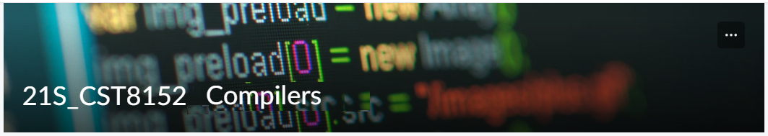

MODEL TASK FOR ASSIGNMENT 2.1 – YOUR LANGUAGE

- Note: This task is part of the Assignment 2 from Compilers Course. Any problem, contact your lab professor.

Task 1: Language Symbols (2.0 marks)

List examples: Define main symbols to be used:
- Special symbols (ex: “{“, “(“, “<=”, etc.)
- Comments
- Variables
- Functions
- Literals (numbers, strings)
- Keywords
- Datatypes

Answer:

Special Symbols:
"{","}","(",")","[","]" ,"$","<", "-","=","+","-", "*","/","^","%","&","|","&","||","=",
"!","=","<",">","<=",">=",":","...","#","@"

Comments:
Single line comments: #......
Multiple line comments: ##........##

Variables:
Use camel case to define a variable.
Using letters(a-z or A-Z),numbers(0-9),period(.),underscore(_) to define a variable name.
Rules:
Cannot start with a number.
Cannot start with an underscore (_).
Case Sensitive.
Example:
L, i, iLike, vecTree, vet_1, v12tj, vet.Interplotation

Function:
Example:
graphPlot <- function(x){
#function body
}

Funtion name(graphPlot): obey the rules of define a variable.
Key word: function
Parameter: x
Symbol: <-, using this symbol to assign the function to a function name.

Literals:
Rules:
For integers: sequence of digits.
For floats: sequence of digits separated by single period.
For String: sequence of chars.
Examples:
Integer: 0,1223,323,56, -12, -3333
Float: 1.2,0.3343242, 5424.42342, -332.347
String: “h”, “hello world”

Key word:
if
else
repeat
while
function
for
in
next
break
continue
readLine
TRUE
FALSE

Data Types:
Int
Numeric
String

Task 2: RE – Regular Expression (3.0 mark)

Lexeme Classes: Define the classes to be used in your regular expression:

Answer:
Classes:
L[0] letters: { a-z & A-Z }
D[1] digit: { 0-9 }
H[2] hashtag: { # }
E[3] Enter:{ \n }
U[4] Underscore: { _ }
P[5] Period: { . }
Q1[6] Single quote: { ‘ }
Q2[7] Double quote: { “ }
O[8] other: { ^[L.D.H.E.U.P.S.Q1.Q2] }
B[9] opening bracket: { ( }
B2[10] closing backside: { ) }
A[11] arrow: { < }
T[12] :{ - }

Define the RE to be used for: variables, literals and keywords:

Answer:
* Comments:
Single Line comments: H(^E)*E
Multi line comments: [H][H](^[H])*[H][H]
* Variables:
L(L|D|U|P)*
* Methods:
L(L|D|U|P)*
* Literals:
- Numbers:
int:D+
numeric: D*PD+
- Strings:
Q1+(^Q1)*Q1
Q2+(^Q2)*Q2
* Keywords:
L+ = { if, else , repeat , while , function , for , in , next , break , continue , readLine , TRUE
, FALSE }

Task 3: TD – Transition Diagram (3.0 marks)

Activity: Starting from the previous lexeme classes and obeying the RE, it is possible to define the automata for your language:
Answer (draw / copy image of the automata):
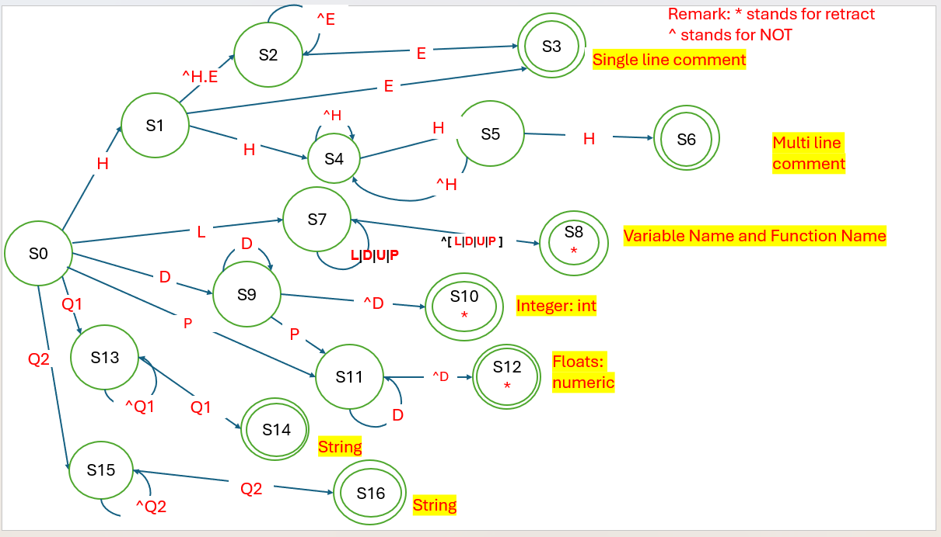

Task 4: TT – Transition Table (2.0 marks)

Activity: Now, it is possible to define the TT for these lexemes:

Answer (Transition Table):
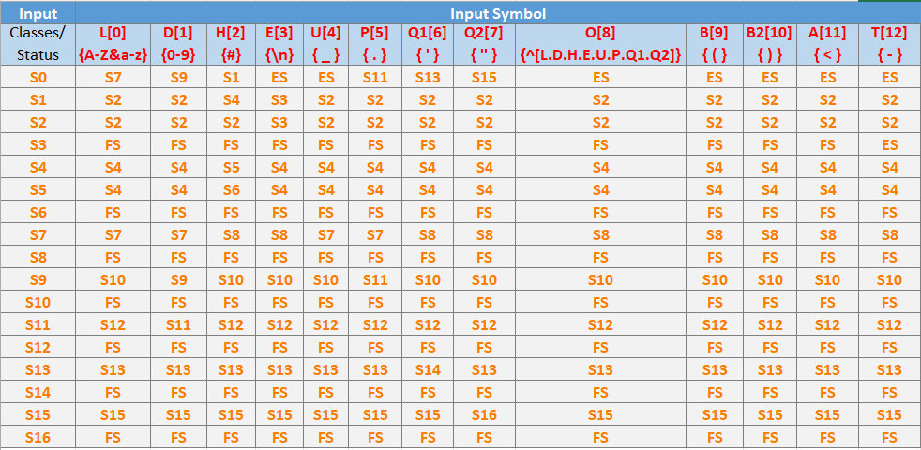

Update: Jun 1st 2024.

Adapted from resources developed by Prof. Svillen Ranev (Algonquin College, 2019)

